

| **TITLE:**  Program to print patterns |
| --- |

**AIM:** Program to print patterns for ‘n’ rows using nested loop **______________________________________________________________________**

**Expected OUTCOME of Experiment:**

CO2: Apply basic concepts of C programming for problem solving.

**_____________________________________________________________________**

**Books/ Journals/ Websites referred:**

1. Programming in C, second edition, Pradeep Dey and Manas Ghosh, Oxford University Press.
2. Programming in ANSI C, fifth edition, E Balagurusamy, Tata McGraw Hill.
3. Introduction to programming and problem solving , G. Michael Schneider ,Wiley India edition.
4. [**http://cse.iitkgp.ac.in/~rkumar/pds-vlab/**](http://cse.iitkgp.ac.in/~rkumar/pds-vlab/)

**_____________________________________________________________________**

**Problem Definition:**

The program is to print a pattern as given by the user. The program makes use of a nested loop to print a pattern of characters, numbers or alphabets.

**Example:**

Input: number of rows = 4, number of columns = 4

Output:

5

             4    5

         3   4   5

    2   3   4   5

1  2   3   4   5

**Algorithm:**

**Pattern 1**

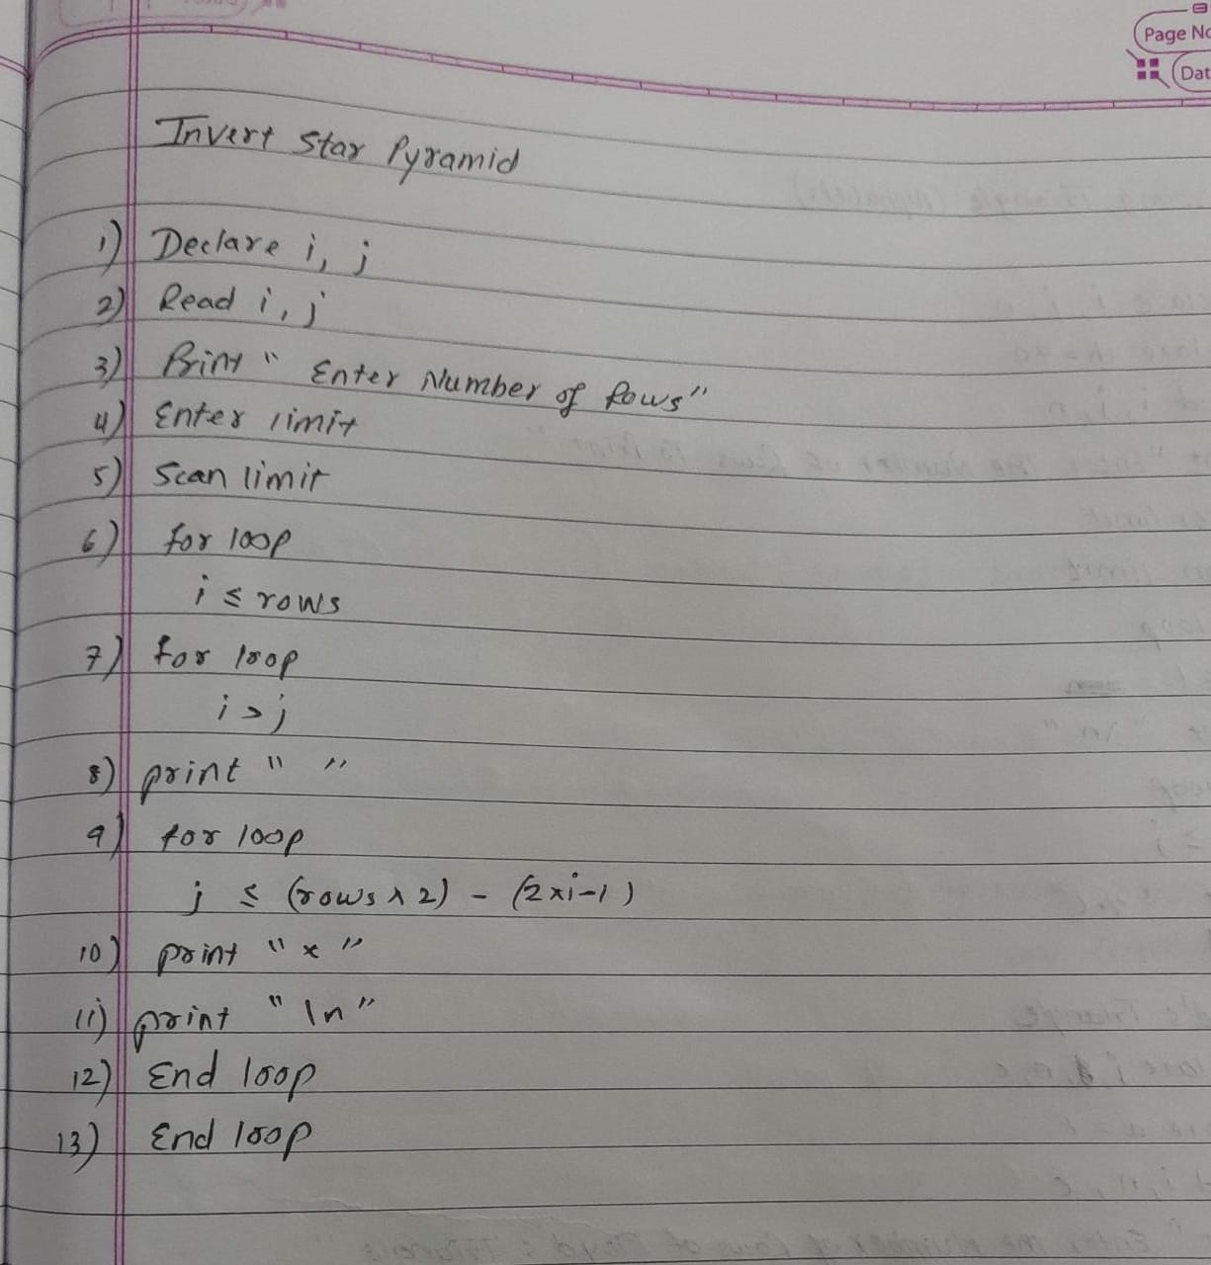

**Pattern 2**

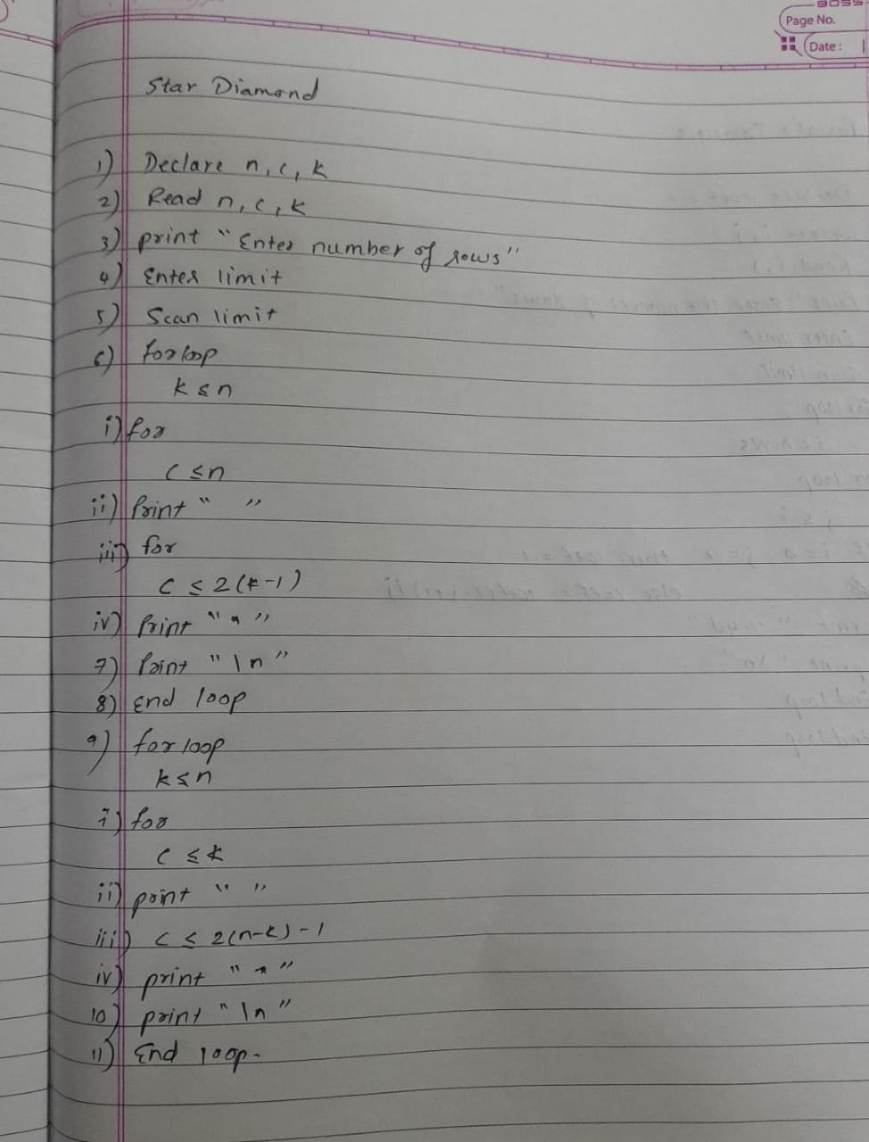

**Pattern 3**

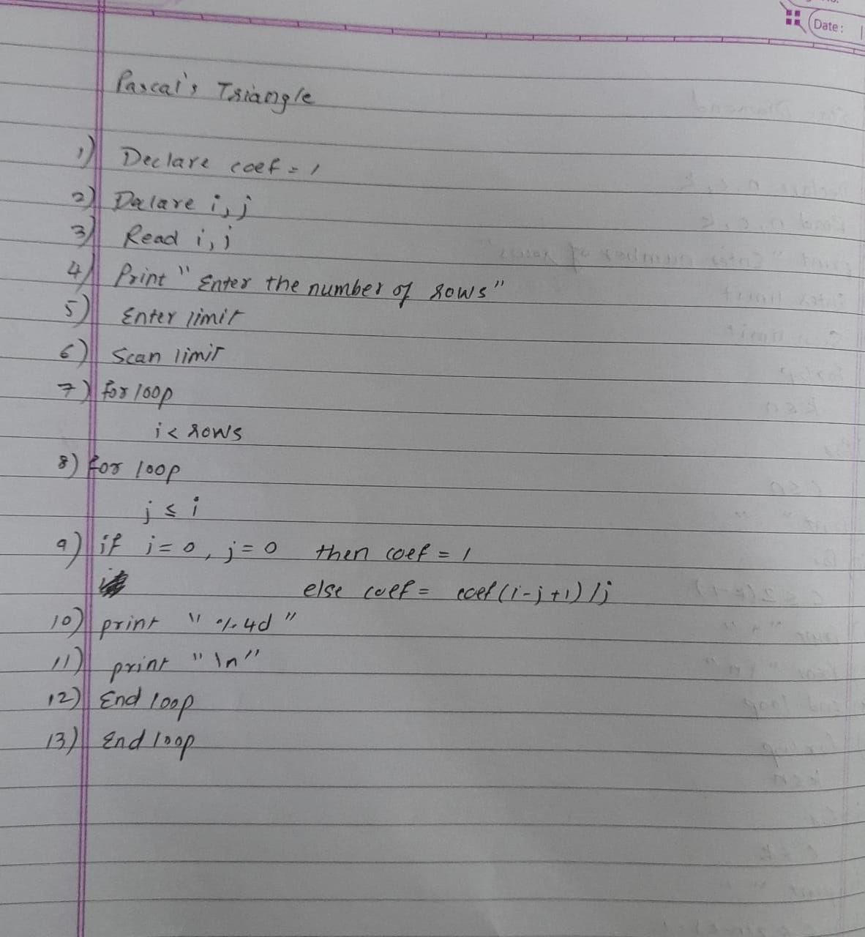

**Pattern 4**

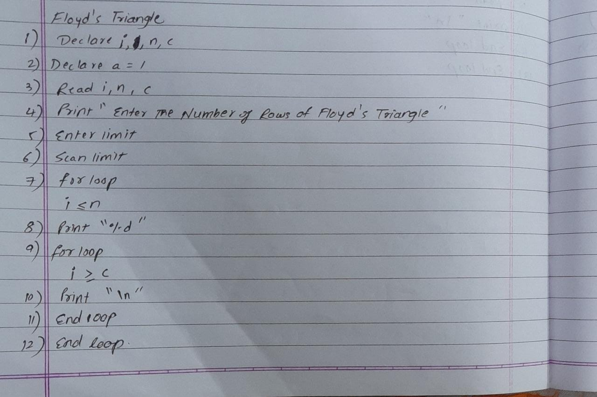

**Pattern 5**

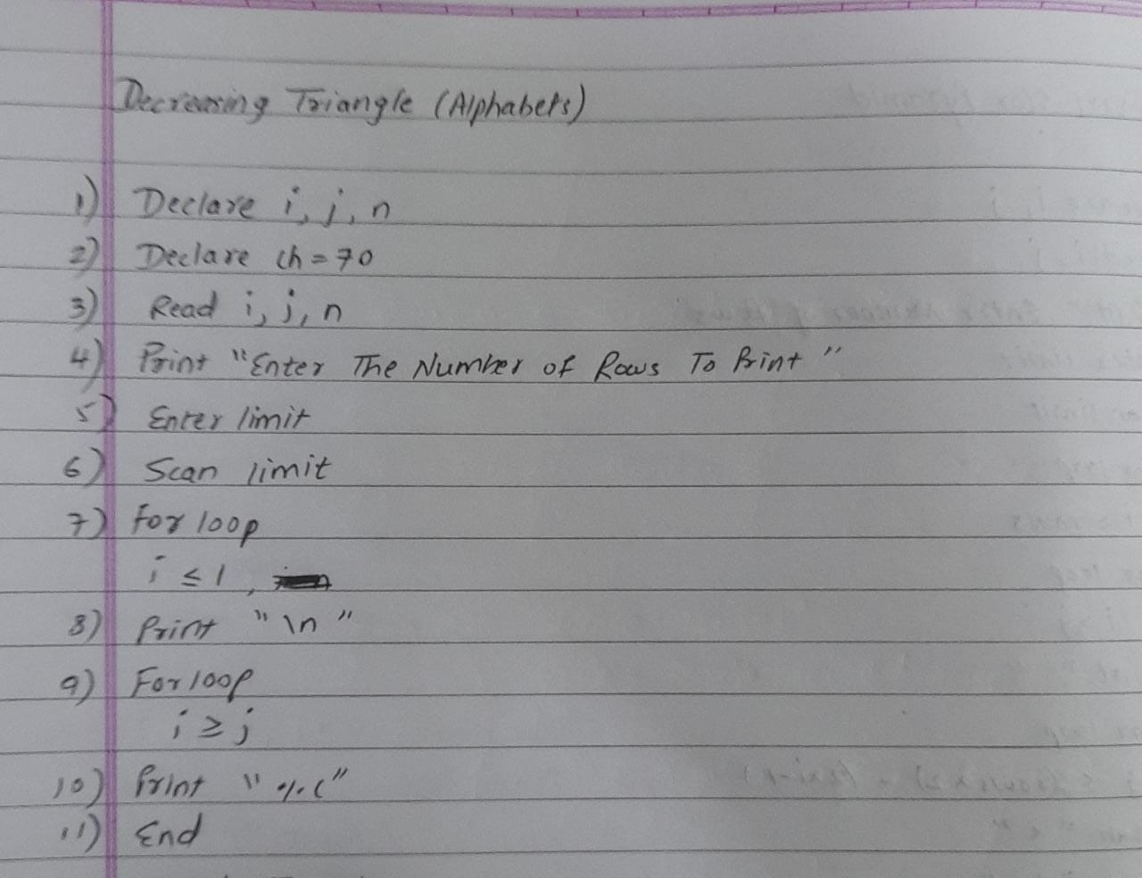

**Implementation details:**

**Pattern 1 :**

**//Inverted star Pyramid Meet Gala 16010121051_A3//**

**#include <stdio.h>**

**int main()**

**{**

**int i, j, rows;**

**printf("Enter number of rows : ");**

**scanf("%d", &rows);**

**for(i=1; i<=rows; i++)**

**{**

**for(j=1; j<i; j++)**

**{**

**printf(" ");**

**}**

**for(j=1; j<=(rows*2 -(2*i-1)); j++)**

**{**

**printf("*");**

**}**

**printf("\n");**

**}**

**return 0;**

**}**

**Pattern 2 :**

**//Star Diamond Meet Gala 16010121051_A3//**

**#include <stdio.h>**

**int main()**

**{**

**int n, c, k;**

**printf("Enter number of rows\n");**

**scanf("%d", &n);**

**for (k = 1; k <= n; k++)**

**{**

**for (c = 1; c <= n-k; c++)**

**printf(" ");**

**for (c = 1; c <= 2*k-1; c++)**

**printf("*");**

**printf("\n");**

**}**

**for (k = 1; k <= n - 1; k++)**

**{**

**for (c = 1; c <= k; c++)**

**printf(" ");**

**for (c = 1 ; c <= 2*(n-k)-1; c++)**

**printf("*");**

**printf("\n");**

**}**

**return 0;**

**}**

**Pattern 3 :**

**//Pascal’s triangle Meet Gala 16010121051_A3//**

**#include <stdio.h>**

**int main() {**

**int rows, coef = 1, space, i, j;**

**printf("Enter the number of rows: ");**

**scanf("%d", &rows);**

**for (i = 0; i < rows; i++) {**

**for (space = 1; space <= rows - i; space++)**

**printf(" ");**

**for (j = 0; j <= i; j++) {**

**if (j == 0 || i == 0)**

**coef = 1;**

**else**

**coef = coef * (i - j + 1) / j;**

**printf("%4d", coef);**

**}**

**printf("\n");**

**}**

**return 0;**

**}**

**Pattern 4:**

**//Floyd's Triangle Meet Gala 16010121051_A3//**

**#include <stdio.h>**

**int main()**

**{**

**int n, i, c, a = 1;**

**printf("Enter the number of rows of Floyd's triangle to print\n");**

**scanf("%d", &n);**

**for (i = 1; i <= n; i++)**

**{**

**for (c = 1; c <= i; c++)**

**{**

**printf("%d ", a);**

**a++;**

**}**

**printf("\n");**

**}**

**return 0;**

**}**

**Pattern 5:**

**//Decreasing Triangle Meet Gala 16010121051_A3 //**

**#include<stdio.h>**

**int main(){**

**int i, j, n;**

**int ch= 70;**

**printf("Enter The Number Of Rows To Print : ");**

**scanf("%d", &n);**

**for(i=n; i>=1; i--){**

**printf("\n");**

**for(j=1; j<=i; j++){**

**printf(" %c", (ch-j));**

**}**

**}**

**}**

**Output(s):**

**Pattern 1:**

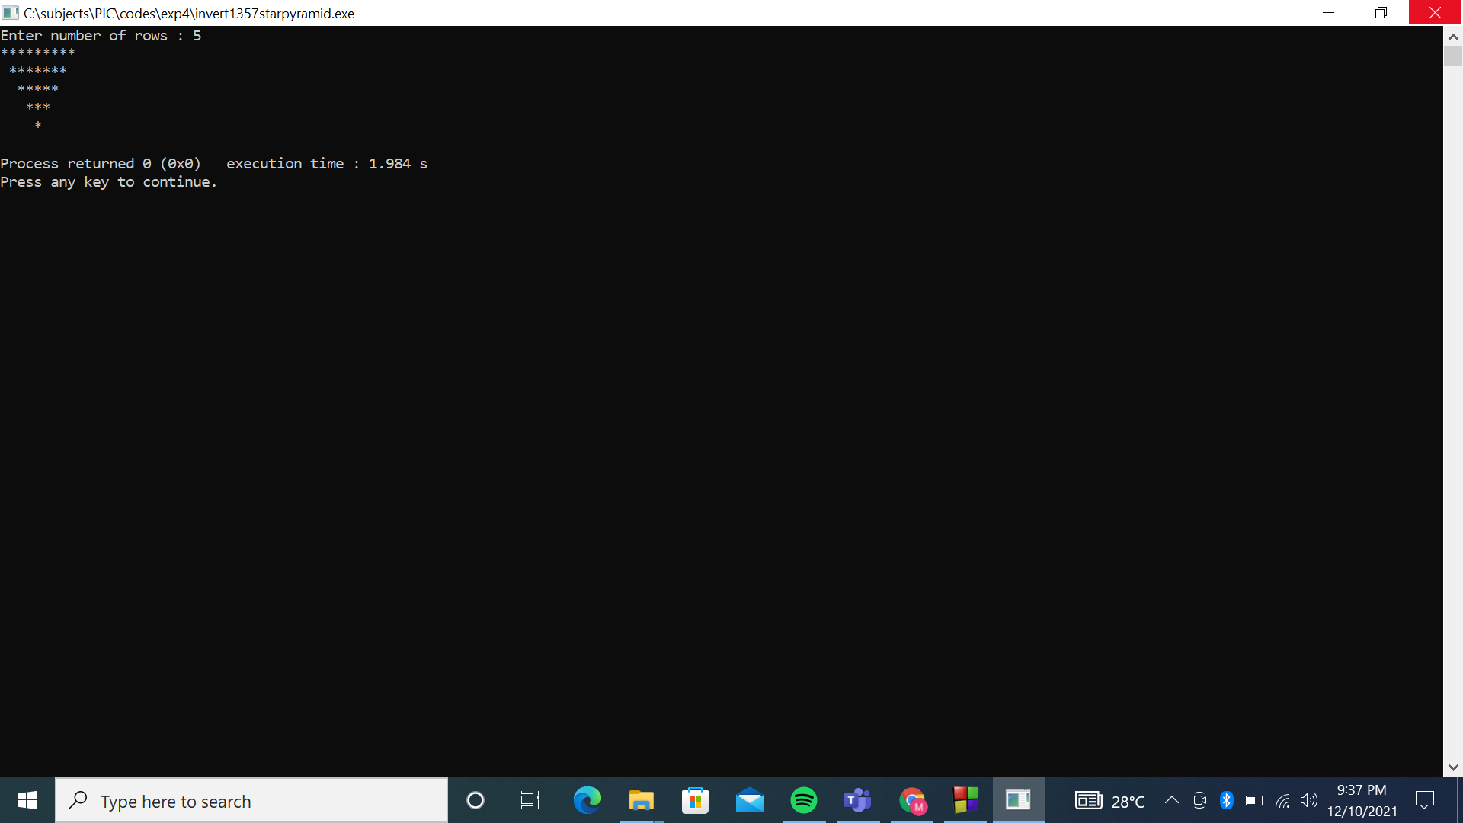

Pattern 2:

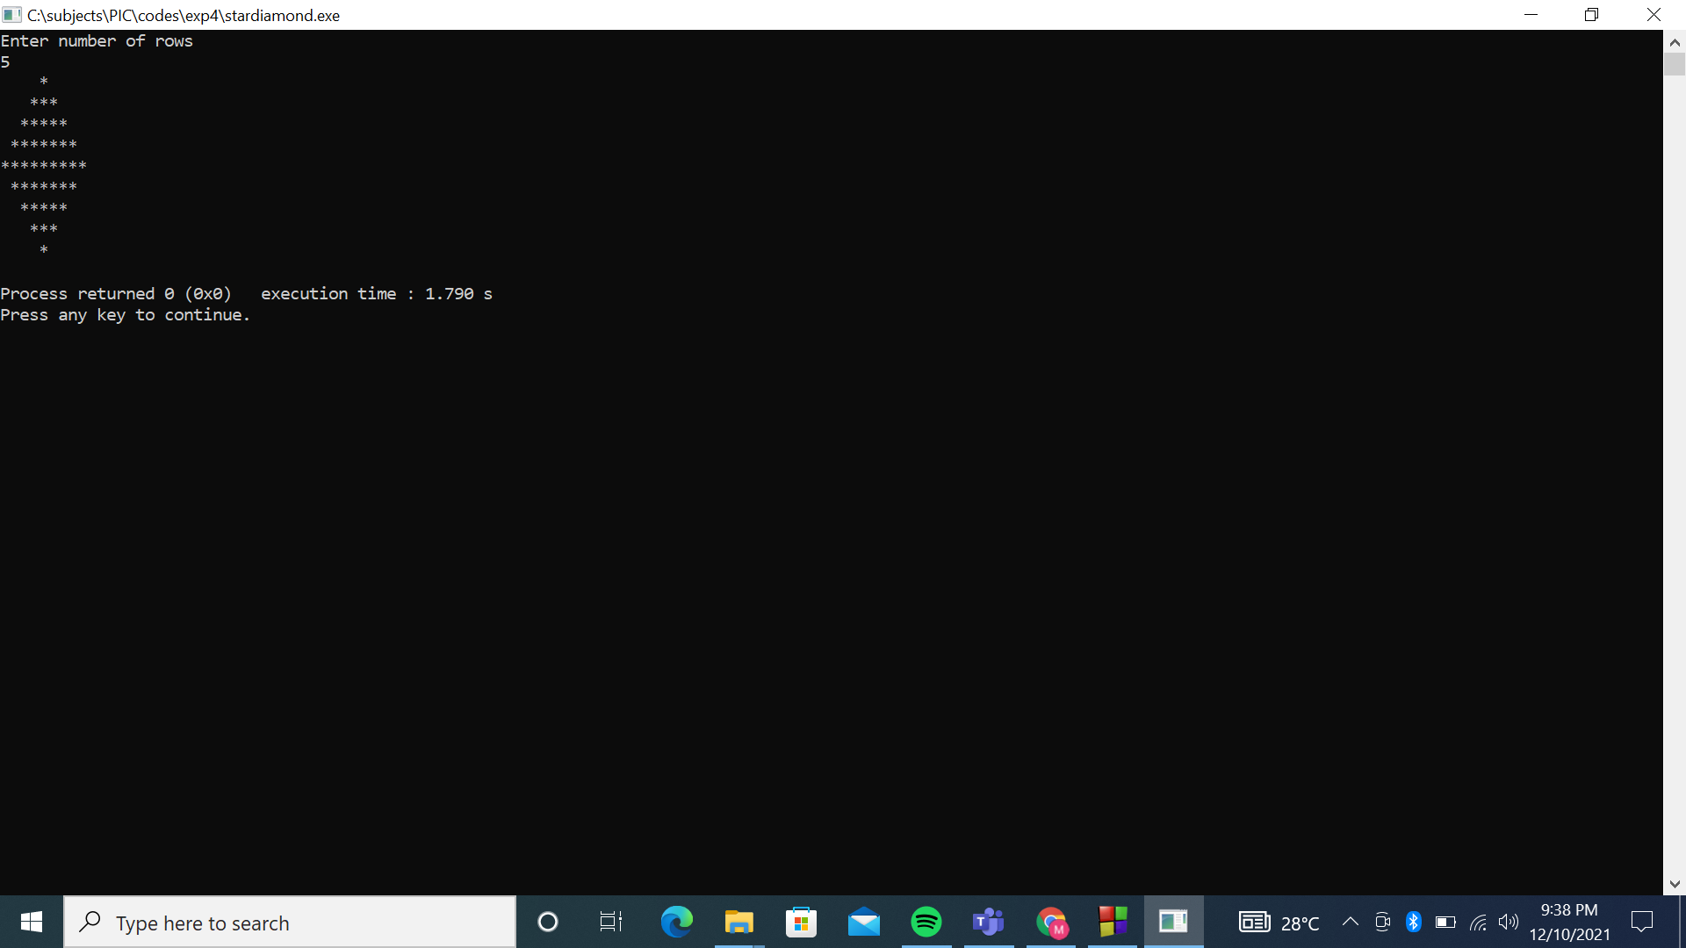

Pattern 3:

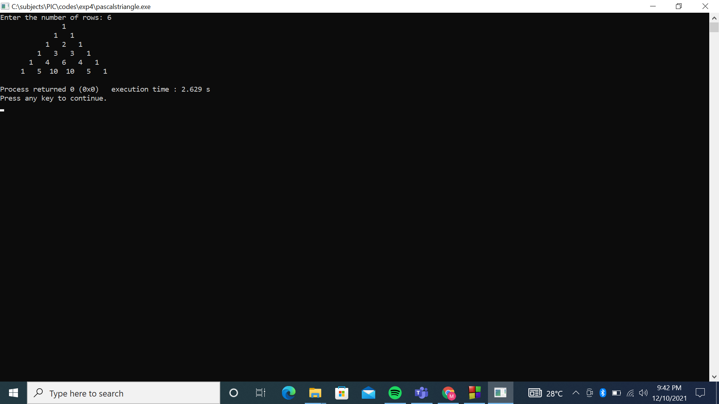

Pattern 4:

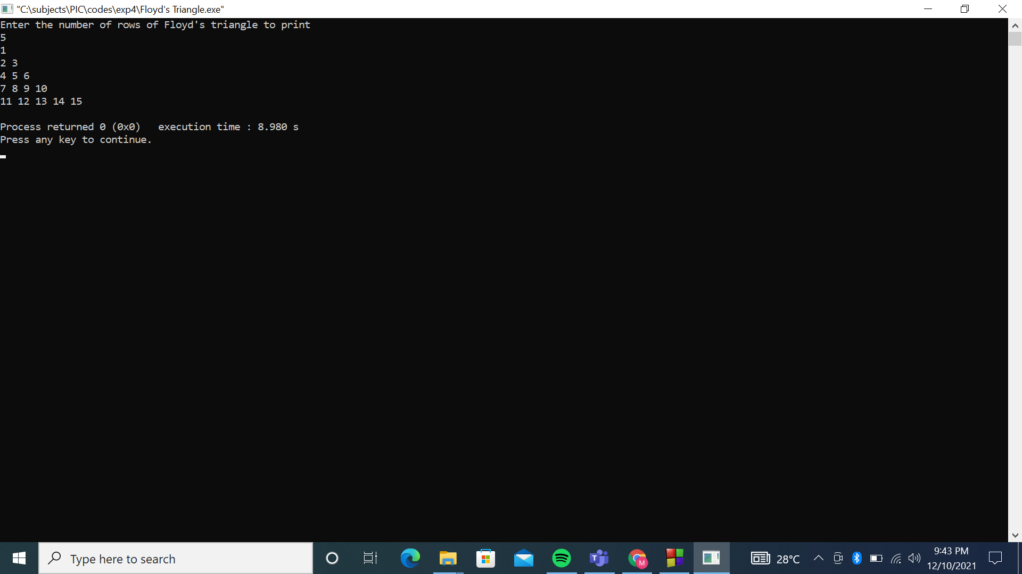

Pattern 5;

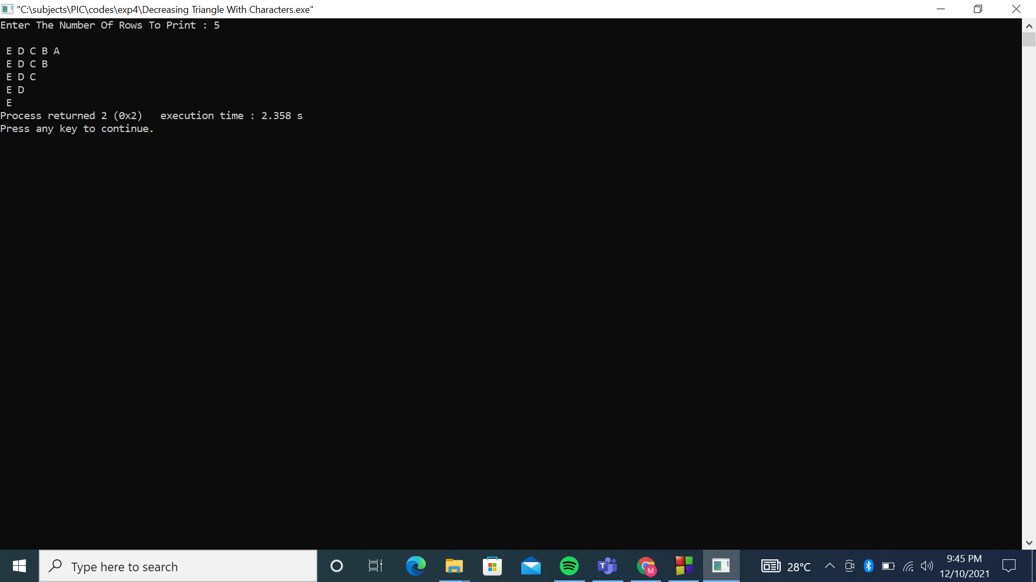

**Conclusion: The desirable unique patterns were successfully obtained.**

**Post Lab Descriptive Questions**

Write a program to print the following:

1

2 4

3 6 9

4 8 12 16

5 10 15 20 25

6 12 18 24 30 36

7 14 21 28 35 42 49

8 16 24 32 40 48 56 64

9 18 27 36 45 54 63 72 81

10 20 30 40 50 60 70 80 90 100

Implementation-

//post lab tables Meet Gala 16010121051_A3//

#include<stdio.h>

int main() {

int i, j;

for (i = 1; i <= 10; i++) {

for (j = 1; j <= i; j++) {

printf("%d ", i * j);

}

printf("\n");

}

return(0);

}

Output:

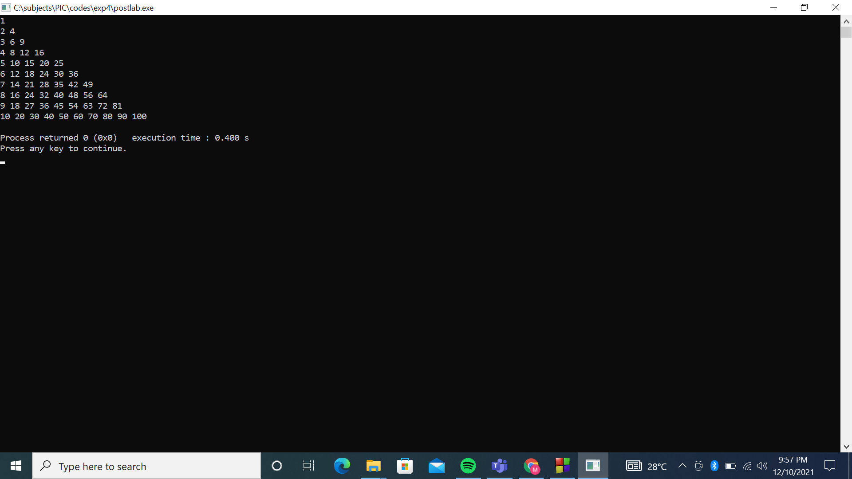

**Date: _____________ Signature of faculty in-charge**