**Batch: A3 Roll No.:16010121051**

**Experiment / assignment / tutorial No. 10**

**Grade: AA / AB / BB / BC / CC / CD /DD**

**Signature of the Staff In-charge with date**

|  |
| --- |
| **TITLE:**  Application Oriented Program |

**AIM:** To develop any application based program.

**______________________________________________________________________**

**Expected OUTCOME of Experiment:**

CO 1: Formulate a problem statement and develop the logic (algorithm/flowchart) for its solution.

CO 2: Apply basic concepts of C programming for problem solving.

CO 3: Illustrate the use of derived and structured data types such as arrays, strings, structures and unions.

CO 4: Design modular programs using functions and demonstrate the concept of pointers and file handling.

**_____________________________________________________________________**

**Books/ Journals/ Websites referred:**

1. Programming in C, second edition, Pradeep Dey and Manas Ghosh, Oxford University Press.
2. Programming in ANSI C, fifth edition, E Balagurusamy, Tata McGraw Hill.
3. Introduction to programming and problem solving , G. Michael Schneider ,Wiley India edition.
4. [**http://cse.iitkgp.ac.in/~rkumar/pds-vlab/**](http://cse.iitkgp.ac.in/~rkumar/pds-vlab/)

**_____________________________________________________________________**

**Problem Definition:**

Consider the marble rolling toy as shown in figure:

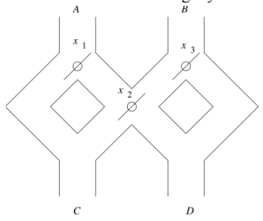

A marble is dropped at A or B. Levers x1, x2 and x3 cause the marble to fall either to the left or to the right. Whenever a marble encounters a lever, it causes the lever to reverse the direction after the marble passes, so the next marble will take the opposite branch.

**Write a C program to accept an input sequence and generate the appropriate output sequence. Example: input: “BAA” Its equivalent output sequence is “CCD” i.e. three marbles are dropped sequentially at B, A and A. First marble will find its way through C, second through C and third through D.**

**Flowchart:**

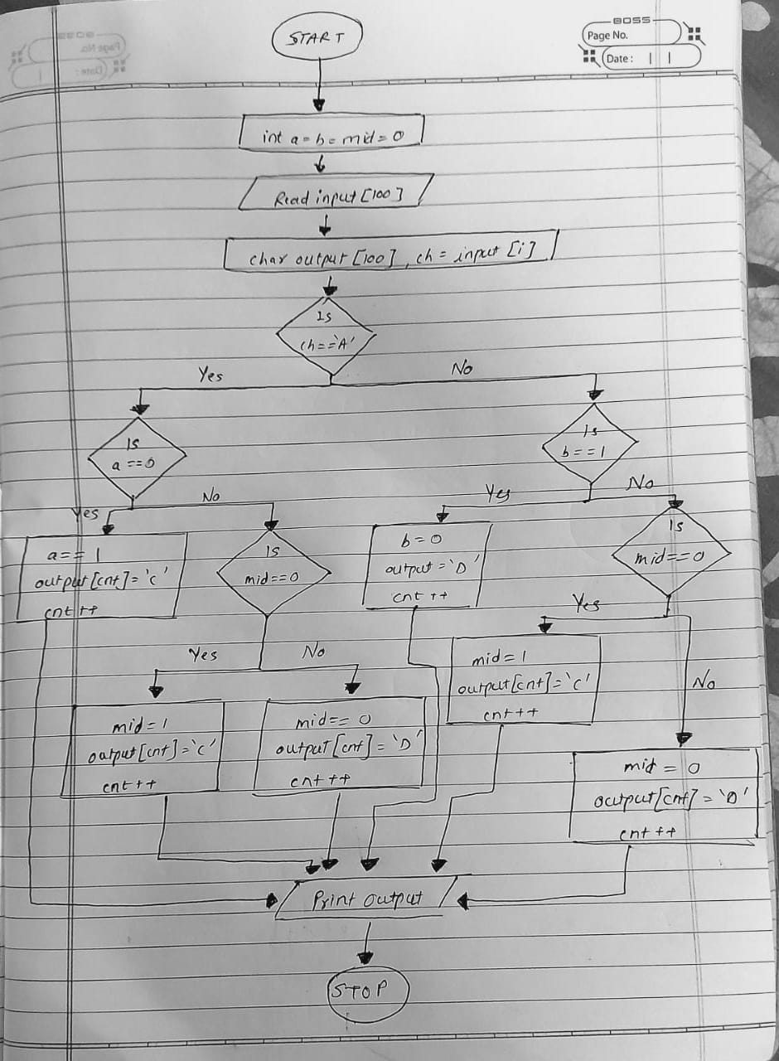

**Implementation details:**

// 16010121051 Meet Gala Experiment 10//

#include<stdio.h>

#include<string.h>

int main()

{

char input[100];

printf("\n\nEnter Input: ");

scanf("%s",input);

int a=0,b=0,i,mid=0;

int cnt=0;

char output[100];

for( i=0;i<strlen(input);i++)

{

char ch=input[i];

if(ch=='A')

{

if(a==0)

{

a=1;

output[cnt]='C';

cnt++;

}

else

{

a=0;

if(mid==0)

{

mid=1;

output[cnt]='C';

cnt++;

}

else

{

mid=0;

output[cnt]='D';

cnt++;

}

}

}

else if(ch=='B')

{

if(b==1)

{

b=0;

output[cnt]='D';

cnt++;

}

else

{

b=1;

if(mid==0)

{

mid=1;

output[cnt]='C';

cnt++;

}

else

{

mid=0;

output[cnt]='D';

cnt++;

}

}

}

}

printf("\nOutput : %s\n\n",output);

return 0;

}

**Output(s):**

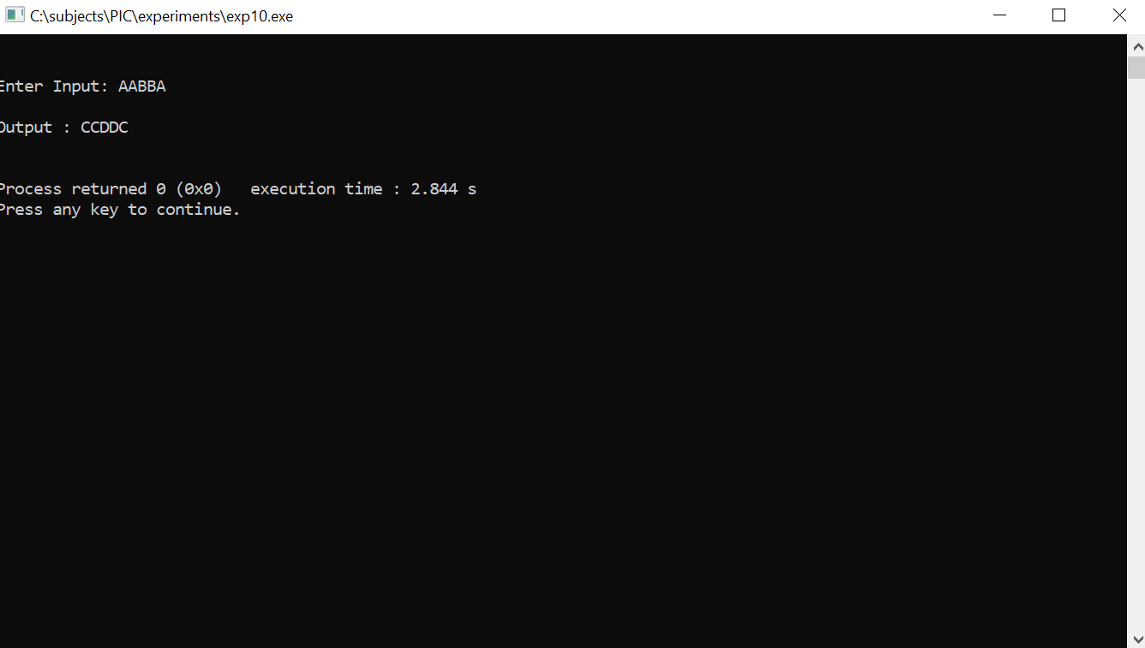

**Conclusion:**

Application Oriented Program Has Been Successfully Executed Without Any Errors & We Have Achieved the Desired Output Sequence.

**Date: _____________ Signature of faculty in-charge**