**Department of Science and Humanities**

F Y B Tech SEM II 2021-22

Engineering Physics Lab Course

**Photoelectric Effect**

**Name: Meet Gala**

**Roll No: 16010121051**

**Branch: Comps**

**Batch: A3**

**Aim:**  To understand the phenomenon Photoelectric effect as a whole.

To plot a graph connecting photocurrent and applied potential.

To determine the stopping potential for the photocurrent versus applied potential.

**Apparatus:** Voltmeter, Rheostat, Battery, Light source, Anode Material.

Diagram(snap shots):-

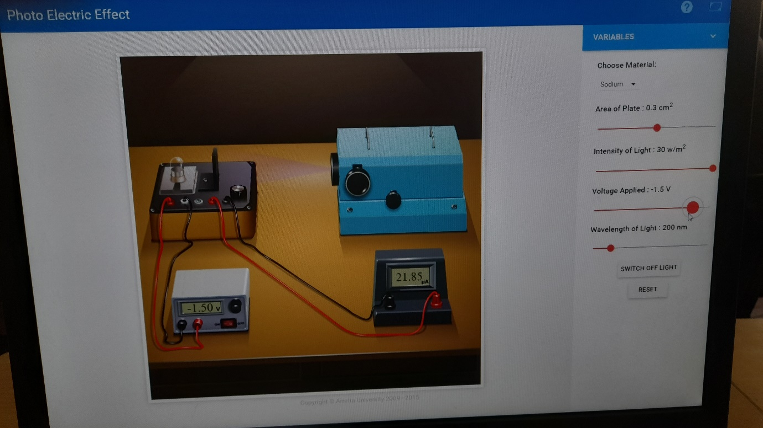

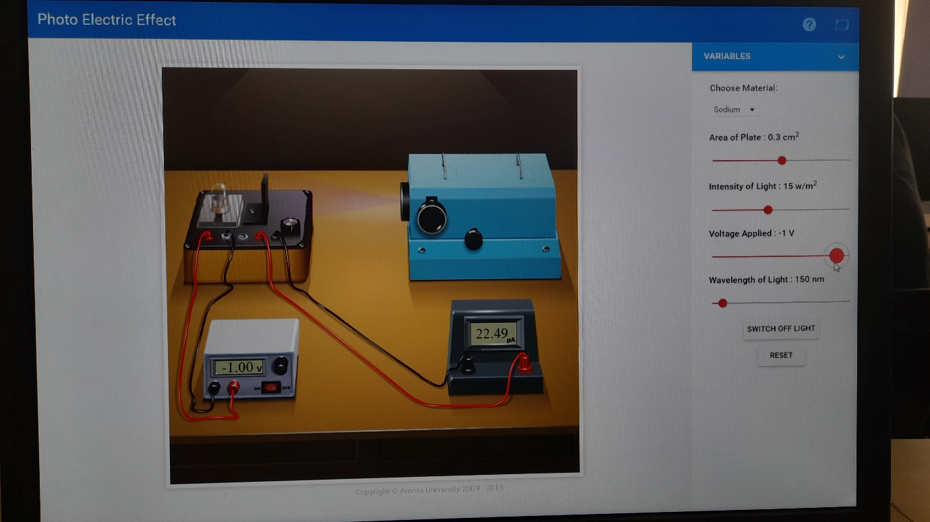

**Observation Table:**

Material: sodium

Area of plates: 0.5 cm2

**TABLE I: Fixed wavelength, varying intensity:**

|  |  |  |  |  |  |
| --- | --- | --- | --- | --- | --- |
| Wavelength: 150 nm | | | | | |
| Intensity = 15 W/m2 | | Intensity = 20 W/m2 | | Intensity = 25 W/m2 | |
| Voltage (V) | Current (µA) | Voltage (V) | Current (µA) | Voltage (V) | Current (µA) |
| 0 | 26.99 | 0 | 35.98 | 0 | 44.98 |
| -0.5 | 24.74 | -0.5 | 32.98 | -0.5 | 41.23 |
| -1 | 22.49 | -1 | 29.98 | -1 | 37.48 |
| -1.5 | 20.24 | -1.5 | 26.98 | -1.5 | 33.78 |
| -2 | 17.99 | -2 | 23.98 | -2 | 29.98 |
| -2.5 | 15.74 | -2.5 | 20.98 | -2.5 | 26.23 |
| -3 | 13.49 | -3 | 17.98 | -3 | 22.48 |
| -3.5 | 11.24 | -3.5 | 14.98 | -3.5 | 18.73 |
| -4 | 8.99 | -4 | 11.98 | -4 | 14.98 |
| -4.5 | 6.79 | -4.5 | 8.98 | -4.5 | 11.23 |
| -5 | 4.49 | -5 | 5.98 | -5 | 7.48 |
| -5.5 | 2.29 | -5.5 | 2.98 | -5.5 | 3.73 |
| -6 | 0 | -6 | 0 | -6 | 0 |
| VS =-6 | 0 | VS =-6 | 0 | VS =-6 | 0 |

VS: Stopping potential

**TABLE II: Fixed intensity, varying wavelength:**

|  |  |  |  |  |  |
| --- | --- | --- | --- | --- | --- |
| Intensity: 30 W/m2 | | | | | |
| Wavelength = 200 nm | | Wavelength = 300 nm | | Wavelength = 400 nm | |
| Voltage (V) | Current (µA) | Voltage (V) | Current (µA) | Voltage (V) | Current (µA) |
| 0 | 35.34 | 0 | 16.73 | 0 | 7.42 |
| -0.5 | 30.85 | -0.5 | 12.23 | -0.5 | 2.92 |
| -1 | 26.35 | -1 | 7.73 | -1 | 0 |
| -1.5 | 21.85 | -1.5 | 3.23 |  |  |
| -2 | 17.35 | -2 | 0 |  |  |
| -2.5 | 12.85 |  |  |  |  |
| -3 | 8.35 |  |  |  |  |
| -3.5 | 3.85 |  |  |  |  |
| -4 | 0 |  |  |  |  |
| VS =-4 | 0 | VS =-2 | 0 | VS =-1 | 0 |

**Graphs:**

1. Voltage (X-axis) v/s current (Y-axis) for different intensities.

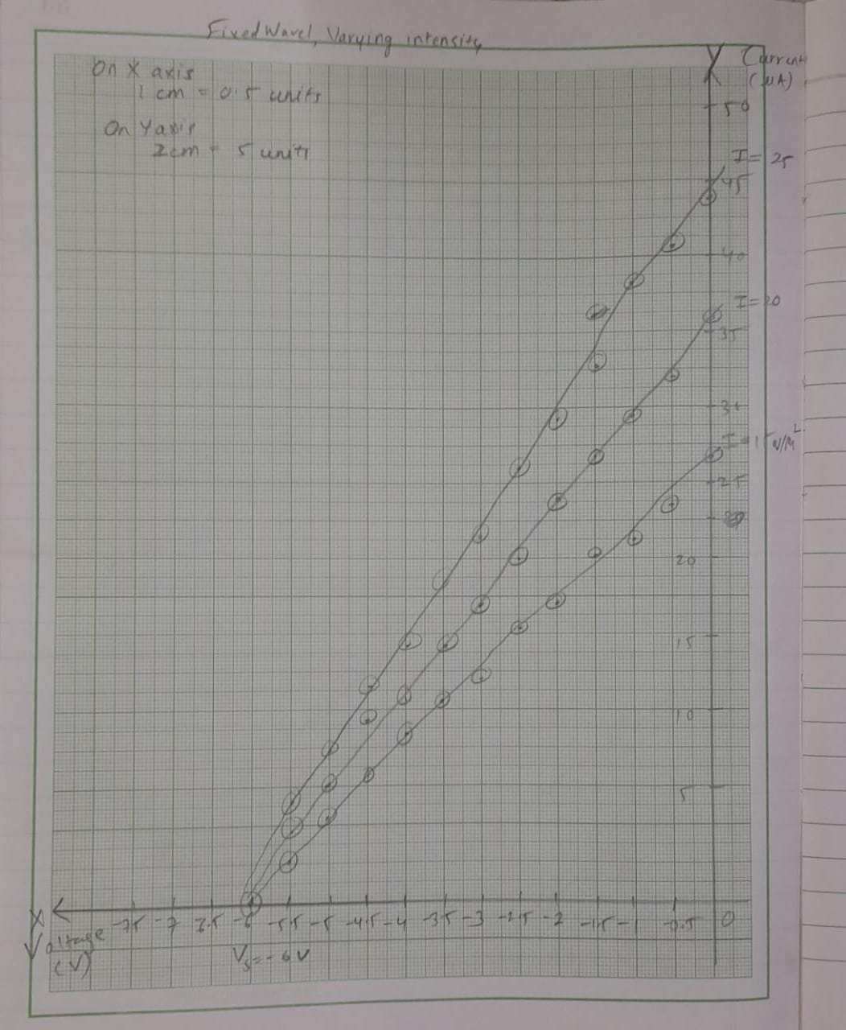

1. Voltage (X-axis) v/s current (Y-axis) for different wavelengths.

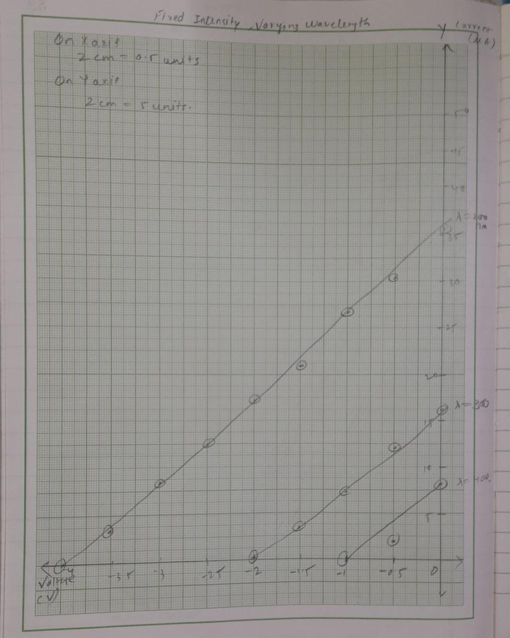

**Home Assignment:**

Same process with different material.

**TABLE I: Fixed wavelength, varying intensity:**

|  |  |  |  |
| --- | --- | --- | --- |
| **Intensity = 20 W/m2** | | **Intensity = 25 W/m2** | |
| **Voltage (V)** | **Current (µA)** | **Voltage (V)** | **Current (µA)** |
| 0 | 77.16 | 0 | 96.45 |
| -1 | 67.16 | -1 | 83.95 |
| -2 | 57.16 | -2 | 71.45 |
| -3 | 47.16 | -3 | 58.95 |
| -4 | 37.16 | -4 | 46.45 |
| -5 | 27.16 | -5 | 33.95 |
| -6 | 17.16 | -6 | 21.45 |
| -7 | 07.16 | -7 | 8.95 |
| -7.8 | 0 | -7.8 | 0 |
| **VS =-7.8** | **0** | **VS =-7.8** | **0** |

**TABLE II: Fixed intensity, varying wavelength:**

|  |  |  |  |
| --- | --- | --- | --- |
| **Intensity= 30W/m2** | | | |
| **Wavelength = 200 nm** | | **Wavelength =150 nm** | |
| **Voltage (V)** | **Current (µA)** | **Voltage (V)** | **Current (µA)** |
| 0 | 22.62 | 0 | 53.66 |
| -0.5 | 19.62 | -0.5 | 46.16 |
| -1 | 16.62 | -1 | 38.66 |
| -1.5 | 13.62 | -1.5 | 31.16 |
| -2 | 10.62 | -2 | 23.66 |
| -2.5 | 7.62 | -2.5 | 16.16 |
| -3 | 4.62 | -3 | 8.66 |
| -3.5 | 1.62 | -3.5 | 1.16 |
| -4 | 0 | 3.6 | 0 |
| **VS =-4** | **0** | **VS =-1.9** | **0** |

Graphs :-

1.Voltage (X-axis) v/s current (Y-axis) for different intensities.

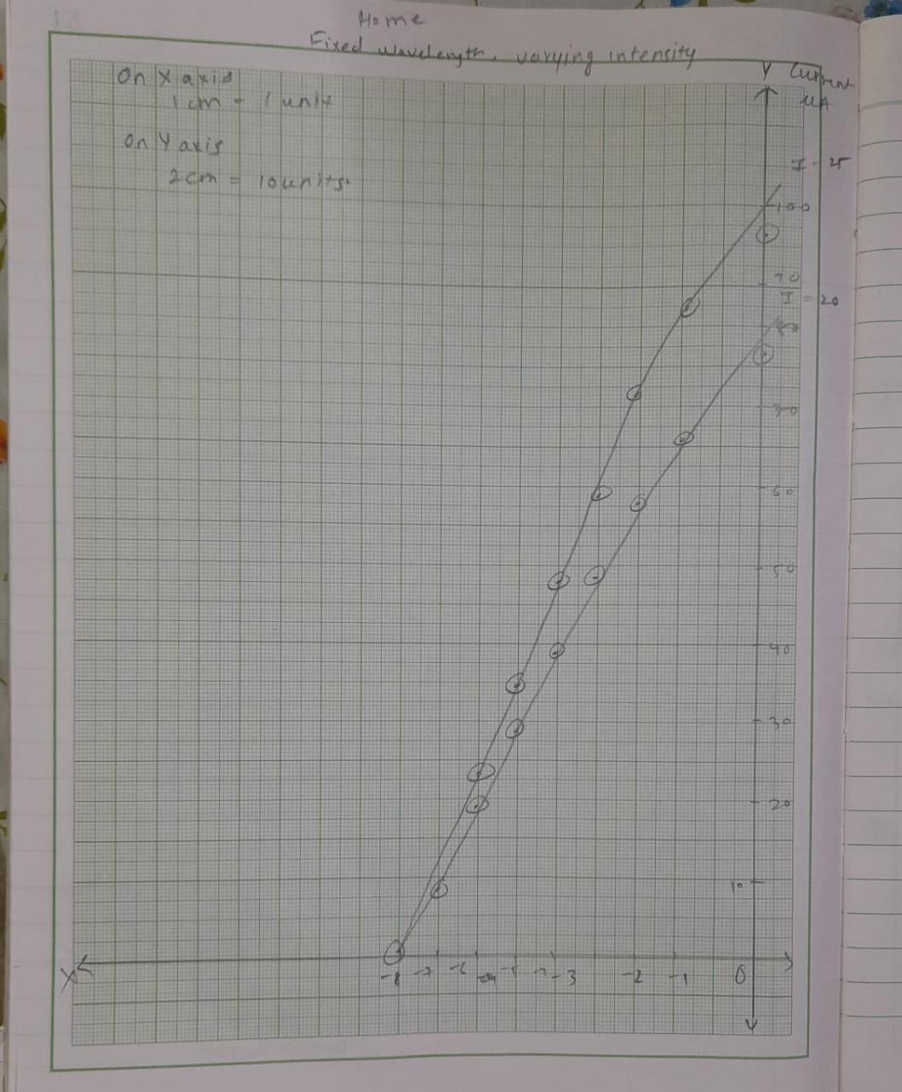

2.Voltage (X-axis) v/s current (Y-axis) for different wavelengths.

