**Hall Effect**

**Name: Meet Gala**

**Roll No: 16010121051**

**Branch: Comps**

**Batch: A3**

**Aim:-**

1. To determine Hall Voltage developed across the sample material
2. To calculate the Hall coefficient and carrier concentration of sample material.

**Apparatus:-**  Two solenoids ,constant current supply , four probe , digital gauss meter , Hall effect Apparatus , digital millivoltmeter , hall probe.

**Diagram:-**

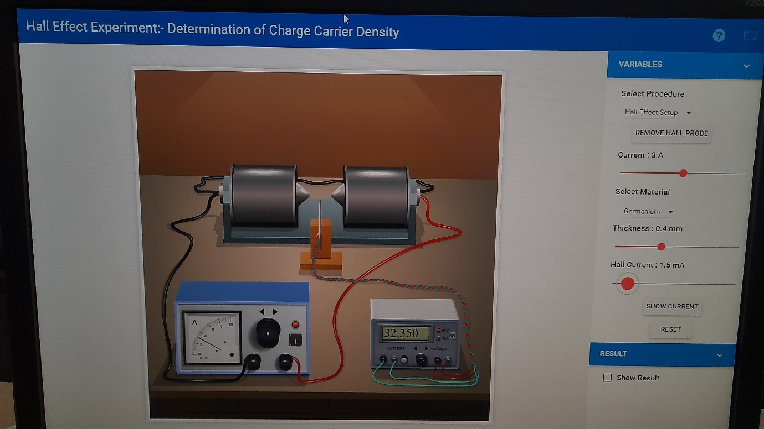

**Observation Table:**

Material: Germanium

Magnetic field B = 0.447 gauss = 0.0000447 tesla

|  |  |  |  |
| --- | --- | --- | --- |
| Thickness t = 0.4 mm | | Thickness t = 0.8 mm | |
| IH mA | VH mV | IH mA | VH mV |
| 1 | 21.567 | 1 | 10.7 |
| 1.5 | 32.350 | 1.5 | 16.17 |
| 2 | 43.13 | 2 | 21.5 |
| 2.5 | 53.91 | 2.5 | 26.9 |
| 3 | 64.7 | 4 | 32.3 |
| 3.5 | 75.4 | 3.5 | 37.7 |
| 4 | 86.2 | 4 | 43.13 |
| 4.5 | 97.05 | 4.5 | 48.5 |
| 5 | 107.8 | 5 | 53.9 |

Hall Coefficient – 0.0194

Carrier Coefficient – 3.22165e+20

**Calculations:-**

**Formula:** carrier concentration $n=\frac{B}{q × t × slope}$

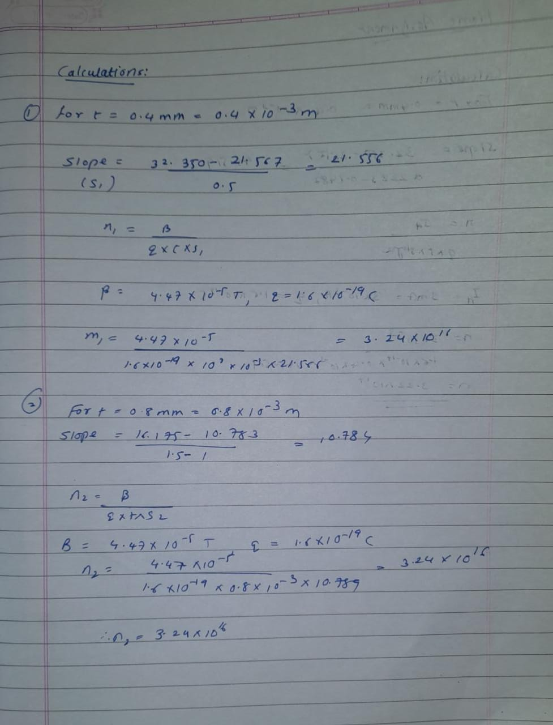

**Graph:**

Plot Hall voltage (Y-axis) v/s Hall current (X-axis) for different thicknesses

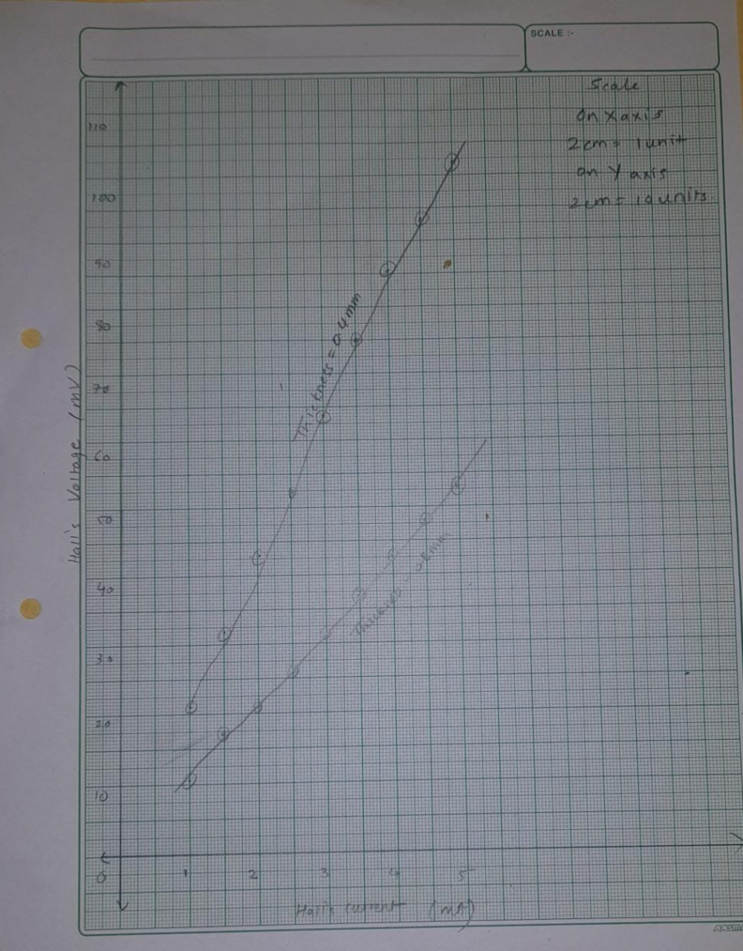

**Result:-**  The value of n is 3.24 x 1016  for thickness 0.4mm and 0.8mm

**Home Assignment:**

Keep Hall current (IH) fixed at 3 mA. Vary Magnet current in steps of 0.5 A and note Hall voltage. Plot graph of Hall voltage (Y-axis) v/s Magnetic field* for any one thickness. Calculate carrier concentration using the formula: $n=\frac{I_{H}}{q × t × slope}$

*Find magnetic field for different magnet currents by selecting “Magnetic field v/s Current” from the “Select Procedure” drop-down menu of the simulator.

Observation table for Home Assignment:

Material: Germanium

Hall current: 3 mA

|  |  |  |
| --- | --- | --- |
| Thickness t = 0.4 OR 0.8 mm | | |
| I ampere  (magnet current) | B gauss | VH mV |
| 1 | 0.1482 | 21.567 |
| 1.5 | 0.2223 | 32.325 |
| 2 | 0.2964 | 43.133 |
| 2.5 | 0.3706 | 53.917 |
| 3 | 0.4447 | 64.700 |
| 3.5 | 0.5188 | 75.484 |
| 4 | 0.5929 | 86.267 |
| 4.5 | 0.6670 | 97.050 |
| 5 | 0.7411 | 107.834 |

**Calculation :-**

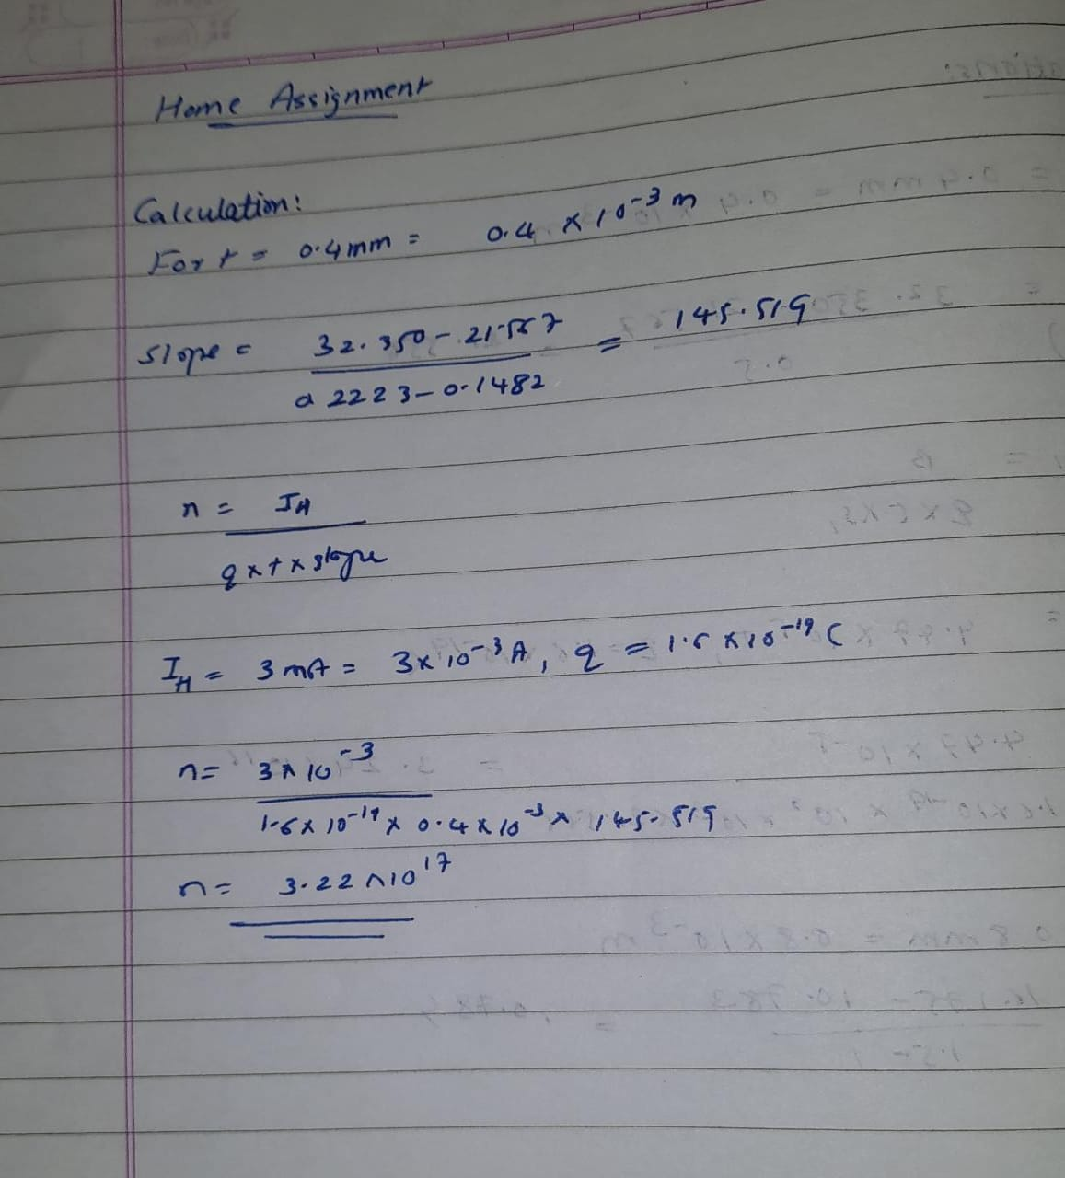

**Graph:-**

