**Name :- Meet gala**

**Batch :- A3**

**Roll No. 16010121051**

**Resistivity by Four Probe method**

**Aim:** To determine the resistivity of semiconductors by Four probe Method.

**Apparatus :** Probes , Oven , Voltmeter , Ammeter

**Procedure** :

1. Select the semiconductor material from the combo box.
2. Select the source current from the slider. Restrict the slider based on the range of current.
3. Select the Range of oven from the combo box.
4. Set the temperature from the slider.
5. Click on the Run Button to start heating the oven in a particular interval, from the default 250C to the temperature that we set already Click on the Wait button to stop heating.
6. Click on the Set button to display the temperature that we set in the oven.
7. Click on the Measure button to display the present temperature in the oven.
8. Select the range of voltmeter from the combo box.
9. Measure the Voltage using Voltmeter.

10.Calculate the Resistivity of semiconductor in eV for the given temperature using equation (2) and (3).

11. A Graph is plotted with Temperature along x-axis and resistivity of semiconductor along y-axis

**Set Up Diagram:**

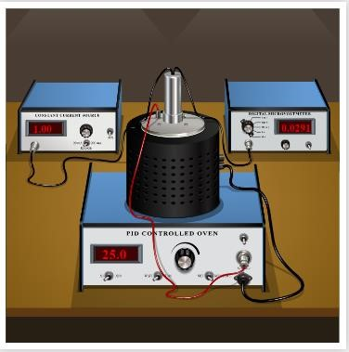

**Observations Table:**

|  |  |  |  |  |  |
| --- | --- | --- | --- | --- | --- |
| Obs. No. | Temperature T (K) | Voltage V(V) | Current I (A) | Resistivity ρo (ohm m) | Resistivity ρ (ohm m) |
| 1 | 298.5 | 0.1454 | 0.005 | 0.3652 | 0.062 |
| 2 | 308.5 | 0.1370 | 0.005 | 0.3441 | 0.058 |
| 3 | 318.5 | 0.1296 | 0.005 | 0.3255 | 0.055 |
| 4 | 328.5 | 0.1231 | 0.005 | 0.3092 | 0.052 |
| 5 | 338.5 | 0.1172 | 0.005 | 0.2944 | 0.049 |
| 6 | 348.5 | 0.1119 | 0.005 | 0.2810 | 0.047 |
| 7 | 358.5 | 0.1071 | 0.005 | 0.2690 | 0.045 |
| 8 | 368.5 | 0.1028 | 0.005 | 0.2582 | 0.043 |

Plot graph of Temperature (along x-axis) and resistivity (along y-axis)

**Calculations:**

Resistivity can be calculated by using the equation given below.

𝜌0

𝜌 = = ………………ohm m

𝑓(𝑤/𝑠)

𝑉

𝜌0 = 𝐼 2𝜋𝑆 = ……………..ohm m

Given: 1. Distance between the probes(S) = 0.2cm

1. Thickness of the sample, (W) = 0.05cm
2. From standard table f (w/S) = 5.89

**Result:** The resistivity of the given semiconductor by four probe method =...0.062....Ohm m

**Graph**

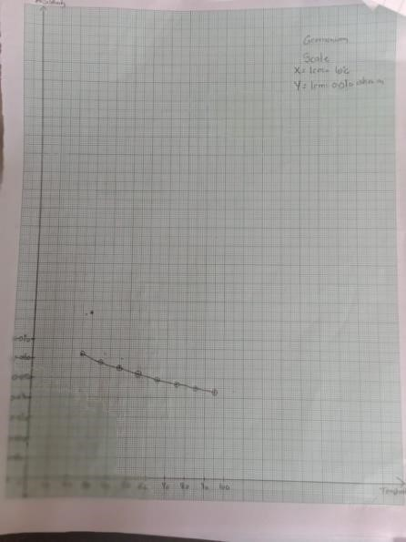

**Home Assignment**: Perform for silicon

Observation table

|  |  |  |  |  |  |
| --- | --- | --- | --- | --- | --- |
| Obs. No. | Temperature T (K) | Voltage V(V) | Current I (A) | Resistivity ρo (ohm m) | Resistivity ρ (ohm m) |
| 1 | 298.5 | 0.6328 | 0.005 | 1.589 | 0.269 |
| 2 | 308.5 | 0.5686 | 0.005 | 1.428 | 0.242 |
| 3 | 318.5 | 0.5143 | 0.005 | 1.291 | 0.219 |
| 4 | 328.5 | 0.4681 | 0.005 | 1.175 | 0.199 |
| 5 | 338.5 | 0.4284 | 0.005 | 1.076 | 0.182 |
| 6 | 348.5 | 0.3941 | 0.005 | 0.989 | 0.168 |
| 7 | 358.5 | 0.3643 | 0.005 | 0.915 | 0.155 |
| 8 | 368.5 | 0.3381 | 0.005 | 0.849 | 0.144 |

**Graph**

