**Department of Science and Humanities**

F Y B Tech SEM II 2021-22

Engineering Physics Lab Course

Name :- Meet Gala

Roll No. 16010121051

Batch A3

**Optical Fibre – Numerical Aperture (using photodetector)**

**Diagram:-**

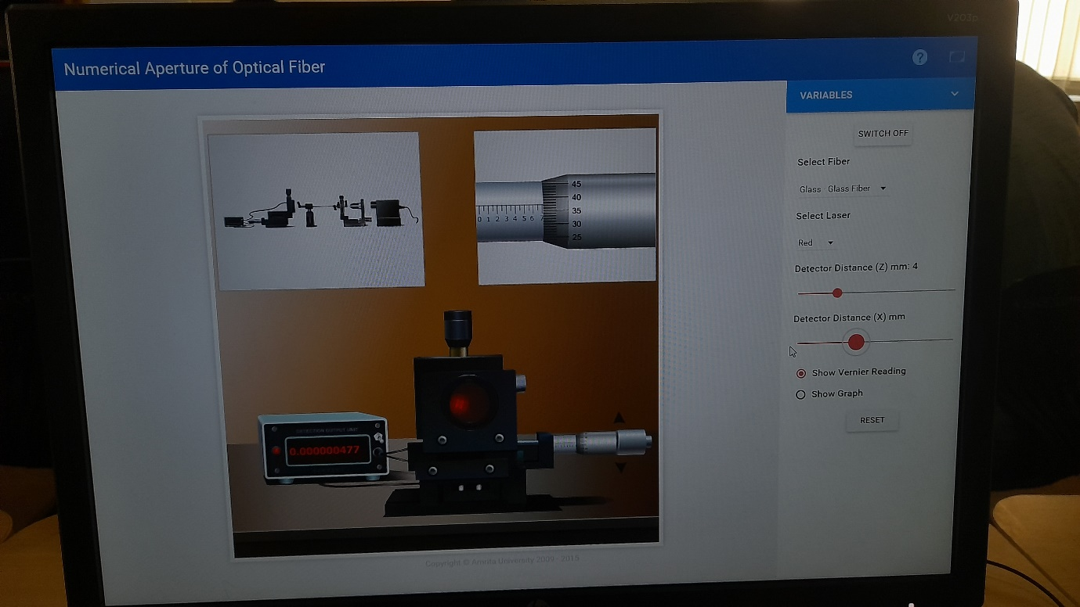

**Observation Table:**

LC of screw gauge = 0.01 mm

Type of optical fibre: Glass-Glass fibre

Light used: Red

Detector axial distance from the fibre (Z) = 2 mm

|  |  |  |  |  |  |
| --- | --- | --- | --- | --- | --- |
| Sr. No | Screw gauge reading | | | | Detector current (µA) |
| Main scale reading M (mm) | Matching division of circular scale (D) | Vernier reading V = D x LC (mm) | detector lateral distance  (X) = M + V (mm) |
| 1 | 2 | 9 | 0.09 | 2.09 | 0 |
| 2 | 3 | 7 | 0.07 | 3.07 | 0 |
| 3 | 4 | 32 | 0.32 | 4.32 | 0.012 |
| 4 | 4 | 45 | 0.45 | 4.85 | 0.051 |
| 5 | 4.5 | 28 | 0.28 | 4.78 | 0.351 |
| 6* | 4.5 | 35 | 0.35 | 4.85 | 0.369 |
| 7 | 4.5 | 39 | 0.39 | 4.89 | 0.361 |
| 8 | 5 | 30 | 0.30 | 5.30 | 0.026 |
| 9 | 5.5 | 12 | 0.12 | 5.62 | 0.0 |
| 10 | 6.5 | 0 | 0 | 6.5 | 0 |

*This should be reading corresponding to peak current

Detector axial distance from the fibre (Z) = 4 mm

|  |  |  |  |  |  |
| --- | --- | --- | --- | --- | --- |
| Sr. No | Screw gauge reading | | | | Detector current  I (µA) |
| Main scale reading M (mm) | Matching division of circular scale (D) | Vernier reading V = D x LC (mm) | detector lateral distance  X = M + V (mm) |
| 1 | 0.5 | 0 | 0 | 0.5 | 0 |
| 2 | 1 | 17 | 0.17 | 1.17 | 0 |
| 3 | 2 | 48 | 0.48 | 2.48 | 0 |
| 4 | 3 | 43 | 0.43 | 3.43 | 0.03 |
| 5 | 4 | 23 | 0.23 | 4.23 | 0.05 |
| 6* | 4.5 | 34 | 0.34 | 4.84 | IP = 0.18 |
| 7 | 5 | 9 | 0.09 | 5.09 | 0.15 |
| 8 | 5.5 | 3 | 0.03 | 5.53 | 0.04 |
| 9 | 6 | 46 | 0.46 | 6.46 | 0.003 |
| 10 | 7 | 37 | 0.37 | 7.37 | 0 |
| 11 | 7.5 | 33 | 0.33 | 7.83 | 0 |

*This should be reading corresponding to peak current

**Graph**:

Plot detector lateral distance X (on X-axis) v/s detector current (on Y-axis) for both the values of detector axial distance (Z) on the same graph paper

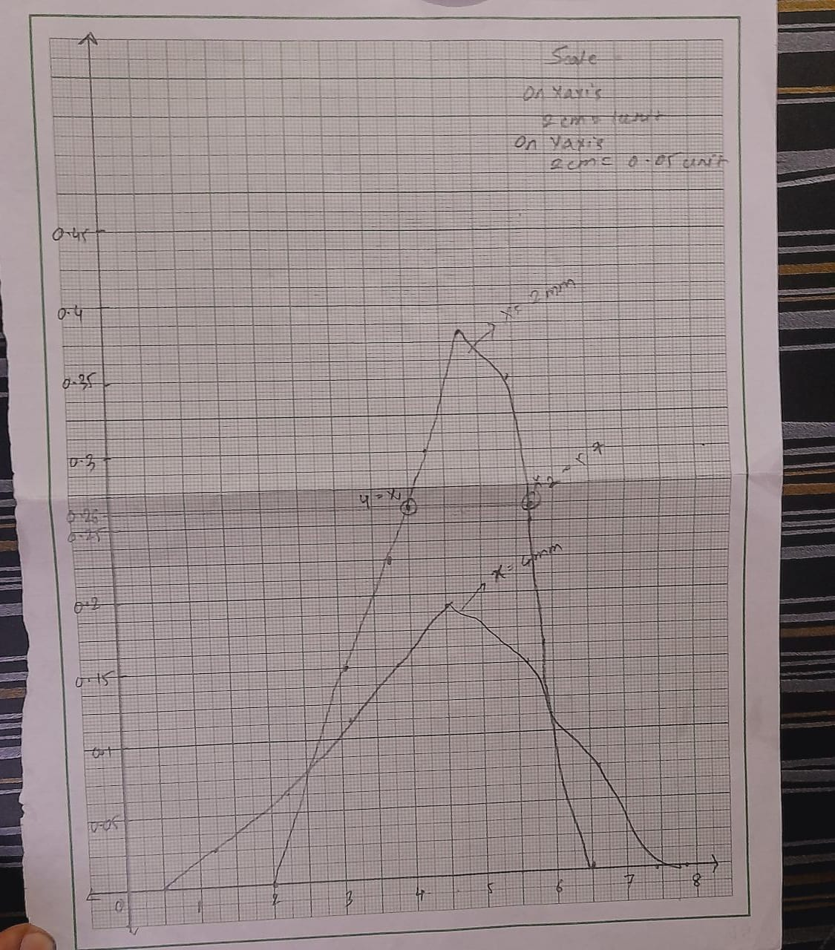

**Calculation:**

1. Determination of spot radius:
2. Find $\frac{1}{\sqrt{2}}$ value of the peak detector current (IP) =
3. These will be two values about the peak value (IP) as show in the diagram
4. Find the corresponding detector lateral distance values say X1 and X2
5. Spot radius (r) is calculated as $r=\frac{X_{2}-X_{1}}{2}$
6. Determination of numerical aperture (NA):
$$NA=\frac{r}{\sqrt{r^{2}+Z^{2}}}$$

7. Determine acceptance angle (θ):

$$θ=\sin^{-1}{NA}$$

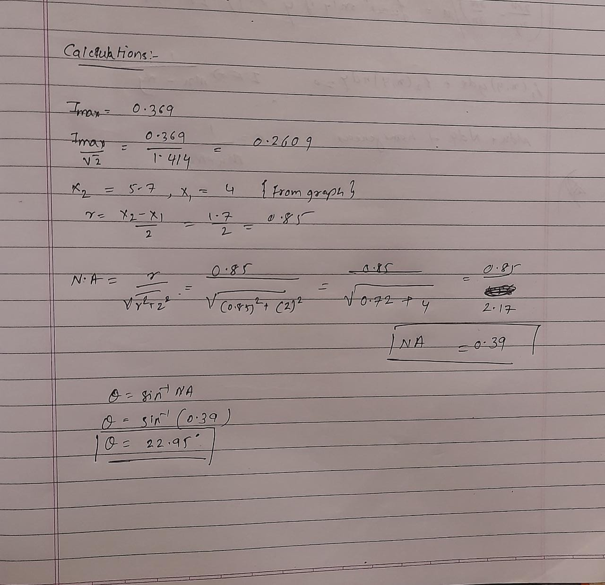

**Result:**

Numerical Aperture of the optical fibre NA =0.39mm

Acceptance angle θ = 22.95 degree



**Home Assignment**:

Determine NA using light of different colour for any one value of detector axial distance Z. Hence conclude whether NA is dependent or independent on the wavelength of light used.

**Observation table for home assignment:**

Type of optical fibre: Glass-Glass fibre

Light used: Green

Detector axial distance from the fibre (Z) = 2 mm

|  |  |  |  |  |  |
| --- | --- | --- | --- | --- | --- |
| Sr. No | Screw gauge reading | | | | Detector current (µA) |
| Main scale reading M (mm) | Matching division of circular scale (D) | Vernier reading V = D x LC (mm) | detector lateral distance  (X) = M + V (mm) |
| 1 | 3 | 17 | 0.17 | 3.17 | 0 |
| 2 | 3.5 | 4 | 0.04 | 3.54 | 0 |
| 3 | 4 | 1 | 0.01 | 4.01 | 0.0915 |
| 4 | 4 | 14 | 0.14 | 4.14 | 0.2137 |
| 5 | 4.5 | 20 | 0.20 | 4.70 | 0.2825 |
| 6* | 4.5 | 34 | 0.34 | 4.84 | IP = 0.3694 |
| 7 | 4.5 | 43 | 0.43 | 4.93 | 0.3382 |
| 8 | 5 | 16 | 0.16 | 5.16 | 0.1078 |
| 9 | 5 | 27 | 0.27 | 5.27 | 0.0414 |
| 10 | 5.5 | 3 | 0.03 | 5.53 | 0.010 |
| 11 | 6 | 10 | 0.10 | 6.10 | 0 |

*This should be reading corresponding to peak current

**Conclusion**

Found numerical aperture of optical fibre using photodetector.