# K. J. Somaiya College of Engineering, Mumbai-77

(Autonomous College Affiliated to University of Mumbai)

# Batch:A3 Roll No.:16010121051

**Experiment / assignment / tutorial No. Grade: AA / AB / BB / BC / CC / CD /DD**

**Signature of the Staff In-charge with date**

**Title:** Problem Definition and Design of Extended-Entity-Relationship diagram

**Objective:** To define a Database Problem and Design an EER diagram for a business domain.

# Expected Outcome of Experiment:

**CO 1:** Design entity-relationship diagrams to represent different database application scenarios.

# Books/ Journals/ Websites referred:

1. G. K. Gupta :”*Database Management Systems*”, McGraw – Hill
2. Korth, Slberchatz, Sudarshan : “Database Systems Concept”, 6th Edition , McGraw Hill
3. Elmasri and Navathe, “Fundamentals *of Database Systems*”, 5thEdition, PEARSON Education.

**Dia Software: A software to Design ER Model**

Dia is one of the convenient open source tool which runs on multiple platforms including Linux, Windows and MacOS.Dia has a number of "sheets" each of which includes diagram objects for different modeling tools, such as UML, ER diagrams, flowcharts, etc.

1

# Department of Computer Engineering

# K. J. Somaiya College of Engineering, Mumbai-77

(Autonomous College Affiliated to University of Mumbai)

The ER tool has objects for entities, relationships, attributes (using the oval notation), edges, and so on. The properties boxes for each of these elements allow you to specify cardinality constraints, total participation, identifying relationship, etc.

It supports many common formats to store diagrams such as jpeg, png, eps, etc.

# Pre Lab/ Prior Concepts:

The ER data model was developed to facilitate the database design by allowing specification of an enterprise schema that represents the overall logical structure of the database. The ER model is one of the several data models. The semantic aspect of the model lies in its representation of the meaning of the data. The ER model is very useful many database design tools drawn on concepts from the ER model. The ER model employs 3 basic notations: entity set, relationship set and attributes.

# Symbols Used in ER Notation

1.

Entity

**Entity set:** An entity is a set of entities of the same type that share the properties or attributes.



2.

Entity Name **Weak entity set:** An entity set may not have sufficient attributes to form a primary key. Such an entity set is termed as weak entity set.

3.

R **Realtionship Set:** A relationship is an association among several entities. A relationship set is a set of relationship

of the same type.

2

# Department of Computer Engineering

# K. J. Somaiya College of Engineering, Mumbai-77

(Autonomous College Affiliated to University of Mumbai)

1. **Identification relationship set for weak entity set:** The relationship associating the weak entity set with the

R

identifying entity set is called the identifying relationship.

5.

**Primary key:** The primary key is used to denote a

**A** candidate key that is chosen by the database designers as the principal means of identifying entities within an entity set.

# 6. Many to Many relationship

R

7.

R

# One to One relationship

1. **Attribute**

**A**

9.

# . A Multi valued Attribute

3

# Department of Computer Engineering

# K. J. Somaiya College of Engineering, Mumbai-77

(Autonomous College Affiliated to University of Mumbai)

**Extended Entity Relationship Diagram:**

The EER model includes all of the concepts introduced by the ER model. Additionally it includes the concepts of a [subclass](https://en.wikipedia.org/wiki/Subclass_(computer_science)) and [superclass](https://en.wikipedia.org/wiki/Superclass_(computer_science)) ([Is-a](https://en.wikipedia.org/wiki/Is-a)), along with the concepts of [specialization](https://en.wikipedia.org/wiki/Inheritance_(computer_science)#Specialization) and [generalization](https://en.wikipedia.org/wiki/Generalization). Furthermore, it introduces the concept of a [union](https://en.wikipedia.org/wiki/Union_(computer_science)) type or category, which is used to represent a collection of objects that is the union of objects of different [entity](https://en.wikipedia.org/wiki/Entity) types. EER model also includes EER diagrams that are conceptual models that accurately represent the requirements of complex databases.

**Example Case Study**: List the data requirements for the database of the company which keeps track of the company employee, department and projects. The database designers provide the following description

* 1. The company is organized into departments. Each department has unique name, unique number, and particular employee to manage the department. We keep track of the start date and the employee begins managing the department. The department has several locations.
  2. The department controls a number of projects each of which has a unique name, unique number and a single location.
  3. We store each employee names social security number, address, salary, sex and dob. An employee is assigned one department but may work on several projects which are not necessarily controlled by the same department. We keep track of the department of each employee works on each project and for insurance purpose. We keep each dependents first name, sex, dob and relation.

# Procedure for doing the ER diagram experiment

1. Identifying the Entities (Strong and weak entities)
2. Identify attributes of the Entity (keys, partial key, simple, composite, multivalued, derived)
3. Identify relationship(recursive)
4. Identify the structural constraints of the relationship (cardinality ratio, participation constraints**)**

4

# Department of Computer Engineering

# K. J. Somaiya College of Engineering, Mumbai-77

(Autonomous College Affiliated to University of Mumbai)

# ER- Diagram for company Case Study Database:

5

# Department of Computer Engineering

RDBMS-2019-2020

# K. J. Somaiya College of Engineering, Mumbai-77

(Autonomous College Affiliated to University of Mumbai)

**Problem Definition:** The main idea behind creating this project is to have a courier management system.It will have different users,admin,courier,delivery, billing system.The user will have his login credentials which includes user id , phone number , mail address, and password.Similarly the admin will have his login credentials. One admin takes care of multiple users in the system.The courier has different characteristics such as weight,courier id .The delivery will have different characteristics like type of delivery, mode of transport, sender’s and receiver’s details, date of order placed and delivered, details of the admin delivering the parcel. The billing system can have characteristics like order id, bill no, mode of payment, total amount to be paid.

**Design of EER:**

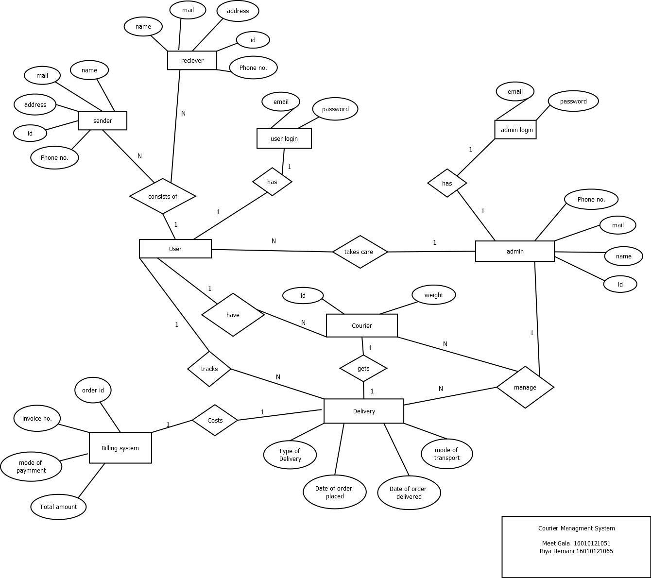

K. J. Somaiya College of Engineering, Mumbai-77

 (Autonomous College Affiliated to University of Mumbai)

# Post Lab Descriptive Questions (Add questions from examination point view)

1. In the Academic database a Grade is issued to each STUDENT for each COURSE taken and stored in the STUDENT COURSE DETAIL entity. A STUDENT may decide to re-take a COURSE to better their GRADE. The administration would like to keep a record of the old/previous Grade as well as the new Grade. Show ER diagram to include historical Grades if the students should have them.

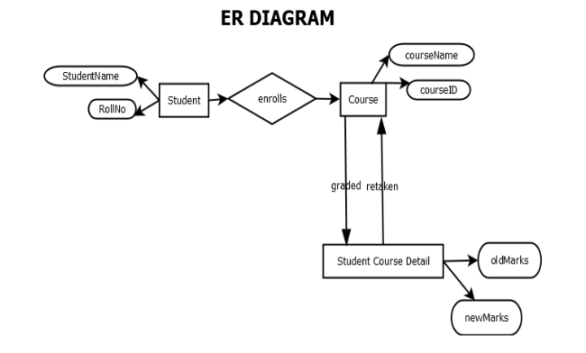

1. Discuss the concept of aggregation. Give an example. How to represent aggregation in ER model (if aggregation is not supported in EER diagram) .

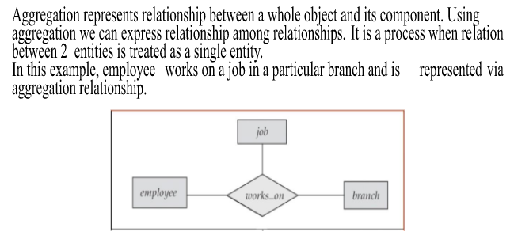

1. Two separate banks which decide to merge. Both banks use same ER database schema(Assume the ER diagram). If the merged bank is to have a single database, there are several potential problems:

* The possibility that two original banks have branches with the same name
* The possibility that some customers are customers of both original banks
* The possibility that some loan or account numbers were used at both original banks

Discuss for each of these potential problems , why there is indeed potential difficulty in database based on ER model. Propose a solution to a problem. For your solution, explain any changes that would have to be made and describe what their effect would be on the ER database schema and the data.

Solution:--

1.Possibility of branches with same name:

Problem: The ER diagram will have entities for branches with unique names, but if the merged bank has two branches with the same name, it would create an issue with the primary key constraint in the database.

Solution: To resolve this issue, a unique identifier such as a branch code or a combination of branch name and location can be added to the branch entity as an additional attribute and made the primary key. This will make the branch entity unique and avoid duplication.

Effect on ER database schema: The ER database schema will have an additional attribute added to the branch entity.

Effect on data: The data in the branch entity will have additional information, i.e. branch code or branch name and location, which will be used as the primary key.

2.Possibility of customers being customers of both banks:

Problem: The ER diagram will have a customer entity with a unique customer identifier, but if a customer is a customer of both original banks, there will be two records for the same customer in the database, which would violate the primary key constraint.

Solution: To resolve this issue, a unique customer identifier can be assigned to each customer when they first become a customer of either bank. This identifier can then be used to merge the two records for the same customer in the database.

Effect on ER database schema: No changes would have to be made to the ER database schema.

Effect on data: The data in the customer entity will have an additional unique identifier assigned to each customer, which will be used to merge records for the same customer.

3.Possibility of loan or account numbers being used at both banks:

Problem: The ER diagram will have loan and account entities with unique loan and account numbers, but if the same loan or account number has been used at both original banks, there will be two records for the same loan or account in the database, which would violate the primary key constraint.

Solution: To resolve this issue, a unique loan or account number can be assigned to each loan or account when it is first created. This number can be created by concatenating a bank identifier and the loan or account number used at that bank.

Effect on ER database schema: The ER database schema will have an additional attribute added to the loan and account entities.

Effect on data: The data in the loan and account entities will have additional information, i.e. the bank identifier, which will be used to create a unique loan or account number.

7

# Department of Computer Engineering

RDBMS-2019-2020