**Batch: A3 Roll No.: 16010121051**

**Experiment / assignment / tutorial No. 3**

**Grade: AA / AB / BB / BC / CC / CD /DD**

|  |
| --- |
| **Title:** Implementation of Database in SQL -DDL |



**Objective:** Define/modify database definitions with proper constraints



**Expected Outcome of Experiment:**

CO 2: Convert entity-relationship diagrams into relational tables, populate a relational

database and formulate SQL queries on the data Use SQL for creation and query the database.

CO 3: Define and apply integrity constraints and improve database design using normalization techniques.



**Books/ Journals/ Websites referred:**

1. Sharaman Shah,”*Oracle for Professional*”, SPD.
2. Dr. P.S. Deshpande, SQL and PL/SQL for Oracle 10g.Black book, Dreamtech Press
3. Korth, Slberchatz, Sudarshan: “Database Systems Concept”, 5th Edition , McGraw Hill
4. Peter Rob and Carlos Coronel,”Database Systems Design, Implementation and Management”, Thompson Learning, 5th Edition

**Pre Lab/ Prior Concepts**:

Resources used: Postgresql

**Theory:** The set of relations in a database must be specifies to the system by means of a data definition language (DDL). The SQL DDL allows specification of not only a set of relations but also specific information about the relation including,

1. The schema for each relation
2. The domain of values associated with each attribute
3. The integrity constraints
4. The set of indices to be maintained for each relation
5. The security and authorization information for each relation
6. The physical storage structure of each relation on disk

# Syntax Create Table:

# create table employee(ssn,fname varchar(10), mname varchar(10), lname varchar(10), desg varchar(20), gender varchar(5), addr varchar(20), bdate datetime, sal float,primary key(ssn));

create table manages(ssn int, dept_code int, start_dt datetime, foreign key(ssn)

create table manages(ssn int, dept_code int, start_dt datetime, foreign key(ssn)

references employee, foreign key(dept_code) refrences department, key(ssn,dept_code) ) on delete set null;primary

# Data Constraints

Busines managers of the organization determine the a set of rules that must be applied before the data is stored in the database. The application of such rules on raw data ensures **data integrity**.

**Eg:-** An employee belonging to Sales department cannot have salary higher than Rs. 1000.

An employee has an unique identification number.

# Applying Data Constraints

Oracle permits data constraints to be attached to table columns using SQL syntax. Constraints can be attached to table columns using

Alter table

# Unique Constraint

**Unique Constraint- At column level Syntax**

**<ColumnName><Datatype>(<size>)**

**UNIQUE Unique Constraint- At table level**

**CREATE TABLE<TableName>(**

**<ColumnName><Datatype>(<size>)**

**<ColumnName><Datatype>(<size>)**

**<Columnname><Datatype>(<size>) UNIQUE(<ColumnName1>,<ColumnName2>);**

**Implementation Details (Problem Statement, Query and Screenshots of Results):**

Query:

create table customer(

uid int primary key,

umail varchar(30),

upassword varchar(10)

);

create table sender(

sname varchar(20),

umail varchar,

saddress varchar(100),

uid int,

sphone int,

primary key(uid)

);

alter table sender add constraint fkey1 foreign key(uid) references customer(uid);

create table receiver(

rname varchar(20),

rmail varchar(30),

raddress varchar(100),

rid int,

rphone int

);

create table courier(

cid int,

primary key(cid),

cweight int

);

alter table courier add constraint fkey2 foreign key(cid) references sender(uid);

create table adminn(

aphone int,

amail varchar(20),

aid int,

uid int,

cid int,

FOREIGN KEY(uid)

REFERENCES customer(uid),

FOREIGN KEY(cid)

REFERENCES courier(cid)

);

create table delivery(

deliverytype varchar(20),

ordrplaceddate int,

ordrdelivereddate int,

modetrans varchar(30),

cid int,

FOREIGN KEY(cid)

REFERENCES courier(cid)

);

create table billingsys(

bid int primary key,

bno int,

modepay varchar(20),

tamount int,

cid int,

uid int,

FOREIGN KEY(uid)

REFERENCES customer(uid),

FOREIGN KEY(cid)

REFERENCES courier(cid)

) ;

Outputs:

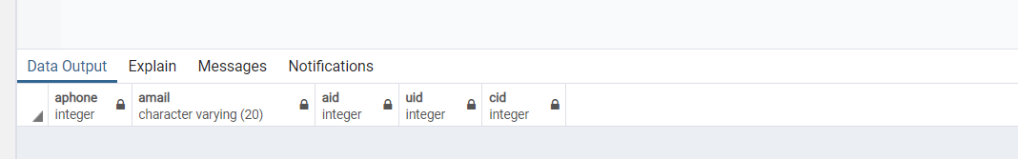

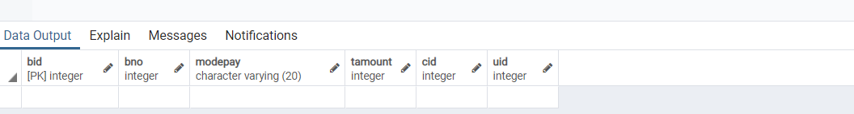

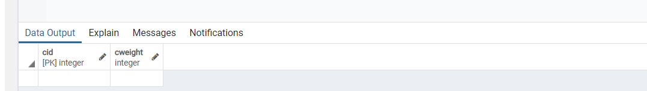

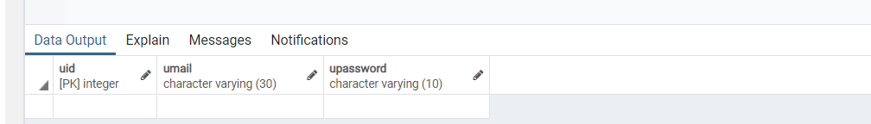

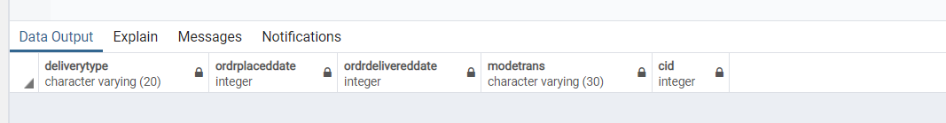

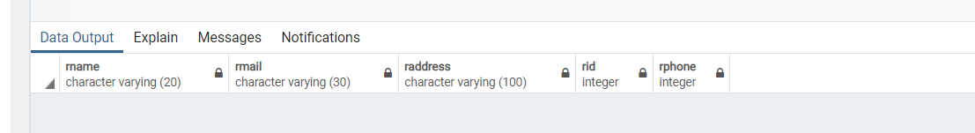

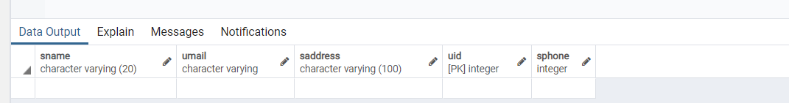

# Conclusion:

# Through this experiment, we apply the relational mode in SQL using PostgreSQL and pgAdmin. This we have implemented all Data Definition Statements

# Post Lab Questions:

# Which command is used for removing a table and all its data from the database:

# DROP Command

# TRUNCATE Command

# Both Commands

# For the given ER model, using DDL command: Write syntax to create CREATE Tables with all possible integrity constraints

# Problem Statement:

# A small accounting firm wants a simple HR application that will help it to keep track of its employees, their positions, allowances, salary scales, and which company vehicles their employees drive. The application must keep track of all the positions at the firm, the employees filling these positions, the allowances for these positions, the salary scales for these positions, and the company vehicles assigned to these positions.

# Case Study 1 detailed E-R diagram

CREATE DATABASE hr;

CREATE TABLE Positions ( positionID varchar[10] PRIMARY KEY, positionName varchar[20],

positionDescription varchar[500]

);

CREATE TABLE SalaryScales (

SalaryScaleCode int PRIMARY KEY,

SalaryScaleName varchar[100], Description varchar[200], minSalary int,

maxSalary int

);

CREATE TABLE EMPLOYEES (

EmployeeID int PRIMARY KEY,

SSNo int,

LastName varchar[20],

FirstName varchar[20],

Gender varchar[10],

DOB date

);

CREATE TABLE ALLOWANCES (

AllowanceID int PRIMARY KEY, AllowanceName varchar[20],

description varchar[100], amount int

);

CREATE TABLE VEHICLE (

VehicleID int PRIMARY KEY,

VIN int,

RegNo int,

Years date,

Make varchar[20],

Model varchar[20],

Color varchar[10] );