**Batch: A3 Roll No.: 16010121051**

**Experiment No. 01**

|  |
| --- |
| **TITLE:** **Design the static web pages with the help of HTML5** |

**AIM:** To create static Web Pages using HTML5.

**______________________________________________________________________**

**Expected Outcome of Experiment:** Design static web pages using various HTML tags.

**_______________________________________________________________**

**Books/ Journals/ Websites referred:**

1. . <https://www.w3schools.com/>
2. <https://stackoverflow.com/>
3. Mam’s ppt

**_____________________________________________________________________**

The students are required to design Web Application using various technologies. A group of 2-3 students will select a topic and will design a web application. Various concepts such as static page, dynamic page, connection with a backend database are essential part of the application.

Students will be required to mention overall description of the problem (website facilities) to be provided by their application.

**Problem Statement:**

The main idea behind creating this project is to have a courier management system .It will have 3 portals mainly the user side , admin side and the delivery boy portal. Common feature about the project is that to create a good and common platform between the user and the courier company to get their courier’s delivered on time and with precautions . the additional features which our application would include are that the customer will have a platform to place orders. They Customer can place courier order .Customer will also be provided with live tracking facility to inspect their parcel stage delivery boy will also be shown the deliveries assigned to him and admin and the user both we will given with a record of past and current order placed by them, we will also include a bill system where user will be provided with a invoice of their order placed.

**Description of the application implemented with output**:

# Home page :

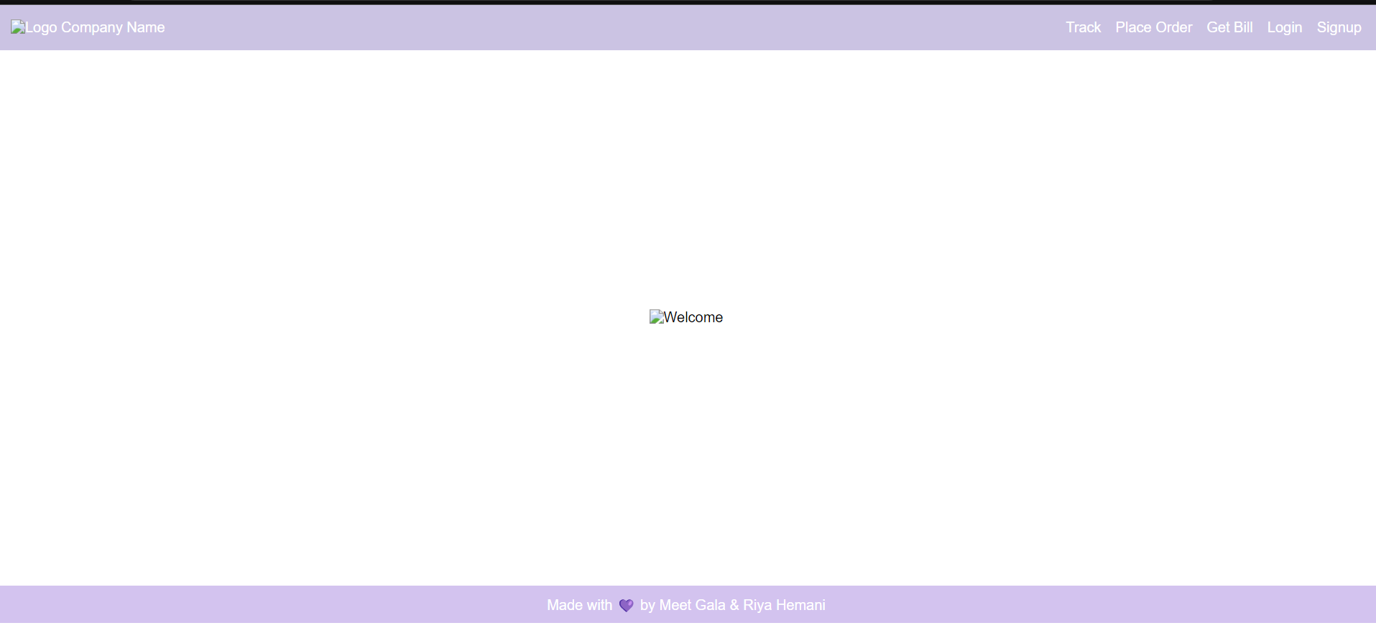

Drop down menu :

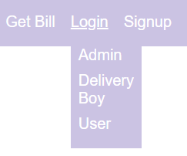

Login page :

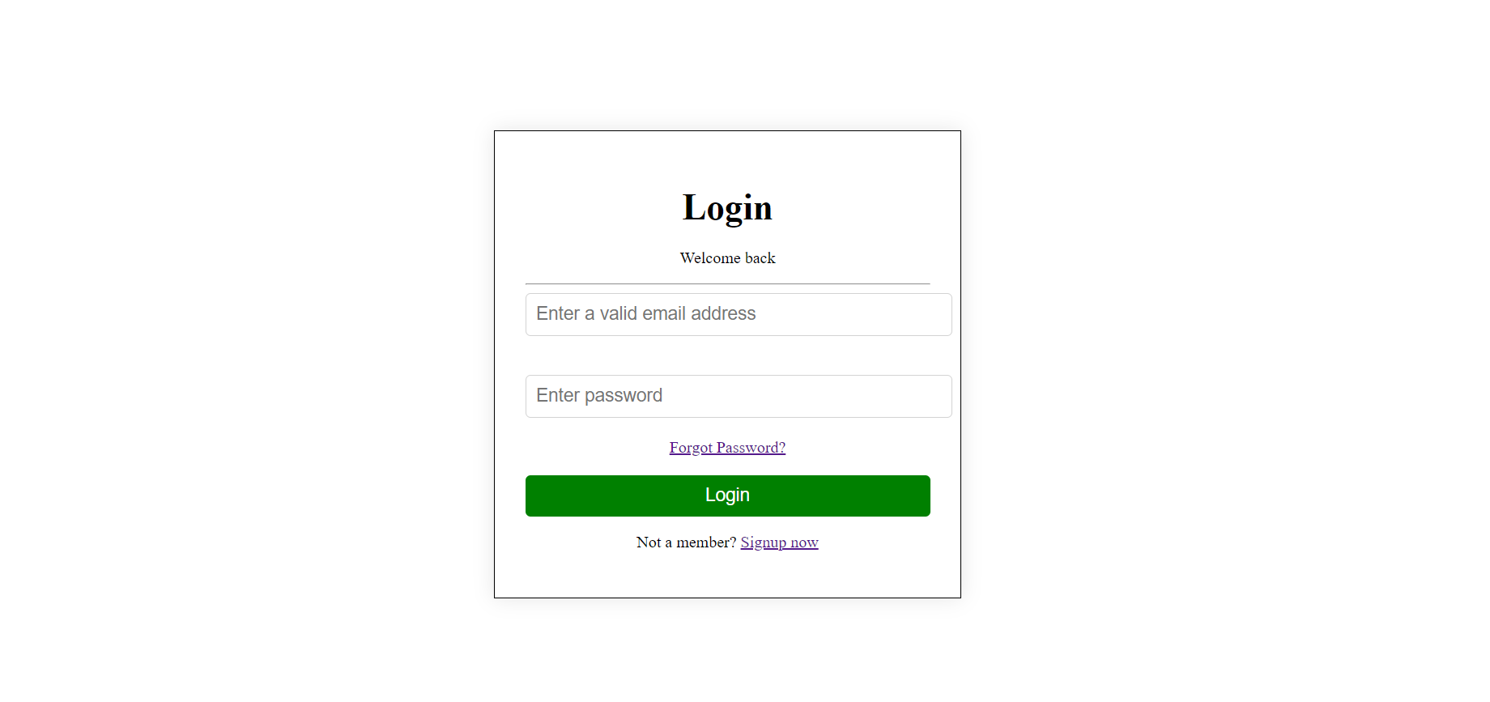

Sign up page:

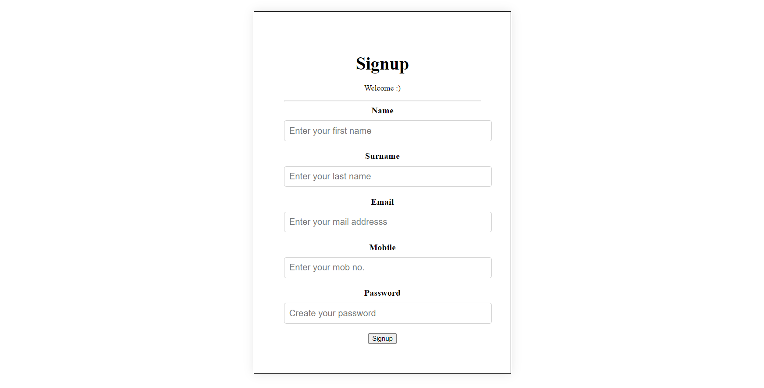

**Forgot password page :**



**Track order page:**



**Place order page :**

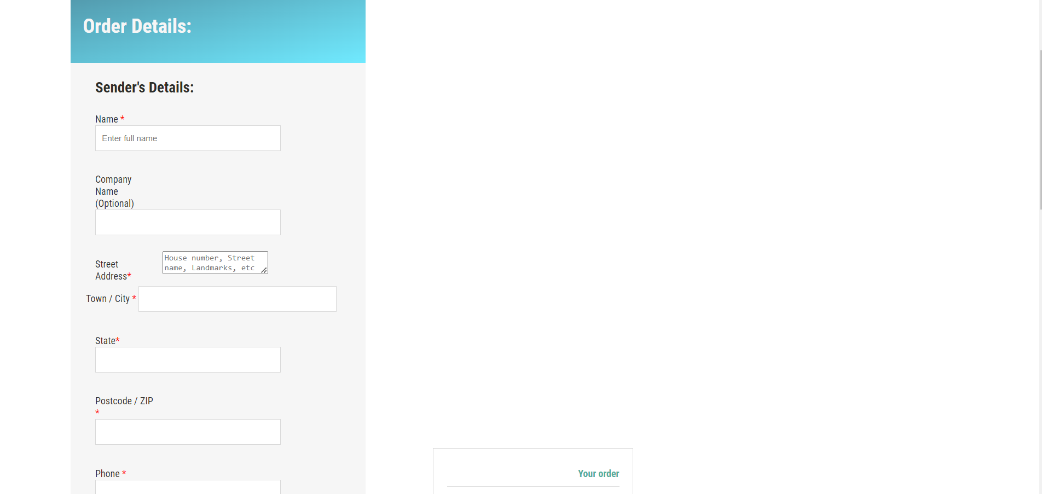

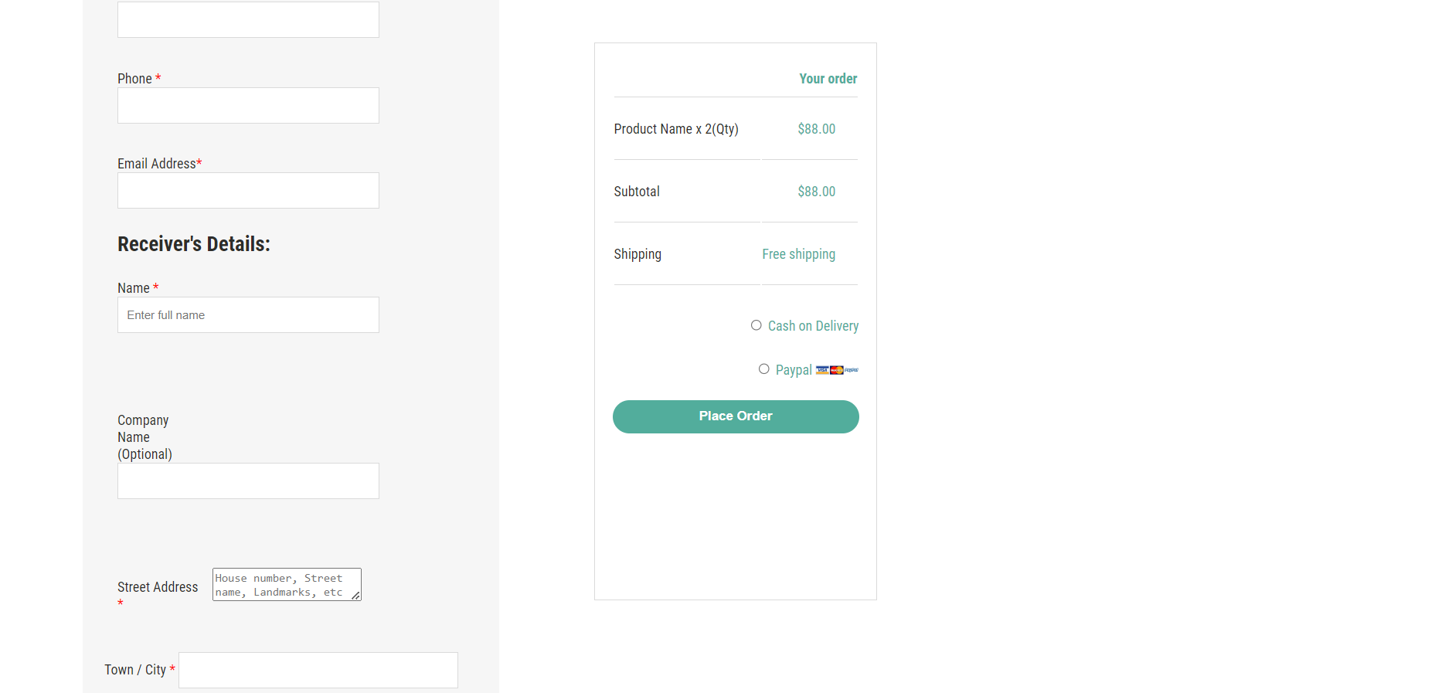

**Delivery boy home page:**

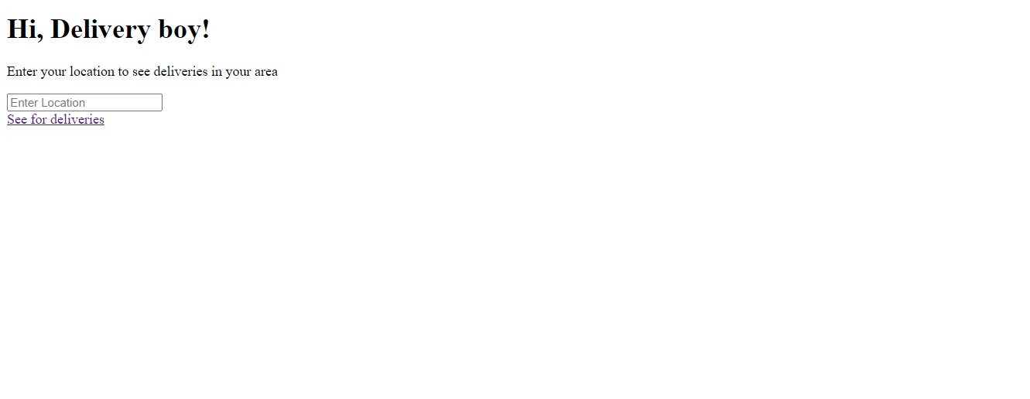

**Delivery boy “deliveries” page**

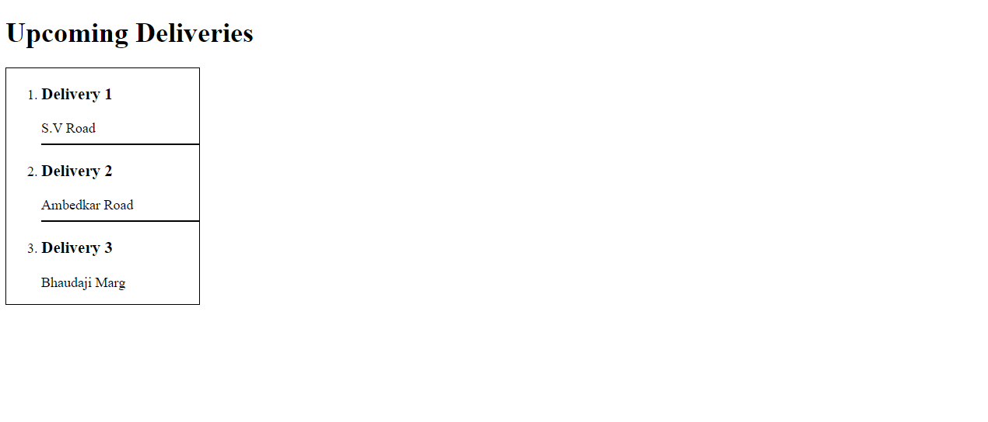

**Post Lab Objective with Ans (Min 5):**

**HTML tags Used :**

Tags used:

 <html></html>

HTML tags are like keywords which defines that how web browser will format and display the content.

<h1></h1>

<h1> defines the most important heading.

<p></p>

defines a paragraph. Browsers automatically add a single blank line before and after each <p> element. Tip: Use CSS to style paragraphs.

<form></form>

The <form> tag is used to create an HTML form for user input.

<input>

The <input> tag specifies an input field where the user can enter data.

<br>

It is a HTML element that produces a line break in text.

<div></div>

The <div> tag is used as a container for HTML elements - which is then styled with CSS or manipulated with JavaScript.

<body></body>

The <body> tag defines the document's body. The <body> element contains all the contents of an HTML document, such as headings, paragraphs, images, hyperlinks, tables, lists, etc.

<a></a>

The <a> tag defines a hyperlink, which is used to link from one page to another.

<hr>

The <a> tag defines a hyperlink, which is used to link from one page to another.

<span></span>

The <span> tag is an inline container used to mark up a part of a text, or a part of a document.

<button></button>

The <button> tag defines a clickable button. Inside a <button> element you can put text (and tags like <i> , <b> , <strong> , <br> , <img> , etc.).

<img>

The <img> tag is used to embed an image in an HTML page.

<link>

The <link> tag defines the relationship between the current document and an external resource.