PIZZA SALES
SQL Query Reference
Database: pizzadb | Dialect: MySQL

A. Key Performance Indicators (KPIs)

1. Total Revenue
Calculates the total revenue generated across all orders.
SELECT SUM(total_price) AS Total_Revenue
FROM pizzadb.pizza_sales;

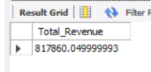

2. Average Order Value
Calculates the average value of each order.
SELECT SUM(total_price) / COUNT(DISTINCT order_id) AS Avg_Order_Value
FROM pizza_sales;

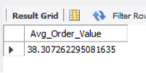

3. Total Pizzas Sold
Calculates the total number of pizzas sold.
SELECT SUM(quantity) AS Total_Pizza_Sold
FROM pizza_sales;

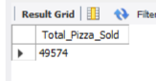

4. Total Orders
Calculates the total number of orders placed.
SELECT COUNT(DISTINCT order_id) AS Total_Orders
FROM pizza_sales;

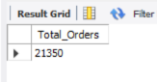

5. Average Pizzas Per Order
Calculates the average number of pizzas sold per order.
SELECT SUM(quantity) / COUNT(DISTINCT order_id) AS Avg_Pizzas_Per_Order
FROM pizza_sales;

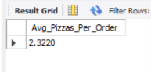

B. Daily Trend for Total Orders
Shows the number of orders placed on each day of the week, ordered from Sunday through Saturday.
SELECT DAYNAME(order_date) AS order_day,
COUNT(DISTINCT order_id) AS total_order
FROM pizza_sales
GROUP BY DAYNAME(order_date), WEEKDAY(order_date)
ORDER BY WEEKDAY(order_date);

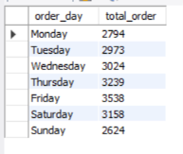

C. Monthly Trend for Orders
Shows the number of orders placed in each month, ranked from highest to lowest.
SELECT MONTHNAME(order_date) AS order_month,
COUNT(DISTINCT order_id) AS total_order
FROM pizza_sales
GROUP BY MONTHNAME(order_date)
ORDER BY total_order DESC;

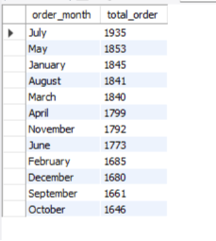

D. Percentage of Sales by Pizza Category
Calculates total sales and the percentage contribution of each pizza category to overall revenue.
SELECT pizza_category,
SUM(total_price) AS total_sales,
(SUM(total_price) * 100) / (SELECT SUM(total_price) FROM pizza_sales) AS PCT_sales
FROM pizza_sales
GROUP BY pizza_category;

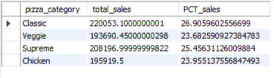

E. Percentage of Sales by Pizza Size
Calculates total sales and the percentage contribution of each pizza size to overall revenue.
SELECT pizza_size,
SUM(total_price) AS total_sales,
(SUM(total_price) * 100) / (SELECT SUM(total_price) FROM pizza_sales) AS PCT_sales
FROM pizza_sales
GROUP BY pizza_size;

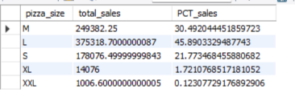

F. Top & Bottom 5 Pizzas by Revenue

Top 5 Pizzas by Revenue
SELECT pizza_name,
SUM(total_price) AS total_revenue
FROM pizza_sales
GROUP BY pizza_name
ORDER BY total_revenue DESC
LIMIT 5;

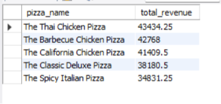

Bottom 5 Pizzas by Revenue
SELECT pizza_name,
SUM(total_price) AS total_revenue
FROM pizza_sales
GROUP BY pizza_name
ORDER BY total_revenue ASC
LIMIT 5;

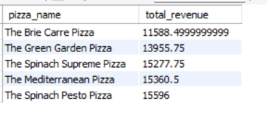

G. Top & Bottom 5 Pizzas by Quantity Sold

Top 5 Pizzas by Quantity
SELECT pizza_name,
SUM(quantity) AS total_quantity
FROM pizza_sales
GROUP BY pizza_name
ORDER BY total_quantity DESC
LIMIT 5;

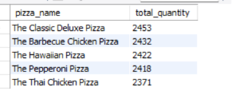

Bottom 5 Pizzas by Quantity
SELECT pizza_name,
SUM(quantity) AS total_quantity
FROM pizza_sales
GROUP BY pizza_name
ORDER BY total_quantity ASC
LIMIT 5;

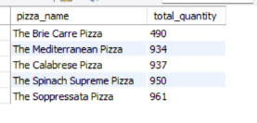

H. Top & Bottom 5 Pizzas by Total Orders

Top 5 Pizzas by Total Orders
SELECT pizza_name,
COUNT(DISTINCT order_id) AS total_orders
FROM pizza_sales
GROUP BY pizza_name
ORDER BY total_orders DESC
LIMIT 5;

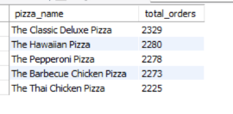

Bottom 5 Pizzas by Total Orders
SELECT pizza_name,
COUNT(DISTINCT order_id) AS total_orders
FROM pizza_sales
GROUP BY pizza_name
ORDER BY total_orders ASC
LIMIT 5;
