Date: ___/___/______
PRACTICAL: 5

Aim: Write a program to implement DDA line drawing algorithm

Program Code:

#include<stdio.h>
#include<conio.h>
#include<math.h>
#include<graphics.h>

void main()
{
int gd=DETECT,gm,x1,x2,y1,y2,dx,dy,i,z,n;
float x,y,xi,yi,dex,dey,l;

initgraph(&gd,&gm,"C:\\TC\\BGI");

printf("\n Enter (x1,y1) : ");
scanf("%d %d",&x1,&y1);

printf("\n Enter (x2,y2) : ");
scanf("%d %d",&x2,&y2);

dx=x2-x1;
dy=y2-y1;

if(abs(dx)>abs(dy))
{
l=abs(dx);
}
else
{
l=abs(dy);
}

dex=dx/l;
dey=dy/l;
x=x1;
y=y1;
putpixel(z,n,10);

for(i=1;i<l;i++)
{
x=x+dex;
y=y+dey;
z=(int)x;
n=(int)y;
putpixel(z,n,10);
}
getch();
closegraph();
}

Output:

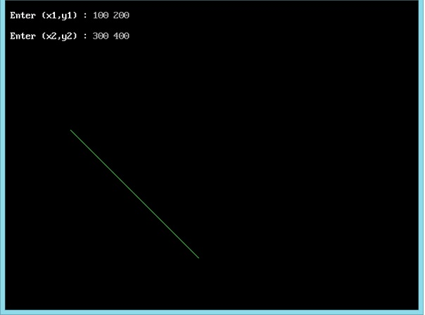

Date: ___/___/______
PRACTICAL: 6

Aim: Write a program to implement Bresenham’s Line Drawing Algorithm

Program Code:

#include<stdio.h>
#include<conio.h>
#include<math.h>
#include<graphics.h>

void main()
{
int gd=DETECT,gm,x,y,x1,x2,y1,y2,dx,dy,i,p,t;

initgraph(&gd,&gm,"C:\\TC\\BGI");
printf("\n Enter (x1,y1) : ");
scanf("%d %d",&x1,&y1);

printf("\n Enter (x2,y2) : ");
scanf("%d %d",&x2,&y2);

dx=x2-x1;
dy=y2-y1;

p=(2*dy)-(dx);

x=x1;
y=y1;

printf("\n dx :%d ",dx);
printf("\n dy :%d ",dy);

for(i=x1;i<=x2;i++)
{
x++;
if(p<0)
{
p=p+(2*dy);
}
else
{
y++;
p=p+(2*dy)-(2*dx);
}
putpixel(x,y,4);
}
getch();
closegraph();
}

Output:

Date: ___/___/______
PRACTICAL: 7

Aim: Write a program to implement Mid-point Circle Algorithm

Program Code:

#include<stdio.h>
#include<conio.h>
#include<math.h>
#include<graphics.h>
void main()
{
int gd=DETECT,gm,xc,x,yc,y,dx,dy,i,p,r;

initgraph(&gd,&gm,"C:\\TC\\BGI");

printf("\n Enter Radius : ");
scanf("%d",&r);
x=0;
y=r;

printf("\n Enter (xc,yc) : ");
scanf("%d %d",&xc,&yc);

p=1-r;

while(x<y)
{
x++;
if(p<0)
{
p=p+2*x+1;
}
else
{
y--;
p=p+2*x-2*y+1;
}
putpixel(xc+x,yc+y,4);
putpixel(xc-x,yc+y,5);
putpixel(xc+x,yc-y,6);
putpixel(xc-x,yc-y,7);
putpixel(xc+y,yc+x,8);
putpixel(xc-y,yc+x,9);
putpixel(xc+y,yc-x,10);
putpixel(xc-y,yc-x,11);
}
getch();
closegraph();
}

Output:

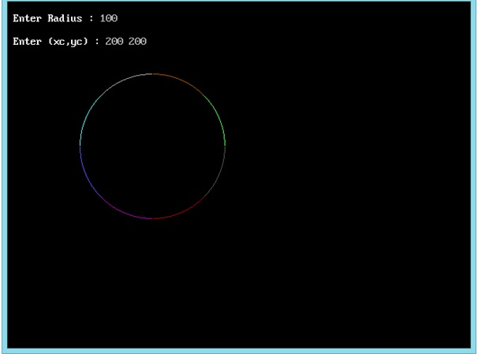

Date: ___/___/______
PRACTICAL: 8

Aim: Write a program to implement Mid-point Ellipse Algorithm

Program code:

#include<stdio.h>
#include<conio.h>
#include<math.h>
#include<graphics.h>

void main()
{
int gd=DETECT,gm,cx,cy,x,y;
float p1,p2,a,b;

initgraph(&gd,&gm,"C:\\TC\\BGI");

printf("\n Enter a & b : ");
scanf("%f %f",&a,&b);

printf("\n Enter C(x,y) : ");
scanf("%d %d",&cx,&cy);

x=0;
y=b;

p1=(b*b)-(a*a*b)+(0.25*a*a);

while((2*b*b*x)<=(2*a*a*y))
{
x++;
if(p1<0)
{
p1=p1+(2*b*b*x)+(b*b);
}
else
{
y--;
p1=p1+(2*b*b*x)-(2*a*a*y)+(b*b);
}
putpixel(cx+x,cy+y,10);
putpixel(cx-x,cy+y,11);
putpixel(cx-x,cy-y,12);
putpixel(cx+x,cy-y,13);
}

p2=(b*b)*((x+0.5)*(x+0.5))+(a*a)*((y-1)*(y-1))-((a*a)*(b*b));
while(y>0)
{
y--;
if(p2>0)
{
p2=p2-(2*a*a*y)+(a*a);
}
else
{
x++;
p2=p2+(2*b*b*x)-(2*a*a*y)+(a*a);
}
putpixel(cx+x,cy+y,10);
putpixel(cx-x,cy+y,11);
putpixel(cx-x,cy-y,12);
putpixel(cx+x,cy-y,13);
}
getch();
closegraph();
}

Output:

