Sports Equipment Management

Software Requirements Specification



Submitted By

Manvendra Singh Kushwah (B16CS015)

Meet Mehta (B16CS016)

Revision History

|  |  |  |  |
| --- | --- | --- | --- |
| **Date** | **Version** | **Description** | **People** |
| 18 Feb 2018 | 1.0 | First draft | Project Group: |
|  |  |  |  |
|  |  |
|  |  |  |  |

Table of Contents

1. Introduction 4

1.1 Purpose 4

1.2 Scope 4

1.3 Constraints 4

1.4 Assumptions 4

1.5 Definitions, Acronyms and Abbreviations 5

1.6 References 5

2. Overall Description 6

2.1 Product Functions 6

2.2 User Characteristics 16

3. Specific Requirements 17

3.1 Use case description 17

3.2 Reliability 19

3.3 Performance Requirements 19

3.4 Supportability 19

3.5 Design Constraints 19

3.7 Interfaces 20

4. Supporting Information 20

Software Requirements Specification

# Introduction

## Purpose of Project

The purpose of this document is to provide the complete description of the working of the Sport Equipment Management System. It will show the complete description of the system with the help of required diagrams and procedures. It will also include assumptions, requirement and system constraints. This document is meant mainly for Administration of the institute as well as for the other developers who may be interested in leading the project further.

## Scope of Project

This software system is designed to increase the efficiency and performance of the administration for proper allocation and management of the hostel sports equipment. This software can be used by any institute to manage the hostel sports equipment.

  Administration can use the software to allocate sports equipment to students, for personal use, as well as to sports society, for any sports competition. The software will check the availability of the required sports equipment whenever any issue request is made. Software will also keep track of the number of days student is holding some particular equipment and accordingly calculate fine if any.

  Student can also check the availability of the equipment and can also make a special request to the management so as to add some more equipment to the inventory. Student can submit any equipment he/she is possessing through the software, software will update the equipment availability accordingly so as to make equipment available for other students. If the equipment is found damaged than the software will keep this particular equipment in the category of damaged equipment, and concerned authority will be informed so that further action can be taken.

Also all the issuing and submitting processes will be done under the surveillance of the security worker for the better security of equipment, so a password with be required to complete any of the above two processes to complete, which will be available with the security worker.

## Constraints

1. No student can possess more than five equipment at the same time.
2. No student can issue an equipment till his previous dues are cleared.
3. No student can possess more than one equipment of same category.

## Assumptions

* 1. A security worker is always present at the inventory.
  2. Every student is given username and password by the Institute already.
  3. A permanent system is allotted in the sport room.
  4. All the students follow the rules.
  5. There is only single sports room, common for all the hostels.
  6. Secretary is also given rights of other normal students in addition to some extra rights.
  7. Guard is already given a password to verify every process.
  8. Every Equipment is issued till next day 23:59 .
  9. Equipment of the already available category can only be added by the secretary.

## Definitions, Acronyms and Abbreviations

|  |  |
| --- | --- |
| **Term** | **Definition** |
| Student | A person who is studying or want to study at Institute |
| Secretary | An student elected sport authority |
| Security Worker | Present all time at the sport room to take care of the sport equipment |
| Administration | The Management authority of the Institute |
| Person | Includes only Students and Secretary |
| Guard | Security person present at sport room |

## References

* 1. IEEE. IEEE std 830-1998 IEEE Recommended Practice for Software Requirements Specifications. IEEE Computer Society, 1998.
  2. <https://helloacm.com/model-view-controller-explained-in-c/>
  3. <https://www.linkedin.com/pulse/top-6-characteristics-good-requirements-srs-abhishek-srivastava/>
  4. <https://reqtest.com/requirements-blog/understanding-the-difference-between-functional-and-non-functional-requirements/>

# Overall Description

## Product Functions

### **Functional Requirements**

#### **Use Case Diagram**

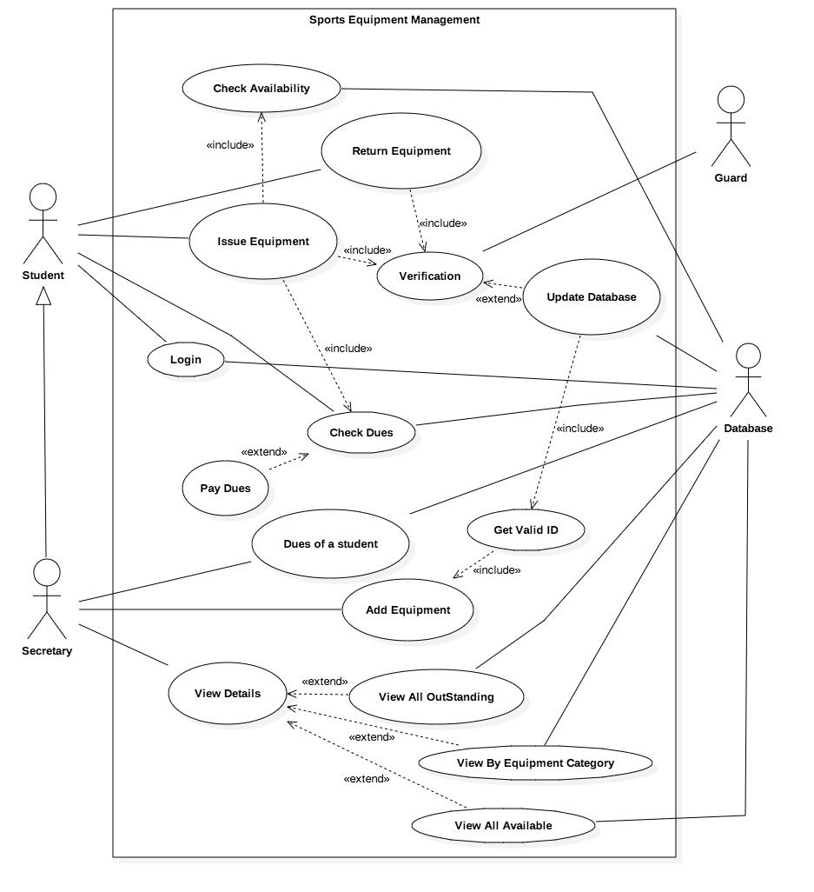

**Figure 1 : Use Case Diagram**

#### **Class Diagram**

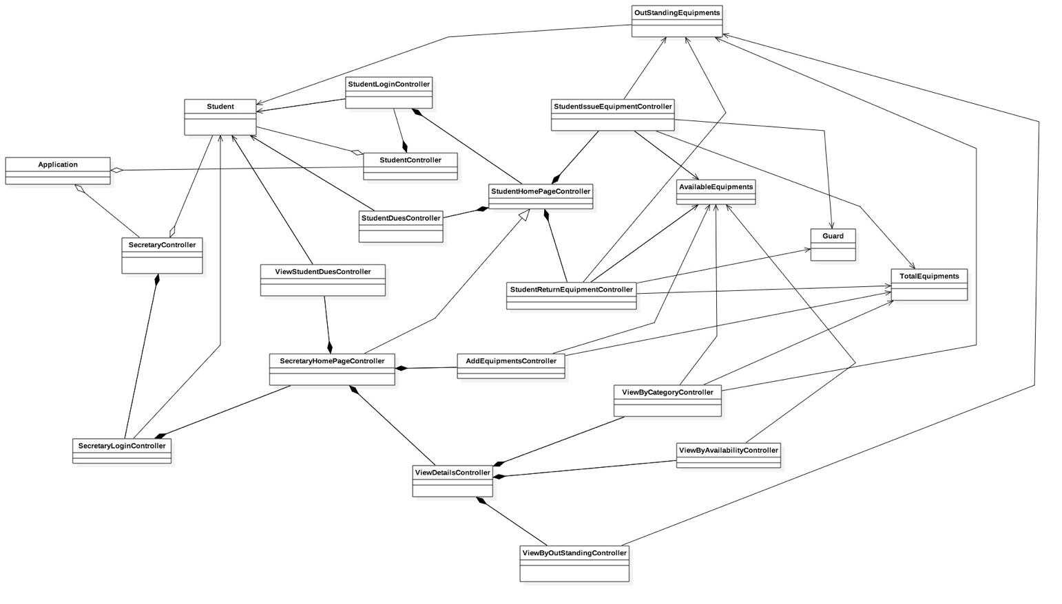

**Figure 2 : Class Diagram**

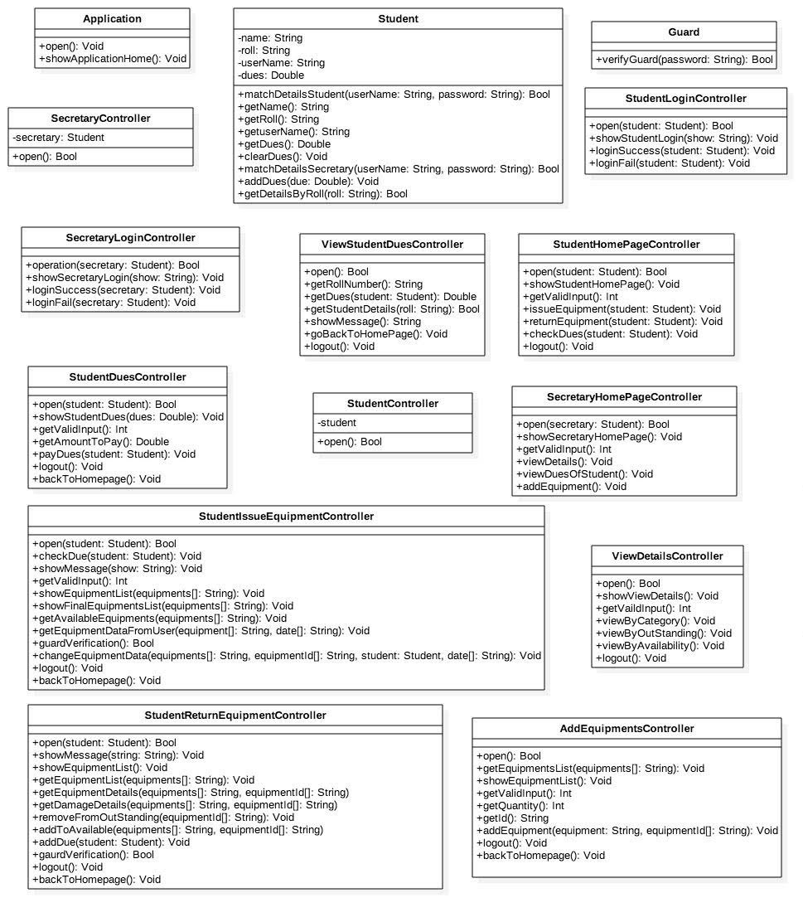

**Figure 3 : Class contents_1**

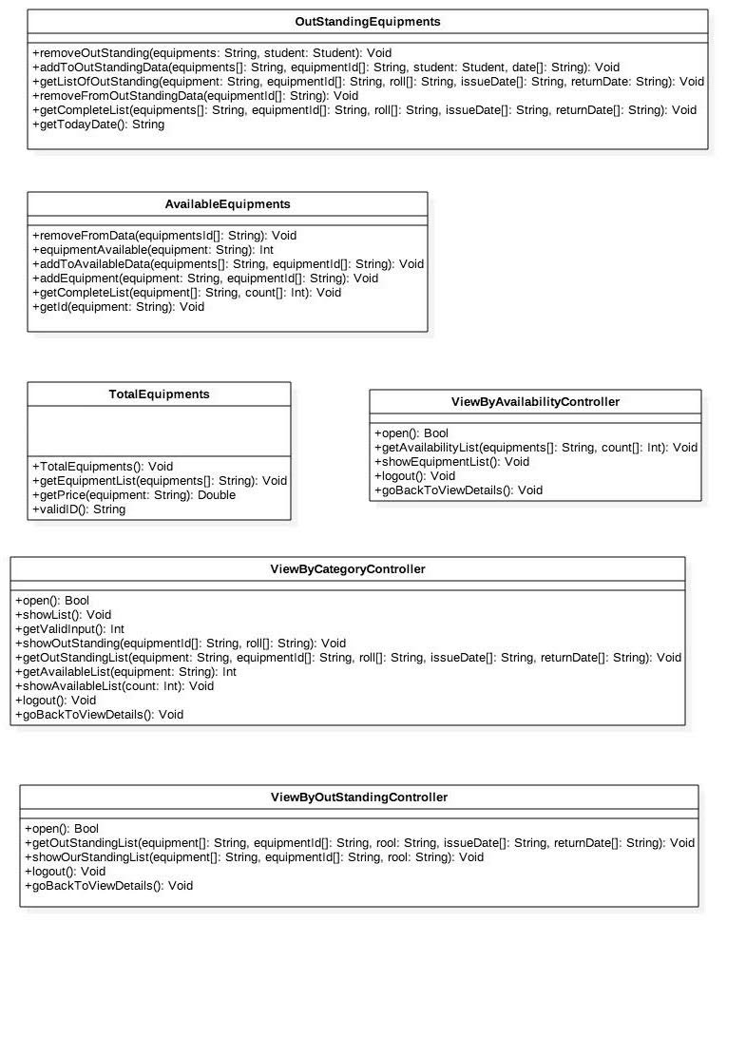

**Figure 4 : Class contents_2**

#### **Sequence Diagram**

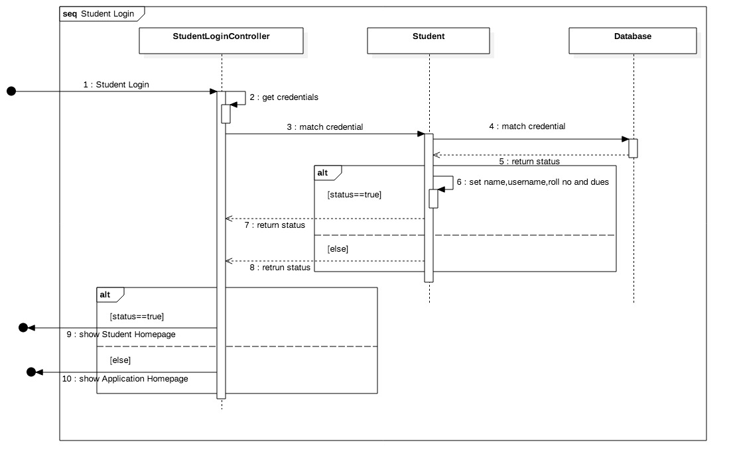

**Figure 4 : Student Login Sequence Diagram**

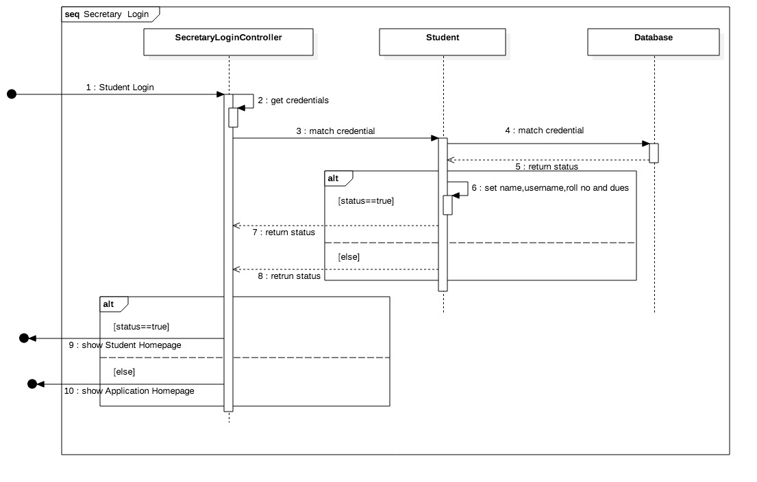

**Figure 5 : Secretary Login Sequence Diagram**

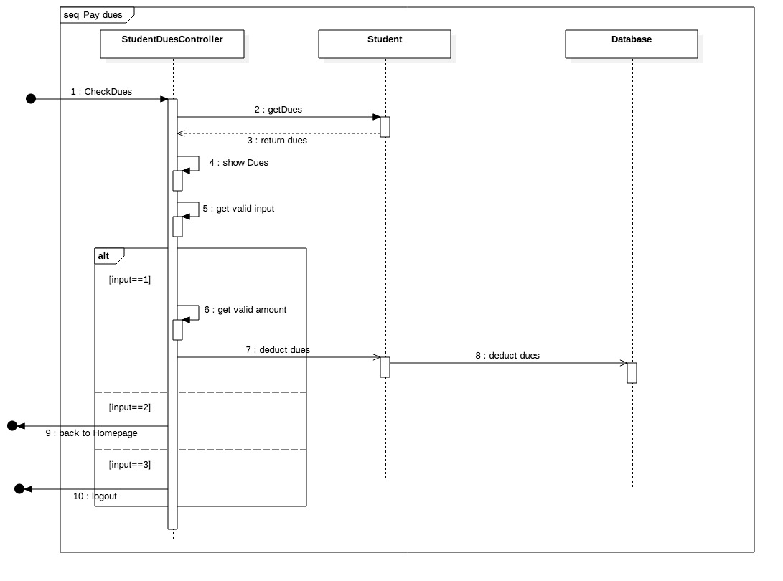

**Figure 6 : Pay Dues Sequence Diagram**

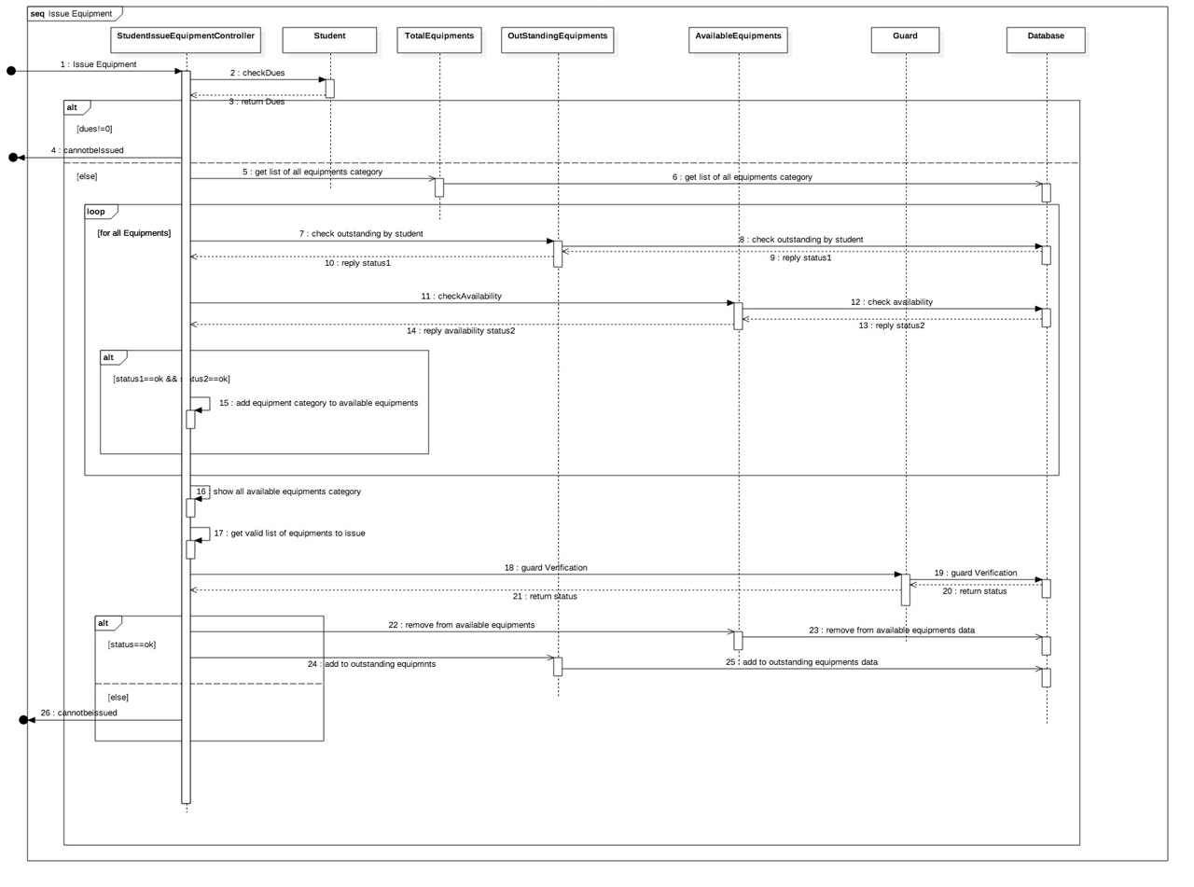

**Figure 7 : Student Issue Equipment Sequence Diagram**

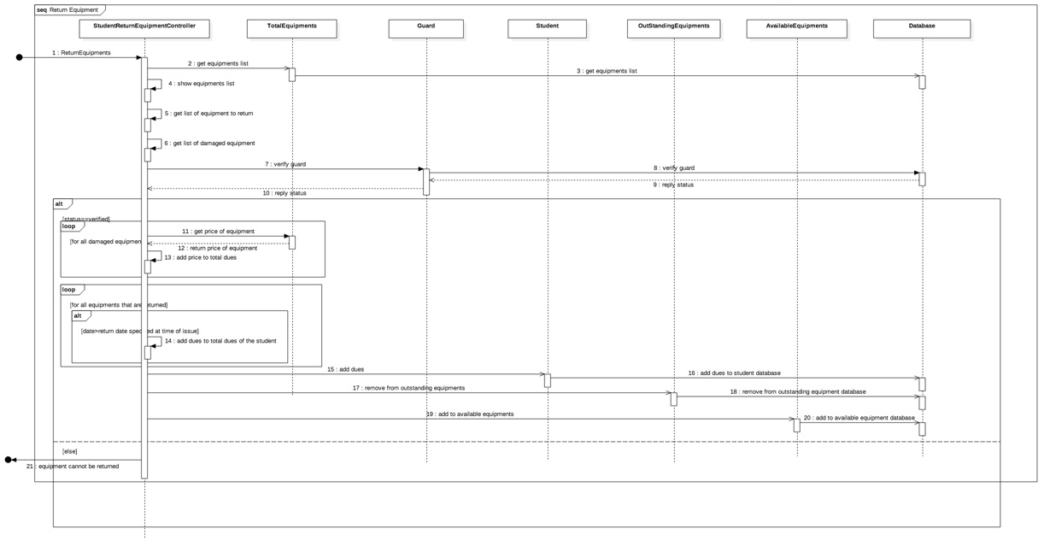

**Figure 8 : Student Return Equipment Sequence Diagram**

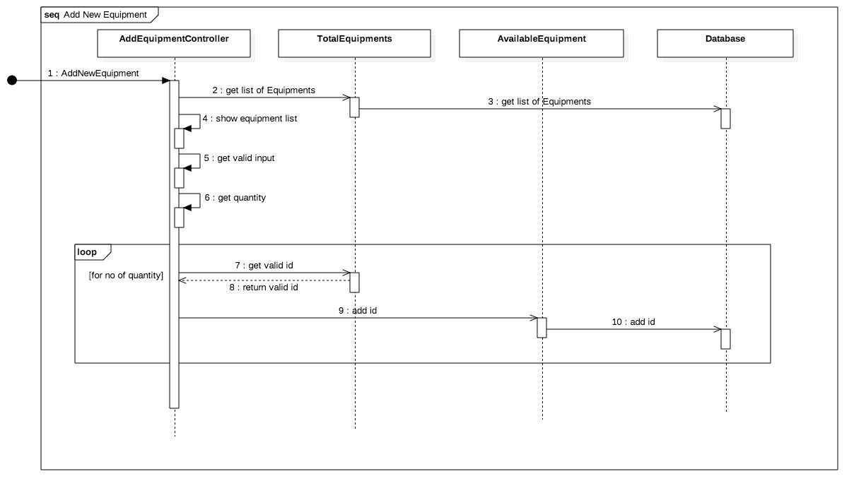

**Figure 9 : Secretary Add New Equipment Sequence Diagram**

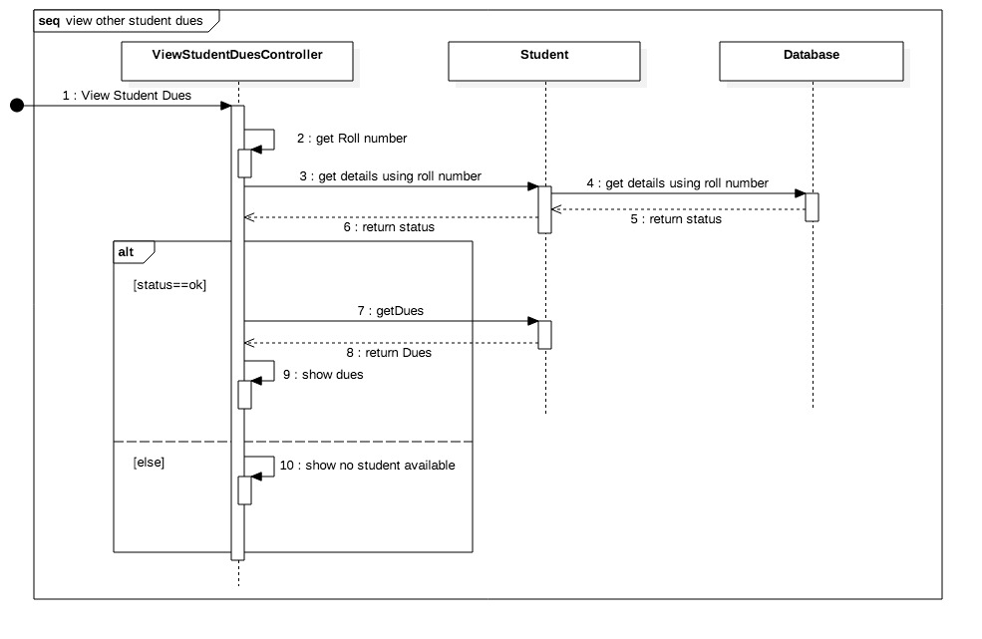

**Figure 10 : View Dues Of Other Students Sequence Diagram**

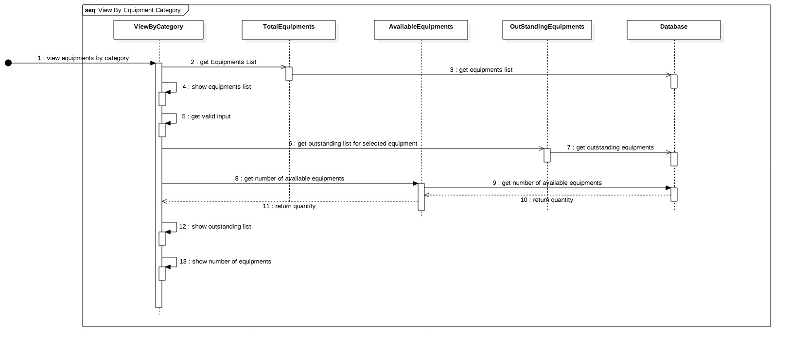

**Figure 11 : View By Equipment Category Sequence Diagram**

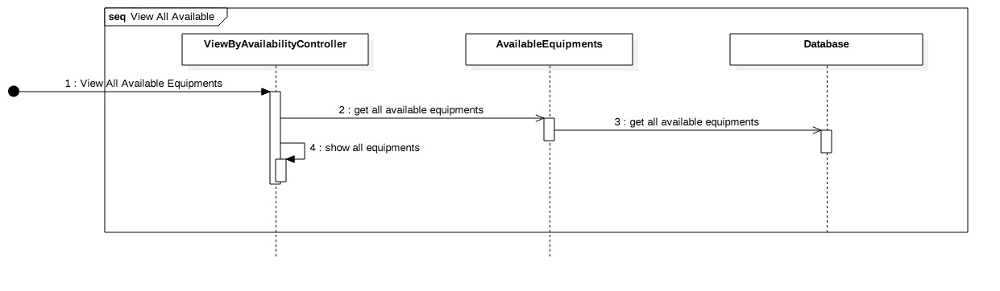

**Figure 12 : View All Available Equipments Sequence Diagram**

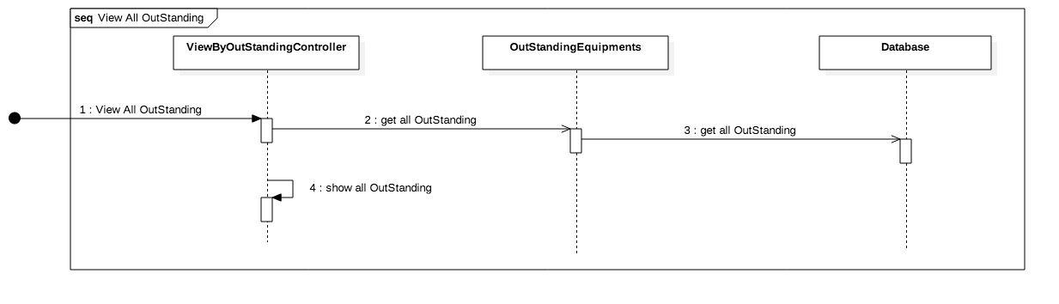

**Figure 13 : View All Outstanding Equipments**

#### **Activity Diagram**

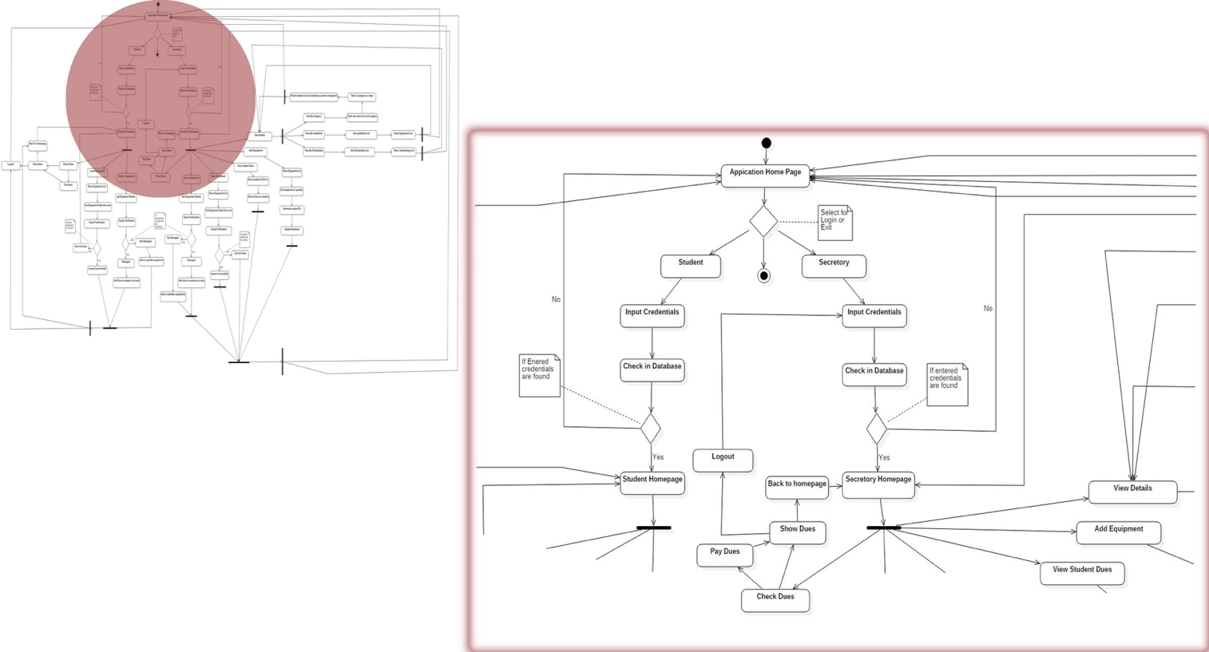

**Figure 14 : Activity Diagram-1**

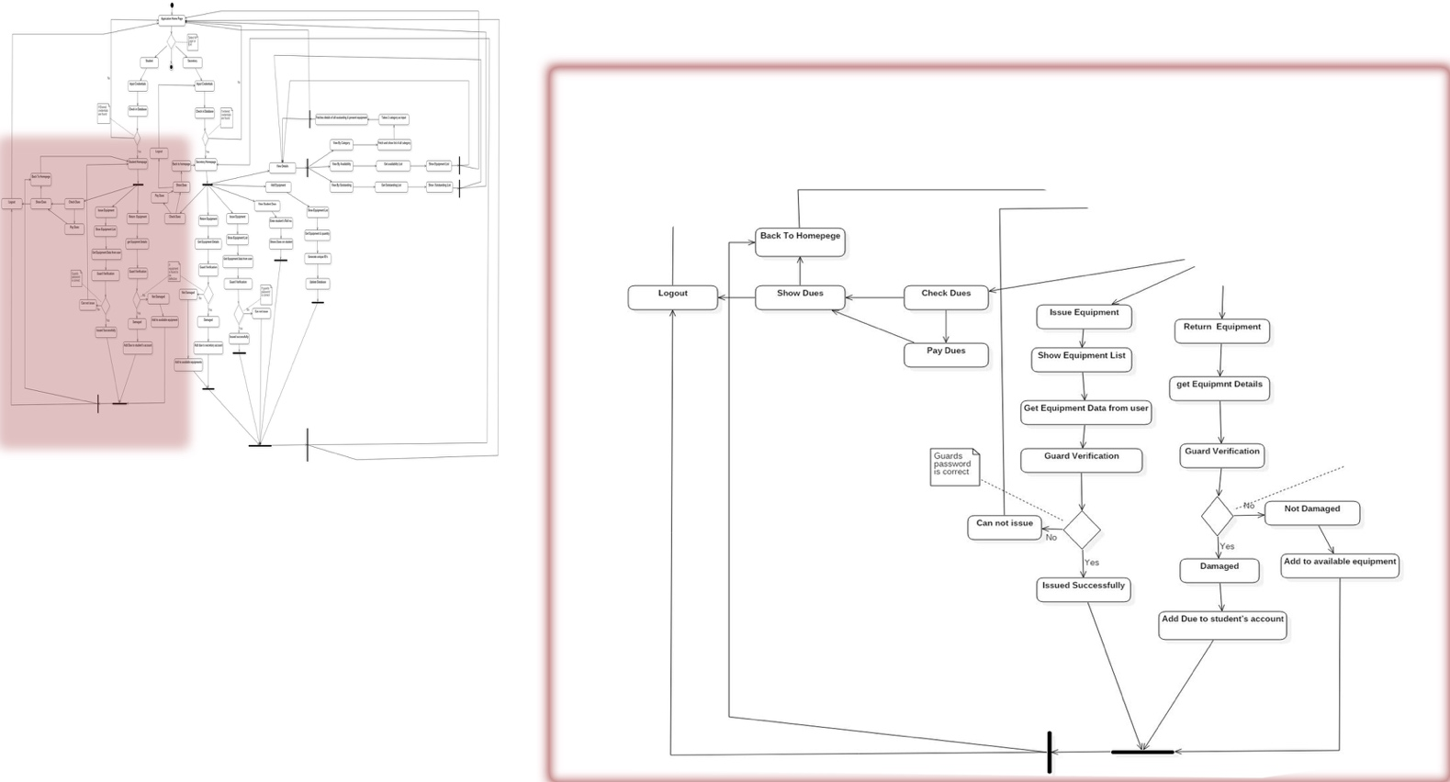

**Figure 15 : Activity Diagram-2**

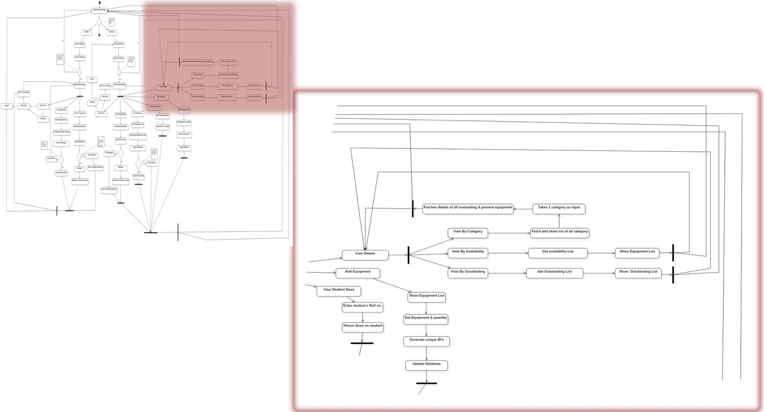

**Figure 16 : Activity Diagram-3**

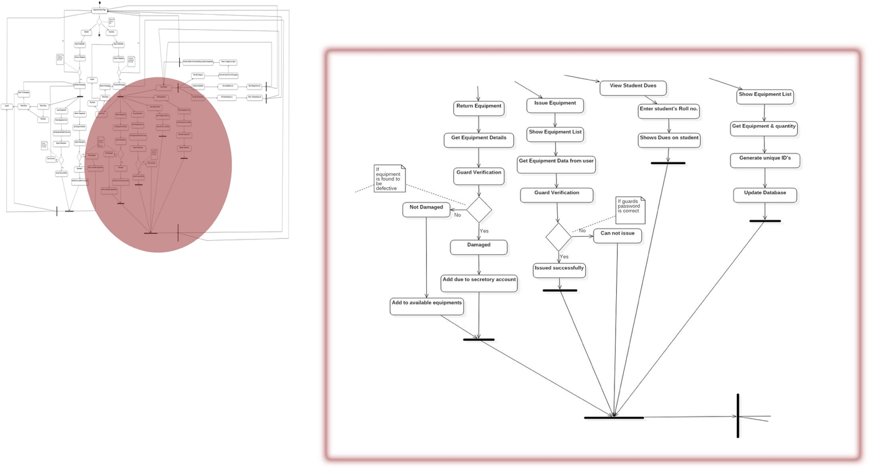

**Figure 17 : Activity Diagram-4**

### **Non-Functional Requirements**

The Sports Equipment Management system will work on a local computer in sports room by interacting with database available in hard disk of computer by keeping the data of details of all equipment and rules of the society and depending upon those it will allow/disallow student to issue or submit some equipment.

## User Characteristics

There are two types of users who will access this software, they include the secretory and the students. However they have different characteristics. students will use this software in order to issue/submit the sport equipment, they can also use it to check the things which they are currently holding or to check their fine amounts whereas secretory can access the software either for issue/submit or for checking availability of products in the  inventory or to check if any special request for some particular equipment is made or not.    In except to both these user there is one more person security person who will also interact with the system to securely facilitate all processes.

# Specific Requirements

## Use case description

### **Student Login**

|  |  |
| --- | --- |
| **Use Case Name** | Student Login |
| **Trigger** | By student only |
| **Precondition** | 1. Student data should be present in database  2.Username and password entered should be correct |
| **Basic Path** | 1.Enter valid input as shown for Student Login.  2.Enter username and password carefully.  3.Enter required input to confirm |
| **Alternative Paths** | No alternative paths for Login are present |
| **Post condition** | Student Is now logged in system and can access other features |
| **Exception Paths** | Student forgot his/her credentials |
| **Other** | None |

### **Issue Equipment**

|  |  |
| --- | --- |
| **Use Case Name** | Issue Equipment |
| **Trigger** | By Person(Student/Secretary) only |
| **Precondition** | 1.Total fine on student should be zero.  2.Item should be available in the inventory. |
| **Basic Path** | 1.First login into the system.  2.Check availability of equipment in inventory.  3.Select equipment and get confirmation of guard. |
| **Alternative Paths** | No alternative paths for Issue Equipment are present |
| **Post condition** | He/She can issue maximum of 5 equipment, 1 of each category. |
| **Exception Paths** | No exception paths are present. |
| **Other** | None |

### **Return Equipment**

|  |  |
| --- | --- |
| **Use Case Name** | Return Equipment |
| **Trigger** | By Person(Student/Secretary) only |
| **Precondition** | 1.Equipments should be issued on the name of that student only which is logged in into the system. |
| **Basic Path** | 1.First login into the system.  2.Enter input for Return Equipment and enter Id’s of equipment you want to return.  3.Get final confirmation of guard and deposit equipment to guard. |
| **Alternative Paths** | No alternative paths for Issue Equipment are present |
| **Post condition** | He/She can issue maximum of 5 equipment, 1 of each category. |
| **Exception Paths** | No equipment is issued on the name of student |
| **Other** | None |

### **Check Dues**

|  |  |
| --- | --- |
| **Use Case Name** | Check Dues |
| **Trigger** | By Person only |
| **Precondition** | 1.Student can check their own dues only. |
| **Basic Path** | 1.First login into the system.  2.Enter valid input for Check Dues. |
| **Alternative Paths** | Student can check his/her dues by asking to secretary too. |
| **Post condition** |  |
| **Exception Paths** | No such exception paths are present. |
| **Other** | None |

### **Pay Dues**

|  |  |
| --- | --- |
| **Use Case Name** | Pay Dues |
| **Trigger** | By Person(Student/Secretary) only |
| **Precondition** | 1.Total fine on student should be non-zero.  2.Student can pay his/her dues only. |
| **Basic Path** | 1.First login into the system.  2.Go for Check Dues.  3.If dues are non zero go for Pay Dues. |
| **Alternative Paths** | No alternative paths for Dues payment are present |
| **Post condition** | Only after paying Dues he/she can go for issue. |
| **Exception Paths** | No exception paths are present. |
| **Other** | None |

### **Dues of a Student**

|  |  |
| --- | --- |
| **Use Case Name** | Dues of a student |
| **Trigger** | By Secretary only |
| **Precondition** | 1.Secretary should  have roll number of concerned student. |
| **Basic Path** | 1.Firstly secretary should login into the system.  2.Then enter input for Dues of a student.  3. Enter the roll number of student. |
| **Alternative Paths** | Student can check his/her fine too but secretary has this option only. |
| **Post condition** | Secretary can take appropriate action if any. |
| **Exception Paths** | No exception paths are present. |
| **Other** | None |

### **Verification**

|  |  |
| --- | --- |
| **Use Case Name** | Verification |
| **Trigger** | By security person only |
| **Precondition** | 1.If person want to issue or return some equipment.  2.Database should be updated. |
| **Basic Path** | 1.Firstly person should complete the process of issue/return.  2.Then security person will enter his/her password to complete the process. |
| **Alternative Paths** | No alternative paths are present for this. |
| **Post condition** | Process of issue/return gets completed. |
| **Exception Paths** | No exception paths are present. |
| **Other** | None |

### **Check Availability**

|  |  |
| --- | --- |
| **Use Case Name** | Check Availability |
| **Trigger** | By person only |
| **Precondition** | 1.If person want to issue some equipment. |
| **Basic Path** | 1.Firstly person should logged in into the system and go for issue equipment.   2.Then availability of desired products are checked in the inventory. |
| **Alternative Paths** | No alternative paths are present for this. |
| **Post condition** | Feasibility of process of issuing gets confirmed. |
| **Exception Paths** | No exception paths are present. |
| **Other** | None |

### **View Details**

|  |  |
| --- | --- |
| **Use Case Name** | View Details |
| **Trigger** | By secretary only |
| **Precondition** |  |
| **Basic Path** | 1.First secretary must be logged in into the system.  2.Then he/she should enter valid input for View Details. |
| **Alternative Paths** | No alternative paths are present for this. |
| **Post condition** | Secretary can check view all details of equipment regarding which are outstanding or present. |
| **Exception Paths** | No exception paths are present. |
| **Other** | None |

### **View By Equipment Category**

|  |  |
| --- | --- |
| **Use Case Name** | View by Equipment Category |
| **Trigger** | By secretary only |
| **Precondition** | 1.Secretary should go into view details. |
| **Basic Path** | 1.First follow the basic path for view details.  2.Then he/she should enter valid input for View Inventory Products.  3.Then List of all available products in inventory are extracted from database and shown. |
| **Alternative Paths** | No alternative paths are present for this. |
| **Post condition** | Secretary can check if any product is present in fewer or in excess amount than desired. |
| **Exception Paths** | No exception paths are present. |
| **Other** | None |

### **View All Available**

|  |  |
| --- | --- |
| **Use Case Name** | View All Available |
| **Trigger** | By secretary only |
| **Precondition** | 1.Secretary should go into view details. |
| **Basic Path** | 1.First follow the basic path for view details.  2.Then he/she should enter valid input for View Equipment Availability.  3.Then List of all equipment of that category(available as well as issued) are counted and listed down. |
| **Alternative Paths** | No alternative paths are present for this. |
| **Post condition** | Secretary can check if any product is present in fewer or in excess amount than desired. |
| **Exception Paths** | No exception paths are present. |
| **Other** | None |

### **View All Outstanding**

|  |  |
| --- | --- |
| **Use Case Name** | View all Outstanding |
| **Trigger** | By secretary only |
| **Precondition** | 1.Secretary should be logged in into the system.  2.Secretary should go into view details. |
| **Basic Path** | 1.First follow the basic path for view details.  2.Then he/she should enter valid input for View Outstanding Products.  3.Then List of all outstanding products with due dates and holder's details etc. gets printed. |
| **Alternative Paths** | No alternative paths are present for this. |
| **Post condition** | Secretary can check due dates for some particular products may be on some particular student. |
| **Exception Paths** | No exception paths are present. |
| **Other** | None |

### **Add New Equipment**

|  |  |
| --- | --- |
| **Use Case Name** | Add Equipment |
| **Trigger** | By secretary only |
| **Precondition** | 1.Secretory should go into add equipment. |
| **Basic Path** | 1.First follow the basic path Secretary Login.  2.Then he/she should enter valid input for adding equipment.  3.Then List of all category products gets printed.  4.Enter Id of one which need to be added.  5. Enter quantity needs to be added. |
| **Alternative Paths** | No alternative paths are present for this. |
| **Post condition** | Desired equipment in desired quantity gets added in inventory. |
| **Exception Paths** | No exception paths are present. |
| **Other** | None |

### **Update Database**

|  |  |
| --- | --- |
| **Use Case Name** | Update Database |
| **Trigger** | By adding equipment. |
| **Precondition** | 1.Secretory should go into add equipment. |
| **Basic Path** | 1.First follow the basic path Secretary Add Equipment.  2.Then add all equipment into the database by generating unique ID's for them. |
| **Alternative Paths** | No alternative paths are present for this. |
| **Post condition** | Requested equipment will be added into system. |
| **Exception Paths** | No exception paths are present. |
| **Other** | None |

### **Get Valid Id**

|  |  |
| --- | --- |
| **Use Case Name** | Get Valid Id |
| **Trigger** | By system only(On secretory request) |
| **Precondition** | 1.Secretory should go into add equipment.  2.Database should be updated. |
| **Basic Path** | 1.First follow the basic path Secretary Add Equipment.  2.Then System will check availability of eqiupment and their id's in database.  3.Next Id which is not used yet will be assigned. |
| **Alternative Paths** | No alternative paths are present for this. |
| **Post condition** | Required unique will be generated for equipment to be added. |
| **Exception Paths** | No exception paths are present. |
| **Other** | None |

Reliability

### **Maintenance**

The software will not allow multiple logins at the same time. Only one login is permitted at a time. Also the software is developed using concepts of object oriented paradigm which helps to keep the structure of the software and easy to understand. All these factors made the maintenance of the software relatively easy, secure, handy and fast.

### **Maximum bug rate**

There will be a maximum of 1 bug/KLOC.

### **Security Considerations**

Software is designed using the key aspects of object oriented programming which includes encapsulation and most of the data is not in the direct reach of customer because of which project is relatively more secured.

Since database is totally separated from software so in case of any fault (crash) in programme database is in the safe hands.

## Performance Requirements

### **Response time**

Since the software will be developed by cpp14 so it will relatively faster than other languages in the other hand developers have tried to make software algorithms as efficient as possible hence speed of the software will be fast enough.

### **Capacity**

All the programming logic is dynamic nothing as a pre-computation or saved data within the code is required , only memory for code is required which would not exceed few Megabytes. And all the Database will be stored in hard disk of system only which has no fixed upper limit.

## Supportability

### **Naming Convention**

All the variables are naming in such a way so that it is easy to identify it’s functionality and which is short too. Except that all the project is prepared by using the Hungarian Naming Convention.

## Design Constraints

### **Software Language**

This software is developed using C++ programming language. The software is not connected to any server it is hosted on a local system.

## Interfaces`

### **User Interfaces**

User Interface is command line which interacts with user by taking valid input using commands for all activities. All classes calls their view functions to show all functionalities on user interface out of which user can enter input for desired activity according to shown on user interface.

### **Hardware Interfaces**

For hardware probably any system would be able to work with this software Just a few megabyte ram and rom for smooth functioning of programme.

### **Software Interfaces**

The software interacts with the operating system, apart from that  a C++ compiler a CPP compiler is also needed for execution of the software . The software uses the  database which is stored in the hard disk of the system , Also it uses certain other  libraries.

# Supporting Information

## Appendix A – Data Dictionary

#### Actors

An actor in unified modelling language represent the user or may be other system which interacts with system and with it’s functionalities.

#### Compiler

Compiler is also a programme which includes necessary files and execution methods to run other programming.

#### Hungarian Naming Convention

In this naming convention variables, methods and other attributes of the programme are named according to their functionalities or the type of work they perform.

#### Interface

It is a Physical or imaginary boundary across which two or more than two software exchange their information.

#### KLOC

It is the measure of the size of a computer programme or application.

#### Software

It is the part of the computer system that consist of computer instructions, data and programs etc.