ShriHari Cow Products E-Commerce Shopping Cart
A PROJECT REPORT
Submitted by
RAJNIKANT HIRAPARA
92200133013
VRAJKUMAR NANDWANA
92200133018

BACHELOR OF TECHNOLOGY
in
Information And Communication Technology


Marwadi University, Rajkot
May, 2024

Information and Communication Technology
2023-24
CERTIFICATE

This is to certify that the project entitled ShriHari Cow Products E-Commerce Shopping Cart has been carried out by RAJNIKANT HIRAPARA (92200133013) and VRAJKUMAR NANDWANA (92200133018) under my guidance in partial fulfilment of the degree of Bachelor Engineering in Information and Communication Technology (4th Semester) of Marwadi University, Rajkot during the academic year 2023-24.

Date : 09-05-2024  Internal Guide | Head of the Department
Mr. Shamsagazarzoo Alam | Prof . C. D. Parmar
Subject Co-ordinator  C.T.O. Ally Soft Solutions | Head of Department ICT Engineering

Abstract
The project aims to develop an e-commerce platform catering specifically to the sale of cow products. In an increasingly digital world, consumers are seeking convenient and reliable avenues to purchase everyday essentials, including dairy and cow-derived products. This e-commerce website serves as a comprehensive solution, offering a user-friendly interface for customers to browse, purchase, and receive high-quality cow products right at their doorstep.

The platform will feature a diverse range of cow products, including dairy items like milk, cheese, and butter, as well as other cow-derived goods such as cosmetics and nutritional supplements. Each product will be meticulously curated to ensure freshness, quality, and ethical sourcing practices.

Developed using HTML, CSS, JavaScript, and PHP, the website will boast key features such as a secure login system, intuitive shopping cart functionality, seamless payment gateways, and personalized user profiles for a tailored shopping experience. Additionally, the website will prioritize user engagement through informative product descriptions, customer reviews, and social sharing options.

Through this e-commerce platform, we aim to bridge the gap between consumers and suppliers, promoting transparency, sustainability, and accessibility in the cow product market. By leveraging the power of technology, we aspire to revolutionize the way consumers interact with and purchase cow products, fostering a healthier and more connected community.
Index
Abstract ................................................................................................................................. i
Table of Contents................................................................................................................... ii
Chapter 1 DESCRIPTION………………………………………….……………………..1
1.1 Project Summary…...........................................................................................................1
1.2 Purpose………..................................................................................................................1
1.3 Features.............................................................................................................................2
1.4 Technology……………………………………………………………………………....3
1.5 Tools……………………………...……………………………………………….……...3
Chapter 2 DIAGRAM……………………………………………….……………………..4
2.1 Flowchart………………….…..………………………………………………………....4
2.2 Use Case Diagram…..…..……….……………………………………………………....5
2.3 E-R Diagram…………..………………………………………………………….….......5
Chapter 3 CODE SNIPPET & SCREENSHOTS………………….……………………..6
3.1 Login activity……...……………………………………………………………………..6
3.2 Home………...…………………………………………………………………………..7
3.3 Order……………………………………………………………………………………..8
3.4 Cart………………………………………………………………………………………9
3.5 Checkout………………………………………………………………………………..10
3.6 Output Screenshots……………………………………………………………………..11
3.7 Future Enhancements…………………………………………………………………..12
References………………………………………………………………………………….13

CHAPTER 1

DESCRIPTION

1.1 Project Summary
Introducing the ShriHari E-commerce platform, a revolutionary website dedicated exclusively to the sale of cow products. ShriHari E-commerce platform transforms the online marketplace by providing a centralized hub for purchasing a wide range of cow-related goods. Tailored to individual preferences, users can browse and purchase products ranging from dairy items to leather goods, all in one convenient location. Developed using PHP, MySQL, and HTML/CSS, ShriHari E-commerce platform prioritizes user experience and accessibility, ensuring seamless navigation and interaction for buyers and sellers alike. By fostering connections and inclusivity within the cow product community, ShriHari E-commerce platform embodies a commitment to innovation, transforming the way individuals buy and sell cow-related items online.

1.2 Purpose
Introducing the ShriHari E-commerce platform, a revolutionary website dedicated exclusively to the sale of cow products. ShriHari E-commerce platform transforms the online marketplace by providing a centralized hub for purchasing a wide range of cow-related goods. Tailored to individual preferences, users can browse and purchase products ranging from dairy items to Gobar(Cow Dung) goods, all in one convenient location. Developed using PHP, MySQL, and HTML/CSS, ShriHari E-commerce platform prioritizes user experience and accessibility, ensuring seamless navigation and interaction for buyers and sellers alike.
What sets ShriHari E-commerce platform apart is its unwavering commitment to quality. We guarantee that all products listed on our platform are 100% natural and original, offering pure cow products without any adulteration. Just like the Amazon E-Commerce Platform, this platform leverages innovative technology to bring the future of cow product commerce right to your fingertips, making it easier and more enjoyable to connect and engage with the cow product community.

1.3 Features
Introducing The e-commerce platform offers a seamless and intuitive user experience, starting with the home page where customers can explore the latest products and discover what's new in the cow product market. This page provides a quick glimpse of featured items, seasonal specials, and exclusive offers, allowing customers to stay updated with the freshest and most popular products.
From there, users can navigate to the About Us page, where they can learn about the mission and values of the company. This section includes a message from the owner, providing insights into the business's history and its commitment to ethical sourcing and sustainability. Customer reviews are also prominently displayed, offering genuine feedback and testimonials that add credibility and build trust among potential buyers from header and footer there is also functionality of contacting through email , linked in n Instagram , facebook , whatsapp.
The Shop page is the heart of the platform, showcasing the complete range of cow products, from dairy to cosmetics to nutritional supplements. Customers can easily browse through categories, use search functionality, and filter products according to their preferences. Each product listing includes product name, high-quality images, and relevant information to guide customers in making informed choices.
Once customers have selected their desired products, they can add them to their shopping cart and proceed to checkout. The shopping cart provides flexibility, allowing users to update quantities, remove items, or continue shopping as needed. The checkout process is designed to be smooth and secure, with options to add user details, select a payment method, and order.
After placing an order, customers are directed to the Order page, where they can track the status of their purchase. This page shows payment confirmation, expected delivery dates, and a list of ordered products, giving customers full visibility into their transactions. With these comprehensive features, the e-commerce platform ensures a convenient and reliable shopping experience for all users.


1.4 Technology
- Frontend Technology

- Html
- CSS
- JavaScript

- Backend Technology

- PHP
- MySql
- Apache

1.5 Tools


- VS code
- XAMPP

CHAPTER 2

DIAGRAM

2.1 Flow Chart
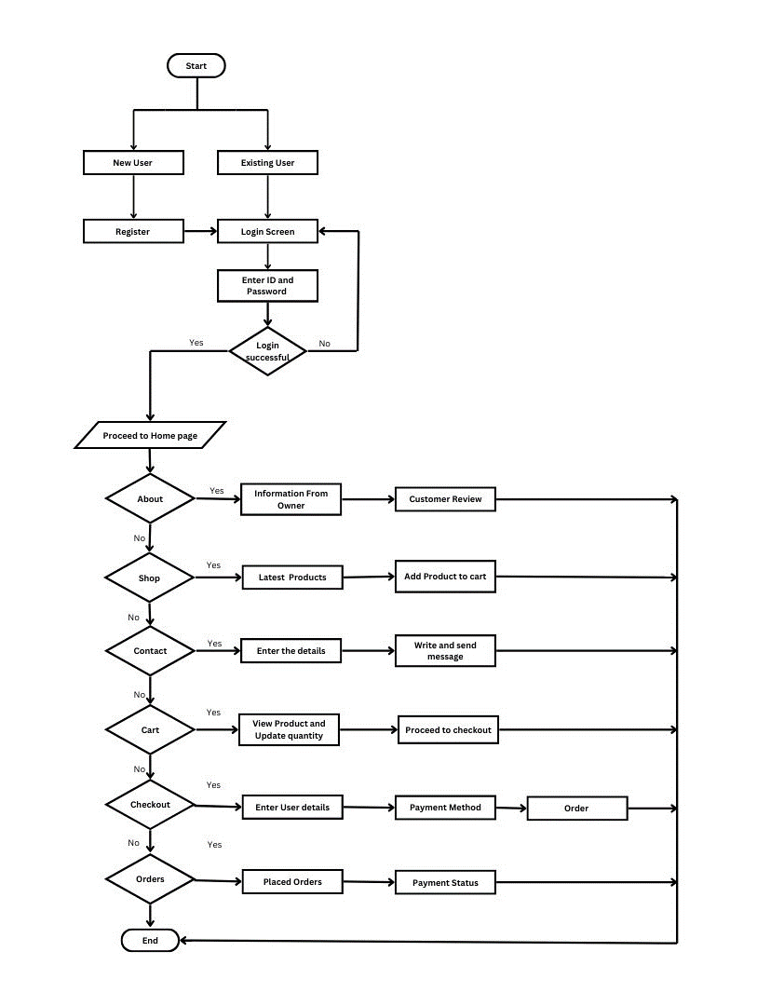
Fig 2.1 Website Flowchart

2.2 Use case Diagram
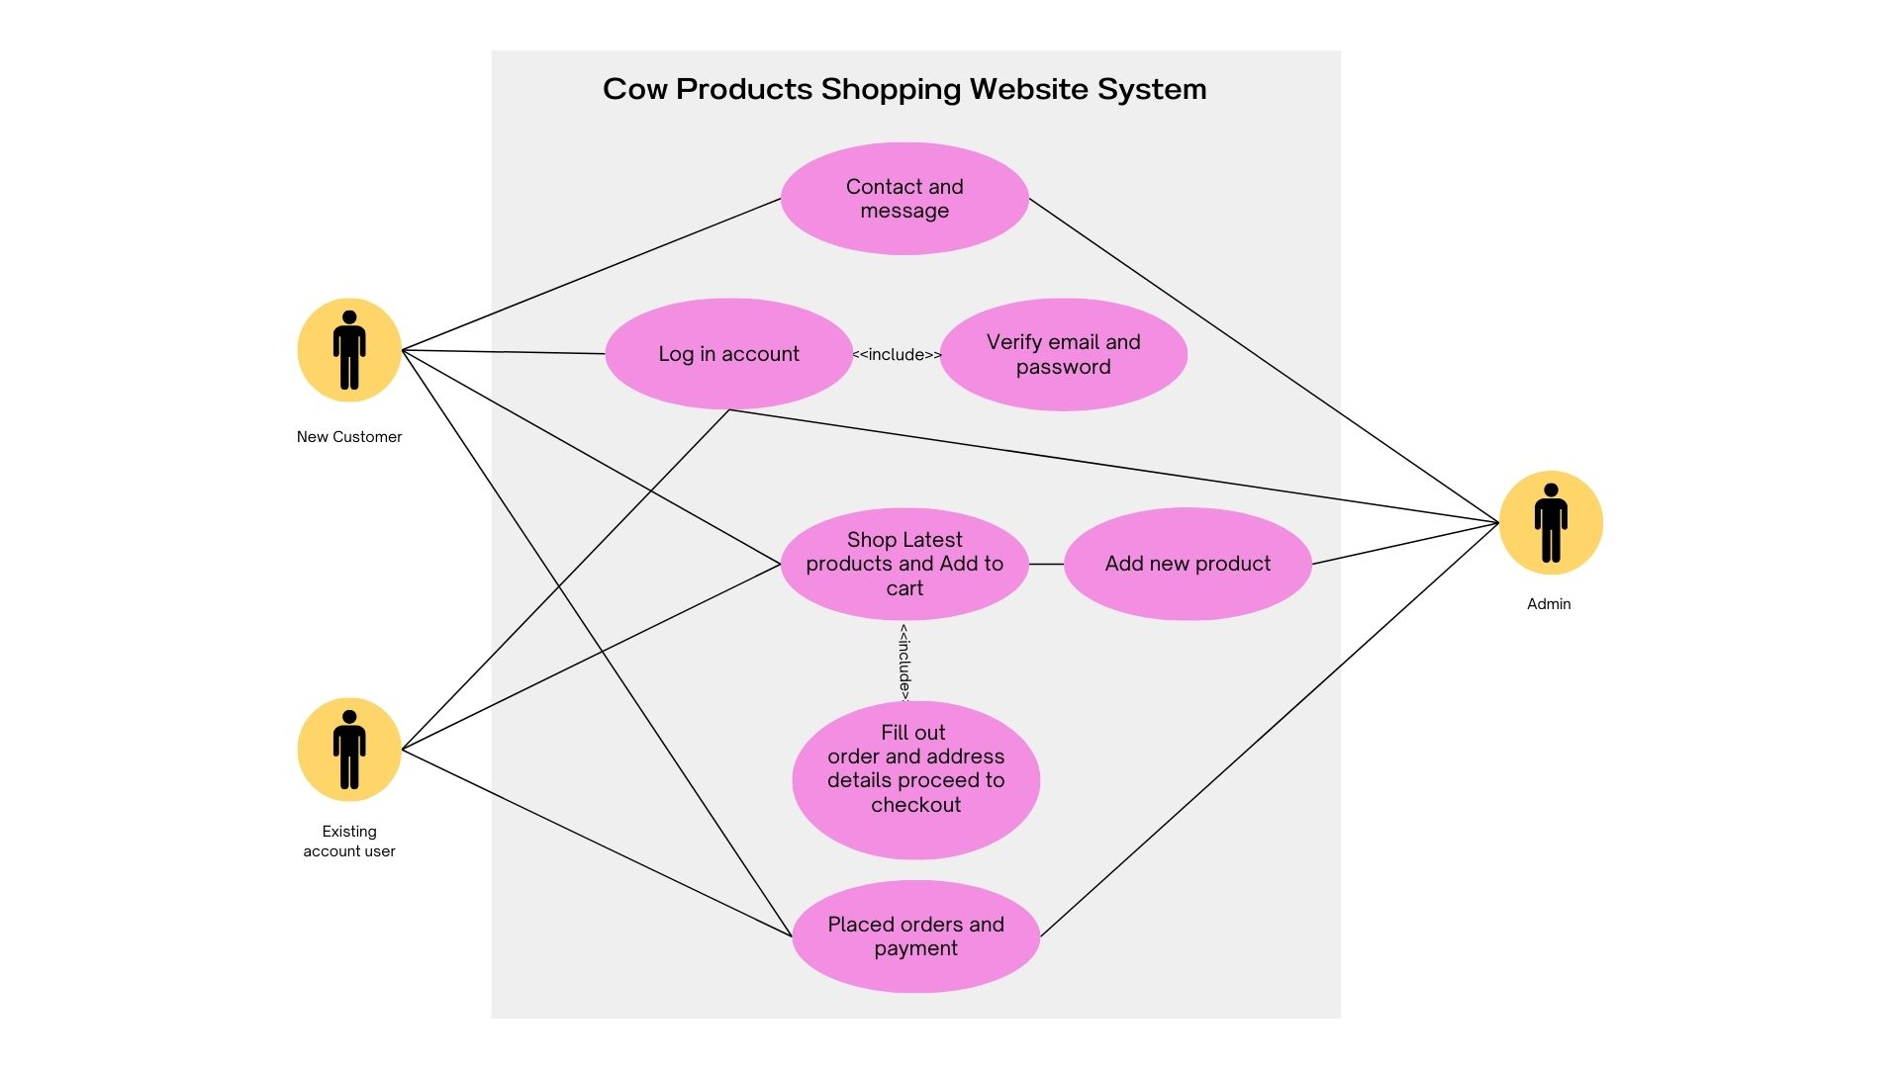

2.3 ER-Diagram
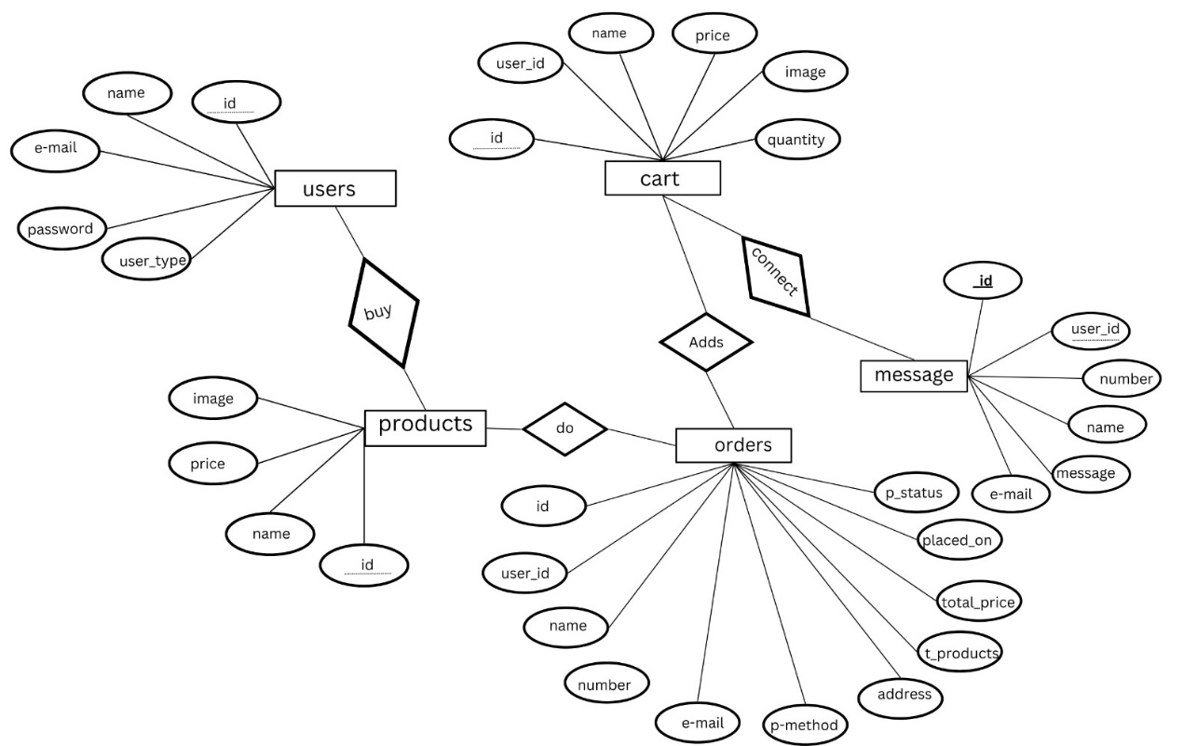

CHAPTER 3

CODE SNIPPET & SCREENSHOTS
3.1.1 Login activity

<?php
include 'config.php';
session_start();

if(isset($_POST['submit'])){

$email = mysqli_real_escape_string($conn, $_POST['email']);
$pass = mysqli_real_escape_string($conn, md5($_POST['password']));

$select_users = mysqli_query($conn, "SELECT * FROM `users` WHERE email = '$email' AND password = '$pass'") or die('query failed');

if(mysqli_num_rows($select_users) > 0){

$row = mysqli_fetch_assoc($select_users);

if($row['user_type'] == 'admin'){

$_SESSION['admin_name'] = $row['name'];
$_SESSION['admin_email'] = $row['email'];
$_SESSION['admin_id'] = $row['id'];
header('location:admin_page.php');

}elseif($row['user_type'] == 'user'){

$_SESSION['user_name'] = $row['name'];
$_SESSION['user_email'] = $row['email'];
$_SESSION['user_id'] = $row['id'];
header('location:home.php');

}

}else{
$message[] = 'Incorrect email or password!';
}

3.2. Home
<?php

include 'config.php';

session_start();

$user_id = $_SESSION['user_id'];

if(!isset($user_id)){
header('location:login.php');
}

if(isset($_POST['add_to_cart'])){

$product_name = $_POST['product_name'];
$product_price = $_POST['product_price'];
$product_image = $_POST['product_image'];
$product_quantity = $_POST['product_quantity'];

$check_cart_numbers = mysqli_query($conn, "SELECT * FROM `cart` WHERE name = '$product_name' AND user_id = '$user_id'") or die('query failed');

if(mysqli_num_rows($check_cart_numbers) > 0){
$message[] = 'already added to cart!';
}else{
mysqli_query($conn, "INSERT INTO `cart`(user_id, name, price, quantity, image) VALUES('$user_id', '$product_name', '$product_price', '$product_quantity', '$product_image')") or die('query failed');
$message[] = 'product added to cart!';
}

}

?>

<!DOCTYPE html>
<html lang="en">
<head>
<meta charset="UTF-8">
<meta http-equiv="X-UA-Compatible" content="IE=edge">
<meta name="viewport" content="width=device-width, initial-scale=1.0">
<title>home</title>

<!-- Font Awesome CDN link -->
<link rel="stylesheet" href="https://cdnjs.cloudflare.com/ajax/libs/font-awesome/6.0.0/css/all.min.css">

3.3. Orders
<!DOCTYPE html>
<html lang="en">
<head>
<meta charset="UTF-8">
<meta http-equiv="X-UA-Compatible" content="IE=edge">
<meta name="viewport" content="width=device-width, initial-scale=1.0">
<title>orders</title>
<!-- font awesome cdn link -->
<link rel="stylesheet" href="https://cdnjs.cloudflare.com/ajax/libs/font-awesome/6.0.0/css/all.min.css">
<?php
$order_query = mysqli_query($conn, "SELECT * FROM `orders` WHERE user_id = '$user_id'") or die('query failed');
if(mysqli_num_rows($order_query) > 0){
while($fetch_orders = mysqli_fetch_assoc($order_query)){
?>
<div class="box">
<p> placed on : <span><?php echo $fetch_orders['placed_on']; ?></span> </p>
<p> name : <span><?php echo $fetch_orders['name']; ?></span> </p>
<p> number : <span><?php echo $fetch_orders['number']; ?></span> </p>
<p> email : <span><?php echo $fetch_orders['email']; ?></span> </p>
<p> address : <span><?php echo $fetch_orders['address']; ?></span> </p>
<p> payment method : <span><?php echo $fetch_orders['method']; ?></span> </p>
<p> your orders : <span><?php echo $fetch_orders['total_products']; ?></span> </p>
<p> total price : <span>₹<?php echo $fetch_orders['total_price']; ?>/-</span> </p>
<p> payment status : <span style="color:<?php if($fetch_orders['payment_status'] == 'pending'){ echo 'red'; }else{ echo 'green'; } ?>;"><?php echo $fetch_orders['payment_status']; ?></span> </p>
</div>
<?php
}
}else{
echo '<p class="empty">no orders placed yet!</p>';
}
?>
</div>
</section>
<?php include 'footer.php'; ?>
<!-- custom js file link -->
<script src="js/script.js"></script>

</body>

3.4 Cart
<style>
/* Custom CSS for fixed image size */
.shopping-cart .box img {
width: 250px; /* Set your desired width */
height: auto; /* Maintain aspect ratio */
}
</style>
</head>
<body>
<?php include 'header.php'; ?>

<div class="heading">
<h3>Shopping Cart</h3>
<p><a href="home.php">Home</a> / Cart </p>
</div>
<section class="shopping-cart">

<h1 class="title">Products Added</h1>
<div class="box-container">
<?php
$grand_total = 0;
$select_cart = mysqli_query($conn, "SELECT * FROM `cart` WHERE user_id = '$user_id'") or die('query failed');
if(mysqli_num_rows($select_cart) > 0){
while($fetch_cart = mysqli_fetch_assoc($select_cart)){
?>
<div class="box">
<a href="cart.php?delete=<?php echo $fetch_cart['id']; ?>" class="fas fa-times" onclick="return confirm('Delete this from cart?');"></a>
<img src="uploaded_img/<?php echo $fetch_cart['image']; ?>" alt="">
<div class="name"><?php echo $fetch_cart['name']; ?></div>
<div class="price">₹<?php echo $fetch_cart['price']; ?>/-</div>
<form action="" method="post">
<input type="hidden" name="cart_id" value="<?php echo $fetch_cart['id']; ?>">
<input type="number" min="1" name="cart_quantity" value="<?php echo $fetch_cart['quantity']; ?>">
<input type="submit" name="update_cart" value="Update" class="option-btn">
</form>
<div class="sub-total"> Subtotal: <span>₹<?php echo $sub_total = ($fetch_cart['quantity'] * $fetch_cart['price']); ?>/-</span> </div>
</div>
<?php
$grand_total += $sub_total;
}
}else{
3.5 Checkout
if(isset($_POST['order_btn'])){

$name = mysqli_real_escape_string($conn, $_POST['name']);
$number = $_POST['number'];
$email = mysqli_real_escape_string($conn, $_POST['email']);
$method = mysqli_real_escape_string($conn, $_POST['method']);
$address = mysqli_real_escape_string($conn, 'flat no. '. $_POST['flat'].', '. $_POST['street'].', '. $_POST['city'].', '. $_POST['country'].' - '. $_POST['pin_code']);
$placed_on = date('d-M-Y');

$cart_total = 0;
$cart_products[] = '';

$cart_query = mysqli_query($conn, "SELECT * FROM `cart` WHERE user_id = '$user_id'") or die('query failed');
if(mysqli_num_rows($cart_query) > 0){
while($cart_item = mysqli_fetch_assoc($cart_query)){
$cart_products[] = $cart_item['name'].' ('.$cart_item['quantity'].') ';
$sub_total = ($cart_item['price'] * $cart_item['quantity']);
$cart_total += $sub_total;
}
}
$total_products = implode(', ',$cart_products);

$order_query = mysqli_query($conn, "SELECT * FROM `orders` WHERE name = '$name' AND number = '$number' AND email = '$email' AND method = '$method' AND address = '$address' AND total_products = '$total_products' AND total_price = '$cart_total'") or die('query failed');
if($cart_total == 0){
$message[] = 'your cart is empty';
}else{
if(mysqli_num_rows($order_query) > 0){
$message[] = 'order already placed!';
}else{
mysqli_query($conn, "INSERT INTO `orders`(user_id, name, number, email, method, address, total_products, total_price, placed_on) VALUES('$user_id', '$name', '$number', '$email', '$method', '$address', '$total_products', '$cart_total', '$placed_on')") or die('query failed');
$message[] = 'order placed successfully!';
mysqli_query($conn, "DELETE FROM `cart` WHERE user_id = '$user_id'") or die('query failed');


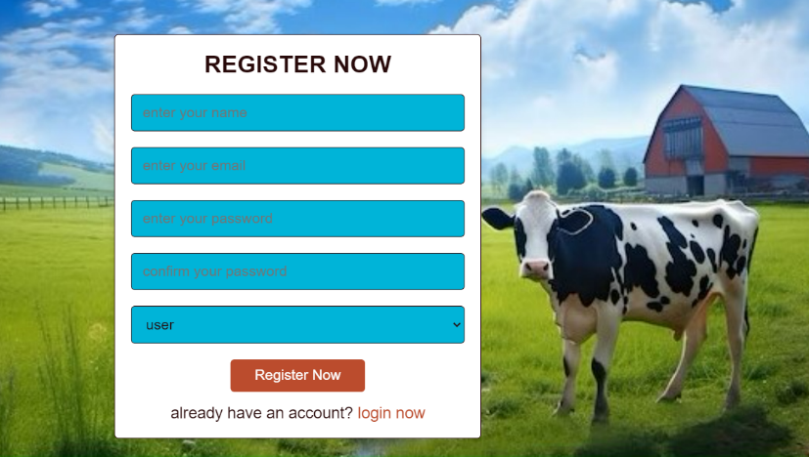
3.6 Output:
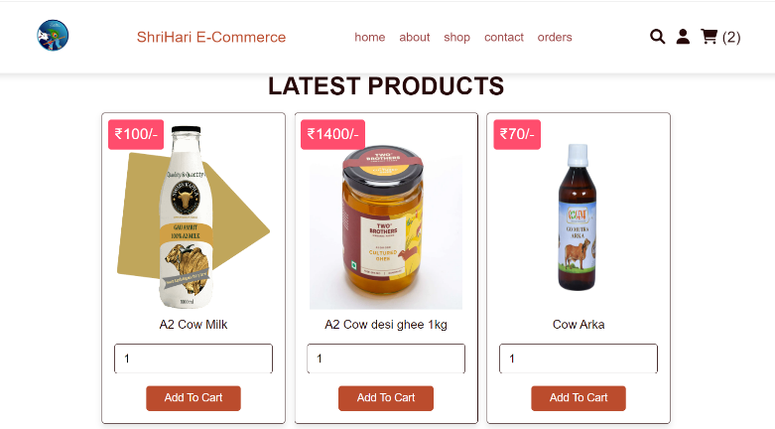
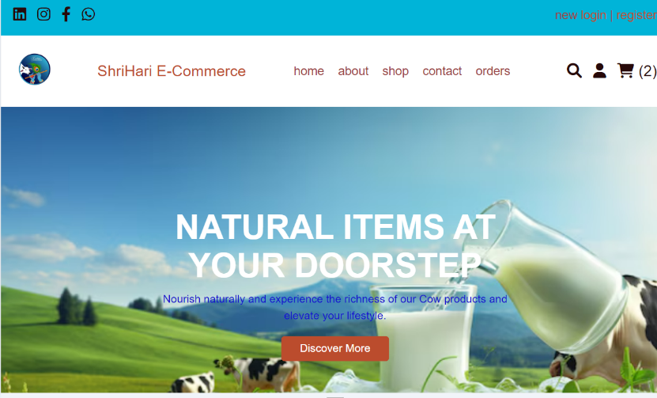

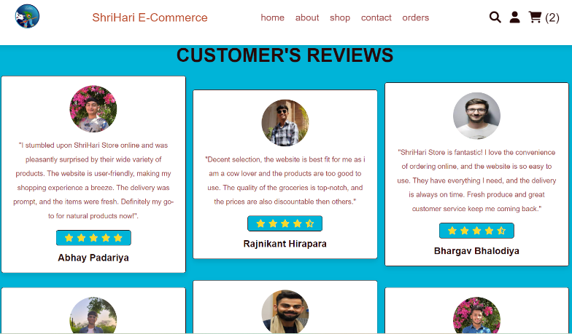
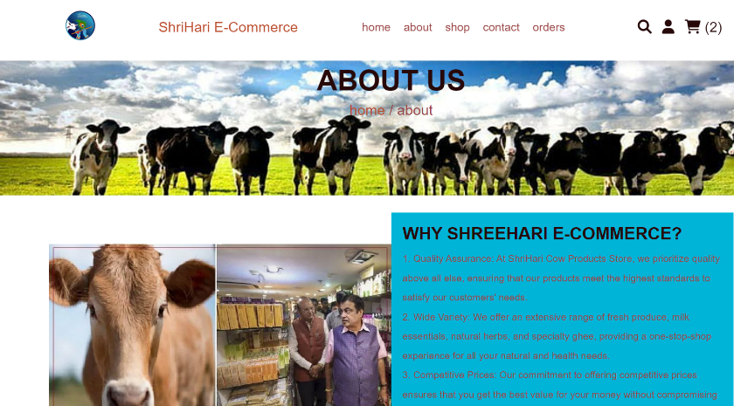

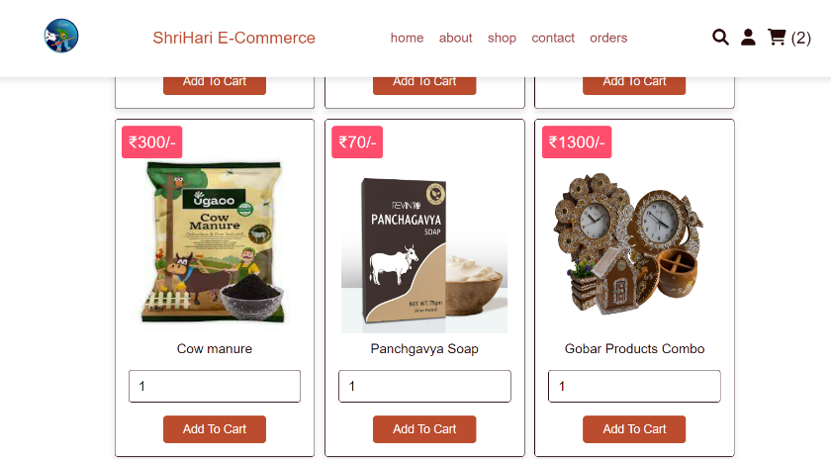
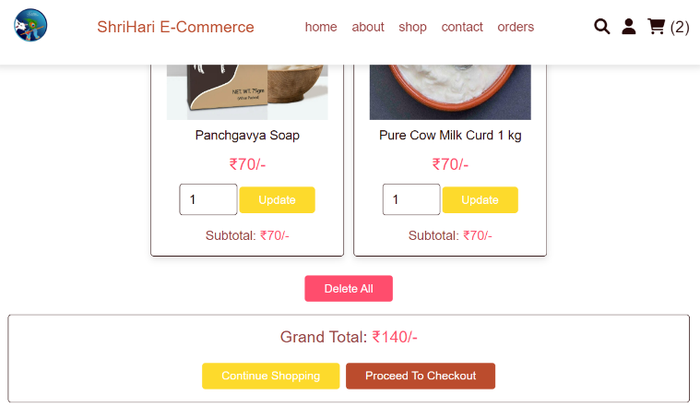
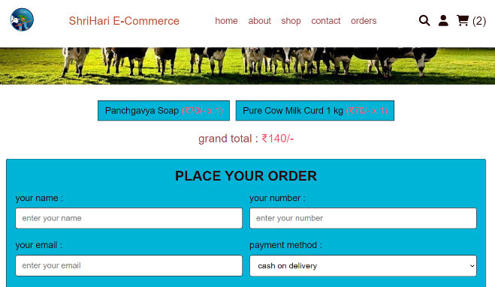

3.7 Future Enhancements:
For future enhancements , we can add many things like adding functionality of blogs in header so that users can see blog , posts related to cow products , animals , farming , organic products . We will also add more in depth product view for each product which has many images of a single product , the quantity can be choose and like in ml or kg and there are many review section for each product , discount and coupon use can be added , and similar products can be shown . Also , more payment gateways functionalities and products category wise can be organized . Moreover ,one more page can be added for showing support and schemes from government that are useful for consumers.

References
[1]https://www.youtube.com/watch?v=D389COfRSCM&t=1098s&pp=ygUVcGhwIGVjb21tZXJjZSB3ZWJzaXRl
- https://youtu.be/QNWIlrW7q_o?si=se0buLVavrket4M8
- https://www.youtube.com/watch?v=aYV4DOPtp3Y
- https://github.com/mohsinenur/E-Commerce-Website-Using-PHP

