**Birla Vishvakarma Mahavidhyalaya**

**Engineering College**

[An Autonomous Institute]

A

Project Report

On

**ChatBot**

Under the course of

**DESIGN ENGINEERING – 3CP08**

B. tech Semester 6

(Computer Engineering)

|  |  |  |
| --- | --- | --- |
| **Sr.** | **Name** | **Id. number** |
| **1** | Zil Rajwadi | 21CP044 |
| **2** | Meet Mistry | 22CP308 |

Submitted by:

Guided by:

Prof. Narendra M. Patel

Academic Year:

(2023-2024)

**CERTIFICATE**

This is certifying that students namely, **Ms. Zil Rajwadi (21CP044), Mr. Meet Mistry (22CP308)** of **B. tech (Computer Engineering) Semester 6** have successfully completed the course work and related tasks for the course of **Design Engineering (3CP08)** during the academic term of ending in the month of May 2024.

(Faculty Guide) (Head of Department)

Table of Contents

**ABSTRACT 1**

**CHAPTER – 1 INTRODUCTION2**

Problem Statement**3**

Project Objectives**4**

Project significance**4**

Target User**5**

**CHAPTER – 2 LITERATURE REVIEW AND PROJECT METGODOLOGY6**

Domain**6**

Existing System**6**

Project Development Phase**7**

**CHAPTER – 3 DESIGN CONSIDERATION FOR DETAIL DESIGN9**

Context Diagram**9**

Level – 1 DFD**9**

Entity-Relationship Diagram**11**

Use case Diagram**12**

**CHAPTER – 4 CANVASES13**

AEIOU Canvas**13**

Ideation Canvas**14**

Empathy Canvas**15**

Product Development Canvas**16**

**CHAPTER – 5 IMPLEMENTATION17**

**CHAPTER – 6 CONCLUSION AND FUTURE SCOPE22**

**CHAPTER – 7 REFERENCES24**

**ABSTRACT**

This project aims to develop a Chatbot integrated with website management functionalities and speech-to-text recognition capabilities, leveraging the Botpress platform. The Chatbot serves both administrators and users, allowing administrators to efficiently manage website data within the Botpress environment while enabling users to access website information seamlessly through natural language interactions. Key activities include data gathering for website details, development of Chatbot features utilizing Botpress's functionality, rigorous testing to ensure functionality and usability, and deployment to provide accessible and reliable service. Through this project, we strive to enhance website management efficiency and user engagement in an intuitive and accessible manner with the aid of Botpress.

CHAPTER 1 – INTRODUCTION

In today's digital age, managing and accessing information on websites can be overwhelming. This is where Chatbots come in. A chatbot is a computer program that can have conversations with people, either through text or voice. These Chatbots are designed to understand human language and provide helpful responses, making them useful for automating tasks and improving user experiences.

**What is a Chatbot?**

A Chatbot is like a virtual assistant that you can chat with. It's a computer program that can understand what you're asking and respond in a way that makes sense. Chatbots are used in many different ways, from helping you order food online to answering questions about a product or service.

**Why do we need this type of Chatbot?**

The chatbot we've developed is special because it helps manage website information and interacts with users using natural language. By using the Botpress platform, website administrators can easily store and manage website data. Users can then ask the chatbot questions in plain language, and it will provide helpful answers. Additionally, our chatbot can understand voice commands, making it even more accessible and user-friendly.

**About Botpress and Python:**

Botpress:

Botpress is a tool that helps developers build chatbots. It provides a visual interface for creating chatbot flows and can understand human language. Botpress is open-source, meaning anyone can use it and contribute to its development.

Python:

Python is a programming language commonly used for building Chatbots. It's known for being easy to read and write, making it ideal for developers of all skill levels. Python also has libraries that help with tasks like speech-to-text recognition, which our chatbot uses to understand voice commands.

**Problem Statement:**

Manual Website Data Management:

Administrators often rely on manual methods to manage website information, leading to inefficiencies and potential errors. This manual process can result in incomplete or outdated website data, making it challenging for users to access accurate information.

Limited User Interaction:

End-users face limitations in accessing comprehensive website details, as they may not have direct access to the entire website or encounter difficulties in navigating through the content. This limited interaction hinders users from finding the information they need efficiently.

Speech Recognition Integration:

Integrating speech recognition technology into the Chatbot requires seamless implementation to enhance user accessibility and interaction. Users may face barriers in accessing website data if they cannot effectively communicate their queries to the Chatbot using speech recognition.

**Project Objectives:**

Efficient Website Data Management:

Develop a system that allows administrators to easily load and manage website information within Botpress, ensuring accuracy and efficiency in data storage and retrieval. This system should enable administrators to upload relevant portions of website data to the Chatbot, enhancing accessibility for end-users.

Seamless User Interaction:

Implement speech-to-text recognition using Python libraries to enable natural language interactions for end-users. The Chatbot should be able to understand and interpret user queries effectively, even if the entire website data is not available.

Enhanced User Experience:

Provide a user-friendly interface for end-users, optimizing usability and accessibility to improve overall satisfaction and engagement. The Chatbot should assist users in finding relevant information from the website data stored in Botpress, offering solutions and answers to their queries in a timely manner.

**Project Significance:**

This project aims to address the challenges faced by users in accessing comprehensive website data and finding relevant information efficiently. By integrating speech recognition technology and optimizing website data management within Botpress, the system enhances user interaction and accessibility. Users can rely on the Chatbot to provide accurate answers and solutions to their queries, even if the entire website data is not available. This improves the overall user experience and satisfaction, leading to increased engagement and productivity.

**Target User:**

Administrators:

Responsible for loading relevant portions of website data into Botpress and managing the Chatbot. Administrators ensure that the Chatbot has access to updated and accurate website information.

End-users:

Interact with the Chatbot to inquire about website details and receive responses in real-time. End-users may not have access to the entire website data but rely on the Chatbot to provide relevant information based on their queries.

CHAPTER 2 – LITERATURE REVIEW AND PROJECT METHODOLOGY

The second phase in the system delivery process involves conducting a literature review and defining the methodology. The purpose of the literature review is to determine the extent of investigation required to address the project's questions and to identify necessary requirements. It involves summarizing previous research on the topic, which can be part of a larger report or research project. The literature review provides valuable insights and guidance for the development of the system.

**Domain:**

This Chatbot system operates within the domain of artificial intelligence (AI) and natural language processing (NLP) applied to website management and user interaction. The system utilizes Botpress, a Chatbot platform, to facilitate website data storage and retrieval. The methodology employed in this project draws inspiration from existing research and applications in the fields of AI, NLP, and website management.

**Existing Systems:**

While there are several existing systems in the realm of website management, the majority of them are paid services. Our Chatbot provides a unique alternative by offering free services for website data management and user interaction. Unlike paid solutions, our Chatbot leverages Botpress to streamline website data storage and retrieval, empowering businesses with cost-effective solutions for their website management needs.

**Project Development Phase:**

Planning Phase:

The project planning phase involves gathering requirements from stakeholders and analysing the existing manual system's shortcomings. In the context of the Chatbot system, this phase entails identifying the key features and functionalities required for website data storage and retrieval. The Chatbot's role in assisting users with website-related queries is outlined, with a focus on enhancing user experience and efficiency.

Analysis Phase:

During the analysis phase, the manual system's functionalities and user requirements are thoroughly examined. This involves identifying potential improvements and determining the Chatbot's capabilities in addressing user queries. Requirements gathering includes understanding the types of website data to be stored in Botpress and defining the user interaction flow for querying this data.

Design Phase:

The design phase translates the analysis findings into a blueprint for the Chatbot system's architecture and interface. Database design considerations include structuring the data storage format within Botpress to facilitate efficient retrieval. Interface design focuses on creating a user-friendly interaction flow that enables seamless communication between users and the Chatbot.

Implementation Phase:

In the implementation phase, the Chatbot system is developed using Botpress for website data storage and retrieval. Integration with speech-to-text recognition using Python libraries enhances user accessibility.

Testing Phase:

Testing is conducted to validate the functionality and performance of the Chatbot system. This includes verifying the accuracy of website data retrieval, assessing the effectiveness of speech-to-text recognition, and ensuring overall system reliability. Any issues identified during testing are addressed through debugging and refinement, with a focus on delivering a seamless user experience.

CHAPTER 3 – DESIGN CONSIDERATION FOR DETAIL DESIGN

This chapter consists of Data Flow Diagrams, Entity Relationship (ER) Diagram, Use Case of the Chatbot. These diagrams help us to determine how the system works and how data flows in the system, how the database looks like, relationship of users with activities.

**DFD level 0(Context diagram):**

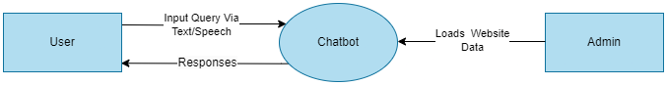

[Fig. 3.1]

In this data flow diagram, the Admin uploads website data, and users input queries via text or speech, triggering the Chatbot Processing. The Chatbot Processing then retrieves pertinent data from the Website Data Store, which was previously loaded by the Admin, in response to the user's query, and generates appropriate responses.

**DFD level 1:**

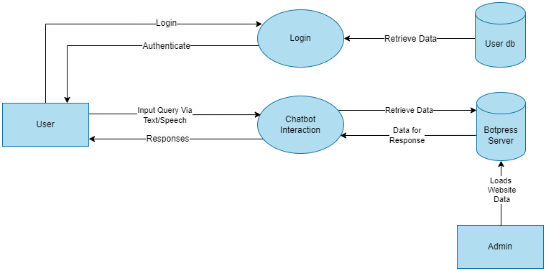

[Fig. 3.2]

In this scenario, the Admin uploads website information onto the botpress server. Users proceed through the "User Authentication" process, logging in or signing up, with their credentials stored in the User Database. Upon successful authentication, users participate in the "Chatbot Interaction" process, submitting queries. The Chatbot Processing retrieves data from the botpress server in response to the user's query and generates appropriate responses.

**Entity Relation Diagram:**

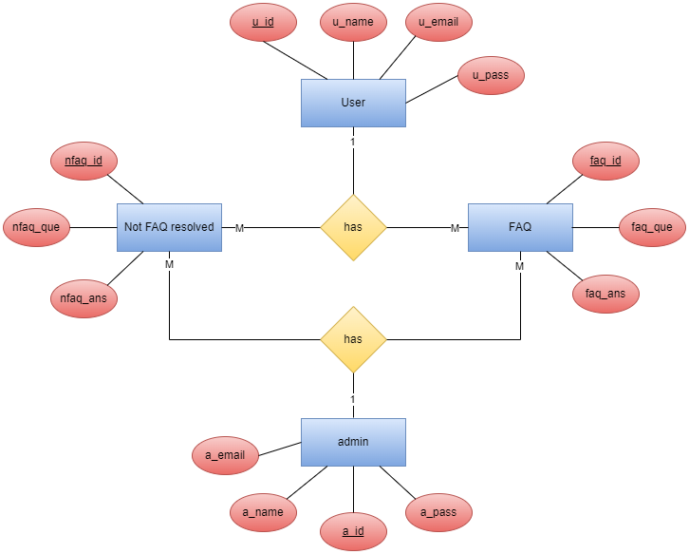

[Fig. 3.3]

**Use case Diagram:**

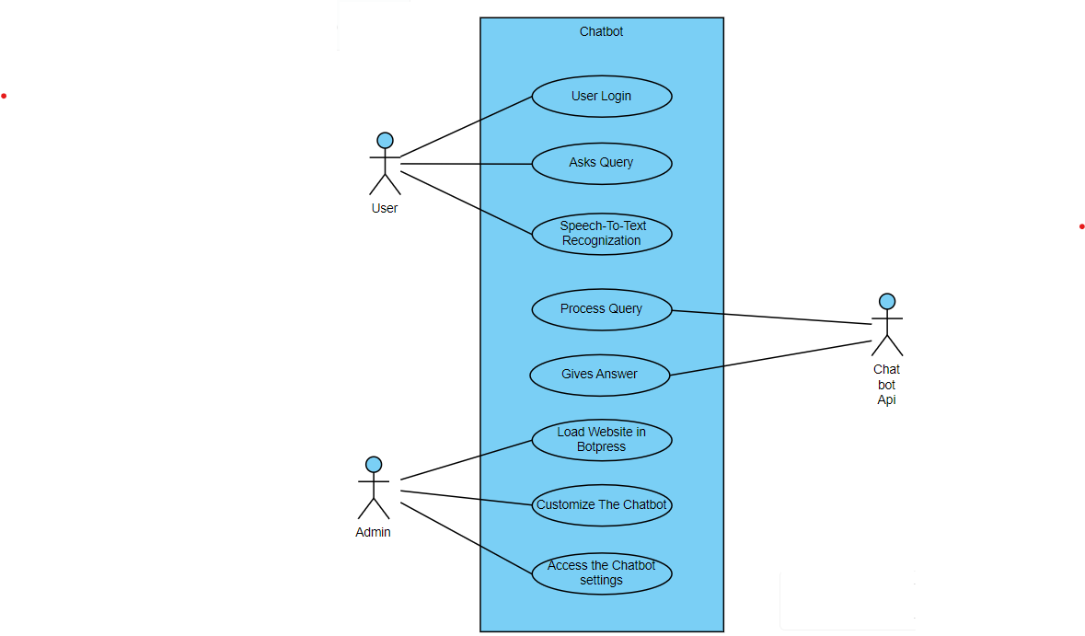

[Fig. 3.4]

A use case diagram a chatbot system showcases how users, administrators, and the chatbot itself interact. Users can login and ask questions, which are converted to text by the chatbot if spoken. The chatbot then analyzes the query and delivers a text or spoken response. It can also retrieve information from websites like Botpress to enhance its answers.

CHAPTER 4 – CANVASES

This chapter consists of canvas related to the project. Moreover, other canvases also lead us towards better understanding of the project and its requirements.

**AEIOU Canvas:**

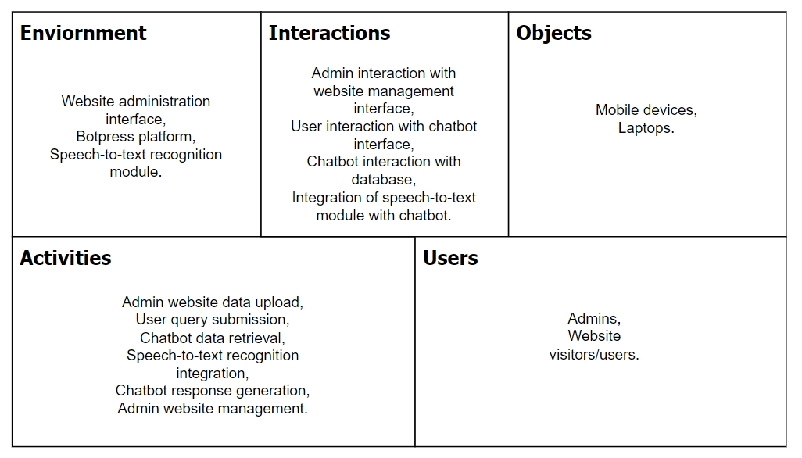

[Fig. 4.1]

The AEIOU framework is a tool used in design thinking to understand and analyse various aspects of a system or environment. It stands for Activities, Environment, Interaction, Objects, and Users. The accompanying diagram visually represents these elements, mapping out the activities, objects, and interactions within the system, as well as the environment in which they occur. Through AEIOU, designers gain a comprehensive understanding of the system's dynamics, facilitating the development of user-centric solutions and improving overall user experience.

**Ideation Canvas:**

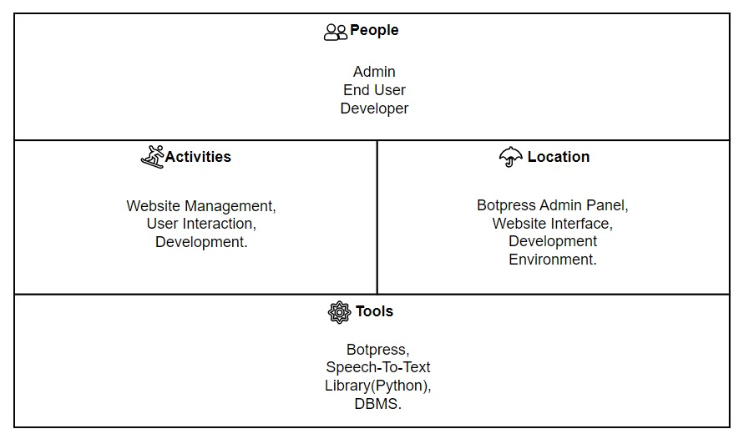

[Fig. 4.4]

The Ideation Canvas is a tool utilized in the ideation phase of design thinking to generate and organize innovative ideas for a project. It consists of sections such as People, Activities, Location, and Tools, which prompt brainstorming around different aspects of the project. By encouraging diverse perspectives and inputs from stakeholders, the canvas facilitates the generation of creative solutions to address specific challenges or goals. When applied to a Chatbot project, the Ideation Canvas helps explore various functionalities, user interactions, and technological integrations, fostering the development of innovative and user-centric Chatbot solutions.

**Empathy Canvas:**

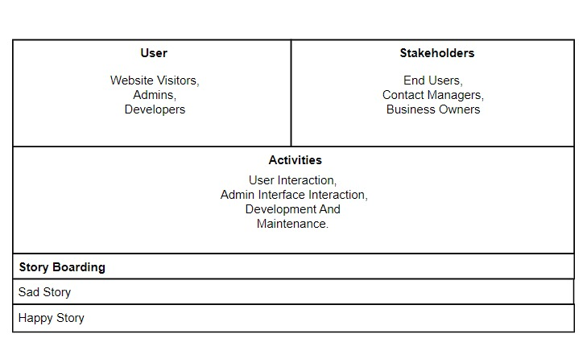

[Fig. 4.3]

The Empathy Canvas is a design tool that helps creators understand the needs and emotions of users and stakeholders. It breaks down users into categories like website visitors, admins, and developers, while stakeholders may include end users, content managers, and business owners. By empathizing with these groups, designers can gain valuable insights into their motivations and frustrations. The accompanying diagram visually represents these insights, offering a clear picture of user personas and their respective needs and emotions. In the context of a Chatbot, specific user personas related to chat interactions, such as frequent users and support staff, would be included. This understanding guides the development of more user-centric and empathetic Chatbot solutions.

**Product Development Canvas:**

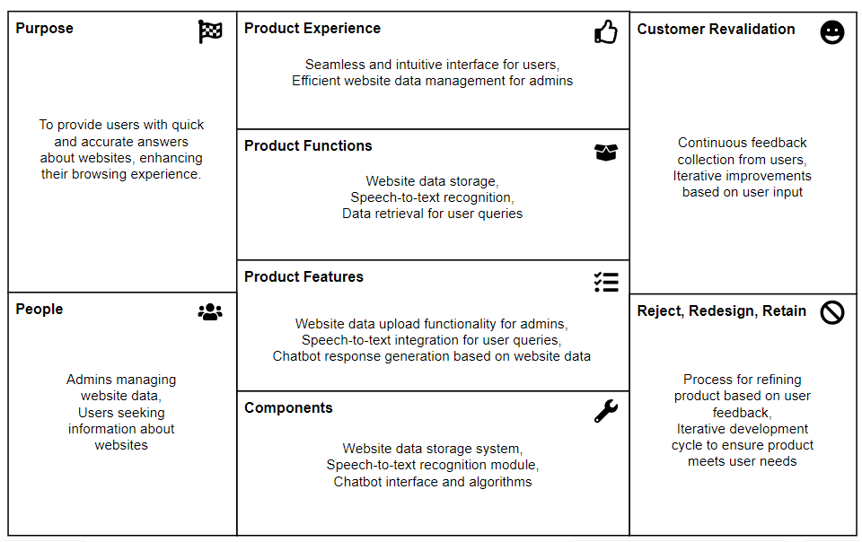

[Fig. 4.2]

The Product Development Canvas is like a detailed roadmap used by product developers to define and improve important aspects of a product or service as it progresses through development. It covers things like the product's purpose, who it's for, what features it has, and how feedback is collected. Specifically, when it's applied to building a Chatbot, this canvas helps outline the special features, how users interact with it, and the technical parts needed for its development. With this organized approach, developers can effectively plan and refine the design and features of the Chatbot, making sure it's user-friendly and functions smoothly.

CHAPTER 5 – IMPLEMENTATION

Our project aims to develop a Chatbot integrated with website management features and speech-to-text recognition capabilities. The Chatbot allows admins to store website data and users to query information about websites through natural language interactions. Key components include an Index Page, login page, signup page, main page with speech-to-text recognizer, and Chatbot functionality.

**Home Page:**

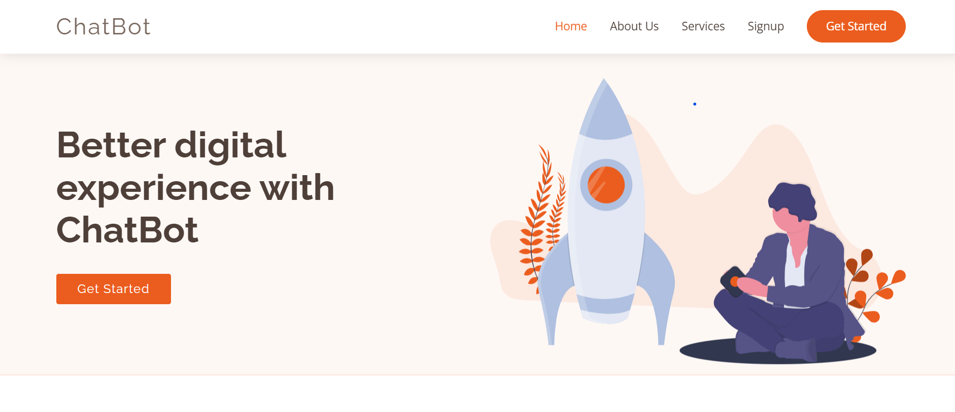

[5.1 Home Page]

**About Us Page:**

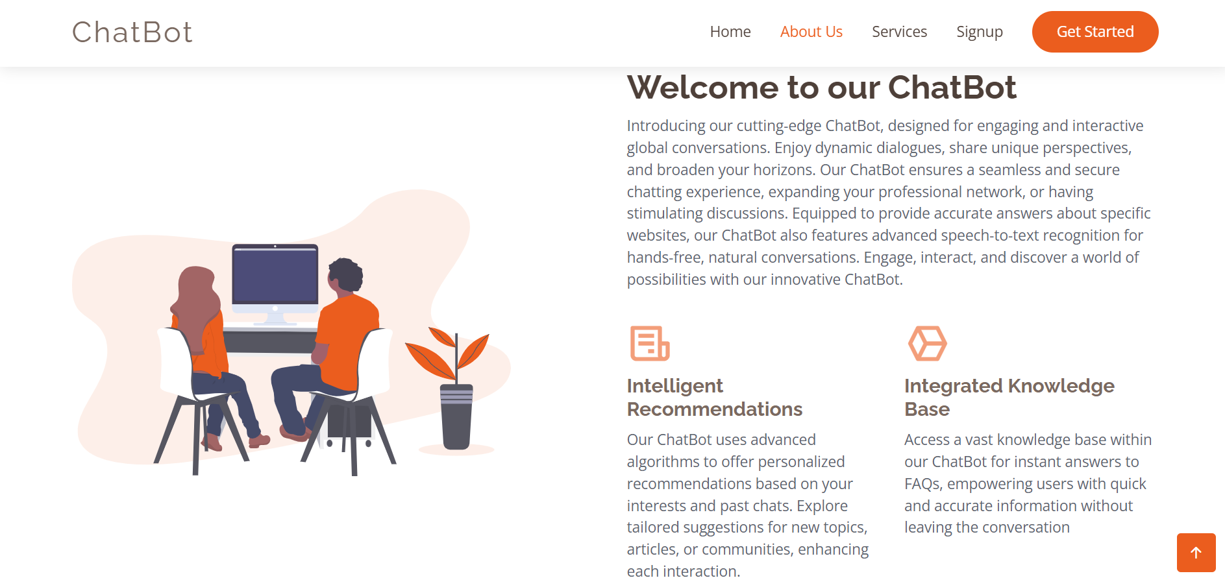

[5.2 About Us Page]

**Services Page:**

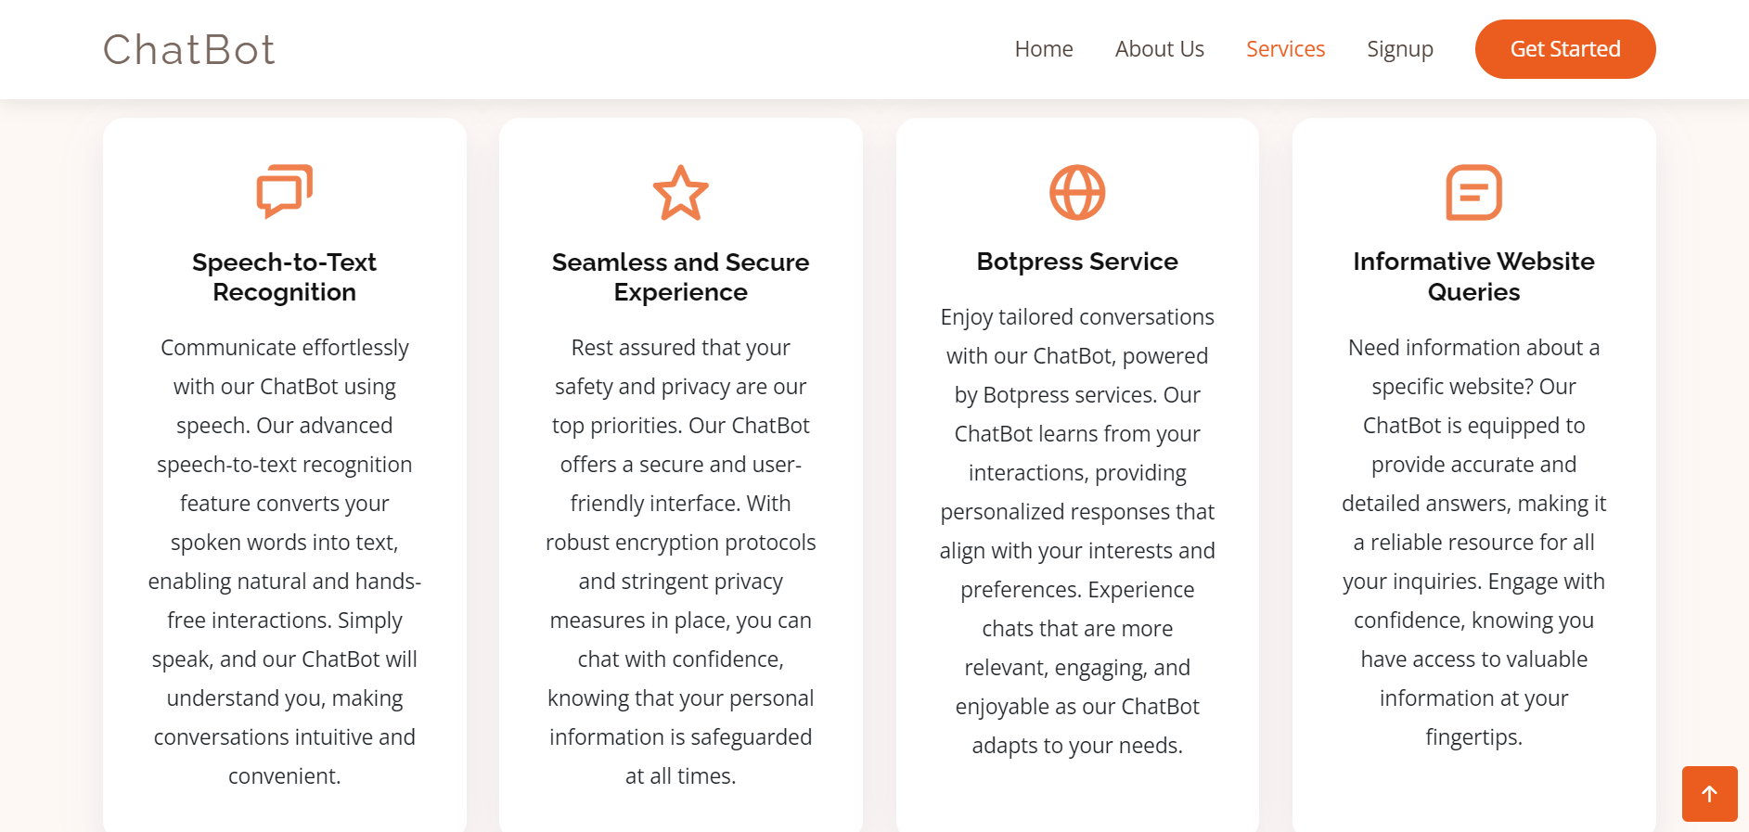

[5.3 Services Page]

**Login Page:**

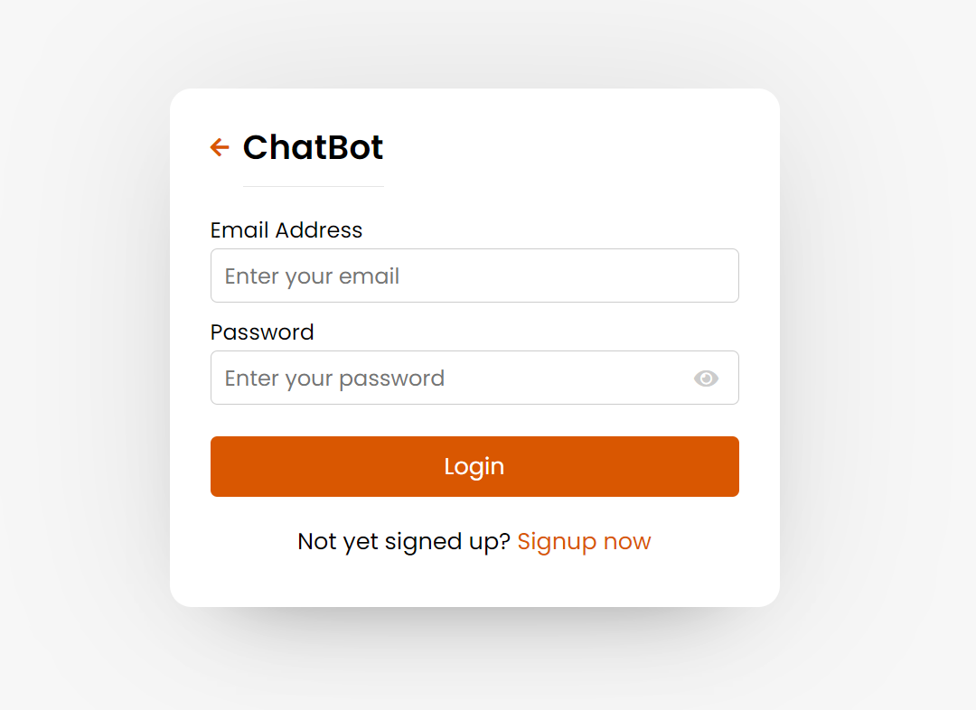

[5.4 Login Page]

The login page serves as the entry point for users and admins to access the chatbot system. Users can input their credentials (username and password) to authenticate and gain access to the main page.

**Signup Page:**

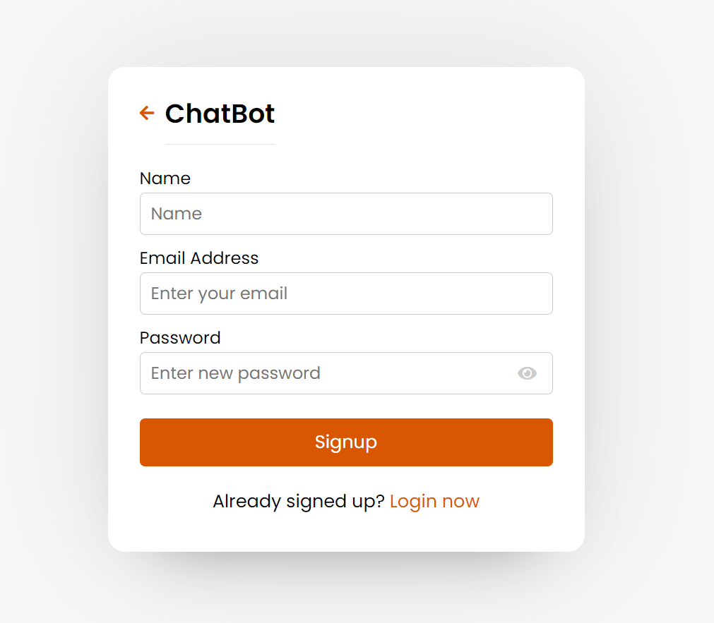

[5.5 Signup Page]

The signup page allows new users to register for an account in the Chatbot system. Users provide necessary details such as username, email, and password to create their account.

**Speech Recognition and Chatbot:**

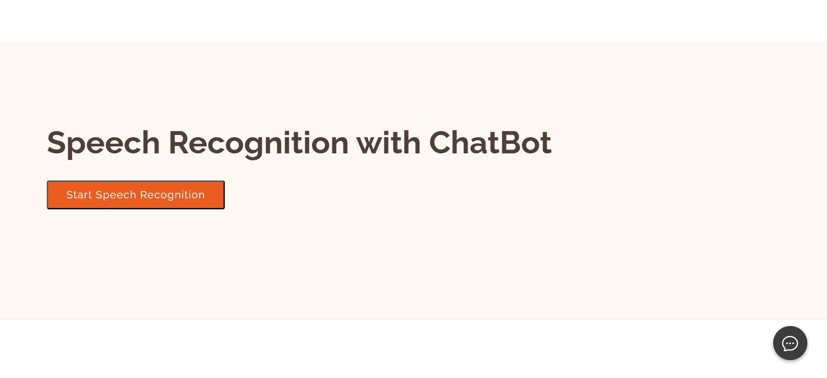

[5.6 Speech Recognition & Chatbot]

The main page hosts the core functionalities of the Chatbot system. It includes a speech-to-text recognizer feature, enabling users to input queries via voice commands.

**Showing the Chatbot:**

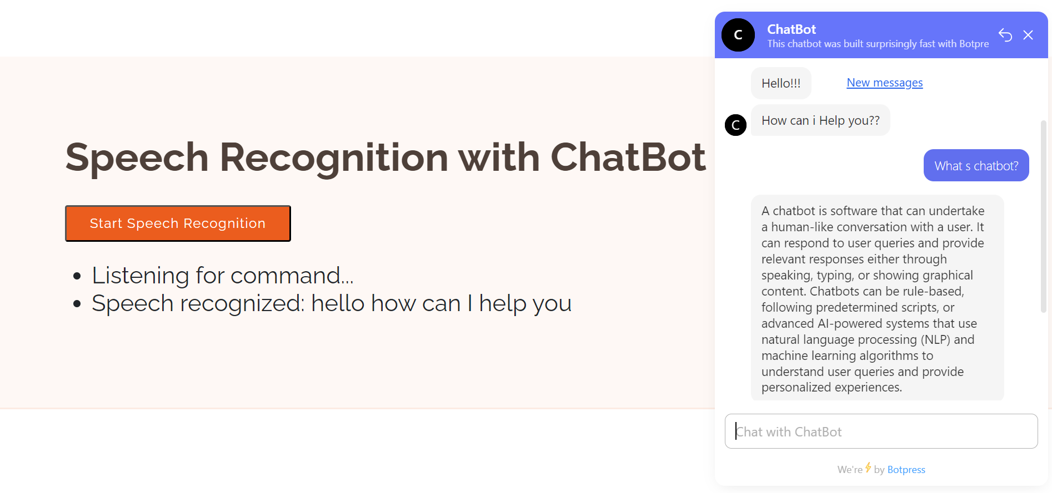

[5.7 Chatbot]

The Chatbot component processes user queries, retrieves relevant website data stored in the database, and generates responses. Users can engage in natural language interactions with the Chatbot to obtain information about websites.

**Botpress Studio and Rule-based Chatbot:**

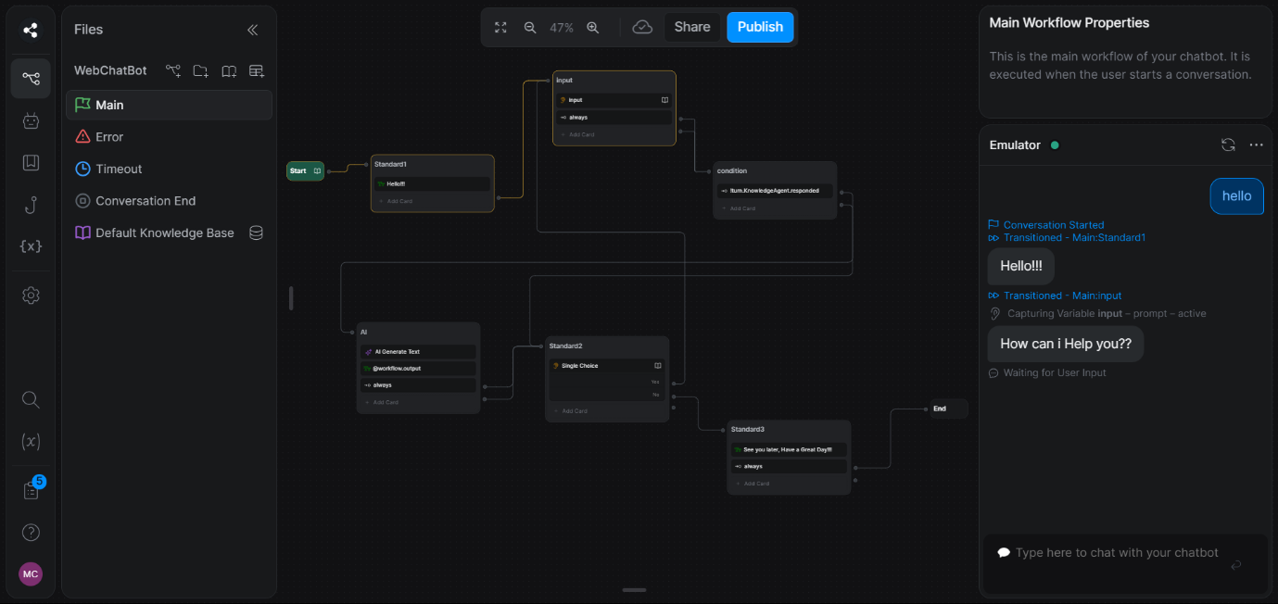

[5.8 Botpress Studio & Rule-based Chatbot]

The Chatbot component processes user queries, retrieves relevant website data stored in the database, and generates responses. Users can engage in natural language interactions with the Chatbot to obtain information about websites.

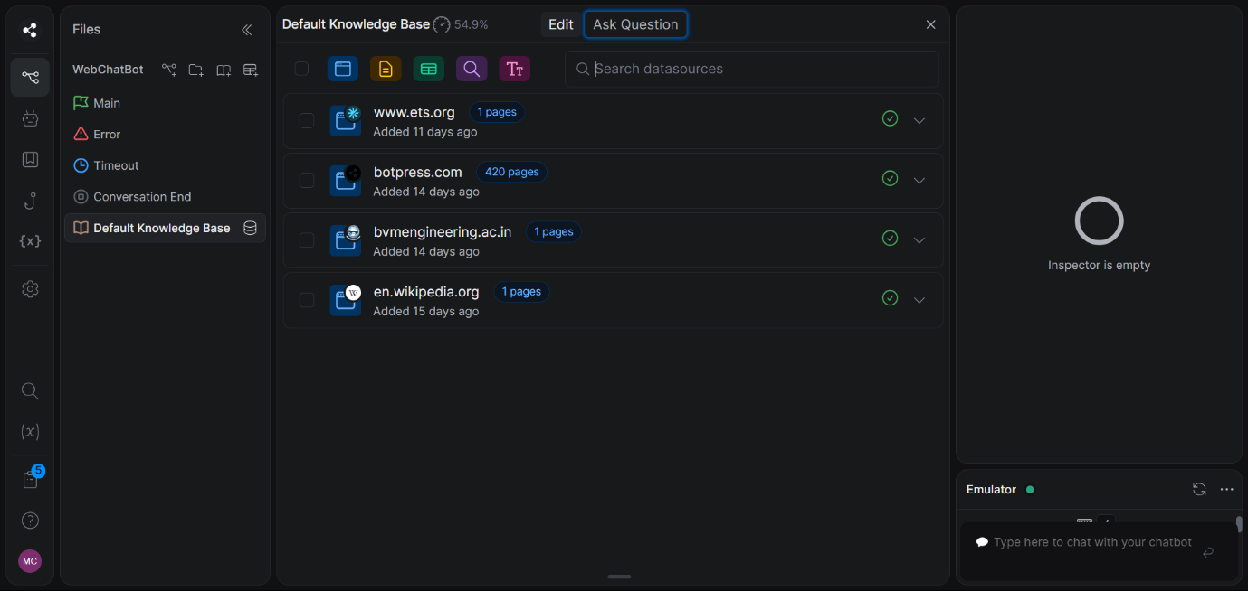

[5.9 Knowledge Base]

Botpress Studio includes a knowledge base feature, allowing developers to incorporate pre-existing knowledge and information into their Chatbots. With Botpress Studio, developers can build sophisticated Chatbots that engage users across different channels, enhancing the overall user experience.

CHAPTER 6 – CONCLUSION AND

FUTURE SCOPE

**Concluding Remarks:**

In conclusion, this project has successfully implemented a functional prototype of a Chatbot-based website management system. Throughout the project phases, rigorous testing ensured the system's reliability and performance met acceptable standards. The project effectively addressed high-priority requirements and documented key research insights and decision-making processes. While the system has achieved its objectives in assisting website management, there remains potential for future extensions and improvements.

**Future Improvement:**

In addition to the current system capabilities, there are several opportunities for further enhancement:

Enhanced User Experience:

Implementing a more intuitive user interface for managing website data and interacting with the Chatbot could improve user satisfaction and efficiency.

Integration of Advanced Features:

Incorporating advanced features such as sentiment analysis or natural language understanding could enhance the Chatbot's ability to interpret user queries and provide more accurate responses.

Integration of Speech Recognition:

Integrate speech recognition capabilities with the Chatbot to allow users to interact via voice commands. This feature would enhance accessibility and convenience, enabling users to interact with the Chatbot hands-free and in various environments.

Expansion of Data Sources:

Integrating additional data sources beyond website content, such as social media feeds or external databases, could enrich the Chatbot's knowledge base and broaden its capabilities.

CHAPTER 7 – REFERENCES

**Websites:**

<https://www.geeksforgeeks.org/connect-flask-to-a-database-with-flask-sqlalchemy/>

<https://botpress.com/docs/>

**Youtube Video Links:**

<https://www.youtube.com/playlist?list=PLlJHGGklthGlUVZlNhG5I0ZK8u1h6UfZ9>

**Entire implementation code for project is available in the following link:**

https://github.com/meetm2003/ChatBot