**Assignment: 1**

**Aim:** Deploying ML model on Web with Flask.

Step 1: Install Flask

* 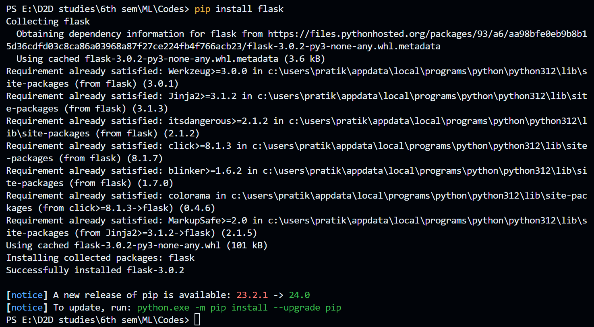To deploy model, flask package of python language is required. To install it write below command in command prompt.

Make sure that above screen will appear showing that flask installed successfully.

Step 2: Create Flask App and Model Logic.

* Create a new directory for your Flask app and navigate to it. Inside the directory, create a file named app.py and add the following:

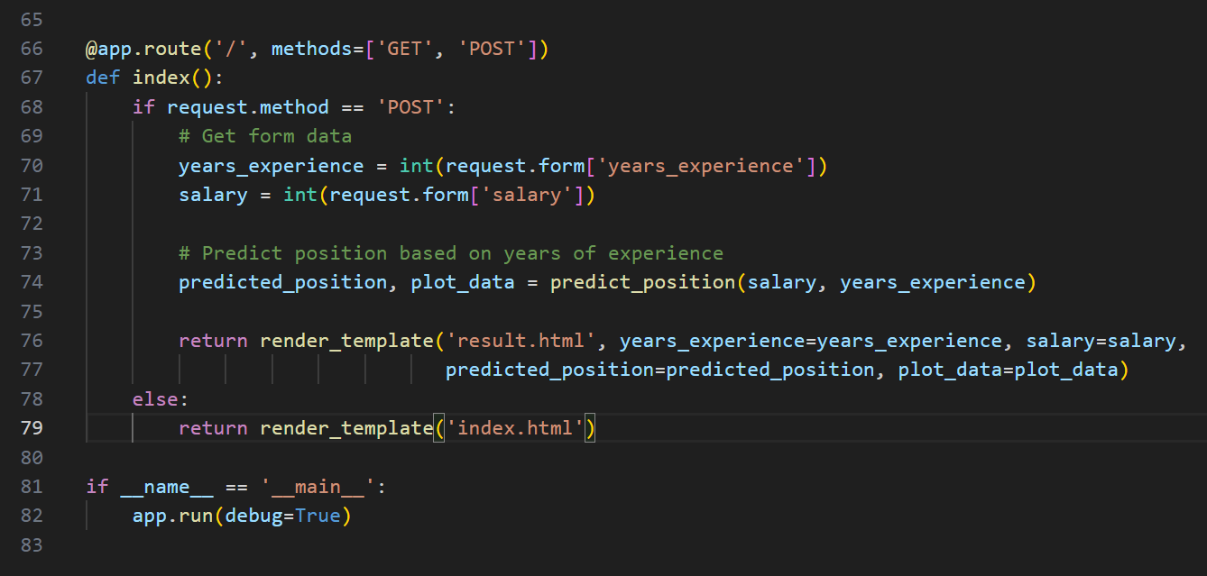

* Also, we can add Model code in app.py file. So, I am using K-nearest Neighbors Model and add following code:

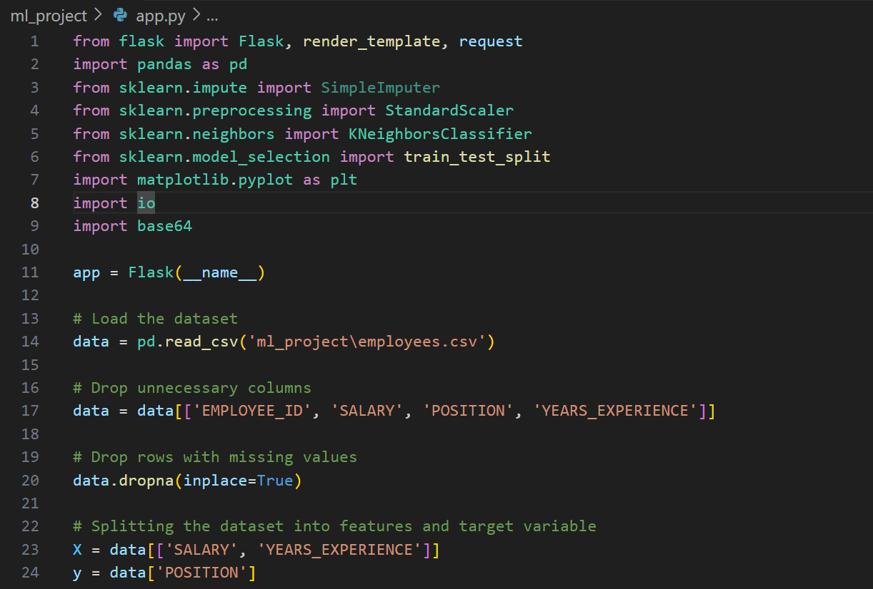

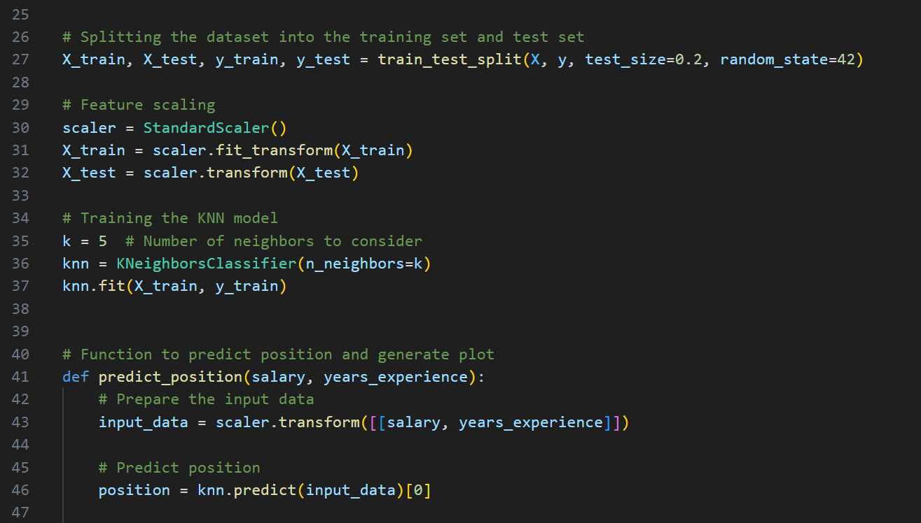

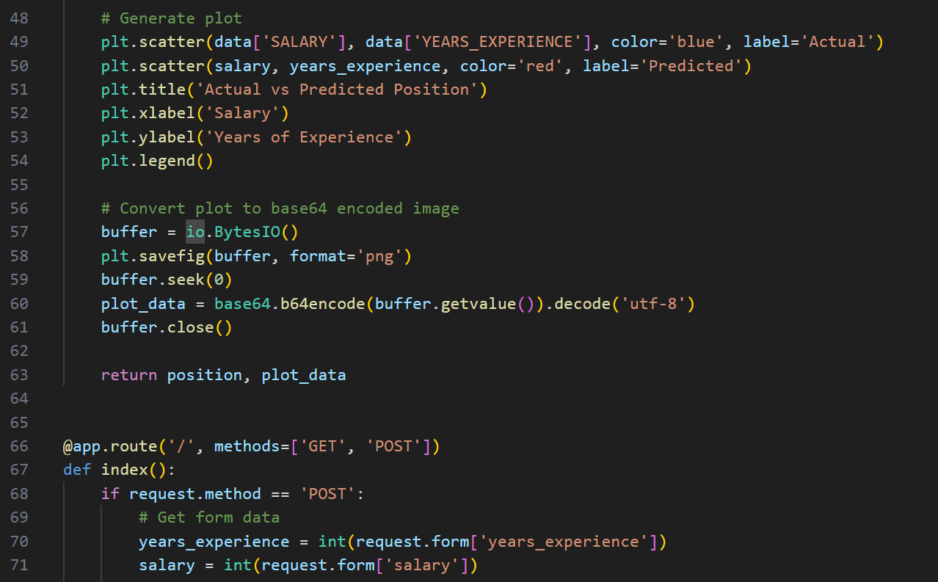

Step 3: Create template folder and add html file into it.

* Inside your Flask app directory, create a folder named templates. This is where you'll store your HTML templates. Create a file named index.html inside the templates folder and include the HTML structure:

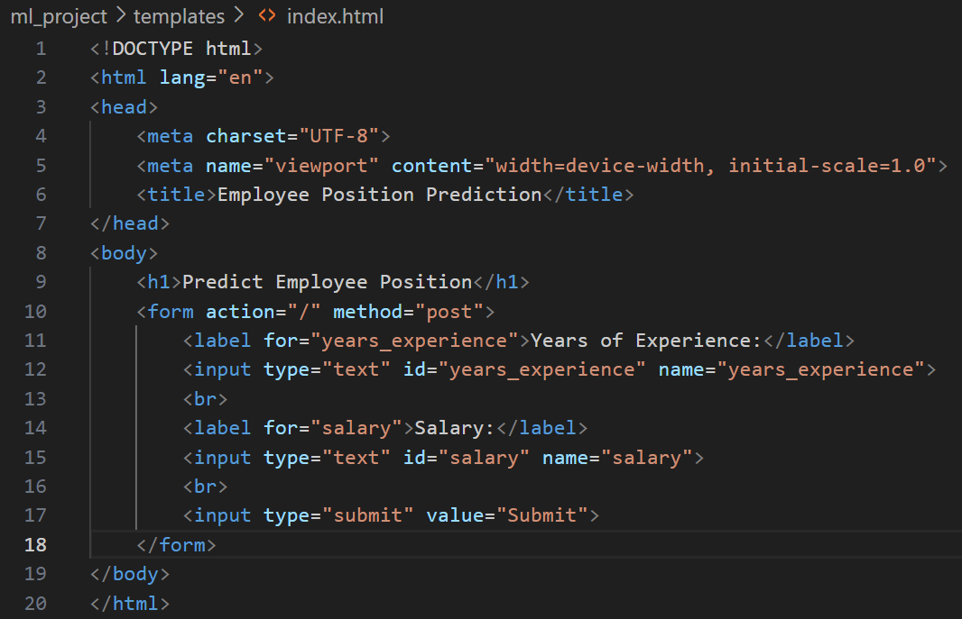

* Here, index.html page takes input from user and it passes to the flask, and based on user input KNN model predicts the position and that shows on result.html.

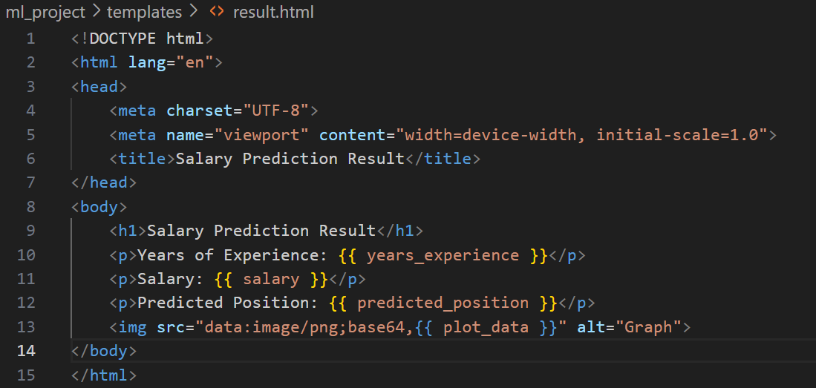

Step 4: Run app.py

* This is final step. Type command **python –u app.py** in command prompt execute this python code, and also it generates the graph.
* Open web browser and go to http://127.0.0.1:5000/ to see your KNN Graph visualization.

**OUTPUT**:

**Index.html**

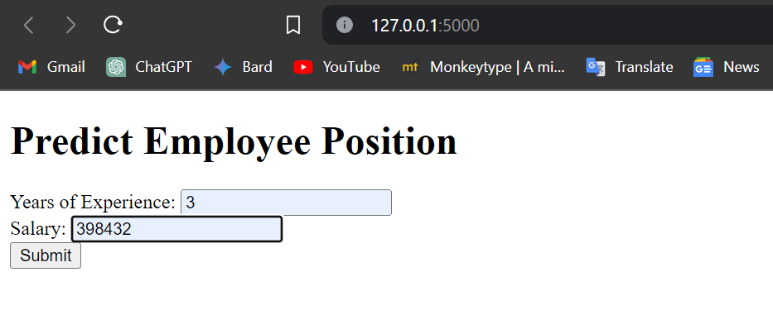

**result.html**

