**Assignment -1**

**Aim:** Deploying ML model on Web with Flask.

Step 1: Install Flask

* 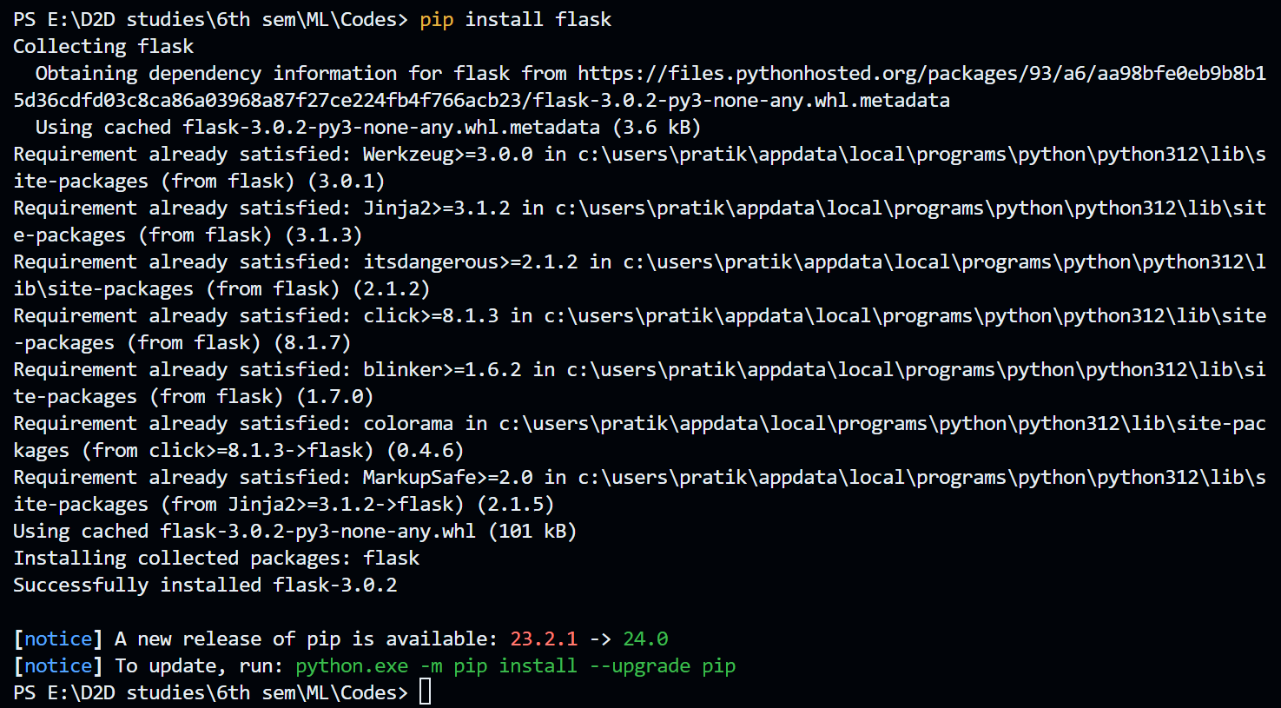To deploy model, flask package of python language is required. To instal it write below command in command prompt.
* Make sure that above screen will appear showing that flask installed successfully.

Step 2: Create a Flask app.

* 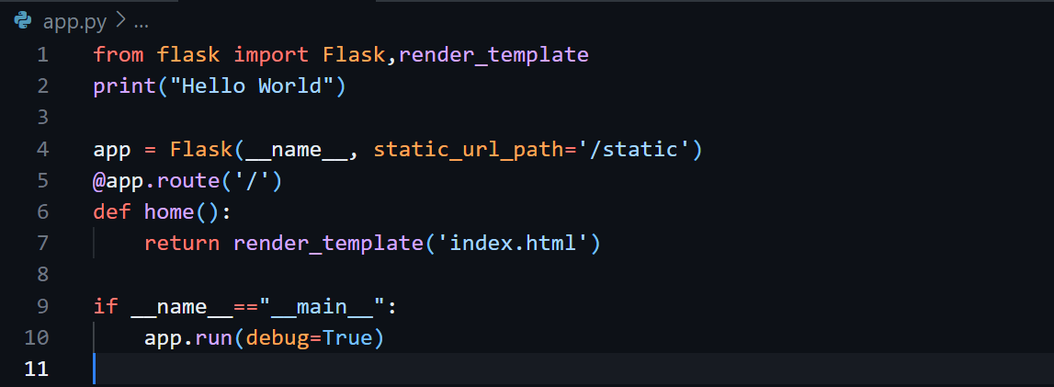Create a new directory for your Flask app and navigate to it. Inside the directory, create a file named app.py and add the following code:

Step 3: Create template folder and add html file into it.

* Inside your Flask app directory, create a folder named templates. This is where you'll store your HTML templates. Create a file named index.html inside the templates folder and include the HTML structure.

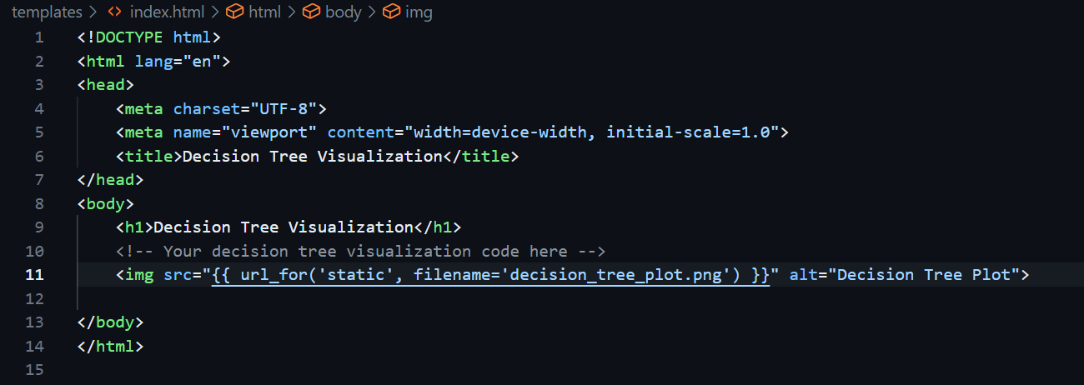

Step 4: Make python file to add code which you want to deploy.

* 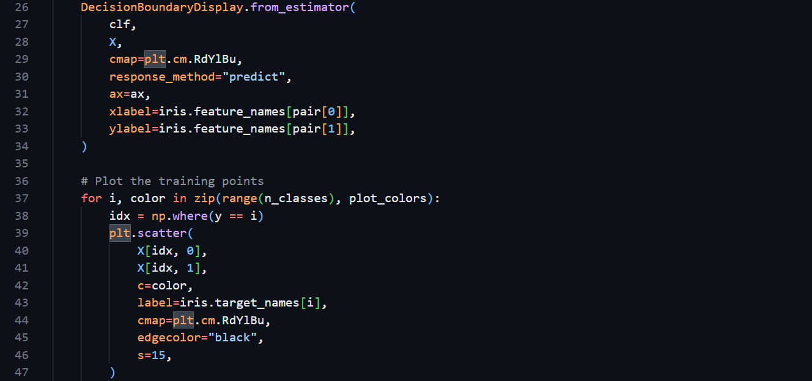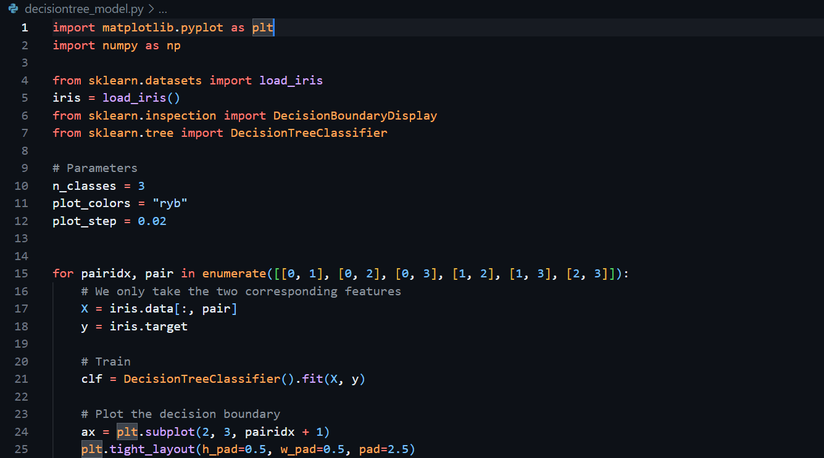Create decision_tree_model.py named file and add content given below:

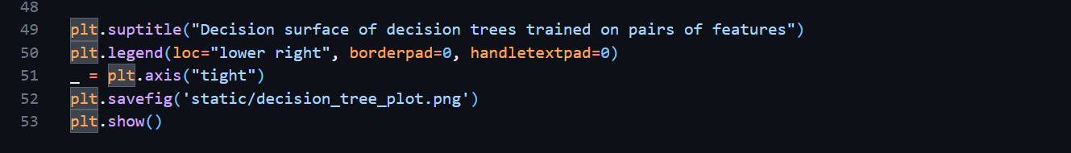

Step 5: Create static folder and run python code.

* Type command python decisiontree_model.py to run above python code.
* It will produce one decision_tree_plot.png named file. To store it create one folder named static which is used to store all assets like css file, image files, etc.

Step 6: Run app.py.

* This is final step. Type command **python app.py** in command prompt execute this python code.
* Open web browser and go to http://127.0.0.1:5000/ to see your Decision Tree visualization.
* 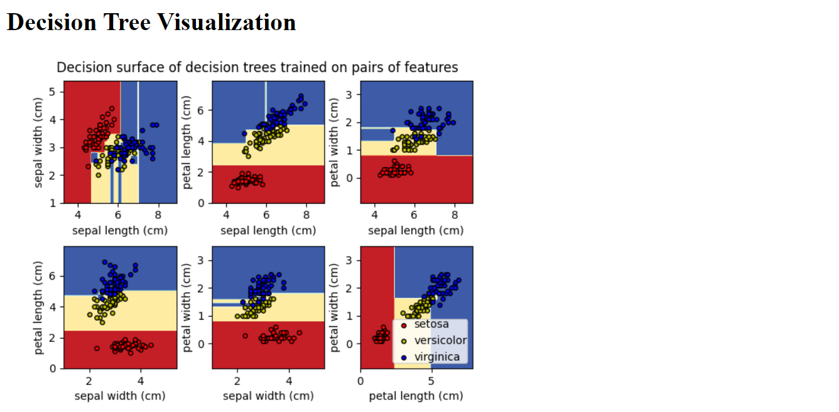Output is as follows: