Learning to Swing Up the Acrobot
A From-Scratch Comparison of Tabular Q-Learning, Deep Q-Networks and Proximal Policy Optimization on Gymnasium Acrobot-v1
Detailed Project Report
Meet Mehta
University Reinforcement Learning Project
October 2026
All numbers, tables and figures in this report are generated from the raw run records stored in results/study/.
Contents
1. Executive Summary 4
2. The Problem: Acrobot-v1 5
2.1 What the Acrobot is 5
2.2 Observation space 5
2.3 Action space 5
2.4 Reward, termination and truncation 5
2.5 Why terminated and truncated must be treated differently 5
3. Reinforcement-Learning Background 7
3.1 The Markov decision process 7
3.2 Value functions and the Bellman equation 7
3.3 Three families of methods 7
4. Algorithms and Their Implementation 8
4.1 Tabular Q-Learning (agents/q_learning.py) 8
4.2 Deep Q-Network (agents/dqn.py) 8
4.3 Proximal Policy Optimization (agents/ppo.py) 9
5. Software Architecture 11
5.1 Repository layout 11
5.2 How a single run works 11
5.3 The shared evaluation protocol 11
5.4 Reproducibility and persistence 12
6. Experimental Design 13
6.1 Hyperparameter tuning 13
6.2 Main comparison 13
6.3 Sensitivity sweeps 13
6.4 Ablations 13
6.5 Statistics 13
6.6 Full default hyperparameters 14
7. Results 15
7.1 Main comparison 15
7.2 Per-seed results 15
7.3 Computational efficiency 16
7.4 Hyperparameter sensitivity 17
7.5 Ablations 18
7.6 Tuning outcomes 19
8. Discussion 21
8.1 Why PPO succeeded 21
8.2 Why DQN was unstable 21
8.3 Why tabular Q-Learning struggled 21
8.4 Summary of trade-offs 21
9. Reproducing the Project 22
9.1 Installation 22
9.2 Quick commands 22
9.3 Device selection 22
10. Testing and Verification 23
11. Limitations and Future Work 24
11.1 Limitations 24
11.2 Possible extensions 24
12. Viva and Demonstration Preparation 25
Suggested demonstration flow 25
13. References 26

If the table of contents appears empty, right-click it in Word and choose “Update Field”.

1. Executive Summary
This project implements three reinforcement-learning (RL) algorithms from scratch — tabular Q-Learning, Deep Q-Networks (DQN) and Proximal Policy Optimization (PPO) — and compares them on Gymnasium’s Acrobot-v1 swing-up task. NumPy is used for the tabular method and analysis; PyTorch is used only for neural networks. No ready-made RL library (Stable-Baselines3, RLlib, CleanRL, …) is used anywhere.
Every method receives the same budget of 100,000 environment interactions, is trained on five independent seeds, and is evaluated with the same exploration-free protocol: every 5,000 interactions, the current greedy policy plays ten fixed held-out episodes. Results are aggregated with the interquartile mean (IQM) and seeded bootstrap 95% confidence intervals.

Headline result
Algorithm | Final return IQM | 95% CI | Final success IQM | Median steps to solve | Mean training time
PPO | -81.7 | (-87.5, -74.4) | 100% | 15,000 | 30.5 s
DQN | -434.7 | (-500.0, -192.2) | 24% | 65,000 | 18.8 s
Q-Learning | -480.5 | (-496.5, -430.6) | 17% | Not solved | 6.6 s

- PPO was the only reliable solver. All five PPO seeds finished with a 100% success rate and a return near −80 (about 80 steps to swing up).
- DQN learned, but was unstable. Four of five seeds crossed the solved threshold at some checkpoint, yet most fell back to failure by the end of training.
- Tabular Q-Learning was fastest in wall-clock time but did not solve the task within the budget — discretizing a six-dimensional continuous state leaves too many states to visit.
- Ablations confirm the stabilizers matter: removing DQN’s target network or PPO’s clipping caused most seeds to fail at 50,000 interactions.
Important caveat. These are conditional results for this environment, these implementations, this search space, these seeds and this budget. They are not a universal ranking of the three algorithms.

2. The Problem: Acrobot-v1

2.1 What the Acrobot is
The Acrobot is a two-link pendulum hanging from a fixed pivot, like a gymnast on a high bar. Only the joint between the two links is motorized; the shoulder joint at the top is passive. This makes the system underactuated: the agent cannot lift the arm directly and must instead pump energy into the system by swinging back and forth, then time a final swing so the free end rises above a target line.

2.2 Observation space
Each observation is a vector of six continuous numbers:
Index | Quantity | Range | Meaning
0 | cos θ₁ | [−1, 1] | Cosine of the first (shoulder) joint angle
1 | sin θ₁ | [−1, 1] | Sine of the first joint angle
2 | cos θ₂ | [−1, 1] | Cosine of the second joint angle (relative to link 1)
3 | sin θ₂ | [−1, 1] | Sine of the second joint angle
4 | θ̇₁ | [−4π, 4π] | Angular velocity of joint 1 (clipped by Gymnasium)
5 | θ̇₂ | [−9π, 9π] | Angular velocity of joint 2 (clipped by Gymnasium)

Using sine and cosine instead of the raw angle avoids the discontinuity at ±π: two nearly identical physical states always have nearly identical observations.

2.3 Action space
There are three discrete actions, each applying a torque to the actuated joint: 0 → −1, 1 → 0, 2 → +1.

2.4 Reward, termination and truncation
- Reward is −1 for every step the goal has not been reached, and 0 on the step that reaches it.
- The episode terminates (a true end of the task) when the free end rises above the target height: −cos θ₁ − cos(θ₁ + θ₂) > 1.
- The episode is truncated after 500 steps by the time limit. Truncation is not a property of the task — it is an artificial cut-off.
Because every step costs −1, the episode return equals minus the number of steps taken. A return of −500 means the agent never reached the goal; a return of −80 means it swung up in about 80 steps. Values closer to zero are better. The project uses −100 as the “solved” threshold for the mean evaluation return.

2.5 Why terminated and truncated must be treated differently
Gymnasium returns two flags from every env.step(): terminated and truncated. The project rule is that a time-limit truncation is not a terminal state of the MDP. When an episode ends because of the clock, the agent was still somewhere in the middle of the task, so the value of the next state is still meaningful and must be bootstrapped. When an episode terminates because the goal was reached, there is no future reward and the next-state value must be zero.
target = r + γ · (1 − terminated) · V(s′)
Note that it is the terminated flag — not terminated or truncated — that multiplies the bootstrap term. All three algorithms follow this rule, and it is covered by unit tests.

3. Reinforcement-Learning Background

3.1 The Markov decision process
The task is modelled as a Markov decision process (MDP): at each time step t the agent sees a state sₜ, picks an action aₜ according to its policy π(a | s), receives a reward rₜ and moves to a new state sₜ₊₁. The aim is to maximise the expected discounted return:
Gₜ = rₜ + γ rₜ₊₁ + γ² rₜ₊₂ + … = Σₖ γᵏ rₜ₊ₖ
The discount factor γ (0.99–0.995 in this project) makes rewards in the near future count more than rewards far away and keeps the sum finite.

3.2 Value functions and the Bellman equation
The action-value function Q^π(s, a) is the expected return when taking action a in state s and then following π. The optimal action-value Q* satisfies the Bellman optimality equation:
Q*(s, a) = E[ r + γ · maxₐ′ Q*(s′, a′) ]
Q-Learning and DQN both try to find Q* by repeatedly moving their estimate towards the right-hand side of this equation (a “temporal-difference target”). PPO instead learns the policy directly and uses a state-value function V(s) only to reduce variance.

3.3 Three families of methods
 | Q-Learning | DQN | PPO
Family | Value-based, tabular | Value-based, function approximation | Policy-gradient, actor-critic
What is learned | Table Q[s, a] | Neural net Q_θ(s, a) | Policy π_θ(a|s) and value V_φ(s)
State representation | Discretized grid of bins | Raw 6-D continuous vector | Raw 6-D continuous vector
Data usage | Each transition used once, immediately | Off-policy; replayed from a 100k buffer | On-policy; a rollout is reused for several epochs, then discarded
Exploration | ε-greedy | ε-greedy | Sampling from the stochastic policy (+ optional entropy bonus)
Stability mechanism | Small learning rate | Target network, Huber loss, gradient clipping | Clipped ratio objective, GAE, advantage normalization

4. Algorithms and Their Implementation
All three agents live in agents/. Each one exposes a small interface (act, an update method, save, load), and the shared experiment harness in experiments/runner.py drives them through adapters so that every method sees identical environment interactions.

4.1 Tabular Q-Learning (agents/q_learning.py)

Discretizing the state
A table needs a finite number of states, but Acrobot’s state is continuous. utils/discretizer.py splits each of the six observation dimensions into equal-width bins between known bounds, and the six bin indices together form the table index:
index_i = clip( ⌊(x_i − low_i) / width_i⌋, 0, bins_i − 1 ), width_i = (high_i − low_i) / bins_i
The tuned configuration uses 8 × 8 × 8 × 8 × 10 × 10 bins: 409,600 cells. With 3 actions per cell, the Q-table holds 1,228,800 entries (about 4.9 MB). This number is the core weakness of the method: 100,000 interactions cannot visit more than a small fraction of these cells, so most of the table is never updated.

The update rule
After every environment step the agent applies the one-step Q-Learning update (Watkins & Dayan, 1992):
Q(s, a) ← Q(s, a) + α · [ r + γ · (1 − terminated) · maxₐ′ Q(s′, a′) − Q(s, a) ]
The bracketed term is the temporal-difference (TD) error. If the next state is a true terminal state, the bootstrap term is dropped; on truncation it is kept.
bootstrap = 0.0 if terminated else float(self.q_table[next_state].max())
target = reward + self.config.gamma * bootstrap
td_error = target - current
self.q_table[state + (action,)] = current + self.config.learning_rate * td_error

Exploration
Actions are chosen ε-greedily. ε decays linearly from 1.0 to 0.05 over epsilon_decay_steps interactions. When several actions share the maximal Q-value (common early on, when the table is all zeros), ties are broken randomly during training; evaluation uses a deterministic arg-max.

4.2 Deep Q-Network (agents/dqn.py)
DQN (Mnih et al., 2015) replaces the table with a neural network Q_θ(s, a) that takes the raw six-dimensional observation and outputs one value per action. The network is a multilayer perceptron with two hidden layers of 128 ReLU units — 17,795 parameters in total. Because nearby states share weights, the network can generalise to states it has never seen, which the table cannot.

Key components
- Experience replay (utils/replay_buffer.py): every transition (s, a, r, s′, terminated) is stored in a circular buffer of 100,000 entries. Mini-batches are sampled uniformly at random, which breaks the strong correlation between consecutive steps.
- Target network: a second copy of the network, Q_θ⁻, computes the bootstrap target. It is updated by copying the online weights every target_sync_frequency interactions, so the target does not move with every gradient step.
- Huber (smooth-L1) loss: quadratic for small errors and linear for large ones, so a few large TD errors cannot dominate the gradient.
- Gradient clipping to a global norm of 10, and the Adam optimizer.
- Schedule: learning starts after 1,000 interactions and one gradient step is taken every 4 interactions — about 24,750 updates in a 100,000-interaction run.

The loss
y = r + γ · (1 − terminated) · maxₐ′ Q_θ⁻(s′, a′)
L(θ) = mean over batch of Huber( Q_θ(s, a) − y )
predicted = self.online(observations).gather(1, actions).squeeze(1)
with torch.no_grad():
bootstrap_network = self.target if self.config.use_target_network else self.online
next_values = bootstrap_network(next_observations).max(dim=1).values
targets = rewards + self.config.gamma * (1.0 - terminated) * next_values
loss = nn.functional.smooth_l1_loss(predicted, targets)
The use_target_network switch lets the ablation study remove the target network and bootstrap from the online network instead.

4.3 Proximal Policy Optimization (agents/ppo.py)
PPO (Schulman et al., 2017) is an actor-critic policy-gradient method. Two separate MLPs with two hidden layers of 64 units form an ActorCritic module (9,476 parameters):
- the actor outputs logits for a categorical distribution π_θ(a | s) over the three actions;
- the critic outputs a scalar state value V_φ(s).

Collecting a rollout
The agent plays with its current stochastic policy for rollout_steps interactions (1,024 in the tuned configuration), recording the observation, action, reward, log-probability of the action, value estimate, next-state value, and the terminated and done flags. It then updates and throws the data away — PPO is on-policy.

Generalized Advantage Estimation (GAE)
The advantage A(s, a) measures how much better an action was than the policy’s average behaviour in that state. GAE (Schulman et al., 2016) computes it as an exponentially-weighted sum of one-step TD errors, working backwards through the rollout:
δₜ = rₜ + γ · (1 − terminatedₜ) · V(sₜ₊₁) − V(sₜ)
Âₜ = δₜ + γλ · (1 − doneₜ) · Âₜ₊₁, returnₜ = Âₜ + V(sₜ)
Two different masks are used on purpose: terminated decides whether to bootstrap from V(sₜ₊₁), while done (terminated or truncated) stops the advantage from leaking across an episode reset. λ = 0.95 trades bias against variance.
for index in reversed(range(len(rewards))):
delta = rewards[index] + gamma * (1.0 - terminated[index]) * next_values[index] - values[index]
gae = delta + gamma * gae_lambda * (1.0 - episode_done[index]) * gae
advantages[index] = gae

The clipped surrogate objective
Advantages are normalised to zero mean and unit variance. For each of 10 epochs, the rollout is shuffled into mini-batches of 64 and the following loss is minimised:
rₜ(θ) = π_θ(aₜ | sₜ) / π_θ_old(aₜ | sₜ)
L_clip = −E[ min( rₜ Âₜ , clip(rₜ, 1 − ε, 1 + ε) Âₜ ) ]
L = L_clip + c_v · (V_φ(s) − returnₜ)² − c_e · H[π_θ(· | s)]
The probability ratio rₜ measures how far the new policy has moved from the policy that collected the data. The clip stops a single update from pushing the ratio outside [1 − ε, 1 + ε] in a direction that would increase the objective — this keeps each update “proximal” and prevents destructive policy collapses. c_v = 0.5 weights the value loss and c_e is the entropy bonus (tuned to 0). Gradients are clipped to a norm of 0.5.
The use_clipping switch replaces L_clip with the plain unclipped surrogate −E[rₜ Âₜ] for the ablation study.

5. Software Architecture

5.1 Repository layout
Path | Responsibility
agents/ | Q-Learning, DQN and PPO implementations (the mathematics)
utils/ | Discretizer, replay buffer, seeding and device selection, plotting helpers
experiments/runner.py | One shared training/evaluation harness for all methods (adapters)
experiments/configuration.py | RunSpec: an exact, hashable description of a single run
experiments/matrix.py | Builds and runs the full study matrix, in parallel, skipping completed runs
experiments/tune.py | Equal-budget random hyperparameter search
experiments/results.py | Saving and loading raw run records (JSON + CSV)
evaluation/ | Exploration-free evaluation protocol and metrics
analysis/ | IQM, bootstrap CIs, tables, figures and GIF demonstrations
training/ | Light-weight per-algorithm training loops used by main.py
config.py | Central dataclass defaults for every hyperparameter
configs/study.yaml, configs/tuned.yaml | Study design and selected hyperparameters
main.py | Simple CLI: train / evaluate / compare / demo
run_study.py | Research CLI: tune → matrix → analyse → demos
tests/ | Mathematical, component and integration tests
results/study/ | Raw records, tables, figures, models and demos
paper/, colab/ | LaTeX research paper and a self-contained Colab notebook

5.2 How a single run works
run_experiment(spec) in experiments/runner.py is the heart of the study. In outline:
- Seed Python, NumPy and PyTorch (seed_everything), seed the environment’s action space, and reset the environment with the run seed. Use one CPU thread for reproducibility.
- Build the right adapter (QAdapter, DQNAdapter or PPOAdapter) from the RunSpec parameters.
- Evaluate the untrained agent at step 0.
- For each of the total_steps interactions: choose an action, call env.step, and pass (s, a, r, s′, terminated, done) to adapter.observe. Each adapter decides when to learn (every step for Q-Learning, every 4 steps for DQN, every full rollout for PPO).
- Every eval_every = 5,000 interactions, run the shared greedy evaluation.
- At the end, flush any partial PPO rollout, run a final evaluation, record wall-clock time, update count, area under the learning curve and diagnostics, and save the model for main-study runs.
Because the loop counts environment interactions rather than episodes or gradient steps, all three methods are compared on exactly the same amount of experience.

5.3 The shared evaluation protocol
- Evaluation is greedy: ε = 0 for Q-Learning and DQN; the arg-max action of the policy for PPO.
- It uses a separate environment reset with ten fixed held-out seeds (90,000–90,009), never used in training.
- It records return, length and success (whether the episode terminated rather than timed out) for every episode.
- Training metrics and evaluation metrics are stored separately; only evaluation metrics are used for the comparison.

5.4 Reproducibility and persistence
Each run is identified by a stable hash of its full specification (e.g. ppo-seed0-e5d5c9a382). The runner writes a JSON record (all metrics and evaluation curves) and a CSV next to it. Re-running the study skips any run whose record already exists, and a test checks that two runs with the same specification produce identical results.

6. Experimental Design
The full study is defined in configs/study.yaml and run by run_study.py. It has five parts.

6.1 Hyperparameter tuning
To give each algorithm a fair chance, a small equal-budget random search is run first: 6 trials per method, each trained for 25,000 interactions on three tuning-only seeds (100, 101, 102). Trials are sampled without replacement from the grid below using a fixed search seed. The trial with the best mean final evaluation return (ties broken by area under the curve) is written to configs/tuned.yaml. Tuning seeds are never reused for the final comparison.
Method | Search space
Q-Learning | α ∈ {0.05, 0.1, 0.2, 0.5}; γ ∈ {0.95, 0.99, 0.995}; ε-decay ∈ {15k, 25k, 50k, 75k}; bins ∈ {4⁴6², 6⁴8², 8⁴10²}
DQN | lr ∈ {3e-4, 1e-3, 3e-3}; batch ∈ {32, 64, 128}; target sync ∈ {250, 500, 1000, 2000}; ε-decay ∈ {25k, 50k, 75k}
PPO | lr ∈ {1e-4, 3e-4, 1e-3}; clip ∈ {0.1, 0.2, 0.3}; rollout ∈ {512, 1024, 2048}; entropy ∈ {0, 0.005, 0.01, 0.02}

Method | Selected hyperparameters (configs/tuned.yaml)
Q-Learning | α = 0.1, γ = 0.995, ε-decay = 75,000 steps, bins = 8×8×8×8×10×10
DQN | lr = 3×10⁻⁴, batch = 32, target sync = 1,000 steps, ε-decay = 50,000 steps
PPO | lr = 1×10⁻³, clip ε = 0.3, rollout = 1,024 steps, entropy coefficient = 0

6.2 Main comparison
- Five final seeds (0–4) per method, 100,000 interactions each.
- Greedy evaluation every 5,000 interactions on ten held-out episodes (21 checkpoints per run).
- A seed is “solved” at the first checkpoint whose mean evaluation return is ≥ −100.

6.3 Sensitivity sweeps
One important hyperparameter per method is varied while the rest stay at their tuned values (3 seeds, 50,000 interactions): Q-table bins, DQN target-synchronisation interval (100, 500, 1,000, 5,000) and PPO clip ratio (0.05, 0.1, 0.2, 0.3).

6.4 Ablations
Each deep method has its key stabiliser removed (3 seeds, 50,000 interactions): DQN without a target network, and PPO without ratio clipping.

6.5 Statistics
With only five seeds, a plain mean is easily dragged around by one outlier, and a median throws away most of the data. Following Agarwal et al. (2021), the project reports the interquartile mean (IQM) — the mean of the middle 50% of values, using fractional weights at the quartile boundaries — together with a 95% percentile bootstrap confidence interval (10,000 resamples, fixed seed). Learning-curve bands use the same method at every checkpoint.

6.6 Full default hyperparameters
Values from config.py; tuned values above override the matching fields.
Parameter | Q-Learning | DQN | PPO
Learning rate | 0.10 | 1e-3 | 3e-4
Discount γ | 0.99 | 0.99 | 0.99
Exploration | ε 1.0 → 0.05 over 75k | ε 1.0 → 0.05 over 75k | Stochastic policy; entropy 0.01
Representation | Bins 8⁴ × 10² | MLP 128-128 | Actor & critic MLPs 64-64
Batch / rollout | — | Batch 64; replay 100k | Rollout 2,048; mini-batch 64; 10 epochs
Update schedule | Every step | Every 4 steps after 1,000 | After each rollout
Stabilisers | — | Target sync 1,000; grad-clip 10; Huber | Clip ε 0.2; GAE λ 0.95; grad-clip 0.5
Loss weights | — | — | Value 0.5

7. Results

7.1 Main comparison
Algorithm | Seeds | Return IQM | 95% CI | Success IQM | Median steps to solve | Seeds never solved | Mean time (s) | Mean updates
PPO | 5 | -81.7 | -87.5 to -74.4 | 100% | 15,000 | 0% | 30.5 | 15,630
DQN | 5 | -434.7 | -500.0 to -192.2 | 24% | 65,000 | 20% | 18.8 | 24,751
Q-Learning | 5 | -480.5 | -496.5 to -430.6 | 17% | — | 100% | 6.6 | 100,000
Table 7.1 — Final-checkpoint results over five seeds (results/study/tables/main_summary.csv).
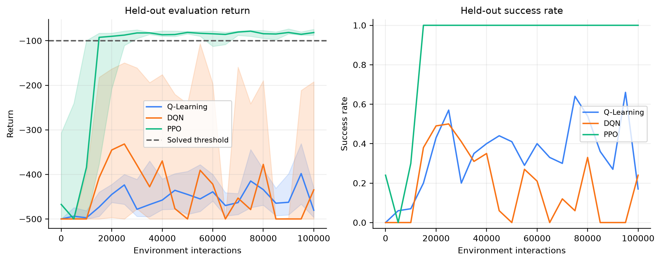
Figure 7.1 — Held-out evaluation return (left) and success rate (right) versus environment interactions. Lines are the IQM across five seeds; shaded bands are bootstrap 95% CIs. The dashed line is the −100 solved threshold.
PPO crosses the solved threshold by about 15,000 interactions and then stays there with a tight confidence band. DQN improves early, reaching roughly −330 IQM at 25,000 interactions, but its curve oscillates widely and its confidence band spans almost the entire range. Q-Learning improves slowly and remains between −400 and −500 throughout.

7.2 Per-seed results
Method | Seed | Final return | Final success | Best checkpoint | First solved at | Time (s)
PPO | 0 | -81.8 | 100% | -79.2 | 30,000 | 31.5
PPO | 1 | -80.4 | 100% | -76.8 | 15,000 | 31.0
PPO | 2 | -71.8 | 100% | -71.8 | 10,000 | 30.4
PPO | 3 | -89.5 | 100% | -70.9 | 15,000 | 29.6
PPO | 4 | -83.0 | 100% | -74.6 | 15,000 | 30.0
DQN | 0 | -424.4 | 30% | -322.1 | — | 19.4
DQN | 1 | -383.1 | 40% | -87.9 | 95,000 | 18.6
DQN | 2 | -500.0 | 0% | -80.0 | 70,000 | 17.6
DQN | 3 | -500.0 | 0% | -94.2 | 55,000 | 19.0
DQN | 4 | -110.4 | 100% | -95.5 | 60,000 | 19.5
Q-Learning | 0 | -470.0 | 20% | -319.8 | — | 6.5
Q-Learning | 1 | -500.0 | 0% | -390.0 | — | 6.4
Q-Learning | 2 | -482.5 | 20% | -366.3 | — | 6.5
Q-Learning | 3 | -413.7 | 60% | -341.6 | — | 6.4
Q-Learning | 4 | -488.3 | 10% | -306.2 | — | 7.0
Table 7.2 — Every main-study run. “Best checkpoint” is the highest mean evaluation return seen during training.
The per-seed view explains DQN’s wide interval. Seed 2 reached -80.0 at 70,000 interactions — as good as PPO — and then collapsed to −500 by the end. Seed 4 finished at -110.4 with 100% success. DQN therefore can find good policies, but it does not reliably keep them. This is the classic instability of bootstrapped off-policy learning with function approximation (the “deadly triad”).
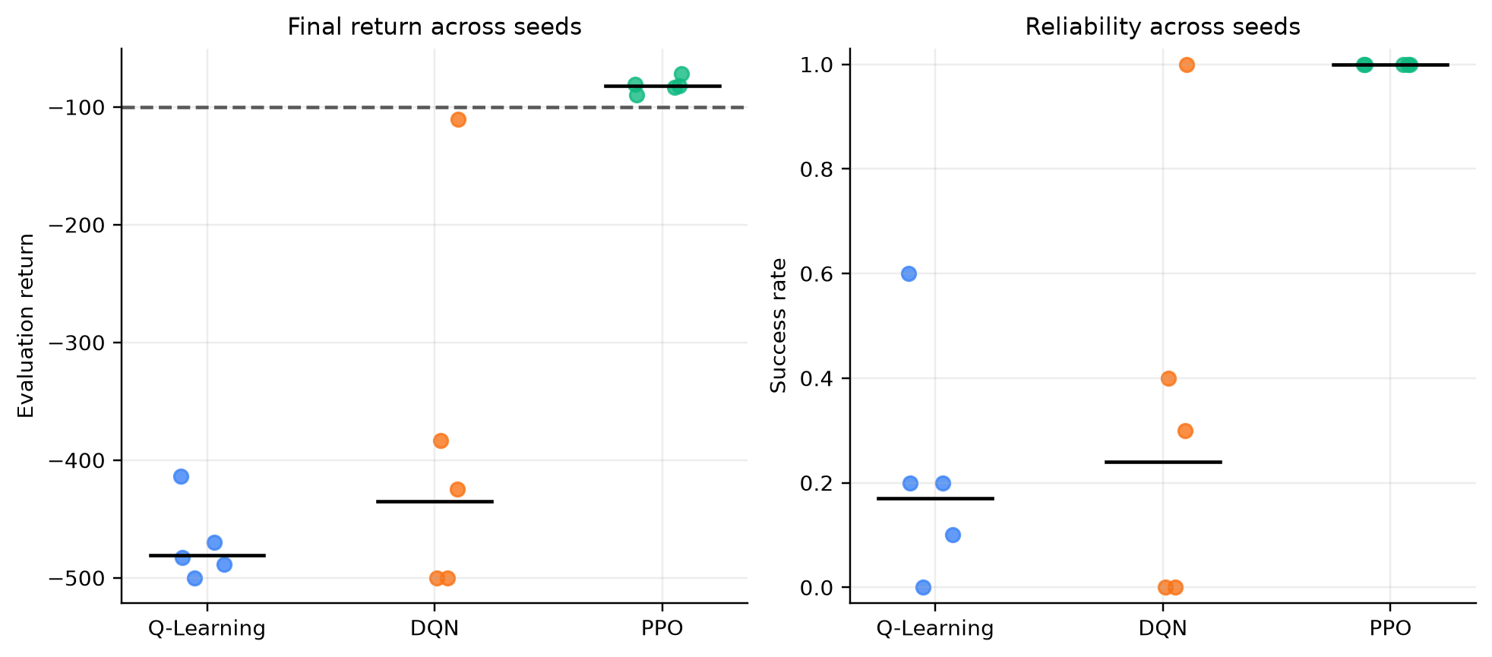
Figure 7.2 — Distribution of final returns across seeds for each method.

7.3 Computational efficiency
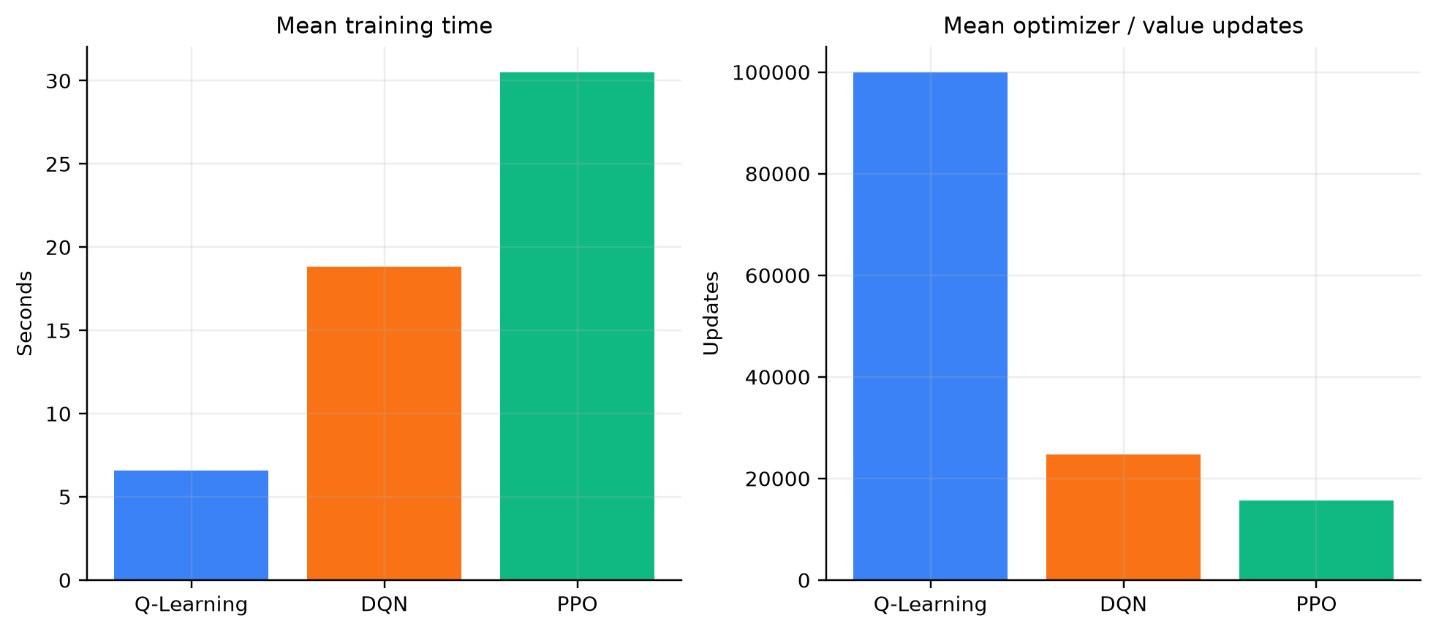
Figure 7.3 — Mean wall-clock training time and number of optimizer/value updates per 100,000-interaction run (CPU, one thread).
Q-Learning is the cheapest per interaction (≈ 6.6 s for 100,000 table updates). DQN takes ≈ 18.8 s for ≈ 24,750 network updates; PPO ≈ 30.5 s for ≈ 15,600 mini-batch updates plus a forward pass for every action. PPO is the most expensive in compute, but it is by far the most sample-efficient — it solves the task with roughly a sixth of the interaction budget. Timings depend on the local CPU.

7.4 Hyperparameter sensitivity
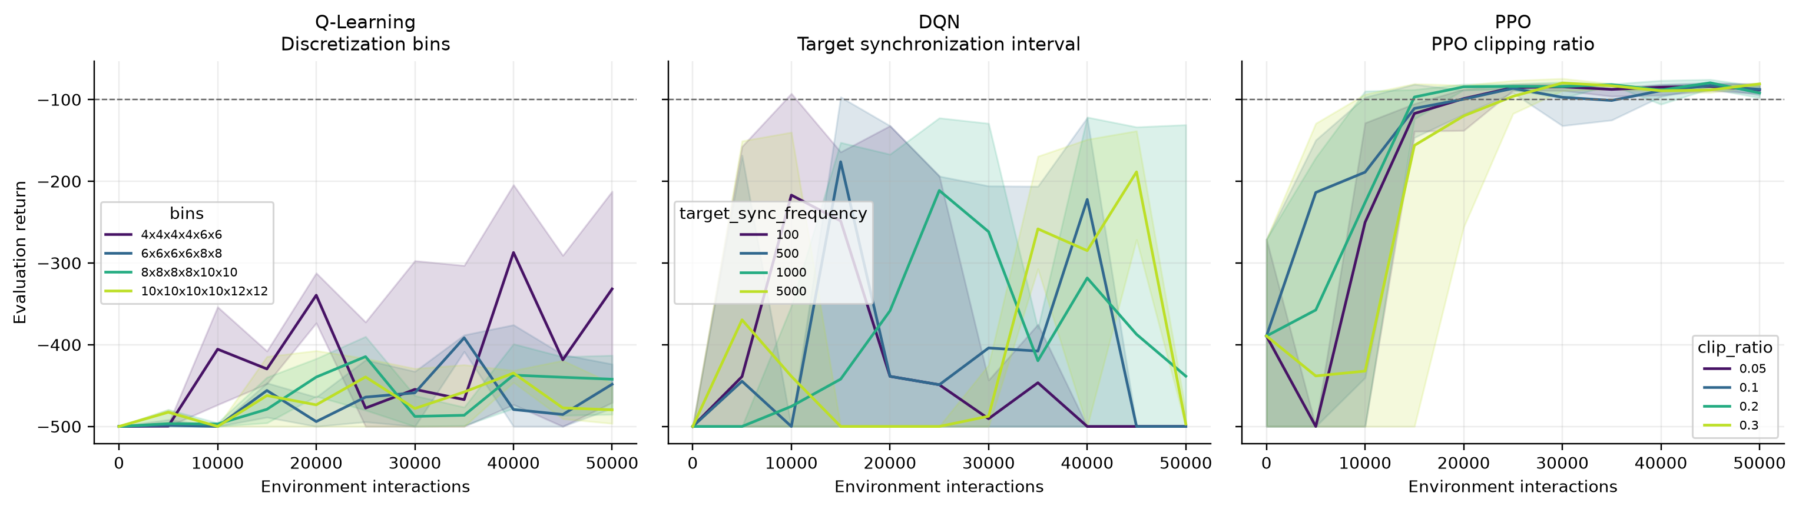
Figure 7.4 — One-factor sweeps: Q-table bins, DQN target-sync interval and PPO clip ratio (3 seeds, 50,000 interactions).

Q-Learning: number of bins
Value | Mean final return | Mean final success | Mean best checkpoint | Seeds solved* | Mean time (s)
4x4x4x4x6x6 | -336.7 | 77% | -226.0 | 0/3 | 3.4
6x6x6x6x8x8 | -449.5 | 40% | -384.0 | 0/3 | 3.6
8x8x8x8x10x10 | -445.7 | 40% | -397.8 | 0/3 | 3.6
10x10x10x10x12x12 | -475.8 | 30% | -413.7 | 0/3 | 3.6

Interestingly, the coarsest grid (4⁴ × 6², only 9,216 cells) gave the best final return at 50,000 interactions, while the finest grid (1.44 million cells) gave the worst. With a limited budget, fewer cells means each cell is visited and updated more often. This is the resolution-versus-coverage trade-off of discretisation. The only tuning trial that used the coarse grid also used α = 0.5 and γ = 0.95 and scored poorly, so the small random search could not separate the effect of the bins from the other settings.

DQN: target-network synchronisation interval
Value | Mean final return | Mean final success | Mean best checkpoint | Seeds solved* | Mean time (s)
100 | -500.0 | 0% | -127.5 | 1/3 | 9.8
500 | -500.0 | 0% | -111.4 | 1/3 | 9.5
1000 | -377.0 | 33% | -188.7 | 0/3 | 9.3
5000 | -494.0 | 3% | -193.1 | 0/3 | 9.4

At 50,000 interactions no DQN configuration ends at the solved threshold on any seed. The best intermediate checkpoints are clearly better with intervals of 100–1,000 steps than with 5,000, where the target becomes too stale. The sweep mainly confirms that DQN’s final performance is noisy for every interval tested.

PPO: clip ratio
Value | Mean final return | Mean final success | Mean best checkpoint | Seeds solved* | Mean time (s)
0.05 | -87.4 | 100% | -81.0 | 3/3 | 15.6
0.1 | -88.1 | 100% | -81.7 | 3/3 | 15.5
0.2 | -91.4 | 100% | -78.4 | 3/3 | 15.6
0.3 | -81.3 | 100% | -77.2 | 3/3 | 16.5

PPO is robust to the clip ratio: every value from 0.05 to 0.3 solved the task on all three seeds.
* “Seeds solved” counts seeds that reached the −100 threshold at any checkpoint.

7.5 Ablations
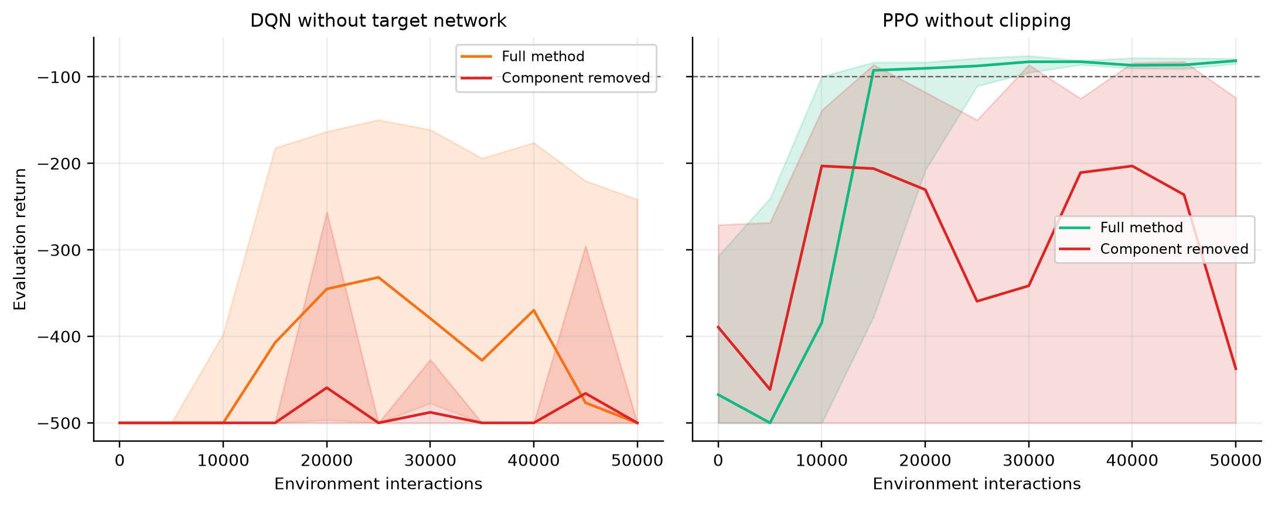
Figure 7.5 — Effect of removing DQN’s target network and PPO’s clipping (3 seeds, 50,000 interactions).
Variant | Mean final return | Mean final success | Mean best checkpoint | Seeds solved* | Mean time (s)
No target network | -500.0 | 0% | -326.1 | 0/3 | 10.2
No clipping | -374.7 | 30% | -166.1 | 1/3 | 18.1

Compare with the full methods at the same budget in the sweep tables (DQN with sync = 1,000; PPO with clip = 0.3). At this shorter budget even the full DQN does not finish solved, so the clearest signal is the best checkpoint: without a target network every seed finished at −500 and the best checkpoints were far worse than with synchronisation every 1,000 steps. Without clipping, PPO solved on only one of three seeds (compared with three of three when clipped). Both ablations support the claim that these mechanisms are what make the deep methods stable.

7.6 Tuning outcomes

Q-Learning
Trial | Parameters | Mean final return (25k)
0 (selected) | learning_rate=0.1, gamma=0.995, epsilon_decay_steps=75000, bins=8×8×8×8×10×10 | -412.2
2 | learning_rate=0.5, gamma=0.995, epsilon_decay_steps=15000, bins=8×8×8×8×10×10 | -452.2
3 | learning_rate=0.2, gamma=0.995, epsilon_decay_steps=75000, bins=8×8×8×8×10×10 | -461.4
5 | learning_rate=0.1, gamma=0.95, epsilon_decay_steps=15000, bins=8×8×8×8×10×10 | -461.5
1 | learning_rate=0.1, gamma=0.95, epsilon_decay_steps=25000, bins=8×8×8×8×10×10 | -464.5
4 | learning_rate=0.5, gamma=0.95, epsilon_decay_steps=50000, bins=4×4×4×4×6×6 | -496.4

DQN
Trial | Parameters | Mean final return (25k)
2 (selected) | learning_rate=0.0003, batch_size=32, target_sync_frequency=1000, epsilon_decay_steps=50000 | -230.2
4 | learning_rate=0.0003, batch_size=64, target_sync_frequency=1000, epsilon_decay_steps=25000 | -282.2
3 | learning_rate=0.0003, batch_size=32, target_sync_frequency=500, epsilon_decay_steps=75000 | -341.2
0 | learning_rate=0.003, batch_size=64, target_sync_frequency=2000, epsilon_decay_steps=25000 | -494.7
5 | learning_rate=0.003, batch_size=128, target_sync_frequency=500, epsilon_decay_steps=25000 | -500.0
1 | learning_rate=0.001, batch_size=32, target_sync_frequency=2000, epsilon_decay_steps=25000 | -500.0

PPO
Trial | Parameters | Mean final return (25k)
3 (selected) | learning_rate=0.001, clip_ratio=0.3, rollout_steps=1024, entropy_coefficient=0 | -88.2
5 | learning_rate=0.0003, clip_ratio=0.3, rollout_steps=512, entropy_coefficient=0 | -135.1
4 | learning_rate=0.0003, clip_ratio=0.1, rollout_steps=512, entropy_coefficient=0.01 | -186.2
2 | learning_rate=0.0003, clip_ratio=0.1, rollout_steps=2048, entropy_coefficient=0.01 | -336.2
1 | learning_rate=0.0001, clip_ratio=0.2, rollout_steps=2048, entropy_coefficient=0.01 | -360.0
0 | learning_rate=0.0003, clip_ratio=0.1, rollout_steps=2048, entropy_coefficient=0.02 | -479.7

8. Discussion

8.1 Why PPO succeeded
- It learns the policy directly. Swinging up only requires choosing the torque in the right phase of the swing — a simple mapping from state to action — even when the exact value of each state is hard to estimate.
- Bounded updates. The clip keeps each policy step small, so one bad batch cannot wreck a good policy. The ablation shows what happens without it.
- Low-variance advantages. GAE plus advantage normalisation give a stable learning signal from the dense −1 reward.
- Data reuse. Each 1,024-step rollout is used for 10 epochs, extracting more learning from each interaction.

8.2 Why DQN was unstable
DQN combines function approximation, bootstrapping and off-policy learning — the “deadly triad” (Sutton & Barto, 2018). Small errors in Q-values can be amplified by the max operator and by bootstrapping. The target network reduces this; removing it made things clearly worse. Because the greedy policy is an arg-max over noisy Q-values, a small change in Q can flip many actions at once, which explains the sudden regressions seen in seed 2. Selecting the best checkpoint (instead of the last) would change DQN’s numbers substantially, but that would need a separate, pre-registered protocol.

8.3 Why tabular Q-Learning struggled
The tabular method suffers from the curse of dimensionality: six dimensions with 8–10 bins give 409,600 cells (1,228,800 table entries). Each cell is learned independently, with no generalisation between neighbours, so most of the table is never visited in 100,000 steps. Coarser grids learn faster but cannot represent a precise policy. Q-Learning is nevertheless the simplest method, the cheapest to run, and fully interpretable.

8.4 Summary of trade-offs
Criterion | Q-Learning | DQN | PPO
Final performance (this study) | Poor | Unreliable | Best
Sample efficiency | Low | Medium | High
Seed-to-seed stability | Consistently weak | Very variable | Consistent
Wall-clock cost | Lowest | Medium | Highest
Memory | ~4.9 MB table | 17.8k params + 100k replay | 9.5k params + rollout
Hyperparameter sensitivity | High (bins) | High | Low (clip ratio)
Interpretability | High | Low | Low

9. Reproducing the Project

9.1 Installation
Python 3.11 or newer is required. With uv:
uv sync --locked --extra dev
uv run python scripts/smoke_test.py
uv run pytest -q
Or with pip:
python3 -m venv .venv
source .venv/bin/activate
python -m pip install -r requirements.txt
pytest -q

9.2 Quick commands
Goal | Command
Short training of all methods | uv run python main.py train --algorithm all --budget 5000 --seed 7
Watch a saved agent | uv run python main.py demo --algorithm ppo --seed 7
Full study (tune → matrix → analyse) | uv run python run_study.py --workers 4 all
Only tuning | uv run python run_study.py --workers 4 tune
Only the run matrix | uv run python run_study.py --workers 4 matrix
Regenerate tables and figures | uv run python run_study.py analyse
One diagnostic run | uv run python run_study.py single --method ppo --seed 7 --steps 5000

Completed runs are detected by their hash and skipped, so an interrupted study can be resumed. A self-contained Google Colab notebook is provided in colab/ for demonstrations without a local setup.

9.3 Device selection
CPU is the safe default. utils/seed.py can select CUDA or Apple MPS automatically for the simple main.py path, but the research runner deliberately uses a single CPU thread per run: the networks are tiny, parallel CPU workers are faster, and results are more reproducible.

10. Testing and Verification
The tests/ folder checks the mathematical components directly, so that a bug in an equation cannot hide behind noisy training curves.
Test file | What it verifies
test_discretizer.py | Boundary values map to the first/last bin, out-of-range values are clipped, and wrong shapes are rejected
test_q_learning.py | The Bellman update gives the exact expected value, and a terminal transition does not bootstrap
test_dqn.py | A learning step changes the online parameters (the loss and gradients flow correctly)
test_replay_buffer.py | The circular buffer overwrites the oldest transition when full
test_ppo.py | GAE masks both terminal states and episode boundaries; a PPO update runs and returns finite losses
test_ablations.py | DQN without a target network and PPO without clipping both still update correctly
test_study_runner.py | Run keys are stable and change with configuration; periodic evaluation and training are reproducible
test_study_stats.py | IQM uses the middle half with fractional boundaries; bootstrap intervals are ordered and reproducible
test_training_integration.py | A short training run completes for all three algorithms

A GitHub Actions workflow (.github/workflows/tests.yml) runs the suite on every push.

11. Limitations and Future Work

11.1 Limitations
- Conclusions rest on one environment, five final seeds and a single 100,000-interaction budget. A larger budget could change DQN’s and Q-Learning’s standing.
- The tuning search is small (6 trials per method, 25,000 interactions), so each method may be under-tuned in different ways.
- Q-Learning’s performance depends strongly on the discretisation; the sweep suggests coarser grids may do better at small budgets.
- DQN can regress after a good intermediate checkpoint; the study reports the final checkpoint only.
- Each checkpoint is evaluated on 10 fixed episodes rather than the conventional 100-episode benchmark protocol.
- Wall-clock times depend on the local CPU and on these particular implementations.

11.2 Possible extensions
- DQN improvements: Double DQN, Dueling networks, prioritised replay, n-step returns, or a learning-rate schedule.
- Tile coding or adaptive discretisation for the tabular method.
- A pre-registered best-checkpoint selection protocol for value-based methods.
- Longer budgets, more seeds and 100-episode evaluation; additional classic-control tasks (CartPole, MountainCar).
- Vectorised environments for faster PPO data collection.

12. Viva and Demonstration Preparation
Likely questions, with concise answers grounded in the code and results.
Q. Why Acrobot?
It is small enough to train on a laptop, yet underactuated and delayed-reward enough that the three methods behave very differently.
Q. Why compare by environment interactions rather than episodes or time?
Interactions are the scarce resource in RL. Episodes vary in length, and wall-clock time depends on hardware, so neither is a fair budget.
Q. What is the difference between terminated and truncated?
Terminated means the task truly ended (goal reached), so the future value is 0. Truncated means the 500-step clock ran out; the state still has a future, so we bootstrap from it.
Q. Why does DQN need a target network?
Without it, the target y moves every time the network is updated, so the network chases its own predictions. Freezing a copy for 1,000 steps makes the regression target stable. Our ablation shows that no seed solved without it.
Q. What does the PPO clip actually do?
It removes the incentive to move the probability ratio beyond 1 ± ε, so each update changes the policy only a little. Without it, PPO solved on one of three seeds.
Q. Why IQM instead of the mean?
With five seeds, one outlier can dominate the mean. IQM drops the extreme quarters on each side but still uses more data than the median.
Q. Is PPO always better than DQN?
No. This study shows PPO was better under these implementations, hyperparameter searches, seeds and budget. A differently tuned DQN, or a longer budget, could narrow or reverse the gap.
Q. Why is Q-Learning faster in seconds but worse?
A table update is a single array write, but each of the 409,600 cells is learned separately, so 100,000 interactions are not enough experience.
Q. How do you know the results are not fabricated?
Every table and figure is regenerated by run_study.py analyse from the stored JSON/CSV records; no benchmark number is hard-coded in the plotting code.

Suggested demonstration flow
- Show an Acrobot episode with a random policy (it hangs and flails).
- Explain the three update rules using sections 4.1–4.3.
- Show results/study/figures/learning_curves.png and Table 7.1.
- Play the saved GIFs in results/study/demos/ for each method.
- Show the ablation figure to justify the stability mechanisms.
- Close with the caveat: the ranking is conditional on this setup.

13. References
- Agarwal, R., Schwarzer, M., Castro, P. S., Courville, A., & Bellemare, M. G. (2021). Deep reinforcement learning at the edge of the statistical precipice. NeurIPS.
- Farama Foundation. Gymnasium documentation: Acrobot-v1. https://gymnasium.farama.org/environments/classic_control/acrobot/
- Mnih, V., et al. (2015). Human-level control through deep reinforcement learning. Nature, 518, 529–533. https://doi.org/10.1038/nature14236
- Schulman, J., Moritz, P., Levine, S., Jordan, M., & Abbeel, P. (2016). High-dimensional continuous control using generalized advantage estimation. ICLR. https://arxiv.org/abs/1506.02438
- Schulman, J., Wolski, F., Dhariwal, P., Radford, A., & Klimov, O. (2017). Proximal policy optimization algorithms. https://arxiv.org/abs/1707.06347
- Sutton, R. S. (1996). Generalization in reinforcement learning: Successful examples using sparse coarse coding. NeurIPS.
- Sutton, R. S., & Barto, A. G. (2018). Reinforcement Learning: An Introduction (2nd ed.). MIT Press.
- Watkins, C. J. C. H., & Dayan, P. (1992). Q-learning. Machine Learning, 8, 279–292. https://doi.org/10.1007/BF00992698

