ChatBot:
import nltk
import string
import re
import requests
from bs4 import BeautifulSoup
from nltk.stem import WordNetLemmatizer
from nltk.corpus import stopwords
import os
import json
import random

for res in ['punkt', 'wordnet', 'stopwords', 'averaged_perceptron_tagger', 'maxent_ne_chunker', 'words']:
nltk.download(res, quiet=True)

HEADERS = {
"User-Agent": "Mozilla/5.0 (Windows NT 10.0; Win64; x64) "
"AppleWebKit/537.36 (KHTML, like Gecko) "
"Chrome/91.0.4472.124 Safari/537.36"
}

def clean_text(text):
patterns_to_remove = [
r"(?i)new customers get.*free credits",
r"(?i)subscribe.*newsletter",
r"(?i)cookie[s]?", r"(?i)advertisement",
r"(?i)accept.*cookie", r"(?i)sign up",
r"(?i)buy now", r"(?i)learn more",
r"\bterms\b.*\bprivacy\b", r"(?i)read.*more.*on.*app",
r"(?i)breaking news.*", r"(?i)latest updates.*",
r"(?i)catch all the.*", r"(?i)choose your reason.*",
r"(?i)settingssearch settings.*", r"(?i)english edition.*",
]
for pattern in patterns_to_remove:
if re.search(pattern, text):
return ""
return text

def clean_answer_text(text):
text = re.sub(r'\[[^\]]*\]', '', text)
text = re.sub(r'\s+', ' ', text).strip()
return text

def is_meaningful_text(text, query_keywords):
if not text or len(text) < 60:
return False
if not any(word in text.lower() for word in query_keywords):
return False
alpha_ratio = sum(c.isalpha() for c in text) / max(len(text), 1)
return alpha_ratio > 0.6

def fetch_google_summary(query, num_results=5, max_answers=5):
try:
from googlesearch import search
except ImportError:
return ["[Error] Install googlesearch-python: pip install googlesearch-python"]

try:
urls = list(search(query, num_results=num_results))
except Exception as e:
return [f"[Error] Google search failed: {e}"]

summaries = []
seen_texts = set()
query_keywords = set(query.lower().split())

for url in urls:
try:
response = requests.get(url, headers=HEADERS, timeout=5)
soup = BeautifulSoup(response.content, 'html.parser')
paragraphs = soup.find_all('p')

for p in paragraphs:
raw_text = p.get_text().strip()
raw_text = clean_text(raw_text)
if raw_text and raw_text not in seen_texts and is_meaningful_text(raw_text, query_keywords):
cleaned = clean_answer_text(raw_text)
if cleaned not in seen_texts:
seen_texts.add(cleaned)
summaries.append(cleaned)
if len(summaries) >= max_answers:
break
except Exception:
continue
if len(summaries) >= max_answers:
break

return summaries if summaries else ["[Info] No accurate and relevant content found. Try rephrasing your question."]

class DocChatBot:
def __init__(self):
self.lemmatizer = WordNetLemmatizer()
self.stop_words = set(stopwords.words('english'))
self.query_memory = {}
self.web_memory = {}
self.known_topics = [
"artificial intelligence", "ai", "svm", "support vector machine",
"machine learning", "ml", "deep learning", "dl", "nlp",
"neural network", "chatbot", "language model"
]

def _normalize_abbreviations(self, text):
text = text.lower()
text = re.sub(r'\bsupport vector machine\b', 'svm', text)
text = re.sub(r'\bartificial intelligence\b', 'ai', text)
return text

def _preprocess_text(self, text):
text = self._normalize_abbreviations(text)
tokens = nltk.word_tokenize(text)
return ' '.join(self.lemmatizer.lemmatize(t) for t in tokens if t not in string.punctuation and t not in self.stop_words)

def _scrape_web_data(self, query):
return fetch_google_summary(query, num_results=10, max_answers=10)

def detect_topic(self, query):
query = query.lower()
for topic in self.known_topics:
if topic in query:
return re.sub(r'\s+', '_', topic) # "deep learning" → "deep_learning"
return "misc"

#fbfhfbg

def get_topic_filename(self, query):
topic = self.detect_topic(query)
folder = "topics"
os.makedirs(folder, exist_ok=True)
return os.path.join(folder, f"{topic}.json")

def get_response(self, query):
filename = self.get_topic_filename(query)
existing_data = []

# Load existing topic file if it exists
if os.path.exists(filename):
with open(filename, "r", encoding="utf-8") as f:
try:
existing_data = json.load(f)
except json.JSONDecodeError:
existing_data = []

question_data = None
for entry in existing_data:
if entry["question"].strip().lower() == query.strip().lower():
question_data = entry
break

if question_data:
if len(question_data["answer"]) < 10:
new_answers = self._scrape_web_data(query)
for ans in new_answers:
cleaned = clean_answer_text(ans)
if cleaned not in question_data["answer"]:
question_data["answer"].append(cleaned)
self.save_qa_to_file(query, cleaned, filename)
return cleaned
return random.choice(question_data["answer"])

if query not in self.web_memory:
self.web_memory[query] = self._scrape_web_data(query)

answers = self.web_memory[query]
if not answers:
return "I'm sorry, I couldn't find anything right now."

answer = random.choice(answers)
self.save_qa_to_file(query, answer, filename)
return answer

def chat(self):
print("Welcome to the ChatBot with Google Web Fallback!")
print("Type 'exit' or 'quit' to stop.")
while True:
user_input = input("You: ").strip()
if user_input.lower() in ['exit', 'quit']:
print("AI Bot: Goodbye!")
break
response = self.get_response(user_input)
print(f"AI Bot: {response}")

def save_qa_to_file(self, question, answer, filename):
data = []
if os.path.exists(filename):
with open(filename, "r", encoding="utf-8") as f:
try:
data = json.load(f)
except json.JSONDecodeError:
data = []

question_found = False
for entry in data:
if entry["question"].strip().lower() == question.strip().lower():
question_found = True
if isinstance(entry["answer"], list):
if answer not in entry["answer"]:
entry["answer"].append(answer)
else:
if answer != entry["answer"]:
entry["answer"] = [entry["answer"], answer]
break

if not question_found:
data.append({
"question": question,
"answer": [answer]
})

with open(filename, "w", encoding="utf-8") as f:
json.dump(data, f, indent=4, ensure_ascii=False)

if __name__ == "__main__":
chatbot = DocChatBot()
chatbot.chat()

Import:
- Import nltk :-
This library is used for create chatbot using its toolkit:- Tokenization, stopwords, Lemmatization.

- Import string :-
This library is used to convert the punctuation in string.

- Import re :-
This library is used to remove the ads, subscription messages, Clean text by removing things in square brackets and Normalize the phrases.

- Import requests :-
This library is used to Fetch data from a public JSON file and also Sends a GET request to each search result URL to fetch its HTML page.

- from bs4 import BeautifulSoup :-
This library is used to Parses the fetched HTML page and Extracts <p> tags (paragraphs) containing relevant answer text.

- from nltk.stem import WordNetLemmatizer :-
This library is used to cleaning a user query or text paragraphs before comparing, searching, or storing.

- from nltk.corpus import stopwords :-
This library is used to remove ['the', 'is', 'in', 'and', 'to', 'a', 'of', 'that', 'this', 'it', 'for', 'on' ...] This types of stopwords during text preprocessing.

Resource Download:
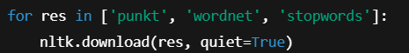
Ensures Download the necessary language processing datasets.

Configuration:
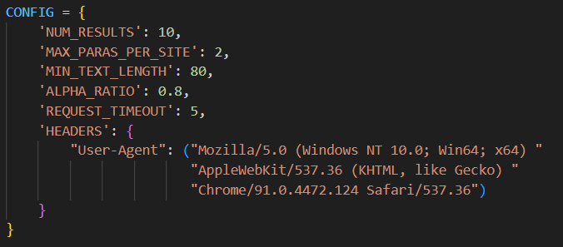

This Controls search limits, text quality, request settings, and scraping headers for HTTP requests.
Key | Value | Purpose
NUM_RESULTS | 10 | Number of Google search result URLs to fetch for each query.
MAX_PARAS_PER_SITE | 2 | Maximum number of relevant paragraphs to extract from each webpage. Prevents overloading from one page and improves variety.
MIN_TEXT_LENGTH | 80 | Minimum character length a paragraph must have to be considered meaningful. Filters out too-short or trivial text.
ALPHA_RATIO | 0.8 | Minimum ratio of alphabetic characters to total characters in a paragraph (to avoid junk like numbers, symbols, or ads).
REQUEST_TIMEOUT | 5 | Number of seconds before a web request is cancelled if no response is received. Prevents your bot from hanging on slow pages.
HEADERS | Dict | HTTP request headers, particularly a User-Agent string that makes your bot appear like a regular browser to avoid being blocked by websites.

Text Cleaning Functions:
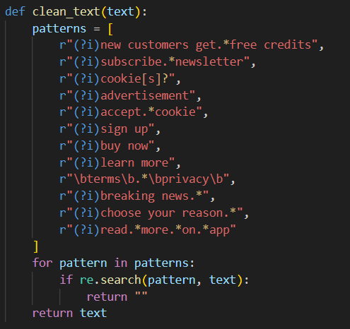

- At the first this remove unwanted web elements like ads, cookie prompts.

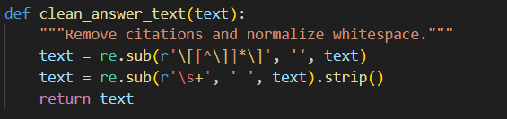

- Then It clean citations and redundant spaces.
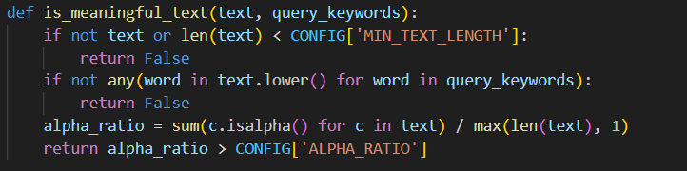

- Then filter meaningful content based on length and alphabetic ratio.

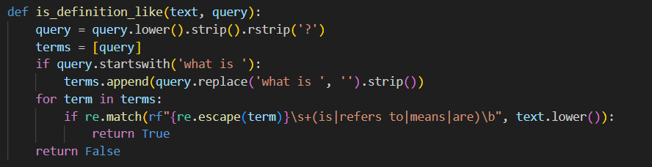

- Then detect definitions like X is Y for direct explanations.

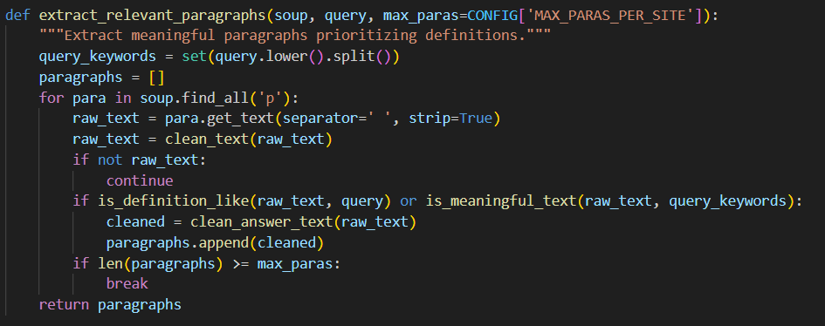

- Then extract and clean relevant paragraphs from the HTML content of a webpage — prioritizing definitions or paragraphs containing important query-related content.

- Soup:- BeautifulSoup object containing the parsed HTML content of a webpage.
- Query:- User’s search query as a string.
- max_paras:- Max number of relevant paragraphs to extract (defaults to value in CONFIG).

- Converts the query to lowercase.
- Splits it into individual words.
- Stores them as a set for faster lookup later when checking if a paragraph contains these keywords.
- An empty list to store cleaned, relevant paragraphs.

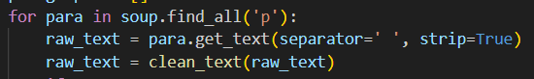
- Loops over all paragraph (<p>) tags found on the page.
- • get_text(separator=' ', strip=True) → extracts text content from the paragraph, removes leading/trailing whitespace.
- • clean_text(raw_text) → applies regex patterns to remove unwanted phrases like ads, cookie notices, or web prompts.

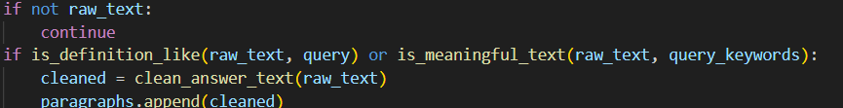
- If the cleaned text is empty (likely removed by clean_text), skip to the next paragraph.
- is_definition_like() → checks if the paragraph defines the query in a X is Y style.
- is_meaningful_text() → checks if paragraph:
  - Contains keywords from query.
  - Has a good alphabetic character ratio.
  - Meets minimum length requirements.
If either is true, it qualifies as a relevant paragraph.
- clean_answer_text() → removes citation markers like [1], [2], and normalizes whitespace.
- Adds the cleaned paragraph to the list.
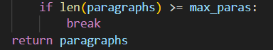
- If the number of relevant paragraphs collected reaches the maximum allowed (max_paras), exit the loop early.
- Returns a list of cleaned, relevant paragraphs extracted from the page.

Google Search Integration:
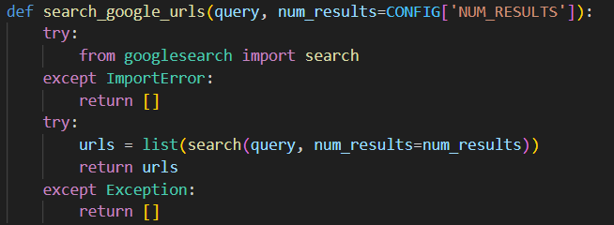
- Query:- The text the user entered.
- num_results:- Number of URLs you want to retrieve from Google search.
Default value is taken from CONFIG['NUM_RESULTS'] (which is 10 in your config).
- It attempts to import the search function from the googlesearch module.
- If the library isn’t installed, it safely returns an empty list [] instead of crashing the program.
- Uses googlesearch.search() to perform the actual search.
- Converts the results (which are URLs) into a list.
- Returns this list of URLs to the caller.
- If anything, else goes wrong while trying to perform the search (like no internet, or query error), it safely returns an empty list.

ChatBot Class Design:
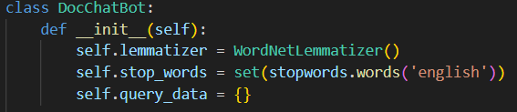
This defines the __init__ method — which automatically runs when a new DocChatBot object is created.
- WordNetLemmatizer reduces words to their root form. It Helps the chatbot understand different forms of a word as the same concept.
- Stopwords are common words like "the", "is", "in", "at", etc. which are often ignored in NLP tasks because they don’t add much meaning. It Helps the chatbot to focus on meaningful words when analyzing or filtering text.
- Query is an empty dictionary that will be used to store data for each unique query during the conversation. It is used to track:
- Which URLs were fetched for a query
- What answers were scraped from each URL
- Which answer was already shown to the user
- Where to continue from next time

Getting Answer:
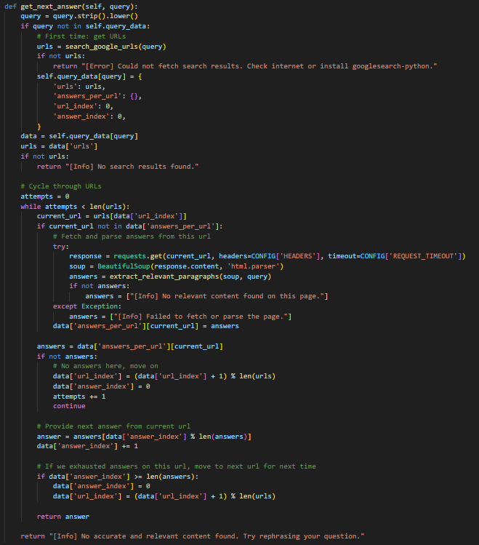
This Function is created to getting the different answer

- Cleans the query and removes extra spaces and converts it to lowercase for uniformity.

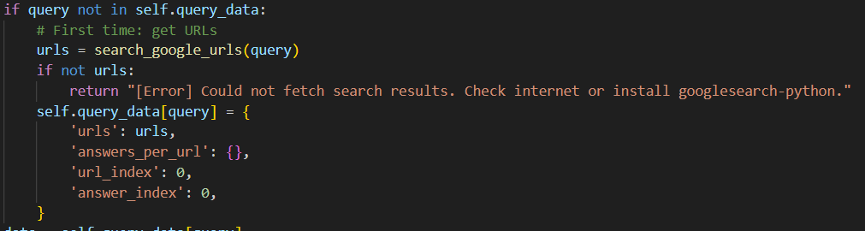
- If it's a first-time query, the chatbot Uses Google search to get relevant URLs
- If no URLs are found → return error
- If URLs found, initialize query data structure

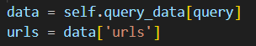
- If no URLs were stored somehow → notify no results.

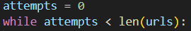
- Loop over URLs one-by-one until an answer is found or all are tried.

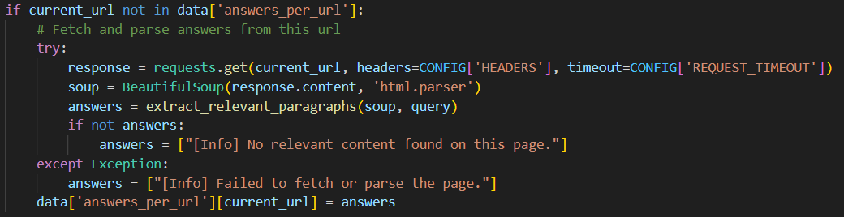
- Fetch and parse it using requests + BeautifulSoup
- Extract meaningful paragraphs using extract_relevant_paragraphs()
- If no relevant content found, use placeholder info
- Store those answers inside:

- Serve answer at current index
- Increment index (modulo ensures cycling through answers if necessary)

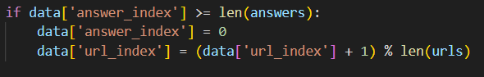
- Reset answer index
- Move to next URL for future queries

- After cycling through all URLs without a good answer:

Chat interface:
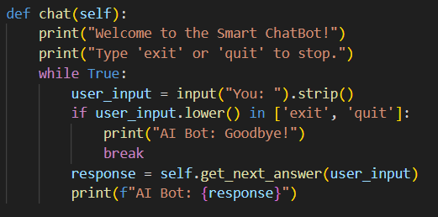
This function is used to make the chat interface for the terminal

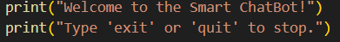
- Simple user instructions printed at the start.

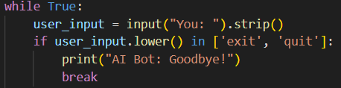
- Keeps running until explicitly told to stop.
- Prompt user to type a message
- . strip() removes extra spaces from start and end.
- If the user types 'exit' or 'quit' (case-insensitive), gracefully exit the loop and say goodbye.

- Calls your earlier get_next_answer() method to fetch a relevant answer based on the user query.
- Displays the bot’s response right after the user’s message.

Main Function:
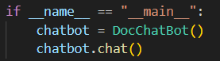
- If this file is run directly
  - Create an instance of your DocChatBot class
  - Call the chat() method to start the chatbot interaction in the terminal.

Program Flow:
- User enters a query.
- Google search results fetched.
- URLs visited and parsed.
- Clean, relevant text extracted.
- AI bot responds with meaningful content.
- User can repeat or exit.

Output:
