ChatBot:
Import:
- Import nltk :-
This library is used for create chatbot using its toolkit:- Tokenization, stopwords, Lemmatization.

- Import string :-
This library is used to convert the punctuation in string.

- Import re :-
This library is used to remove the ads, subscription messages, Clean text by removing things in square brackets and Normalize the phrases.

- Import requests :-
This library is used to Fetch data from a public JSON file and also Sends a GET request to each search result URL to fetch its HTML page.

- from bs4 import BeautifulSoup :-
This library is used to Parses the fetched HTML page and Extracts <p> tags (paragraphs) containing relevant answer text.

- from nltk.stem import WordNetLemmatizer :-
This library is used to cleaning a user query or text paragraphs before comparing, searching, or storing.

- from nltk.corpus import stopwords :-
This library is used to remove ['the', 'is', 'in', 'and', 'to', 'a', 'of', 'that', 'this', 'it', 'for', 'on' ...] This types of stopwords during text preprocessing.

- import os:-
This library is specifically used for creating directories and checking if files exist.

- import json:-
This library is used to reading from and writing to JSON files — which are lightweight text files for storing structured data in a key-value format.

- import random:-
In this library Python provides functions to generate random values, select random items from lists, shuffle data, etc.

Resource Download:
In This a for loop that downloads several important NLTK resources your chatbot depends on for natural language processing.

Headers:
This is creating a dictionary called HEADERS with a custom User-Agent string that will be sent along with HTTP requests when your chatbot fetches webpages.

clean_text():
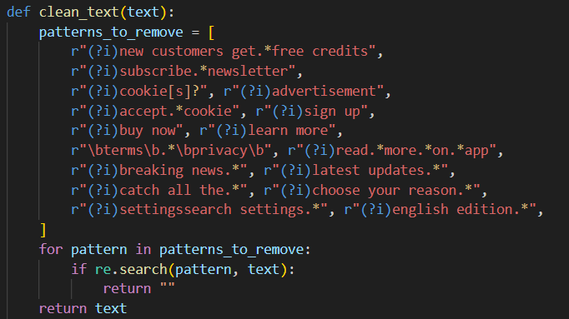
This function is designed to remove unwanted, promotional, or irrelevant text commonly found on web pages, like ads, cookie banners, newsletter prompts, etc.

clean_answer_text():
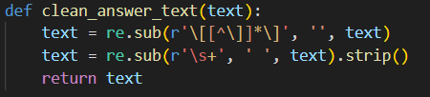
This function takes a text string and cleans it up by:
- Removing things in square brackets like [1], [citation needed], [note]
- Removing extra spaces and newlines, replacing them with a single space
- Trimming leading and trailing spaces

is_meaningful_text():
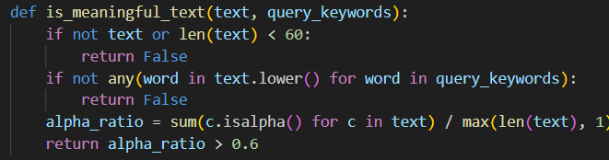
- If it's empty or too short, it's probably not meaningful so we discard it
- Converts text to lowercase for case-insensitive matching.
- Loops through each word in query_keywords
- If none of the keywords appear in the text, discard it — as it's probably unrelated.
- c.isalpha() → True if character is a letter (A-Z, a-z)
- sum() counts how many characters are alphabetic.
- Divides that by the total length of the text.
- If more than 60% of characters are letters, it returns True, else False.

fetch_google_summary():
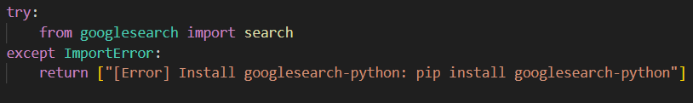
- Tries to import search function from googlesearch.
- If not installed, sends back an error message.

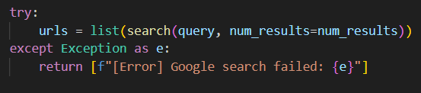
- Uses search() to find num_results Google search result URLs for the query.
- If something fails (like no internet, or captcha issue), returns an error.

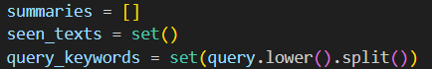
- summaries → to store the final clean answers.
- seen_texts → to track and skip duplicate texts.
- query_keywords → lowercase set of words from your query for relevance check.

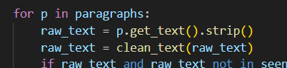
- Get text content from each <p> tag.
- Remove unwanted ads/promos using clean_text() (defined elsewhere in your code).

- Make sure:
  - Text isn’t empty.
  - Text hasn’t been seen before.
  - Text is meaningful (using your is_meaningful_text() function — remember it checks length, keyword presence, and if it's mostly alphabetic text).

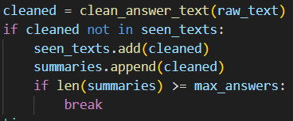
- Clean the text further using clean_answer_text() (which removes things like [1], [note], extra whitespace)
- If it’s unique:
- Add to seen_texts and summaries
- Stop adding if we’ve collected max_answers

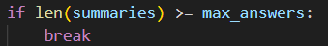
- If enough answers have been collected already, no need to scrape more URLs.

- If summaries found, return them.
- Otherwise, send a polite fallback message.

DocChatBot:
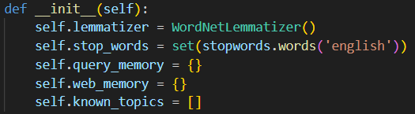
- def __init__(self):
- This is the constructor method of a class.
- Runs automatically whenever an instance of this class is created.
- Prepares necessary components and variables for the object.

- self.lemmatizer = WordNetLemmatizer()
- Creates an instance of NLTK's WordNetLemmatizer.
- Lemmatizer reduces words to their base form (e.g. running → run, better → good).
- Useful for normalizing text before analysis.

- self.stop_words = set(stopwords.words('english'))
- Loads a set of stop words (common words like the, is, and, etc. that don’t add much meaning to a sentence and are often removed in text analysis).
- Converts them to a set for faster lookup (since checking membership in a set is quicker than a list).

- self.query_memory = {}
- An empty dictionary to store past user queries and their responses.
- Can be used for caching or context management (e.g., remembering what the user asked before).

- self.web_memory = {}
- Another empty dictionary to store previously fetched web data.
- Prevents unnecessary duplicate Google searches or web scraping for the same question.

- self.known_topics = [...]
- A list of predefined keywords/topics your chatbot recognizes and can confidently talk about.
- Helps decide if a query is within the chatbot’s expertise, or if it needs to search online.

- Converts full-form phrases like "artificial intelligence" into abbreviations like "ai", so your system stays consistent.
- Uses NLTK’s tokenizer to split the text into individual word tokens.
- Iterates over all the tokens.
- Removes:
  - Any token that is a punctuation symbol (like ., ,, ?)
  - Any token that's a stopword (like "is", "than", "the") — words that don’t add meaningful value for your chatbot’s understanding.
- Lemmatizes the remaining words — converts them to their base or dictionary form.
  - Example: "running" → "run"
- Finally, joins those clean tokens back together into a single string separated by spaces.

- Takes the user’s question (query) as input.
- Calls the external function fetch_google_summary(query, num_results=10, max_answers=10):
- This function uses the Googlesearch API to get 10 URLs.
- Then for each page, it uses BeautifulSoup to extract paragraphs.
- It cleans the text, removes unwanted patterns (ads, cookies, etc.), and filters out irrelevant or short text.
- Collects up to 10 meaningful, clean text snippets related to the query.
- Returns this list of 10 or fewer relevant web summaries back to the chatbot.

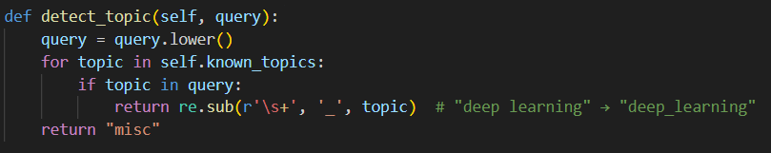
- Converts the query to lowercase — making the comparison case-insensitive.
- Loops through self.known_topics — a list of topics the chatbot is designed to recognize (like "ai", "machine learning", "deep learning" etc.).

- If a topic is found inside the query:
  - Replaces spaces in the topic with underscores ("deep learning" → "deep_learning"), making it a consistent label.
  - Returns this formatted topic name.
- If no topic matches:
  - Returns the string "misc" (for miscellaneous), meaning it didn’t recognize a specific topic.

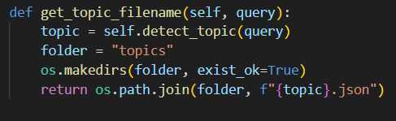
- Detects the topic from the query:-
Uses the detect_topic() method we just discussed to figure out what topic the query is related to (like "ai" or "deep_learning").

- Specifies the folder:-
All topic-based JSON files will be saved inside a folder named topics.

- Creates the folder if it doesn't exist:-
Ensures the topics folder exists — if it’s not there, this line creates it. The exist_ok=True prevents errors if the folder already exists.

- Generates the complete file path

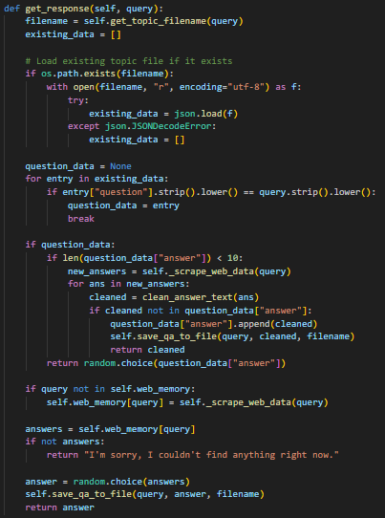
It’s an important core function in your chatbot’s workflow.
When a user asks a question (the query), this function:
- Checks if an answer already exists in a topic-based JSON file.
- If yes → returns a stored answer (or fetches new ones if too few).
- If no → scrapes web data, picks an answer, and saves it for future use.

- Uses the topic detection method to generate the appropriate JSON file path for storing/finding answers.

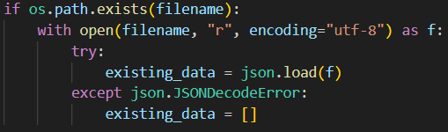
- If a file already exists for that topic → load its JSON content into existing_data.
- If file content is corrupted/invalid JSON → initialize it as an empty list.

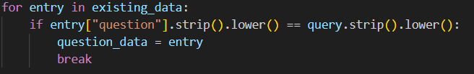
- Loops through each existing entry in the file.
- Compares question text (case-insensitive, no extra spaces).
- If found, saves it into question_data.
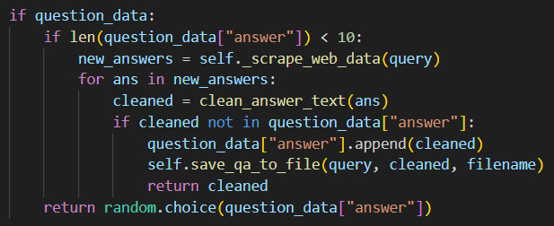
- If not enough answers (<10) → scrape fresh answers, clean them, and add any new ones to the list.
- Also immediately return any newly fetched answer.
- If enough answers → pick one randomly and return it.

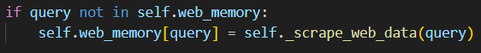
- Check if the query was previously searched during this session (stored in web_memory).
- If not, scrape web data using _scrape_web_data() and cache it in web_memory.

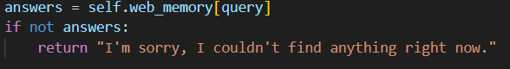
- If scraping gave nothing → show an apologetic fallback message.

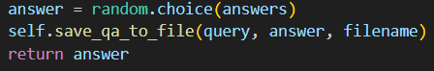
- Randomly choose one from the scraped answers.
- Save it into the JSON file (using save_qa_to_file() method).
- Return that answer to the user.

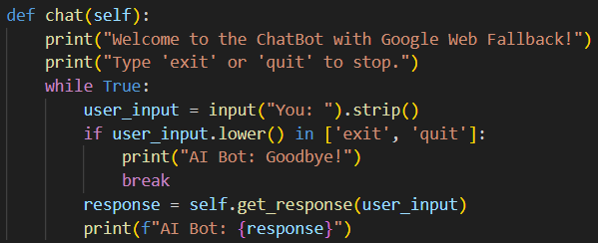
Runs an infinite loop where:
- It asks the user for input.
- Processes the input using get_response().
- Displays the AI bot’s reply.
- Keeps going until the user types exit or quit.

- Simple welcome message and usage instructions.

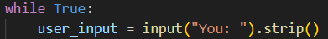
- An infinite loop to keep the conversation going.
- Prompt the user with You:
- strip() removes any leading/trailing whitespace.

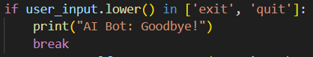
- If user types exit or quit (case-insensitive), the bot says goodbye and exits the loop.

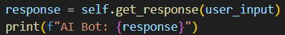
- Passes the user’s query to get_response() (the core method we just explained).
- Prints the bot’s response to the terminal.

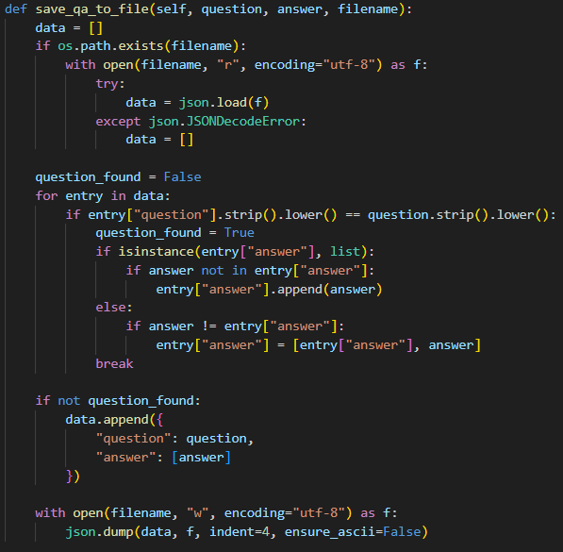
- Loads existing Q&A pairs from a file (if it exists).
- Adds the new answer to the matching question’s list, if it's not already present.
- Or creates a new Q&A entry if the question wasn't saved before.
- Saves the updated data back to the JSON file.
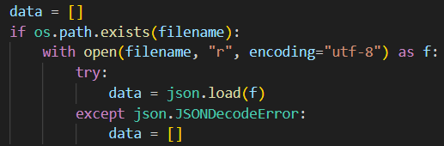
- If the file exists, open and try to load its JSON content into data.
- If the file is empty or malformed, safely fall back to an empty list.

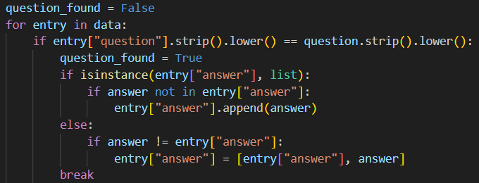
- Loops through existing entries.
- Compares each question case-insensitively and ignoring extra spaces.
- If found, set question_found = True and process its answer list.
- If the existing answer is a list:
  - Only add the new answer if it’s not already there.
- If it's a single string (edge case from older entries maybe):
  - Convert it into a list with both old and new answers.
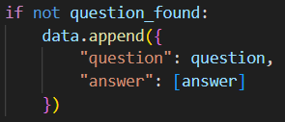
- Adds a new dictionary for this question-answer pair.
- Stores answer as a list right away for consistency.

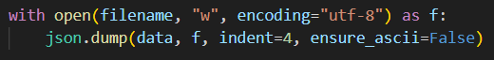
- Writes the whole data list back into the file.
- Uses indent=4 for pretty formatting.
- ensure_ascii=False allows Unicode characters to be saved properly.

Main Function:
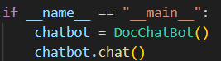
- if __name__ == "__main__":
- This is a special Python construct.
- It means: only run the following code if this file is executed directly (not if it's imported as a module elsewhere).

- chatbot = DocChatBot()
- Creates an instance (object) of the DocChatBot class.
- This runs its __init__() method, setting up lemmatizer, stopwords, memory structures, etc.

- chatbot.chat()
- Calls the chat() method on the chatbot object.
- This launches the interactive loop:
- Waits for user input.
- Processes queries.
- Fetches/generates responses.
- Prints replies.
- Continues until user types exit or quit.

Workflow:
- User types a query
- Detect topic
→ Get topic filename (like ai.json)
- Check topic file
→ If question exists:
  - Return a stored answer (or fetch new if too short)
- If not found
→ Search web (Google) for answers
  - Clean & filter results
  - Cache in web_memory
  - Save answer to topic file
- Reply to user
- Repeat until 'exit'

Output:
