**Testing Record - Stellaris I2C Timing Analysis**

by Arielle Blum 3/9/12

Figure 1 show the timing constraints from the TCM8230MD camera datasheet. The two parameters boxed in red will be examined.

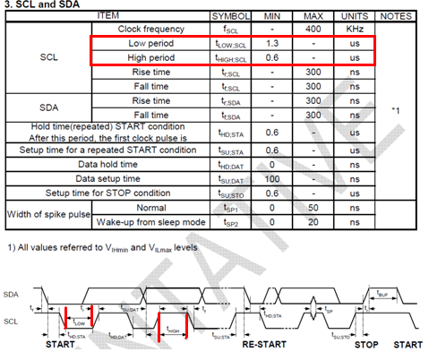

Figure 1: Camera I2C Timing Parameters

Figure 2 displays the logic analyzer capture of an I2C command generated by the Stellaris. The Stellaris, configured as the I2C Master successfully executed a write command, writing the data 0x30 to register 0xA0 to the slave address of 0x50.

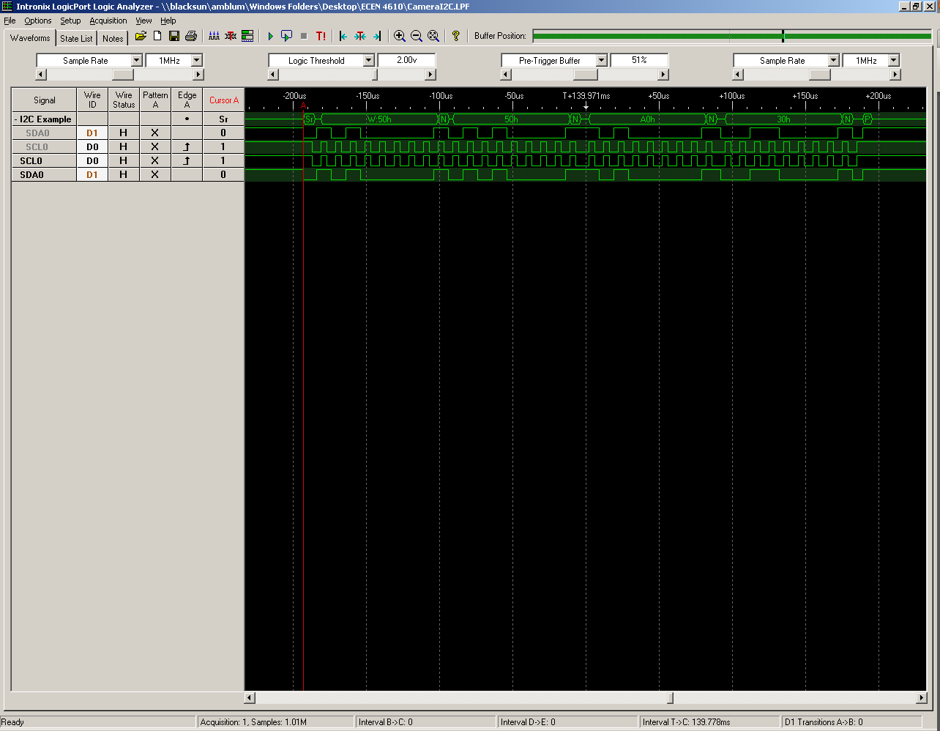

Figure 2: Logic Analyzer Capture of Stellaris I2C

The Figure 3 displays the I2C protocol used by the camera.

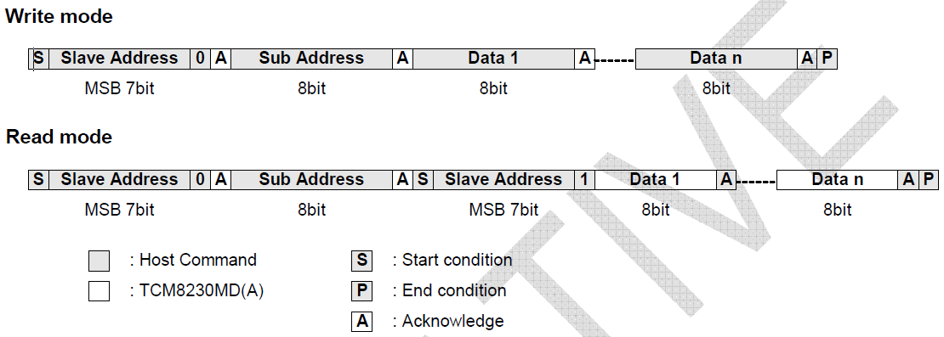

Figure 3: TCM8230 I2C Protocol

As shown by Figure 2, I2C communication was initialized with a START command followed by the write command. The Stellaris should wait for an ACK here but since it received no response, the I2C interpreter translated it as a NACK. Next the slave address, 0x50 was sent out, again with no ACK response. Next the subaddress or register address, 0xA0 was sent with no ACK received. Finally the data, 0x30, with a NACK. To end the transmission, the Stellaris generated a STOP command.

Figure 4 displays the timing analysis conducted on SCL.

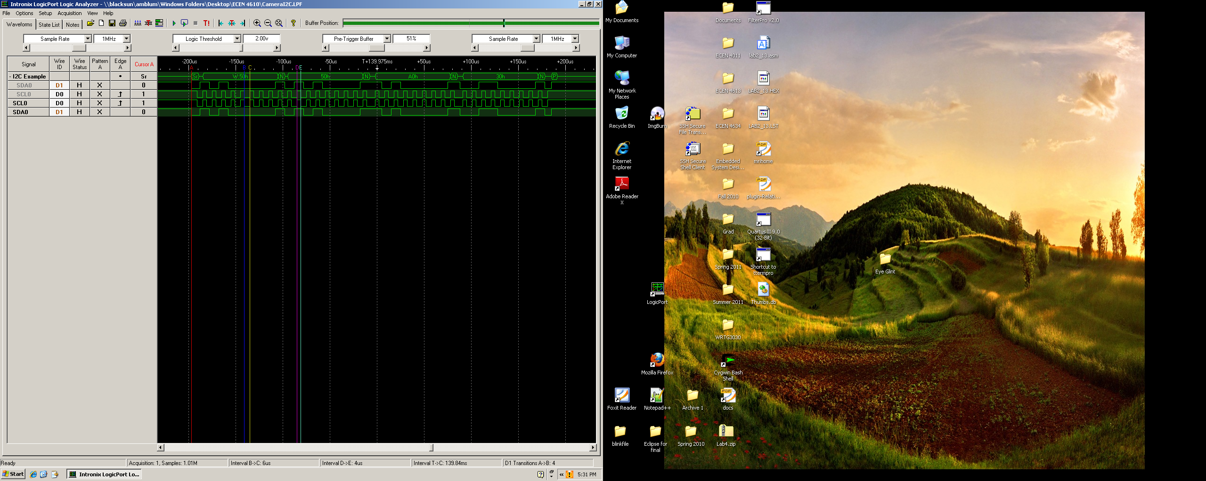

Figure 2: Logic Analyzer Capture of Stellaris I2C

The following table compares the required timing for SCL I2C communication with the measured SCL timing for the Stellaris.

|  |  |  |
| --- | --- | --- |
|  | Measured | TCM8230MD Required Minimum |
| SCL Low Period | 6us (Interval B -> C) | 1.3us |
| SCL High Period | 4us (Interval D -> E) | 0.6us |

Table 1: SCL Timing for Measured and Required

From the table it is clear that the SCL generated by the Stellaris satisfies the camera’s timing constraints.