RESUME
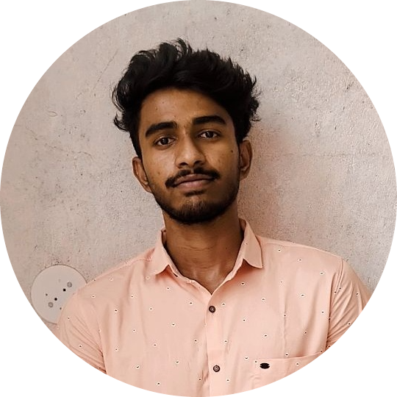 MEET RAJENDRA NERAL
Bhumkar Nagar Narhe, Pune
District: Pune Email: meetneral33@gmail.com
State: Maharashtra, India Mobile: 9175787558

CAREER OBJECTIVE: -
Results-driven Java Full Stack Developer with 3 years of experience in designing, developing, and deploying scalable web applications. Proficient in Java, Spring Boot, and Microservices on the backend, and Reactjs for modern, responsive UIs. Strong expertise in RESTful APIs, SQL/NoSQL databases, and cloud services (AWS/Azure). Adapt at CI/CD pipelines, Docker, and Kubernetes, ensuring efficient DevOps practices. Passionate about writing clean, maintainable code and delivering high-performance applications.
SKILLS & TOOLS: -

- Programming Languages: Core Java.
- Backend Technologies: Spring Boot, Hibernate, JPA, RESTful APIs, Microservices
- Frontend Technologies: React.js, HTML, CSS, Bootstrap
- Database: MySQL, PostgreSQL, MongoDB
- Testing Frameworks: JUnit, Selenium, TestNG.
- Version Control: Git, GitHub, GitLab
- Tools: Maven, Gradle, Jenkins, docker, SonarQube, Kafka, RabbitMQ
- Agile Methodologies: Scrum, Kanban, Jira
- Cloud: AWS.
PROJECT: -

E-commerce Platform Development (Full-Stack)
Description:
"Developed a full-stack e-commerce application with Spring Boot and React, facilitating product browsing, reviews, and user management. Implemented RESTful APIs for backend-frontend communication, utilizing MongoDB for data storage. Focused on robust error handling, data validation, and secure CORS configuration."
Key Skills:
Spring Boot, React, MongoDB, RESTful APIs, Axios, React Router, Lombok, Maven, npm, CORS, Full-Stack Development.
Roles and Responsibilities:
- Designed and implemented core backend services and RESTful APIs.
- Developed responsive React components for product listings and user reviews.
- Implemented robust error handling and input validation on both client and server sides.
- Collaborated on database schema design and optimized queries.
- Participated in testing and deployment processes, ensuring high-quality deliverables.

Journal App – Personal Notes Management System
Tech Stack: Java 17, Spring Boot, MongoDB, JWT, SonarQube, React
Description:
A full-stack application that allows users to create, update, and delete personal journal entries with secure authentication.:
Roles and Responsibilities:
- RESTful APIs built with Spring Boot for CRUD operations.
- JWT-based stateless authentication for secure access.
- MongoDB Atlas for cloud-hosted database storage.
- React frontend with Material UI for responsive UI.
  - Integrated SonarQube for code quality and static analysis.

Work Experience: -

Java Developer-(Globe Telecomm Project)
[Tech Mahindra] – [Pune] – [04/2022] to Present
- Developed RESTful microservices using Spring Boot and deployed them on AWS.
- Optimized database queries and performed data migration using MySQL and MongoDB.
- Implemented authentication and authorization using Spring Security and JWT.
- Developed and managed CI/CD pipelines using Jenkins and Docker for automated deployments.
- Collaborated with Agile teams using Scrum, participating in daily stand-ups and sprint planning.
React Developer
Indivisible Solution-(Remote) –[01/2021] to [04/2021]
- Built Google Keep clone & Photo Gallery app using React.js with responsive UI and Material UI components.
- Implemented CRUD operations, search/filter, and local Storage persistence for notes.
- Developed image upload, preview, and modal view features with responsive grid layout.
- Integrated React Router, hooks, and Firebase/local backend for smooth navigation and data handling.
STRENGTHS: -

- Self-Motivated & Positive Attitude.
- Quick learner & Good Team player
- Leadership & Discipline
HOBBIES / INTERESTS:

- Travelling and Swimming
- Learning Guitar
- Playing Chess
EDUCATIONAL QUALIFICATION: -

- Pursued Bachelor of Engineering in Computer science (2018-2022) stream from SGBAU University
at Prof Ram Meghe college of Eng. And Management with 83.23%

LANGUAGE:
• English (Full Professional Competency)
• Hindi (Native)
• Marathi (Native)
• Japanese(rudimentary)

