**PRACTICAL NO 1**

* **AIM:** Introduction to Android, Introduction to Android Studio IDE, Application

Fundamentals: Creating a Project, Android Components, Activities, Services, Content Providers, Broadcast Receivers, Interface overview, Creating Android Virtual device, USB debugging mode, Android Application Overview. Simple “Hello World” program.

* **PROCEDURE:**
* **Step 1:** create new project enter application name and click include kotlin support.
* **Step2:** click phone and tablet and select API 15 IceCream sandwich and click next button.
* **Step3:** create empty activity and click next button.
* **Step4:** create main activity and click finish button.
* **CODING:**

1. **Hello World:**

* **Activity_Main.Kt:**

package com.rohit.hello

import android.support.v7.app.AppCompatActivity

import android.os.Bundle

class MainActivity : AppCompatActivity()

{

override fun onCreate(savedInstanceState: Bundle?)

{

super.onCreate(savedInstanceState)

setContentView(R.layout.*activity_main*)

}

}

* **Activity_Main.xml:**

<?xml version="1.0" encoding="utf-8"?>

<android.support.constraint.ConstraintLayout xmlns:android="http://schemas.android.com/apk/res/android" xmlns:tools="http://schemas.android.com/tools" xmlns:app="http://schemas.android.com/apk/res-auto"

android:layout_width="match_parent"

android:layout_height="match_parent"

tools:context=".MainActivity">

<TextView

android:layout_width="wrap_content"

android:layout_height="wrap_content"

android:text="Hello World!"

app:layout_constraintBottom_toBottomOf="parent" app:layout_constraintLeft_toLeftOf="parent"

app:layout_constraintRight_toRightOf="parent"

app:layout_constraintTop_toTopOf="parent"/>

</android.support.constraint.ConstraintLayout>

* **OUTPUT:**

|  |
| --- |
|  |

1. **BroadcastActivity:**

* **MyReceiver.kt:**

import android.content.BroadcastReceiver

import android.content.Context

import android.content.Intent

import android.widget.Toast

class MyReceiver : BroadcastReceiver()

{

override fun onReceive(context: Context, intent: Intent)

{

// TODO: This method is called when the BroadcastReceiver is receiving

// an Intent broadcast.

Toast.makeText(context, "Broadcast : Flight mode changed.",

Toast.LENGTH_LONG).show()

}

}

* **activity_main.xml:**

<?xml version="1.0" encoding="utf-8"?>

<manifest xmlns:android="http://schemas.android.com/apk/res/android"

package="in.eyehunt.androidbroadcasts">

<application

android:allowBackup="true"

android:icon="@mipmap/ic_launcher"

android:label="@string/app_name"

android:roundIcon="@mipmap/ic_launcher_round"

android:supportsRtl="true"

android:theme="@style/AppTheme">

<activity

android:name=".MainActivity">

<intent-filter>

<action

android:name="android.intent.action.MAIN" />

<category

android:name="android.intent.category.LAUNCHER" />

</intent-filter>

</activity>

<receiver

android:name=".MyReceiver"

android:enabled="true"

android:exported="true">

<intent-filter>

<action

android:name="android.intent.action.AIRPLANE_MODE"/>

</intent-filter>

</receiver>

</application>

</manifest>

* **MainActivity.kt:**

import android.support.v7.app.AppCompatActivity

import android.os.Bundle

class MainActivity : AppCompatActivity() {

override fun onCreate(savedInstanceState: Bundle?) {

super.onCreate(savedInstanceState)

setContentView(R.layout.activity_main)

}

}

* **main_activity.xml:**

<?xml version="1.0" encoding="utf-8"?>

<android.support.constraint.ConstraintLayout xmlns:android="http://schemas.android.com/apk/res/android"

xmlns:app="http://schemas.android.com/apk/res-auto"

xmlns:tools="http://schemas.android.com/tools"

android:layout_width="match_parent"

android:layout_height="match_parent"

android:background="@color/colorPrimary"

tools:context="in.eyehunt.androidbroadcasts.MainActivity">

<ImageView

android:id="@+id/imageView"

android:layout_width="40dp"

android:layout_height="40dp"

android:layout_margin="8dp"

android:layout_marginTop="16dp"

app:layout_constraintStart_toStartOf="parent"

app:layout_constraintTop_toTopOf="parent"

app:srcCompat="@mipmap/baseline_airplanemode_active_white_24" />

<TextView

android:id="@+id/textView"

android:layout_width="300dp"

android:layout_height="36dp"

android:layout_marginEnd="8dp"

android:layout_marginStart="8dp"

android:gravity="center_vertical"

android:text="Flight Mode"

android:textColor="@color/colorWhite"

android:textSize="24dp"

app:layout_constraintEnd_toEndOf="parent"

app:layout_constraintStart_toEndOf="@+id/imageView"

app:layout_constraintTop_toTopOf="@+id/imageView"/>

</android.support.constraint.ConstraintLayout>

* **OUTPUT:**

|  |
| --- |
|  |

**Practical No:02**

* **Aim:** Programming Resources Android Resources: (Color, Theme, String, Drawable, Dimension, Image)
* **Coding:**

1. Defining new color properties in **colors.xml**

2. Create a new project and go to: ProjectName>App>src>main>res>values>**colors.xml**

<?xml version="1.0" encoding="utf-8"?>

<resources>

<color name="colorPrimary">#3F51B5</color>

<color name="colorPrimaryDark">#303F9F</color>

<color name="colorAccent">#FF4081</color>

//Add new colors here **<color name="ColorRed">#FF0000</color> <color name="ColorBlue">#0000FF</color>** </resources>

1. Now go to **activity_main.xml** and type the following code:

<?xml version="1.0" encoding="utf-8"?>

<LinearLayout //Add the orientation line if required

android:orientation="vertical"> //Create multiple TextViews <TextView

android:text="Practical No. 2" //For each TextView rename the id

android:id="@+id/textView" //For each TextView enter a new color

android:background="@color/ColorRed"/>

<TextView

android:text="Alpha" //For each TextView rename the id android:id="@+id/textView1"

//For each TextView enter a new color android:background="@color/ColorBlue"/>

<TextView

android:text="India" //For each TextView rename the id

android:id="@+id/textView2"

//For each TextView enter a new color android:background="#00FF00"/>

</LinearLayout>

* **OUTPUT:**



1. Defining new theme properties in **styles.xml**

2. Create a new project and go to: ProjectName>App>src>main>res>values>**styles.xml**

<resources>

<style name="AppTheme" parent="Theme.AppCompat.Light.DarkActionBar">

//Add new color to the background

<item name="android:background">#00F0EF</item> <item name="android:textColor">#000000</item> </style> </resources>

3. Now go to ProjectName>App>src>main>res>AndroidManifest.xml

<?xml version="1.0" encoding="utf-8"?>

<manifest

xmlns:android="http://schemas.android.com/apk/res/android" package="com.example.admin.androidresources">

<application

android:allowBackup="true" android:icon="@mipmap/ic_launcher" android:label="@string/app_name" android:roundIcon="@mipmap/ic_launcher_round" android:supportsRtl="true" android:theme="@style/AppTheme">

<activity

android:name=".MainActivity"> <intent-filter>

<action

android:name="android.intent.action.MAIN"/>

<category android:name="android.intent.category.LAUNCHER"/> </intent-filter> </activity> </application> </manifest>

**OUTPUT:**

1. Defining paragraph and header property in **strings.xml**

2. Create a new project and go to: ProjectName>App>src>main>res>values>**strings.xml**

<resources>

//Add these lines in the file

<string name="app_name">Android Resources</string>

<string name="ParaHead">Programming Resources</string> <string name="Description">The Android multimedia framework includes support for playing variety of common media types.</string> </resources>

1. Now go to **activity_main.xml** and type the following code:

<?xml version="1.0" encoding="utf-8"?>

<TextView

**//use the variable created in strings.xml and import here (ParaHead)_**

android:text="@string/ParaHead" android:layout_width="match_parent" android:layout_height="wrap_content" android:id="@+id/textView" android:background="@color/ColorRed"/>

<TextView

**//use the variable created in strings.xml and import here (Description)**

android:text="@string/Description" android:layout_width="match_parent" android:layout_height="wrap_content" android:id="@+id/textView1" android:background="@color/ColorBlue"/>

**//This TextView can be deleted if not required here OR Add a random text for display**

<TextView

android:text="Welcome"

android:layout_width="match_parent" android:layout_height="wrap_content" android:id="@+id/textView2"

android:background="#00FF00"/>

</LinearLayout>

**OUTPUT:**



**1.** Adding Images to Application created

**2.** For adding a new image files, do the following:

ProjectName>App>src>main>res>drawable>Right-click and paste the images that are copied

**3.** Add a new **dimens.xml** file and write the following code in dimens.xml

<?xml version="1.0" encoding="utf-8" ?> <resources>

<dimen name="textview_height">35dp</dimen>

<dimen name="textview_width">150dp</dimen>

<dimen name="font_size">26sp</dimen> </resources>

1. Now go to **activity_main.xml** and type the following code:

<TextView

android:text="Normal"/>

<TextView

android:text="Modified"

android:textSize="@dimen/font_size" />

<ImageView

android:id="@+id/img1"

android:layout_width="wrap_content"

android:layout_height="wrap_content"

android:src="@drawable/dig10k_maples" />

<ImageView

android:id="@+id/img2"

android:layout_width="wrap_content"

android:layout_height="wrap_content"

android:src="@drawable/dig10k_penguin" />

<ImageView

android:id="@+id/img3"

android:layout_width="wrap_content"

android:layout_height="wrap_content" android:src="@drawable/free_twitter_icon_set_icons_pack_120715" />

**Output:**



**Practical No:03**

* **Aim:** Programming Activities and fragments Activity Life Cycle, Activity methods, Multiple Activities, Life Cycle of fragments and multiple fragments.
* **Objectives:**

1. Activities and Activity Lifecylce
2. Fragments and Fragment Lifecylce

* **Coding:**

**a.** Activities and Activity Lifecylce:

* activity_main.xml:

<LinearLayout

xmlns:android="http://schemas.android.com/apk/res/android" android:layout_width="match_parent" android:layout_height="match_parent"

android:orientation="vertical"

android:gravity="center">

<TextView

android:id="@+id/txt1"

android:layout_height="wrap_content"

android:text="Multiple Activities"

android:textSize="30sp" />

<TextView

android:id="@+id/txt2"

android:layout_width="wrap_content" android:layout_height="wrap_content”

android:text="This is First Activity"

android:textSize="30sp" />

<Button

android:id="@+id/btn1"

android:layout_width="wrap_content" android:layout_height="wrap_content"

android:text="Submit"

android:textSize="30sp" />

</LinearLayout>

* **activity_second.xml:**

<LinearLayout

xmlns:android="http://schemas.android.com/apk/res/android" android:layout_width="match_parent" android:layout_height="match_parent"

android:orientation="vertical"

android:gravity="center">

<TextView

android:id="@+id/txt3"

android:layout_width="wrap_content"

android:layout_height="wrap_content”

android:text="Multiple Activities"

android:textSize="30sp" />

<TextView

android:id="@+id/txt4"

android:layout_width="wrap_content"

android:layout_height="wrap_content"

android:text="This is Second Activity"

android:textSize="30sp" />

</LinearLayout>

* **MainActivity.kt:**

package com.sslinks.androidbatch2

import android.content.Intent

import android.os.Bundle

import android.support.v7.app.AppCompatActivity

import kotlinx.android.synthetic.main.activity_main.*

class MainActivity : AppCompatActivity() {

override fun onCreate(savedInstanceState: Bundle?) { super.onCreate(savedInstanceState) setContentView(R.layout.activity_main)

btn1.setOnClickListener{ val intent = Intent(this, SecondActivity::class.java) startActivity(intent)

}

}

}

* **SecondActivity.kt:**

package com.sslinks.androidandBatch2

import android.os.Bundle import android.support.v7.app.AppCompatActivity import android.util.Log

class SecondActivity : AppCompatActivity() {

val tag = "Activity Lifecycle"

override fun onCreate(savedInstanceState: Bundle?) { super.onCreate(savedInstanceState)

setContentView(R.layout.activity_second)

Log.d(tag,"onCreateBatch2")

}

override fun onStart(){

super.onStart()

Log.d(tag,"onStartBatch2")

}

override fun onResume(){

super.onResume()

Log.d(tag,"onResumeBatch2")

}

override fun onPause(){

super.onPause()

Log.d(tag,"onPauseBatch2")

}

override fun onStop(){

super.onStop()

Log.d(tag,"onStopBatch2")

}

override fun onDestroy(){

super.onDestroy()

Log.d(tag,"onDestroyBatch2")

}

}

* **AndroidManifest.xml :**

<activity android:name=".MainActivity">

<intent-filter>

<action android:name="android.intent.action.MAIN"/>

<category android:name="android.intent.category.LAUNCHER"/> </intent-filter> </activity>

<activity android:name=".SecondActivity">

</activity>

* **Output:**

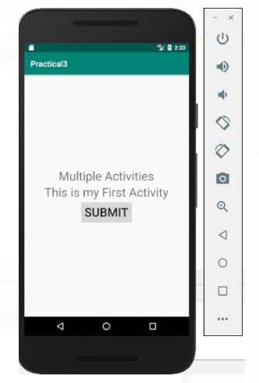 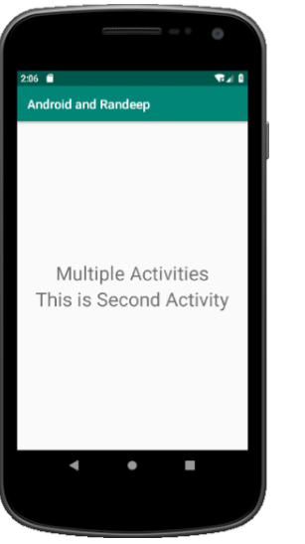

**b.** Fragments and Fragment Lifecylce:

* activity_main.xml:

<LinearLayout

xmlns:android="http://schemas.android.com/apk/res/android" android:layout_width="match_parent" android:layout_height="match_parent"

android:orientation="vertical"

android:gravity="center">

<TextView

android:id="@+id/txt1"

android:layout_width="wrap_content" android:layout_height="wrap_content"

android:gravity="center"

android:textSize="30sp"

android:text="Fragment Lifecycle Example"/>

<Button

android:id="@+id/btn1"

android:layout_width="wrap_content" android:layout_height="wrap_content"

android:textSize="30sp"

android:text="Change Fragment"/>

<FrameLayout

android:id="@+id/fragmentHolder" android:layout_width="match_parent" android:layout_height="match_parent"/>

</LinearLayout>

* **fragment_one.xml:**

<FrameLayout

xmlns:android="http://schemas.android.com/apk/res/android" android:layout_width="match_parent" android:layout_height="match_parent">

<TextView

android:gravity="center"

android:layout_width="match_parent" android:layout_height="match_parent"

android:textSize="30sp"

android:text="Fragment One"/>

</FrameLayout>

* **fragment_two.xml:**

<FrameLayout

xmlns:android="http://schemas.android.com/apk/res/android" android:layout_width="match_parent" android:layout_height="match_parent">

<TextView

android:gravity="center"

android:layout_width="match_parent" android:layout_height="match_parent"

android:textSize="30sp"

android:text="Fragment Two"/>

</FrameLayout>

* **MainActivity.kt:**

package com.sslinks.androidandBatch2 import android.os.Bundle

import android.support.v7.app.AppCompatActivity

import kotlinx.android.synthetic.main.activity_main.*

class MainActivity : AppCompatActivity() {

var isFragmentOneLoaded = true val manager = supportFragmentManager

override fun onCreate(savedInstanceState: Bundle?) { super.onCreate(savedInstanceState)

setContentView(R.layout.activity_main)

showFragmentOne()

btn1.setOnClickListener {

if (isFragmentOneLoaded)

showFragmentTwo()

else

showFragmentOne()

}

}

fun showFragmentOne(){

val transaction = manager.beginTransaction()

val fragment = FragmentOne() transaction.replace(R.id.fragmentHolder,fragment) transaction.addToBackStack(null)

transaction.commit()

isFragmentOneLoaded = true }

fun showFragmentTwo(){

val transaction = manager.beginTransaction()

val fragment = FragmentTwo() transaction.replace(R.id.fragmentHolder,fragment) transaction.addToBackStack(null)

transaction.commit()

isFragmentOneLoaded = false

}

}

* **fragment_one.kt:**

package com.sslinks.androidandBatch2 import android.content.Context

import android.os.Bundle import android.support.v4.app.Fragment

import android.util.Log import android.view.LayoutInflater

import android.view.View import android.view.ViewGroup

class FragmentOne : Fragment() {

val TAG = "FragmentOne"

override fun onAttach(context: Context?) { Log.d(TAG,"onAttachBatch21")

super.onAttach(context) }

override fun onCreate(savedInstanceState: Bundle?) { Log.d(TAG,"onCreateBatch21")

super.onCreate(savedInstanceState) }

override fun onCreateView(inflater: LayoutInflater, container: ViewGroup?, savedInstanceState: Bundle?): View? { Log.d(TAG,"onCreateViewBatch21")

return inflater.inflate (R.layout.fragment_one,container,false) }

override fun onActivityCreated(savedInstanceState: Bundle?) { Log.d(TAG,"onActivityCreatedBatch21") super.onActivityCreated(savedInstanceState) }

override fun onStart() {

Log.d(TAG,"onStartBatch21")

super.onStart() }

override fun onResume() {

Log.d(TAG,"onResumeBatch21")

super.onResume() }

override fun onPause() {

Log.d(TAG,"onPauseBatch21")

super.onPause() }

override fun onStop() {

Log.d(TAG,"onStopBatch21")

super.onStop() }

override fun onDestroyView() {

Log.d(TAG,"onDestroyViewBatch21")

super.onDestroyView() }

override fun onDestroy() {

Log.d(TAG,"onDestroyBatch21")

super.onDestroy() }

override fun onDetach() {

Log.d(TAG,"onDetachBatch21")

super.onDetach()

}

}

* **fragment_two.kt:**

package com.sslinks.androidandBatch2

import android.content.Context import android.os.Bundle

import android.support.v4.app.Fragment

import android.util.Log

import android.view.LayoutInflater

import android.view.View

import android.view.ViewGroup

class FragmentTwo : Fragment() {

val TAG = "FragmentTwo"

override fun onAttach(context: Context?) { Log.d(TAG,"onAttachBatch22")

super.onAttach(context) }

override fun onCreate(savedInstanceState: Bundle?) { Log.d(TAG,"onCreateBatch22")

super.onCreate(savedInstanceState) }

override fun onCreateView(inflater: LayoutInflater, container: ViewGroup?, savedInstanceState: Bundle?): View? { Log.d(TAG,"onCreateViewBatch22")

return inflater.inflate (R.layout.fragment_two,container,false) }

override fun onActivityCreated(savedInstanceState: Bundle?) { Log.d(TAG,"onActivityCreatedBatch22") super.onActivityCreated(savedInstanceState) }

override fun onStart() {

Log.d(TAG,"onStartBatch22")

super.onStart() }

override fun onResume() {

Log.d(TAG,"onResumeBatch22")

super.onResume() }

override fun onPause() {

Log.d(TAG,"onPauseBatch22")

super.onPause() }

override fun onStop() {

Log.d(TAG,"onStopBatch22")

super.onStop() }

override fun onDestroyView() {

Log.d(TAG,"onDestroyViewBatch22")

super.onDestroyView() }

override fun onDestroy() {

Log.d(TAG,"onDestroyBatch22")

super.onDestroy() }

override fun onDetach() {

Log.d(TAG,"onDetachBatch22")

super.onDetach()

}

}

* **Output:**

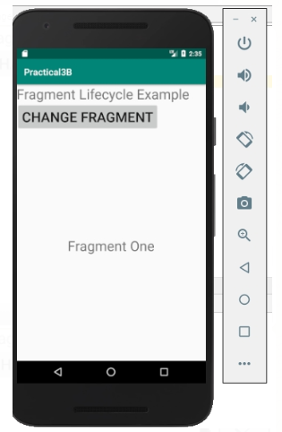 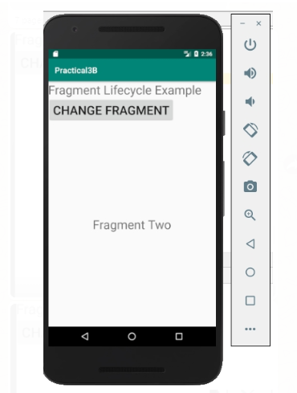

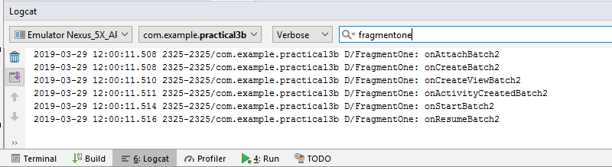

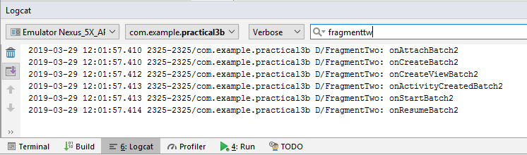

**Practical No:04**

* **Aim:** Programs related to different Layouts Coordinate, Linear, Relative, Table, Absolute, Frame, List View, Grid View.

1. **LinearLayout:**

* **Activity_main.xml:**

<?xml version="1.0" encoding="utf-8"?>

<LinearLayout

xmlns:android="http://schemas.android.com/apk/res/android"

xmlns:tools="http://schemas.android.com/tools"

xmlns:app="http://schemas.android.com/apk/res-auto"

android:layout_width="wrap_content"

android:layout_height="wrap_content"

android:orientation="vertical"

tools:context=".MainActivity"

android:background="@android:color/holo_orange_light"

android:gravity="center_horizontal"

android:orientation="vertical">

<ImageView

android:layout_width="wrap_content"

android:layout_height="130dp"

android:src="@drawable/logo" />

<EditText

android:layout_width="150dp"

android:layout_height="40dp"

android:layout_marginTop="50dp"

android:background="@color/colorAccent"

android:drawableLeft="@drawable/email"

android:hint="@string/email" />

<EditText

android:layout_width="150dp"

android:layout_height="50dp"

android:layout_marginTop="20dp"

android:background="@color/colorAccent"

android:drawableLeft="@drawable/password"

android:hint="@string/password" />

<Button

android:layout_width="wrap_content"

android:layout_height="40dp"

android:layout_marginTop="20dp"

android:text="@string/login" />

<LinearLayout

android:layout_width="wrap_content"

android:layout_height="wrap_content"

android:orientation="horizontal">

<TextView

android:layout_width="wrap_content"

android:layout_height="40dp"

android:layout_marginTop="20dp"

android:textStyle="bold"

android:layout_marginLeft="10dp"

android:text="@string/not_register" />

</LinearLayout>

<Button

android:layout_width="wrap_content"

android:layout_height="40dp"

android:text="@string/register" />

</LinearLayout>

* **Mainactivity.kt:**

package com.login.linearlayout

import android.support.v7.app.AppCompatActivity

import android.os.Bundle

class MainActivity : AppCompatActivity() {

override fun onCreate(savedInstanceState: Bundle?) {

super.onCreate(savedInstanceState)

setContentView(R.layout.activity_main)

}

}

* **Output:**

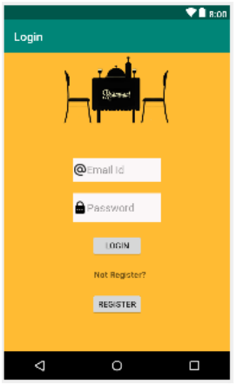

1. **RelativeLayout:**

* **Activity_main.xml:**

<?xml version="1.0" encoding="utf-8"?>

<RelativeLayout

xmlns:android="http://schemas.android.com/apk/res/android"

xmlns:tools="http://schemas.android.com/tools"

xmlns:app="http://schemas.android.com/apk/res-auto"

android:layout_width="match_parent"

android:layout_height="match_parent"

tools:context=".MainActivity"

android:background="@android:color/holo_orange_light">

<EditText

android:layout_width="wrap_content"

android:layout_height="wrap_content"

android:inputType="textEmailAddress"

android:ems="10"

android:layout_alignParentTop="true"

android:layout_marginTop="78dp"

android:id="@+id/Email"

android:hint="Email"

android:layout_alignStart="@+id/Password"/>

<EditText

android:layout_width="wrap_content"

android:layout_height="wrap_content"

android:inputType="textPassword"

android:ems="10"

android:layout_centerHorizontal="true" android:layout_alignParentTop="true"

android:id="@+id/Password"

android:layout_marginTop="168dp"

android:hint="Password"

<EditText

android:layout_width="wrap_content"

android:layout_height="wrap_content"

android:inputType="textPassword"

android:ems="10"

android:layout_alignParentBottom="true"

android:id="@+id/ConfirmPassword"

android:layout_marginLeft="80dp"

android:layout_marginBottom="214dp"

android:layout_alignStart="@+id/editText"

android:hint="Confirm Password"

<EditText

android:layout_width="wrap_content"

android:layout_height="wrap_content"

android:inputType="phone"

android:ems="10"

android:layout_centerHorizontal="true" android:layout_alignParentBottom="true"

android:id="@+id/Phoneno"

android:layout_marginBottom="133dp"

android:hint="Phone no"

<Button

android:text="Register"

android:layout_width="wrap_content"

android:layout_height="wrap_content" android:layout_alignParentRight="true"

android:layout_alignParentEnd="true"

android:layout_marginEnd="131dp"

android:layout_alignParentBottom="true"

android:id="@+id/Register"

android:layout_marginBottom="51dp"

android:layout_marginRight="131dp" />

</RelativeLayout>

* **Mainactivity.kt:**

package com.login.relativelayout

import android.support.v7.app.AppCompatActivity

import android.os.Bundle

class MainActivity : AppCompatActivity() {

override fun onCreate(savedInstanceState: Bundle?) {

super.onCreate(savedInstanceState)

setContentView(R.layout.activity_main)

}

}

* **Output:**

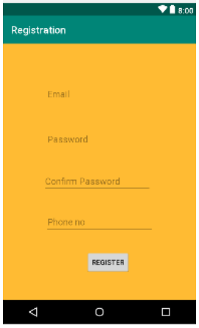

1. **TableLayout:**

* **Activity main.xml**

*<?*xml version="1.0" encoding="utf-8"*?>*<TableLayout  
 xmlns:android="http://schemas.android.com/apk/res/android"  
 xmlns:tools="http://schemas.android.com/tools"  
 xmlns:app="http://schemas.android.com/apk/res-auto"  
 android:layout_width="match_parent"  
 android:layout_height="match_parent"  
 tools:context=".MainActivity"  
 android:background="@drawable/images">  
  
 <TableRow  
 android:layout_width="match_parent"  
 android:layout_height="match_parent"  
 android:layout_marginTop="50dp"  
 android:layout_marginLeft="50dp">  
  
 <EditText  
 android:layout_width="wrap_content"  
 android:layout_height="wrap_content"  
 android:inputType="textPersonName"  
 android:ems="10"  
 android:id="@+id/username"  
 android:hint="@string/username"  
 android:background="@color/colorAccent"/>  
 </TableRow>  
  
 <TableRow  
 android:layout_width="match_parent"  
 android:layout_height="match_parent"  
 android:layout_marginTop="50dp"  
 android:layout_marginLeft="50dp">  
  
 <EditText  
 android:layout_width="wrap_content"  
 android:layout_height="wrap_content"  
 android:inputType="textPassword"  
 android:ems="10"  
 android:id="@+id/password"  
 android:hint="Password"  
 android:background="@color/colorAccent"/>  
 </TableRow>  
  
 <TableRow  
 android:layout_width="match_parent"  
 android:layout_height="match_parent"  
 android:layout_marginTop="50dp"  
 android:layout_marginLeft="70dp">  
  
 <Button  
 android:text="@string/login"  
 android:layout_width="wrap_content"  
 android:layout_height="wrap_content"  
 android:id="@+id/login"/>  
 </TableRow>

* **Mainactivity.xml**

package com.login.tablelayout

import android.support.v7.app.AppCompatActivity

import android.os.Bundle

import android.widget.Button

import android.widget.EditText

import android.widget.Toast

class MainActivity : AppCompatActivity() {

override fun onCreate(savedInstanceState: Bundle?) { super.onCreate(savedInstanceState)

setContentView(R.layout.activity_main)

var text=findViewById<EditText>(R.id.username)

val btn=findViewById<Button>(R.id.login)

btn.setOnClickListener {

var strMessage:String

strMessage=text.getText().toString() Toast.makeText(this,"Hello $strMessage",Toast.LENGTH_LONG).show() }

} }

* **Output:**

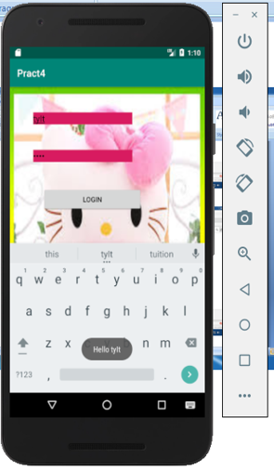

1. **AbsoluteLayout:**

* **Activity_main.xml:**

<?xml version="1.0" encoding="utf-8"?>

<AbsoluteLayout

xmlns:android="http://schemas.android.com/apk/res/android"

xmlns:tools="http://schemas.android.com/tools"

xmlns:app="http://schemas.android.com/apk/res-auto"

android:layout_width="match_parent"

android:layout_height="match_parent"

tools:context=".MainActivity"

android:background="@drawable/reserved">

<EditText

android:layout_width="wrap_content"

android:layout_height="wrap_content"

android:inputType="textPersonName"

android:hint="Username"

android:layout_x="200px"

android:layout_y="200px"

android:ems="10"

android:id="@+id/editText" android:background="@color/colorAccent"/>

<EditText

android:layout_width="wrap_content"

android:layout_height="wrap_content"

android:inputType="textPassword"

android:hint="@string/password"

android:layout_x="200px"

android:layout_y="350px"

android:ems="10"

android:id="@+id/editText2" android:background="@color/colorAccent"/>

<Button

android:text="Login"

android:layout_width="wrap_content"

android:layout_height="wrap_content"

android:id="@+id/button"

android:layout_x="330px"

android:layout_y="500px"/>

</AbsoluteLayout>

* **MainActivity.kt:**

package com.login.absolutelayout

import android.support.v7.app.AppCompatActivity

import android.os.Bundle

class MainActivity : AppCompatActivity() {

override fun onCreate(savedInstanceState: Bundle?) {

super.onCreate(savedInstanceState)

setContentView(R.layout.activity_main)

}

}

* **Output:**

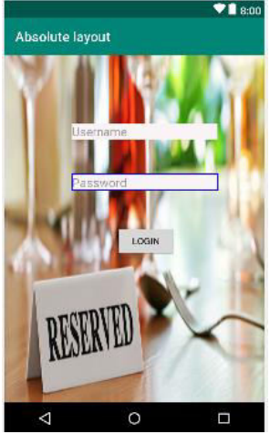

1. **FrameLayout:**

* **Activity_main.xml**

<?xml version="1.0" encoding="utf-8"?>

<FrameLayout

xmlns:android="http://schemas.android.com/apk/res/android" xmlns:tools=”<http://schemas.android.com/tools>”

xmlns:app=”<http://schemas.android.com/apk/res-auto>”

android:layout_width="match_parent"

android:layout_height="match_parent"

tools:context=".MainActivity">

<ImageView

android:layout_width="wrap_content"

android:layout_height="wrap_content"

android:src="@drawable/res"

android:id="@+id/imageView"/>

<TextView

android:layout_width="match_parent"

android:layout_height="wrap_content"

android:inputType="textPersonName"

android:layout_marginTop="40dp"

android:layout_marginLeft="40dp"

android:layout_marginRight="30dp"

android:textStyle="bold"

android:textSize="20dp"

android:text="Restaurant reservation system"

android:ems="10"

android:id="@+id/editText"/>

<Button

android:text="Get Started"

android:layout_marginTop="430dp"

android:layout_marginBottom="10dp"

android:layout_width="match_parent"

android:layout_height="wrap_content"

android:id="@+id/button" />

</FrameLayout>

* **MainActivity.kt:**

package com.login.frame

import android.support.v7.app.AppCompatActivity import android.os.Bundle

class MainActivity : AppCompatActivity() {

override fun onCreate(savedInstanceState: Bundle?) {

super.onCreate(savedInstanceState) setContentView(R.layout.activity_main) }}

* **Output:**

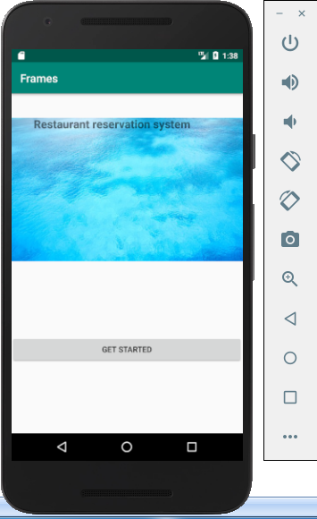

1. **ListView:**

* **ActivityMain.xml:**

*<?*xml version="1.0" encoding="utf-8"*?>*<LinearLayout  
 xmlns:android="http://schemas.android.com/apk/res/android"  
 xmlns:tools="http://schemas.android.com/tools"  
 xmlns:app="http://schemas.android.com/apk/res-auto"  
 android:layout_width="match_parent"  
 android:layout_height="match_parent"  
 tools:context=".MainActivity">  
 <ListView  
 android:layout_width="match_parent"  
 android:layout_height="match_parent"  
 android:id="@+id/list">  
 </ListView>  
</LinearLayout>

* **Mainactivity.kt:**

package com.example.mscitlab.p4_listview  
import android.support.v7.app.AppCompatActivity  
import android.os.Bundle  
import android.view.Gravity  
import android.widget.ArrayAdapter  
import android.widget.ListView  
import android.widget.Toast  
  
class MainActivity : AppCompatActivity() {  
 override fun onCreate(savedInstanceState: Bundle?) {  
 super.onCreate(savedInstanceState)  
 setContentView(R.layout.*activity_main*)  
 val Dishes = *arrayOf*<String>("Vadapav", "Chinese bhel", "Samosa", "Kachori", "Dhokala")  
 val listView = findViewById<ListView>(R.id.*list*);  
 listView.*adapter* = ArrayAdapter<String>(this, android.R.layout.*simple_list_item_1*, Dishes)  
 listView.setOnItemClickListener { parent, view, position, id ->  
 val toast = Toast.makeText(this, "you clicked on the Dish\n" + Dishes[position], Toast.*LENGTH_LONG*)  
 toast.setGravity(Gravity.*CENTER*, 0, 0)  
 toast.show()  
 }  
 }  
}

* **Output:**

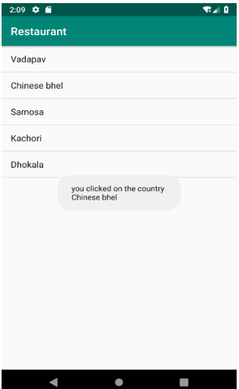

1. **GridView:**

* **Activity_main.xml:**

*<?*xml version="1.0" encoding="utf-8"*?>*<GridLayout  
 xmlns:android="http://schemas.android.com/apk/res/android"  
 xmlns:tools="http://schemas.android.com/tools"  
 xmlns:app="http://schemas.android.com/apk/res-auto"  
 android:layout_width="match_parent"  
 android:layout_height="match_parent"  
 tools:context=".MainActivity"  
 android:rowCount="3"  
 android:columnCount="3"  
 android:padding="20dp">

<Button  
 android:layout_width="110dp"  
 android:layout_height="100dp"  
 android:text="1"/>  
  
 <Button  
 android:layout_width="110dp"  
 android:layout_height="100dp"  
 android:text="2"/>  
 <Button  
 android:layout_width="110dp"  
 android:layout_height="100dp"  
 android:text="3"/>  
 <Button  
 android:layout_width="110dp"  
 android:layout_height="100dp"  
 android:text="4"/>  
  
 <Button  
 android:layout_width="110dp"  
 android:layout_height="100dp"  
 android:text="5"/>  
 <Button  
 android:layout_width="110dp"  
 android:layout_height="100dp"  
 android:text="6"/>  
 <Button  
 android:layout_width="110dp"  
 android:layout_height="100dp"  
 android:text="7"/>  
  
 <Button  
 android:layout_width="110dp"  
 android:layout_height="100dp"  
 android:text="8"/>  
 <Button  
 android:layout_width="110dp"  
 android:layout_height="100dp"  
 android:text="9"/>  
  
</GridLayout>

* **Output:**

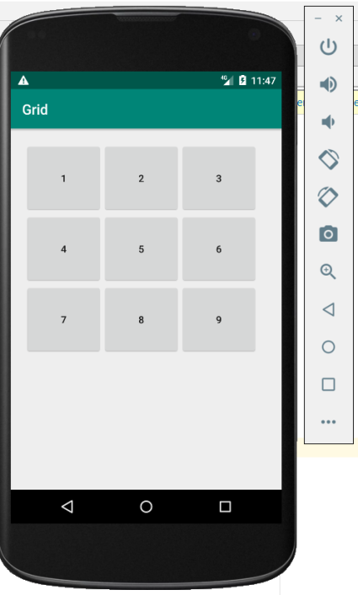

**Practical 5**

**Aim:-Programming UI elements**

**AppBar,Fragments,UI Components**

* Go to Gradle Scripts -> bulid gradle(Module app)
* Add two libraries in dependencies

implementation 'com.android.support:design:28.0.0'  
implementation 'com.android.support:support-v13:28.0.0'

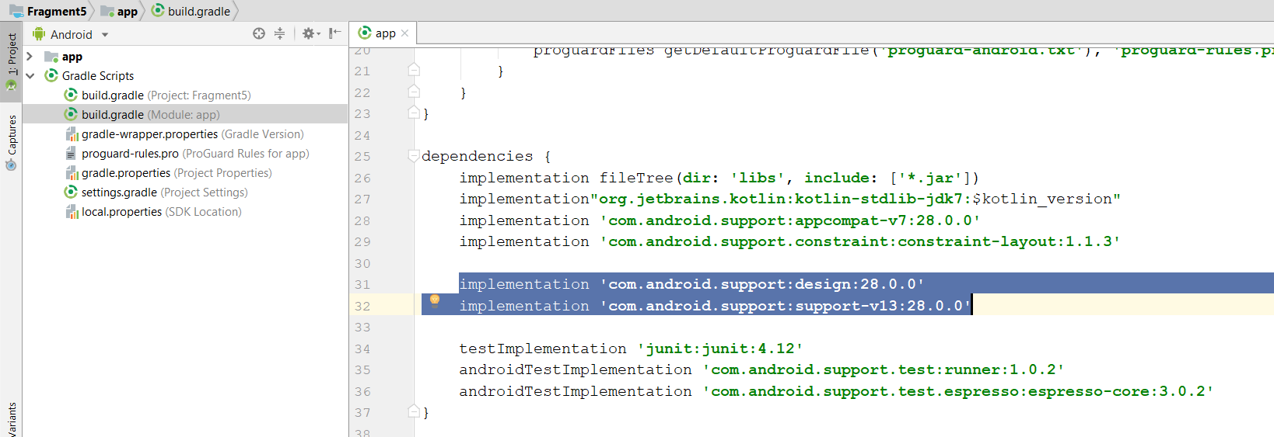

**Styles.xml**

<resources>  
*<!-- Base application theme. -->*<style name="AppTheme" parent="Theme.AppCompat.Light.NoActionBar">  
 *<!-- Customize your theme here. -->* <item name="colorPrimary">@color/colorPrimary</item>  
 <item name="colorPrimaryDark">@color/colorPrimaryDark</item>  
 <item name="colorAccent">@color/colorAccent</item>  
</style>  
</resources>

* **Go to, ProjectName > App > Src > Main > Res > Layout . Right Click on layout and add a new file “toolbar_layout.xml”**

**toolbar_layout.xml**

*<?*xml version="1.0" encoding="utf-8"*?>*<android.support.v7.widget.Toolbar  
 xmlns:android="http://schemas.android.com/apk/res/android"  
 xmlns:app="http://schemas.android.com/apk/res-auto"  
 android:layout_width="match_parent"  
 android:layout_height="?attr/actionBarSize"  
 android:background="?attr/colorPrimary"  
 android:theme="@style/Base.ThemeOverlay.AppCompat.Dark.ActionBar"  
 app:popupTheme="@style/ThemeOverlay.AppCompat.Light"  
 android:id="@+id/toolBar">  
</android.support.v7.widget.Toolbar>

**Activity_main.xml**

*<?*xml version="1.0" encoding="utf-8"*?>*<LinearLayout  
 xmlns:android="http://schemas.android.com/apk/res/android"  
 xmlns:app="http://schemas.android.com/apk/res-auto"  
 xmlns:tools="http://schemas.android.com/tools"  
 android:layout_width="match_parent"  
 android:layout_height="match_parent"  
 android:orientation="vertical"  
 tools:context=".MainActivity">  
  
 <include layout="@layout/toolbar_layout"/>  
</LinearLayout>

* **ProjectName > App > Src > Main > Res > New > Resource File > Give a filename (app_bar_menu.xml) and select menu in resource type.**

**app_bar_menu.xml**

*<?*xml version="1.0" encoding="utf-8"*?>*<menu  
 xmlns:android="http://schemas.android.com/apk/res/android"  
 xmlns:app="http://schemas.android.com/apk/res-auto">  
 <item  
 android:id="@+id/action_search"  
 android:title="Setting"  
 android:icon="@drawable/ic_launcher_background"  
 app:showAsAction="ifRoom"/>  
 <item  
 android:id="@+id/action_about"  
 android:title="About"  
 app:showAsAction="never"/>  
</menu>

**MainActivity.kt**

package rozi.com.practical5  
  
import android.support.v7.app.AppCompatActivity  
import android.os.Bundle  
import android.view.Menu  
import android.view.MenuItem  
import android.widget.Toast  
import android.widget.Toolbar  
import rozi.com.practical5.R.id.*toolBar*class MainActivity : AppCompatActivity() {  
 private var tbar = null  
  
 override fun onCreate(savedInstanceState: Bundle?) {  
 super.onCreate(savedInstanceState)  
 setContentView(R.layout.*activity_main*)  
  
 val tbar = findViewById(R.id.*toolBar*) as android.support.v7.widget.Toolbar  
 if (*toolBar* != null)  
 setSupportActionBar(tbar)  
 }  
 override fun onCreateOptionsMenu(menu: Menu): Boolean {  
 val mi = *menuInflater* mi.inflate(R.menu.*app_bar_menu*, menu)  
 return true  
 }  
 override fun onOptionsItemSelected(item: MenuItem): Boolean {  
 when (item.*itemId*) {  
 R.id.*action_search* -> {  
 Toast.makeText(this, "Search Menu Click", Toast.*LENGTH_SHORT*).show()  
 return true  
 }  
 R.id.*action_about* -> {  
 Toast.makeText(this, "About Menu Click", Toast.*LENGTH_SHORT*).show()  
 return true  
 }  
 else -> {  
 return super.onOptionsItemSelected(item)  
 }  
 }  
 }  
}

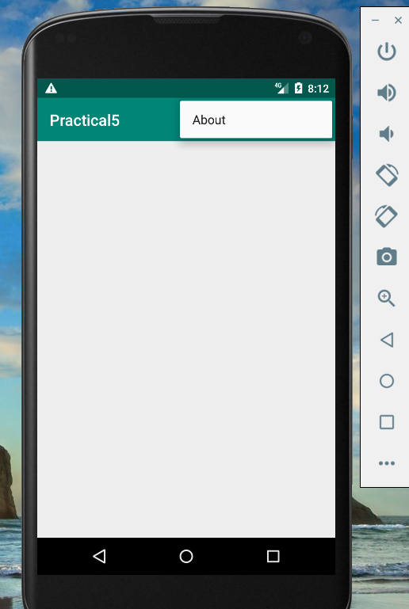**OUTPUT:**

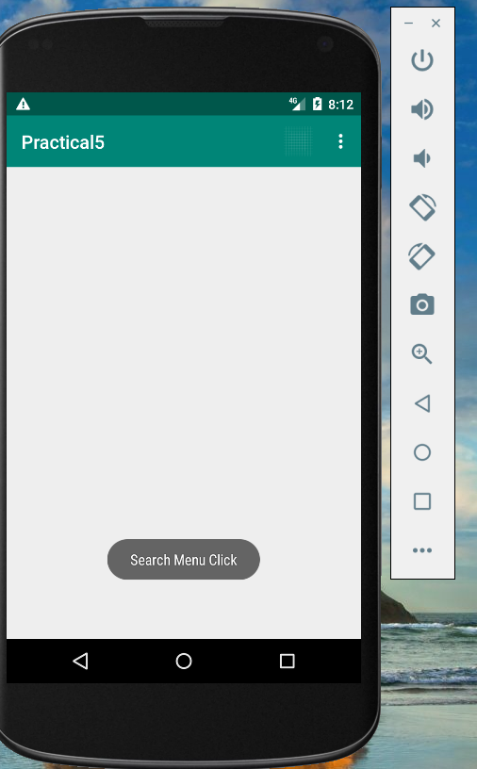

**Practical No:06**

* **Aim**: Programming menus, dialog, dialog fragments
* **Coding:**

1. **Menu Example:**

* **activity_main.xml:**

*<?*xml version="1.0" encoding="utf-8"*?>*<LinearLayout  
 xmlns:android="http://schemas.android.com/apk/res/android"  
 xmlns:tools="http://schemas.android.com/tools"  
 xmlns:app="http://schemas.android.com/apk/res-auto"  
 android:layout_width="match_parent"  
 android:layout_height="match_parent"  
 tools:context=".MainActivity"  
 android:orientation="vertical"  
 android:gravity="center">  
 <TextView  
 android:id="@+id/txt1"  
 android:layout_width="wrap_content"  
 android:layout_height="wrap_content"  
 android:text="Activity 1"  
 android:textSize="30sp"  
 android:padding="20dp"/>  
 <TextView  
 android:id="@+id/txt2"  
 android:layout_width="wrap_content"  
 android:layout_height="wrap_content"  
 android:text="Menu Example"  
 android:textSize="30sp"  
 android:padding="20dp"/>  
</LinearLayout>

* **mainactivity.kt:**

*<?*xml version="1.0" encoding="utf-8"*?>*<LinearLayout xmlns:android="http://schemas.android.com/apk/res/android"  
 xmlns:tools="http://schemas.android.com/tools"  
 xmlns:app="http://schemas.android.com/apk/res-auto"  
 android:layout_width="match_parent"  
 android:layout_height="match_parent"  
 tools:context=".MainActivity"  
 android:orientation="vertical"  
 android:gravity="center">  
 <TextView  
 android:id="@+id/txt1"  
 android:layout_width="wrap_content"  
 android:layout_height="wrap_content"  
 android:text="Activity 1"  
 android:textSize="30sp"  
 android:padding="20dp"/>  
 <TextView  
 android:id="@+id/txt2"  
 android:layout_width="wrap_content"  
 android:layout_height="wrap_content"  
 android:text="Menu Example"  
 android:textSize="30sp"  
 android:padding="20dp"/>  
</LinearLayout>

* menufile.xml:

*<?*xml version="1.0" encoding="utf-8"*?>*<menu xmlns:android="http://schemas.android.com/apk/res/android">  
 <item android:title="Contact Us"  
 android:id="@+id/contact"/>  
 <item android:title="About Us"  
 android:id="@+id/about"/>  
 <item android:title="Help"  
 android:id="@+id/help"/>  
 <item android:title="FAQ"  
 android:id="@+id/faq"/>  
</menu>

* Output:

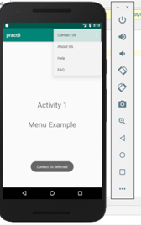

1. **Alert Dialog Example:**

* activity_main:

*<?*xml version="1.0" encoding="utf-8"*?>*<LinearLayout xmlns:android="http://schemas.android.com/apk/res/android"  
 xmlns:tools="http://schemas.android.com/tools"  
 xmlns:app="http://schemas.android.com/apk/res-auto"  
 android:layout_width="match_parent"  
 android:layout_height="match_parent"  
 tools:context=".MainActivity"  
 android:orientation="vertical"  
 android:gravity="center">  
 <TextView  
 android:id="@+id/txt1"  
 android:layout_width="wrap_content"  
 android:layout_height="wrap_content"  
 android:text="Activity 1"  
 android:textSize="30sp"  
 android:padding="20dp"/>  
 <TextView  
 android:id="@+id/txt2"  
 android:layout_width="wrap_content"  
 android:layout_height="wrap_content"  
 android:text="Alert Example"  
 android:textSize="30sp"  
 android:padding="20dp"/>  
</LinearLayout>

* **mainactivity:**

package com.abc.pract6  
  
import android.app.AlertDialog  
import android.content.Intent  
import android.net.Uri  
import android.support.v7.app.AppCompatActivity  
import android.os.Bundle  
import kotlinx.android.synthetic.main.activity_main.*  
class MainActivity : AppCompatActivity() {  
 override fun onCreate(savedInstanceState: Bundle?) {  
 super.onCreate(savedInstanceState)  
 setContentView(R.layout.*activity_main*)  
 }  
 override fun onBackPressed()  
 {  
 val builder = AlertDialog.Builder(this)  
 builder.setTitle("Are you sure")  
 builder.setMessage("Are you sure you want to close the app ?")  
 builder.setPositiveButton("Yes",  
 {dialogInterface, i -> finish()})  
 builder.setNegativeButton(**"No"**,**{** dialogInterface, i **-> }**)  
 builder.show()  
 }  
}

* **Output:**

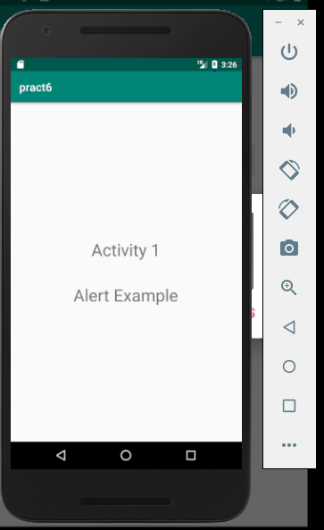 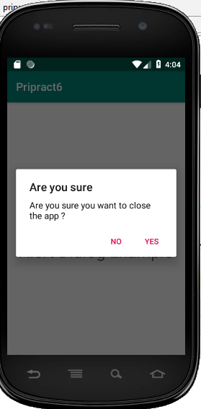

1. **ProgressDialog Example:**

* **Activitymain.xml:**

*<?*xml version="1.0" encoding="utf-8"*?>*<LinearLayout  
 xmlns:android="http://schemas.android.com/apk/res/android"  
 xmlns:tools="http://schemas.android.com/tools"  
 xmlns:app="http://schemas.android.com/apk/res-auto"  
 android:layout_width="match_parent"  
 android:layout_height="match_parent"  
 tools:context=".MainActivity"  
 android:orientation="vertical"  
 android:gravity="center">  
 <TextView  
 android:id="@+id/txt1"  
 android:layout_width="wrap_content"  
 android:layout_height="wrap_content"  
 android:text="Activity 1"  
 android:textSize="30sp"  
 android:padding="20dp"/>  
 <TextView  
 android:id="@+id/txt2"  
 android:layout_width="wrap_content"  
 android:layout_height="wrap_content"  
 android:text="Alert Example"  
 android:textSize="30sp"  
 android:padding="20dp"/>  
</LinearLayout>

* **Mainactivity.kt:**

package com.abc.pract6  
  
import android.app.ProgressDialog  
import android.os.Bundle  
import android.os.Handler  
import android.support.v7.app.AppCompatActivity  
class MainActivity : AppCompatActivity() {  
 override fun onCreate(savedInstanceState: Bundle?) {  
 super.onCreate(savedInstanceState)  
 setContentView(R.layout.*activity_main*)  
 val progressDialog = ProgressDialog(this)  
 progressDialog.setMessage("Downloading Data......")  
 progressDialog.setCancelable(false)  
 progressDialog.show()  
 Handler().postDelayed({progressDialog.dismiss()},10000)  
 }  
}

* **Output:**

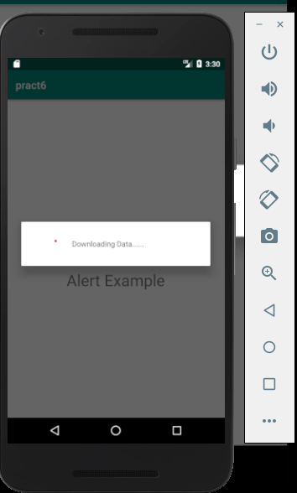

1. **Custom Alert Dialog Example Using the new ProgressBar Element**

* **activity_main.xml:**

*<?*xml version="1.0" encoding="utf-8"*?>*<LinearLayout  
 xmlns:android="http://schemas.android.com/apk/res/android"  
 xmlns:tools="http://schemas.android.com/tools"  
 xmlns:app="http://schemas.android.com/apk/res-auto"  
 android:layout_width="match_parent"  
 android:layout_height="match_parent"  
 tools:context=".MainActivity"  
 android:orientation="vertical"  
 android:gravity="center">  
 <TextView  
 android:id="@+id/txt1"  
 android:layout_width="wrap_content"  
 android:layout_height="wrap_content"  
 android:text="Activity 1"  
 android:textSize="30sp"  
 android:padding="20dp"/>  
 <TextView  
 android:id="@+id/txt2"  
 android:layout_width="wrap_content"  
 android:layout_height="wrap_content"  
 android:text="Progress Example"  
 android:textSize="30sp"  
 android:padding="20dp"/>  
</LinearLayout>

* **mainactivity.kt:**

package com.abc.pract6  
  
import android.app.AlertDialog  
import android.os.Bundle  
import android.support.v7.app.AppCompatActivity  
import android.widget.TextView  
class MainActivity : AppCompatActivity() {  
 override fun onCreate(savedInstanceState: Bundle?) {  
 super.onCreate(savedInstanceState)  
 setContentView(R.layout.*activity_main*)  
 val builder = AlertDialog.Builder(this)  
 val dialogView = *layoutInflater*.inflate(R.layout.*progbar*,null)  
 val message = dialogView.findViewById<TextView>(R.id.*message*)  
 message.*text* = "Downloading Data......"  
 builder.setView(dialogView)  
 builder.show() } }

* **progbar.xml:**

*<?*xml version="1.0" encoding="utf-8"*?>*<LinearLayout  
 xmlns:android="http://schemas.android.com/apk/res/android"  
 android:layout_width="match_parent"  
 android:layout_height="match_parent"  
 android:orientation="horizontal"  
 android:gravity="center">  
 <ProgressBar  
 android:layout_width="50dp"  
 android:layout_height="50dp"/>  
 <TextView  
 android:id="@+id/message"  
 android:layout_width="wrap_content"  
 android:layout_height="wrap_content"  
 android:text="Downloading Data......"/>  
</LinearLayout>

* **Output:**

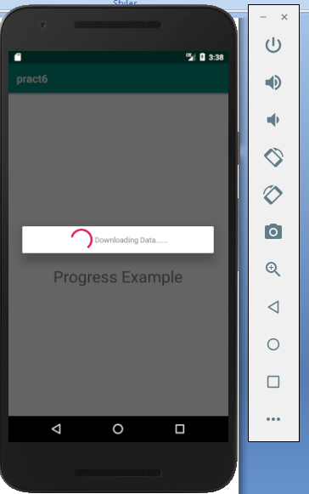 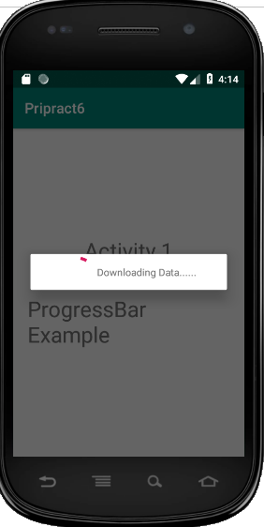

**Practical No:07**

* **Aim:** Programs on Intents, Events, Listeners and Adapters The Android Intent Class, Using Events and Event Listeners
* **Coding:**
* **Explicit Intent** **(Navigate between Activities):**
* **activity_main.xml:**

<LinearLayout

xmlns:android="http://schemas.android.com/apk/res/android" android:layout_width="match_parent" android:layout_height="match_parent"

android:orientation="vertical"

android:gravity="center" >

<TextView

android:id="@+id/txt1"

android:layout_width="wrap_content" android:layout_height="wrap_content"

android:text="First Activity"

android:textSize="30sp"

android:padding="20dp" />

<Button

android:id="@+id/btn1"

android:layout_width="wrap_content" android:layout_height="wrap_content"

android:text="Submit"

android:textSize="30sp"

android:padding="20dp" />

</LinearLayout>

* **activity_second.xml:**

<LinearLayout

xmlns:android="http://schemas.android.com/apk/res/android" android:layout_width="match_parent" android:layout_height="match_parent"

android:orientation="vertical"

android:gravity="center" >

<TextView

android:id="@+id/txt2"

android:layout_width="wrap_content" android:layout_height="wrap_content"

android:text="Second Activity"

android:textSize="30sp"

android:padding="20dp" />

<TextView

android:id="@+id/text3"

android:layout_width="wrap_content" android:layout_height="wrap_content"

android:text="Welcome"

android:textSize="30sp"

android:padding="20dp" />

</LinearLayout>

* **MainActivity.kt:**

package com.sslinks.androidandBatch2

import android.content.Intent import android.support.v7.app.AppCompatActivity import android.os.Bundle import kotlinx.android.synthetic.main.activity_main.*

class MainActivity : AppCompatActivity() {

override fun onCreate(savedInstanceState: Bundle?) { super.onCreate(savedInstanceState) setContentView(R.layout.activity_main)

btn1.setOnClickListener {

val intent = Intent(this, SecondActivity::class.java) startActivity(intent)

} } }

* **SecondActivity.kt :**

package com.sslinks.androidandBatch2

import android.support.v7.app.AppCompatActivity

import android.os.Bundle

class SecondActivity : AppCompatActivity() {

override fun onCreate(savedInstanceState: Bundle?) { super.onCreate(savedInstanceState) setContentView(R.layout.activity_second) } }

* **AndroidManifest.xml :**

<activity android:name=".MainActivity">

<intent-filter>

<action android:name="android.intent.action.MAIN"/>

<category android:name="android.intent.category.LAUNCHER"/> </intent-filter> </activity>

<activity android:name=".SecondActivity">

</activity>

* **Output:**

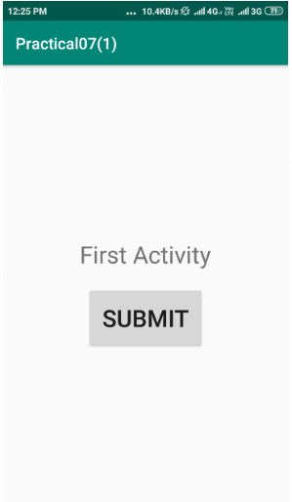 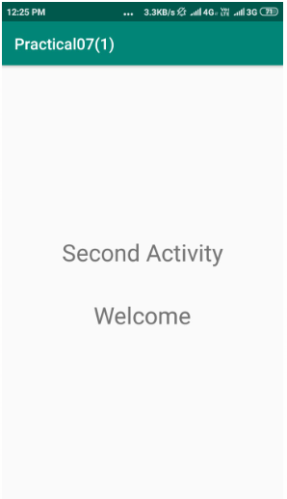

* **Explicit Intent (Share Data between different Activities) (Same Application):**
* **activity_main.xml:**

<LinearLayout

xmlns:android="http://schemas.android.com/apk/res/android" android:layout_width="match_parent"

android:layout_height="match_parent"

android:orientation="vertical"

android:gravity="center" >

<TextView

android:id="@+id/txt1"

android:layout_width="wrap_content" android:layout_height="wrap_content"

android:text="First Activity"

android:textSize="30sp"

android:padding="20dp" />

<EditText

android:id="@+id/edt1"

android:layout_width="wrap_content" android:layout_height="wrap_content"

android:hint="Enter Your Name"

android:textSize="30sp"

android:padding="20dp" />

<Button

android:id="@+id/btn1"

android:layout_width="wrap_content" android:layout_height="wrap_content"

android:text="Submit"

android:textSize="30sp"

android:padding="20dp" />

</LinearLayout>

* **activity_second.xml :**

<LinearLayout

xmlns:android="http://schemas.android.com/apk/res/android" android:layout_width="match_parent"

android:layout_height="match_parent"

android:orientation="vertical"

android:gravity="center" >

<TextView

android:id="@+id/txt2"

android:layout_width="wrap_content" android:layout_height="wrap_content"

android:text="Second Activity"

android:textSize="30sp"

android:padding="20dp" />

<TextView

android:id="@+id/txt3"

android:layout_width="wrap_content" android:layout_height="wrap_content"

android:text="Welcome"

android:textSize="30sp"

android:padding="20dp" />

</LinearLayout>

* **MainActivity.kt :**

package com.sslinks.androidandBatch2

import android.content.Intent

import android.support.v7.app.AppCompatActivity

import android.os.Bundle

import kotlinx.android.synthetic.main.activity_main.*

class MainActivity : AppCompatActivity() {

override fun onCreate(savedInstanceState: Bundle?) { super.onCreate(savedInstanceState) setContentView(R.layout.activity_main)

btn1.setOnClickListener {

val message: String = edt1.text.toString()

val intent = Intent(this,SecondActivity::class.java) intent.putExtra("key1",message) startActivity(intent)

} } }

* **SecondActivity.kt :**

package com.sslinks.androidandBatch2

import android.support.v7.app.AppCompatActivity

import android.os.Bundle

import com.sslinks.androidandBatch2.R.id.txt3

import kotlinx.android.synthetic.main.activity_second.*

class SecondActivity : AppCompatActivity() {

override fun onCreate(savedInstanceState: Bundle?) { super.onCreate(savedInstanceState) setContentView(R.layout.activity_second)

val bundle: Bundle? = intent.extras val grabMsg = bundle!!.getString("key1")

txt3.text = "Welcome " + grabMsg

} }

* **AndroidManifest.xml :**

<activity android:name=".MainActivity">

<intent-filter>

<action android:name="android.intent.action.MAIN"/>

<category android:name="android.intent.category.LAUNCHER"/> </intent-filter> </activity>

<activity android:name=".SecondActivity">

</activity>

* **Output:**

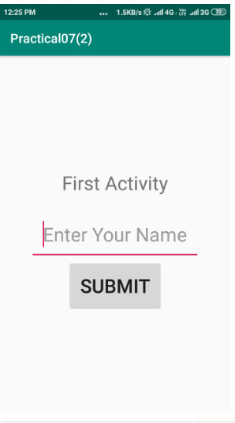 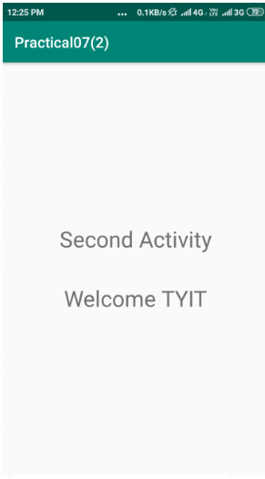

* **Implicit Intent (Share Data between different Applications):**
* **activity_main.xml :**

<LinearLayout

xmlns:android="http://schemas.android.com/apk/res/android" android:layout_width="match_parent" android:layout_height="match_parent"

android:orientation="vertical"

android:gravity="center" >

<TextView

android:id="@+id/txt1"

android:layout_width="wrap_content" android:layout_height="wrap_content"

android:text="First Activity"

android:textSize="30sp"

android:padding="20dp" />

<EditText

android:id="@+id/edt1"

android:layout_width="wrap_content" android:layout_height="wrap_content"

android:hint="Enter Your Name"

android:textSize="30sp"

android:padding="20dp" />

<Button

android:id="@+id/btn1"

android:layout_width="wrap_content" android:layout_height="wrap_content"

android:text="Submit"

android:textSize="30sp"

android:padding="20dp" />

</LinearLayout>

* **MainActivity.kt**

package com.sslinks.androidandBatch2

import android.content.Intent

import android.support.v7.app.AppCompatActivity

import android.os.Bundle

import kotlinx.android.synthetic.main.activity_main.*

class MainActivity : AppCompatActivity() { override fun onCreate(savedInstanceState: Bundle?) { super.onCreate(savedInstanceState) setContentView(R.layout.activity_main)

btn1.setOnClickListener {

val message: String = edt1.text.toString()

val intent = Intent()

intent.action = Intent.ACTION_SEND intent.putExtra(Intent.EXTRA_TEXT, message)

intent.type = "text/plain"

startActivity(Intent.createChooser(intent, "Send my Data to:")) } } }

* **Output:**

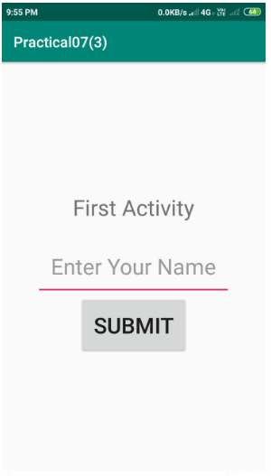 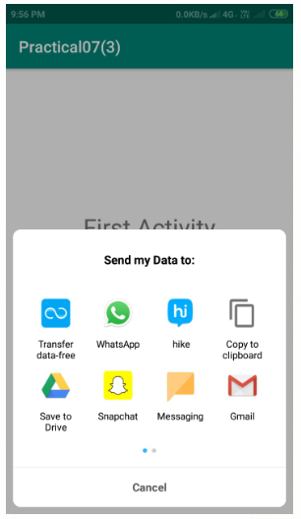

* **Implicit Intent (Share Data between different Applications): activity_main.xml**

<?xml version="1.0" encoding="utf-8"?>

<LinearLayout

xmlns:android="http://schemas.android.com/apk/res/android" android:layout_width="match_parent" android:layout_height="match_parent"

android:orientation="vertical"

android:gravity="center" >

<Button

android:id="@+id/btn1"

android:layout_width="wrap_content" android:layout_height="wrap_content"

android:text="Submit"

android:textSize="30sp"

android:padding="20dp" />

</LinearLayout>

* **MainActivity.kt :**

package com.sslinks.androidandBatch2

import android.content.Intent

import android.net.Uri import android.support.v7.app.AppCompatActivity import android.os.Bundle

import kotlinx.android.synthetic.main.activity_main.*

class MainActivity : AppCompatActivity() {

override fun onCreate(savedInstanceState: Bundle?) { super.onCreate(savedInstanceState) setContentView(R.layout.activity_main)

btn1.setOnClickListener {

val intent = Intent()

intent.action = Intent.ACTION_VIEW

intent.data = Uri.parse("https://www.google.com/")

startActivity(intent) } } }

* **Output:**

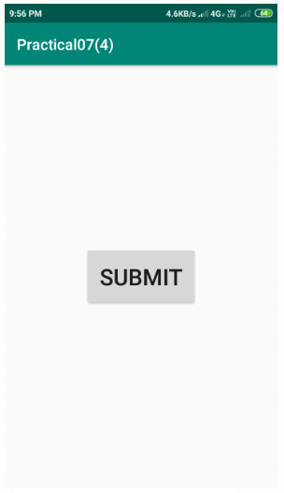 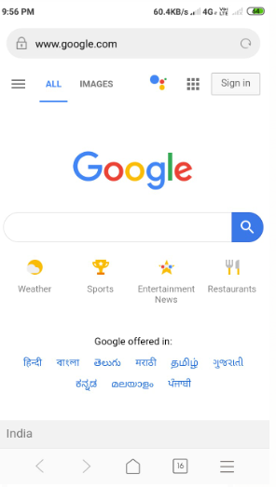

**Practical No:08**

* **Aim:** Programs on Services, notification and broadcast receivers
* **Procedure:**
* **MyReceiver.kt:**

import android.content.BroadcastReceiver

import android.content.Context

import android.content.Intent

import android.widget.Toast

class MyReceiver : BroadcastReceiver()

{

override fun onReceive(context: Context, intent: Intent)

{

// TODO: This method is called when the BroadcastReceiver is receiving

// an Intent broadcast.

Toast.makeText(context, "Broadcast : Flight mode changed.",

Toast.LENGTH_LONG).show()

}

}

* **activity_main.xml:**

<?xml version="1.0" encoding="utf-8"?>

<manifest xmlns:android="http://schemas.android.com/apk/res/android"

package="in.eyehunt.androidbroadcasts">

<application

android:allowBackup="true"

android:icon="@mipmap/ic_launcher"

android:label="@string/app_name"

android:roundIcon="@mipmap/ic_launcher_round"

android:supportsRtl="true"

android:theme="@style/AppTheme">

<activity

android:name=".MainActivity">

<intent-filter>

<action

android:name="android.intent.action.MAIN" />

<category

android:name="android.intent.category.LAUNCHER" />

</intent-filter>

</activity>

<receiver

android:name=".MyReceiver"

android:enabled="true"

android:exported="true">

<intent-filter>

<action

android:name="android.intent.action.AIRPLANE_MODE"/>

</intent-filter>

</receiver>

</application>

</manifest>

* **MainActivity.kt:**

import android.support.v7.app.AppCompatActivity

import android.os.Bundle

class MainActivity : AppCompatActivity() {

override fun onCreate(savedInstanceState: Bundle?) {

super.onCreate(savedInstanceState)

setContentView(R.layout.activity_main)

}

}

* **main_activity.xml:**

<?xml version="1.0" encoding="utf-8"?>

<android.support.constraint.ConstraintLayout xmlns:android="http://schemas.android.com/apk/res/android"

xmlns:app="http://schemas.android.com/apk/res-auto"

xmlns:tools="http://schemas.android.com/tools"

android:layout_width="match_parent"

android:layout_height="match_parent"

android:background="@color/colorPrimary"

tools:context="in.eyehunt.androidbroadcasts.MainActivity">

<ImageView

android:id="@+id/imageView"

android:layout_width="40dp"

android:layout_height="40dp"

android:layout_margin="8dp"

android:layout_marginTop="16dp"

app:layout_constraintStart_toStartOf="parent"

app:layout_constraintTop_toTopOf="parent"

app:srcCompat="@mipmap/baseline_airplanemode_active_white_24" />

<TextView

android:id="@+id/textView"

android:layout_width="300dp"

android:layout_height="36dp"

android:layout_marginEnd="8dp"

android:layout_marginStart="8dp"

android:gravity="center_vertical"

android:text="Flight Mode"

android:textColor="@color/colorWhite"

android:textSize="24dp"

app:layout_constraintEnd_toEndOf="parent"

app:layout_constraintStart_toEndOf="@+id/imageView"

app:layout_constraintTop_toTopOf="@+id/imageView"/>

</android.support.constraint.ConstraintLayout>

* **OUTPUT:**

|  |
| --- |
|  |

**Practical No:09**

* **Aim:** Database Programming with SQLite
* **Coding:**
* **activity_main.xml:**

<?xml version="1.0" encoding="utf-8"?>

<LinearLayout

xmlns:android="http://schemas.android.com/apk/res/android" xmlns:app=<http://schemas.android.com/apk/res-auto>

xmlns:tools="http://schemas.android.com/tools"

android:layout_width="match_parent"

android:layout_height="wrap_content"

android:orientation="vertical"

android:gravity="center"

tools:context="com.tutorialkart.sqlitetutorial.MainActivity">

<TextView

android:layout_width="wrap_content"

android:layout_height="wrap_content"

android:text="SQLite Tutorial - User Management"

android:textSize="20dp"

android:padding="10dp" />

<LinearLayout

android:layout_width="match_parent"

android:layout_height="wrap_content"

android:orientation="vertical">

<EditText

android:id="@+id/edittext_userid"

android:hint="User ID"

android:gravity="center"

android:layout_width="match_parent"

android:layout_height="wrap_content" />

<EditText

android:id="@+id/edittext_name"

android:hint="User Name"

android:gravity="center"

android:layout_width="match_parent"

android:layout_height="wrap_content" />

<EditText

android:id="@+id/edittext_age"

android:hint="User Age"

android:gravity="center"

android:layout_width="match_parent"

android:layout_height="wrap_content" />

</LinearLayout>

<LinearLayout

android:layout_width="match_parent"

android:layout_height="wrap_content"

android:orientation="horizontal">

<Button

android:id="@+id/button_add_user"

android:layout_width="wrap_content"

android:layout_height="wrap_content"

android:layout_weight="1"

android:onClick="addUser"

android:text="Add" />

<Button

android:id="@+id/button_delete_user"

android:layout_width="wrap_content"

android:layout_height="wrap_content" 43

android:layout_weight="1"

android:onClick="deleteUser"

android:text="Delete" />

<Button

android:id="@+id/button_show_all"

android:layout_width="wrap_content"

android:layout_height="wrap_content"

android:layout_weight="1"

android:onClick="showAllUsers"

android:text="Show All" />

</LinearLayout>

<TextView

android:id="@+id/textview_result"

android:layout_width="match_parent"

android:layout_height="wrap_content" />

<LinearLayout

android:id="@+id/ll_entries" android:padding="15dp"

android:orientation="vertical"

android:layout_width="match_parent"

android:layout_height="wrap_content">

</LinearLayout>

</LinearLayout>

* **UserModel.kt:**

package com.tutorialkart.sqlitetutorial

class UserModel(val userid: String, val name: String, val age: String)

* **DBContract.kt:**

package com.tutorialkart.sqlitetutorial

import android.provider.BaseColumns

object DBContract {

/* Inner class that defines the table contents */

class UserEntry : BaseColumns {

companion object {

val TABLE_NAME = "users"

val COLUMN_USER_ID = "userid"

val COLUMN_NAME = "name"

val COLUMN_AGE = "age"

}

}

}

* **UserDBHelper.kt:**

package com.tutorialkart.sqlitetutorial

import android.content.ContentValues

import android.content.Context

import android.database.Cursor

import android.database.sqlite.SQLiteConstraintException

import android.database.sqlite.SQLiteDatabase

import android.database.sqlite.SQLiteException

import android.database.sqlite.SQLiteOpenHelper

import java.util.ArrayList

class UsersDBHelper(context: Context) : SQLiteOpenHelper(context, DATABASE_NAME, null, DATABASE_VERSION) {

override fun onCreate(db: SQLiteDatabase) {

db.execSQL(SQL_CREATE_ENTRIES)

}

override fun onUpgrade(db: SQLiteDatabase, oldVersion: Int, newVersion: Int) {

// This database is only a cache for online data, so its upgrade policy is

// to simply to discard the data and start over

db.execSQL(SQL_DELETE_ENTRIES)

onCreate(db)

}

override fun onDowngrade(db: SQLiteDatabase, oldVersion: Int, newVersion: Int) {

onUpgrade(db, oldVersion, newVersion)

}

@Throws(SQLiteConstraintException::class)

fun insertUser(user: UserModel): Boolean {

// Gets the data repository in write mode

val db = *writableDatabase*

// Create a new map of values, where column names are the keys

val values = ContentValues()

values.put(DBContract.*UserEntry*.*COLUMN_USER_ID*, user.*userid*)

values.put(DBContract.UserEntry.COLUMN_NAME, user.name)

values.put(DBContract.UserEntry.COLUMN_AGE, user.age)

// Insert the new row, returning the primary key value of the new row

val newRowId = db.insert(DBContract.UserEntry.TABLE_NAME, null, values)

return true

}

@Throws(SQLiteConstraintException::class)

fun deleteUser(userid: String): Boolean {

// Gets the data repository in write mode

val db = writableDatabase

// Define 'where' part of query.

val selection = DBContract.UserEntry.COLUMN_USER_ID + " LIKE ?"

// Specify arguments in placeholder order.

val selectionArgs = arrayOf(userid)

// Issue SQL statement.

db.delete(DBContract.UserEntry.TABLE_NAME, selection, selectionArgs)

return true

}

fun readUser(userid: String): ArrayList<UserModel> {

val users = ArrayList<UserModel>()

val db = writableDatabase

var cursor: Cursor? = null

try {

cursor = db.rawQuery("select * from " + DBContract.UserEntry.TABLE_NAME + " WHERE " + DBContract.UserEntry.COLUMN_USER_ID + "='" + userid + "'", null)

} catch (e: SQLiteException) {

// if table not yet present, create it

db.execSQL(SQL_CREATE_ENTRIES)

return ArrayList()

}

var name: String

var age: String

if (cursor!!.moveToFirst()) {

while (cursor.isAfterLast == false) {

name = cursor.getString(cursor.getColumnIndex(DBContract.UserEntry.COLUMN_NAME))

age = cursor.getString(cursor.getColumnIndex(DBContract.UserEntry.COLUMN_AGE))

users.add(UserModel(userid, name, age))

cursor.moveToNext()

}

}

return users

}

fun readAllUsers(): ArrayList<UserModel> {

val users = ArrayList<UserModel>()

val db = writableDatabase

var cursor: Cursor? = null

try{

cursor = db.rawQuery("select * from " + DBContract.UserEntry.TABLE_NAME, null)

}catch (e: SQLiteException) {

db.execSQL(SQL_CREATE_ENTRIES)

return ArrayList()

}

var userid: String

var name: String

var age: String

if (cursor!!.moveToFirst()) {

` while (cursor.*isAfterLast* == false) {

userid =

cursor.getString(cursor.getColumnIndex(DBContract.*UserEntry*.*COLUMN_USER_ID*))

name = cursor.getString(cursor.getColumnIndex(DBContract.*UserEntry*.*COLUMN_NAME*))

age = cursor.getString(cursor.getColumnIndex(DBContract.*UserEntry*.*COLUMN_AGE*))

users.add(UserModel(userid, name, age))

cursor.moveToNext()

}

}

return users

}

companion object {

// If you change the database schema, you must increment the database version.

val DATABASE_VERSION = 1

val DATABASE_NAME = "FeedReader.db"

private val SQL_CREATE_ENTRIES =

"CREATE TABLE " + DBContract.*UserEntry*.*TABLE_NAME* + " (" +

DBContract.*UserEntry*.*COLUMN_USER_ID* + " TEXT PRIMARY KEY," + DBContract.*UserEntry*.*COLUMN_NAME* + " TEXT," + DBContract.*UserEntry*.*COLUMN_AGE* + " TEXT)"

private val SQL_DELETE_ENTRIES = "DROP TABLE IF EXISTS " + DBContract.*UserEntry*.*TABLE_NAME*

}

}

* **MainActivity.kt:**

package com.tutorialkart.sqlitetutorial

import android.support.v7.app.AppCompatActivity

import android.os.Bundle

import android.view.View

import android.widget.TextView

import kotlinx.android.synthetic.main.activity_main.*

class MainActivity : AppCompatActivity() {

lateinit var usersDBHelper : UsersDBHelper

override fun onCreate(savedInstanceState: Bundle?) {

super.onCreate(savedInstanceState)

setContentView(R.layout.activity_main)

usersDBHelper = UsersDBHelper(this)

}

fun addUser(v:View){

var userid = this.edittext_userid.text.toString()

var name = this.edittext_name.text.toString()

var age = this.edittext_age.text.toString()

var result = usersDBHelper.insertUser(UserModel(userid = userid,name = name,age = age))

//clear all edittext s this.edittext_age.setText("")

this.edittext_name.setText("")

this.edittext_userid.setText("")

this.textview_result.*text* = "Added user : "+result

this.ll_entries.removeAllViews()

}

fun deleteUser(v:View){

var userid = this.edittext_userid.text.toString()

val result = usersDBHelper.deleteUser(userid)

this.textview_result.text = "Deleted user : "+result

this.ll_entries.removeAllViews()

}

fun showAllUsers(v:View){

var users = usersDBHelper.readAllUsers()

this.ll_entries.removeAllViews()

users.forEach **{**

var tv_user = TextView(this)

tv_user.textSize = 30F

tv_user.text = it.name.toString() + " - " + it.age.toString()

this.ll_entries.addView(tv_user) **}** this.textview_result.text = "Fetched " + users.size + " users"

}

}

* **OUTPUT:**

