Set up of HENkaku webservice

Forword:

By using this software you agree that I will not be held responsible for any loss/damage/fire/doomsday as a result of its use. Please be sure to check the output of this service against known good payloads generated by go.henkaky.xyz before using on your vita. You have been warned!

Part 1 Creating prerequisites:

- Download HENkaku payload generator from https://github.com/meetpatty/HENkaku-payload-generator/releases
- Install fiddler
- Setup your vita to use fiddlers proxy (port is 8888)
- Browse to henkaku.xyz and install exploit
- In fiddler, view GET request to go.henkaku.xyz /
- In tab TextView, copy out all of the contents starting with “<script src=” to a file called index.html
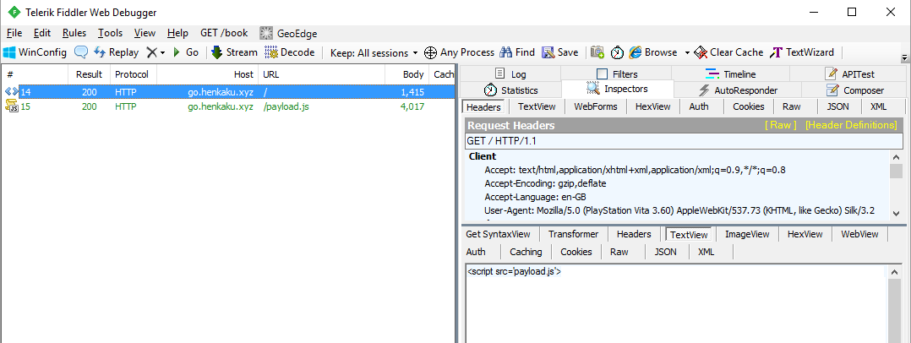
- Add html tags around the copied text in the index.html file. It should look like:
<html>
<script src=…
</html>
- Repeat for the call to go.henkaku.xyz /payload.js and save to a file called payload.js. You do not need to add html tags around this.
- Open HENkaku payload generator
- Browse to go.henkaku.xyz/x?a1=89d02000&a2=81b00240&a3=e0002190&a4=811c08d0&&a5=e062d200&a6=e0603470&a7=e0022cf0& on your pc and save the resulting file as x1.bin
- Browse to go.henkaku.xyz/x?a1=89f02000&a2=81a00060&a3=e0008820&a4=81140190&&a5=e064c2c0&a6=e0603a00&a7=e004cda0& from your pc and save the resulting file as x2.bin
- Set Get textbox in request 1 to x?a1=89d02000&a2=81b00240&a3=e0002190&a4=811c08d0&&a5=e062d200&a6=e0603470&a7=e0022cf0&
- Set Get textbox in request 2 to x?a1=89f02000&a2=81a00060&a3=e0008820&a4=81140190&&a5=e064c2c0&a6=&a7=e004cda0&
- Browse to x1.bin in Request 1 response
- Browse to x2.bin in Request 2 repsonse
- It should look as follows:

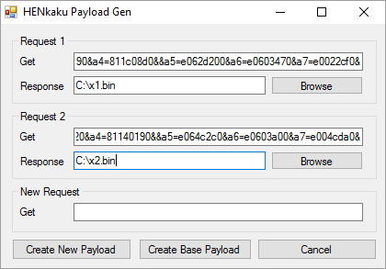
- The “Create base Payload” button should now be enabled. Click this to generate base_payload.bin and offsets.txt
- As a sanity check, copy the GET field for request 1 or 2 into New Request GET field. Click “Create New Payload”, this will generate a payload called “new_payload.bin” based off the addresses passed in. Compare this to the response saved in request 1 or 2. They should be the same. THIS IS IMPORTANT. If they do not match, repeat the process again.
- You can now setup the webservice

Part 2 – Webservice install:

- In IIS add a new Application:
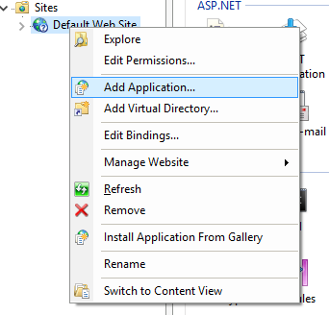
- Enter the following details:
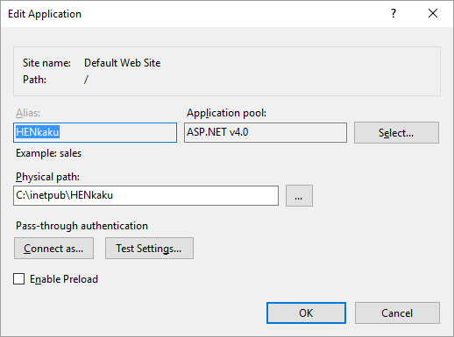
- Give “IIS AppPool\ASP.NET v4.0” user all permissions to folder C:\inetpub\HENkaku
- Set the Default Document of application HENkaku to index.html
- Download https://github.com/meetpatty/HENkaku-webserver and copy contents of folder HENkakuExploitServer to C:\inetpub\HENkaku
- Copy index.html, payload.js, base_exploit.bin and offsets.txt to c:\inetpub\HENkaku.
- Add the following rule in Fiddler to redirect the request for the payload to the local webservice (replace 192.168.1.199) with the ip address of the host machine:
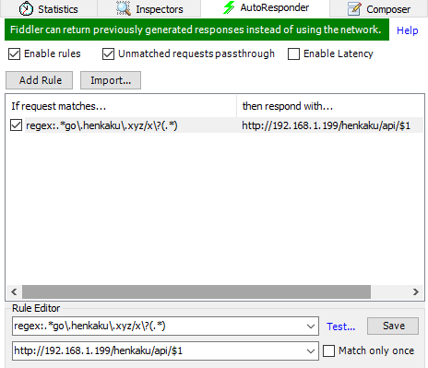

- Ensure “Enable rules” and “Unmatched requests passthrough” are enabled.
- You can test by entering http://go.henkaku.xyz/<get request from previous steps>. For example http://go.henkaku.xyz/x?a1=89d02000&a2=81b00240&a3=e0002190&a4=811c08d0&&a5=e062d200&a6=e0603470&a7=e0022cf0& This should return a file called x, which should match the response that was saved through fiddler.
- Check the textbox in “If the request matches...”
- You should now be set to go…
- Browse to <ipaddressofmachine>/henkaku on your vita. With any luck it should just work

