**Electronics Instrumentation Lab**

**Mini Project Report**



**Session: 2023-2024**

**Department:** Electronics and Communication Engineering

**Year of Study:** 4th Year

**Group Name:** am19

**Submitted By:** Harshit Kumar (204126)  
 Meet Rajesh Popat (204157)  
 Suraj Bothara (204169)

**Submitted To:** Dr. Prakash Kodali

**Title:** Normal Screen to Touch Screen using Camera Sensor

**Introduction:**

In this project, we systematically used inbuilt camera sensors, effectively transforming standard normal laptops into touch screen devices. Employing Python code for the software component, our solution adeptly identifies colors and executes corresponding actions based on predefined commands within the code. Specifically, we designated blue for cursor movement, red for a single click, green for a double click, and yellow for a right click, thereby encompassing all essential mouse functions. The flexibility of color selection is inherent in our design, allowing for interchangeable choices. Additionally, we implemented a writing screen for virtual handwriting exclusively through color detection. Despite the project's commendable functionality, minor accuracy issues surfaced due to similar colors in the environment captured by the camera frame.

**Working:**

This project started with doing in depth analysis of the available python libraries that can be used. We finally decided to move forward with the CV2 library. To test the functionality of the library, we went on testing the virtual screen writing part and tested the same. Once we got the successful result of the virtual screen, we tried to improve the accuracy. For this purpose, we defined the contour and the center of the contour. This was used for free-hand writing on the screen with the chosen color. We also implemented the clear board section on the screen.  
Then comes the second section of our project, where we now have the detection part ready and need to focus on how to provide these clicks using the mouse driver. Again, we ended up writing the python code for the same which executed our task with 100 % accuracy. Only issues remained with trade off between pixel value and the resolution value. To cover the entire screen we need to multiply with a pixel value of 2, but this reduces the exact pixel value accuracy. For instance, earlier we covered 720*720 screen pixel, but now we need to cover the 1440*1440 screen, then we end up controlling 4 points instead of 1 point with a given cursor. So we had this accuracy issue if the size of the screen increases, but works well with a normal screen.  
Finally we planned to design a hand held small device which generates different colors of light depending on the button pressed. This way we can give different instructions like cursor movement, left click, right click and double click using our prepared device.

Last step was to go for a range of color detection, for which we defined hue and saturation of the color in a range. So upper and lower limits were defined and we successfully got the desired range for the particular color.

Finally, we merged all the aforementioned steps and we had our required controller to control the screen using the inbuilt camera sensor of the laptop. Inbuilt camera sensors were used to ensure the cost effectiveness of the project.

**Result:**  
The normal laptop was successfully converted to a touch screen with a built-in device used in front of white screen. We also successfully implemented the virtual writing screen.The screenshots of the image of the running programs are attached below:

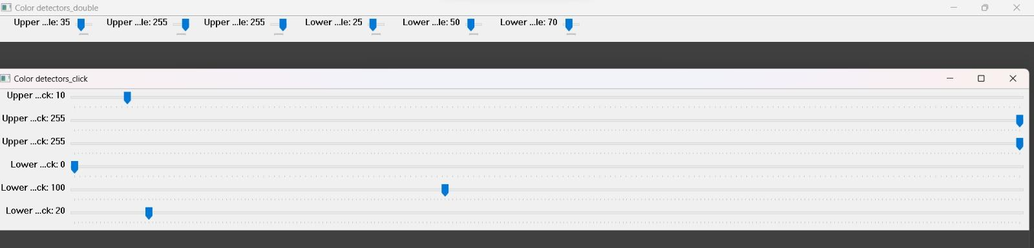

Fig 1. Upper & Lower limits adjuster for hue,saturation and value of a color

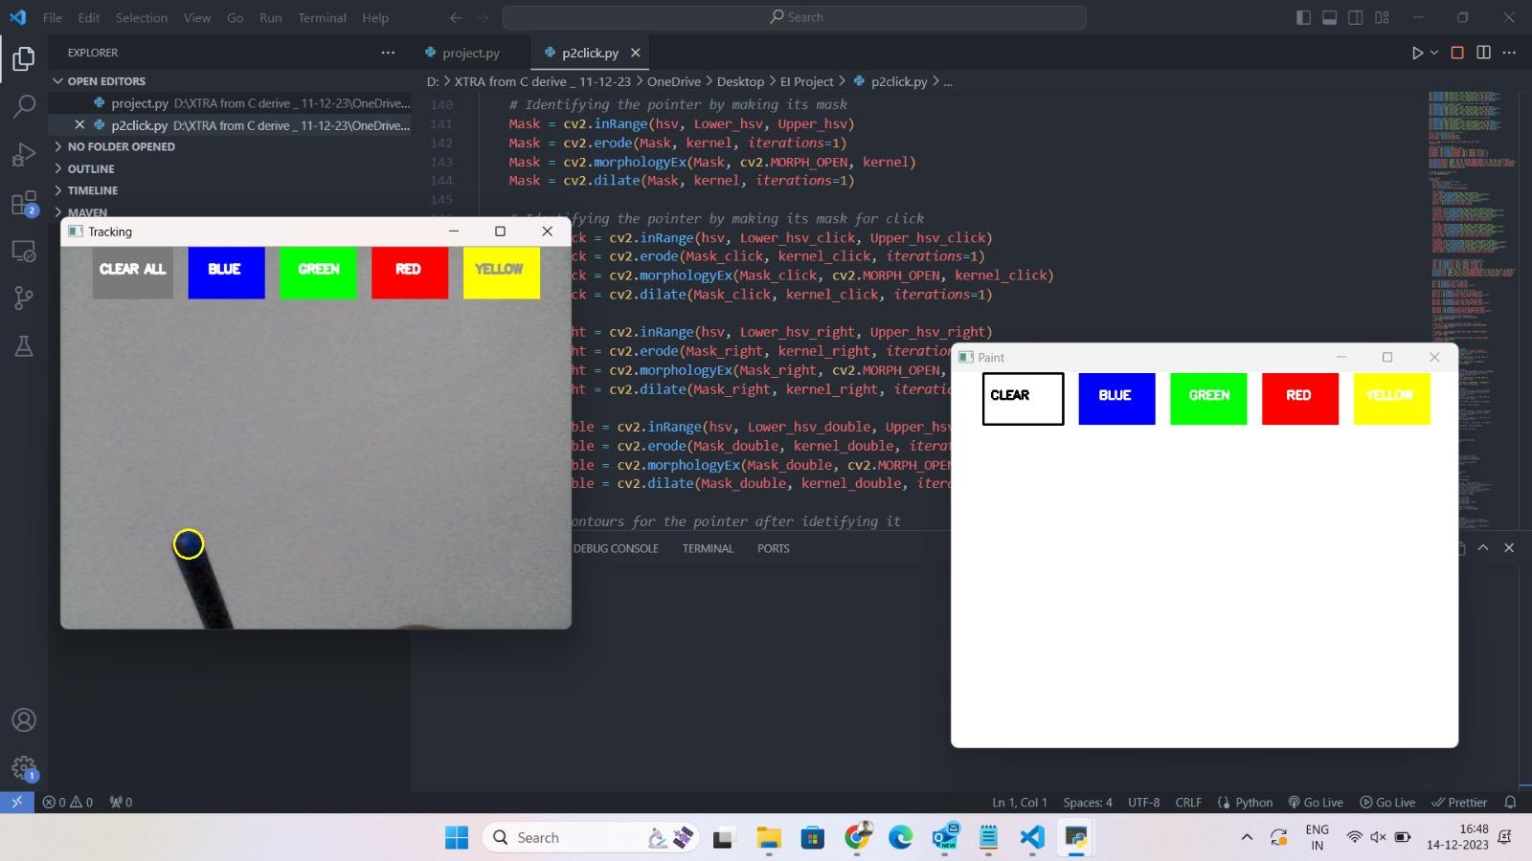

Fig 2. Color detection and corresponding mouse functionality executed

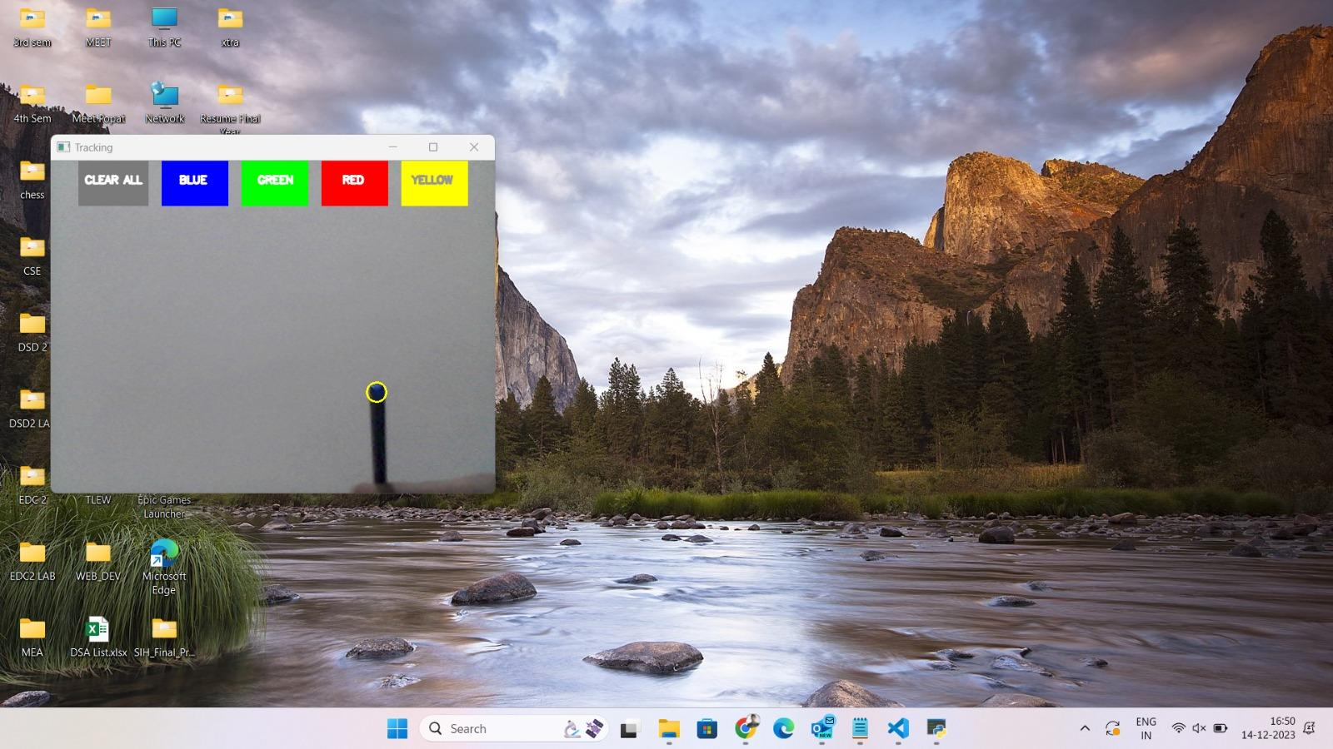

Fig 3. Color Movement and corresponding mouse pointer is moved

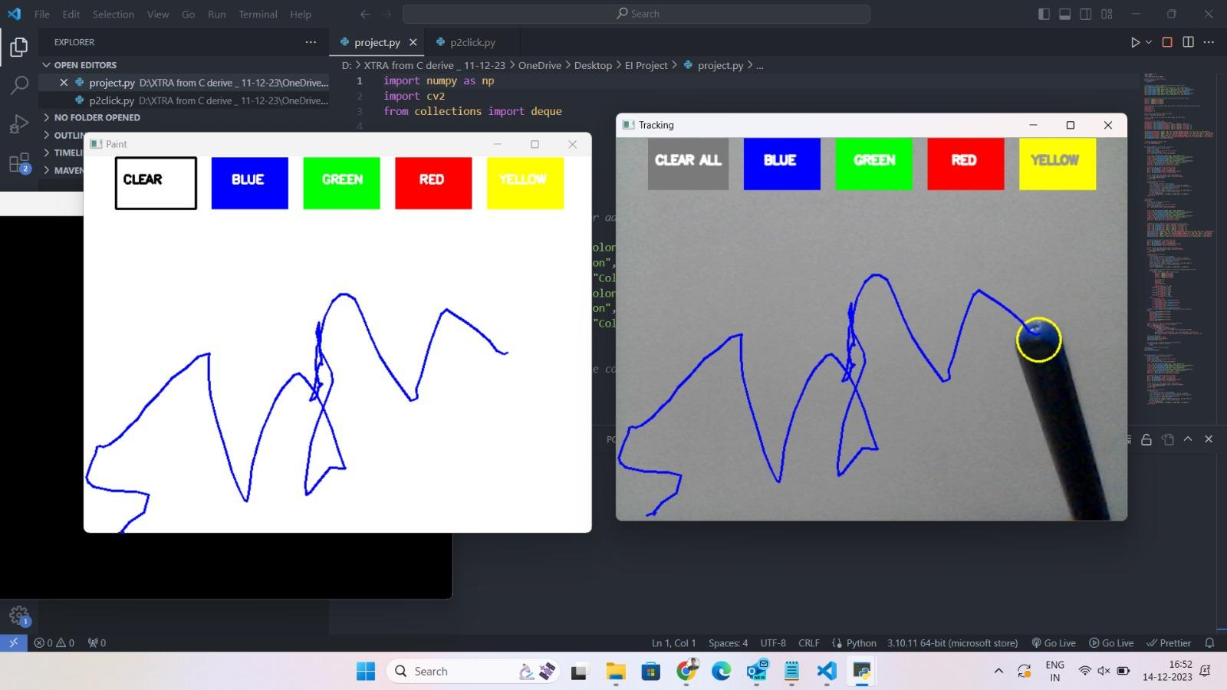

Fig 4. Virtual writing on screen using color detection

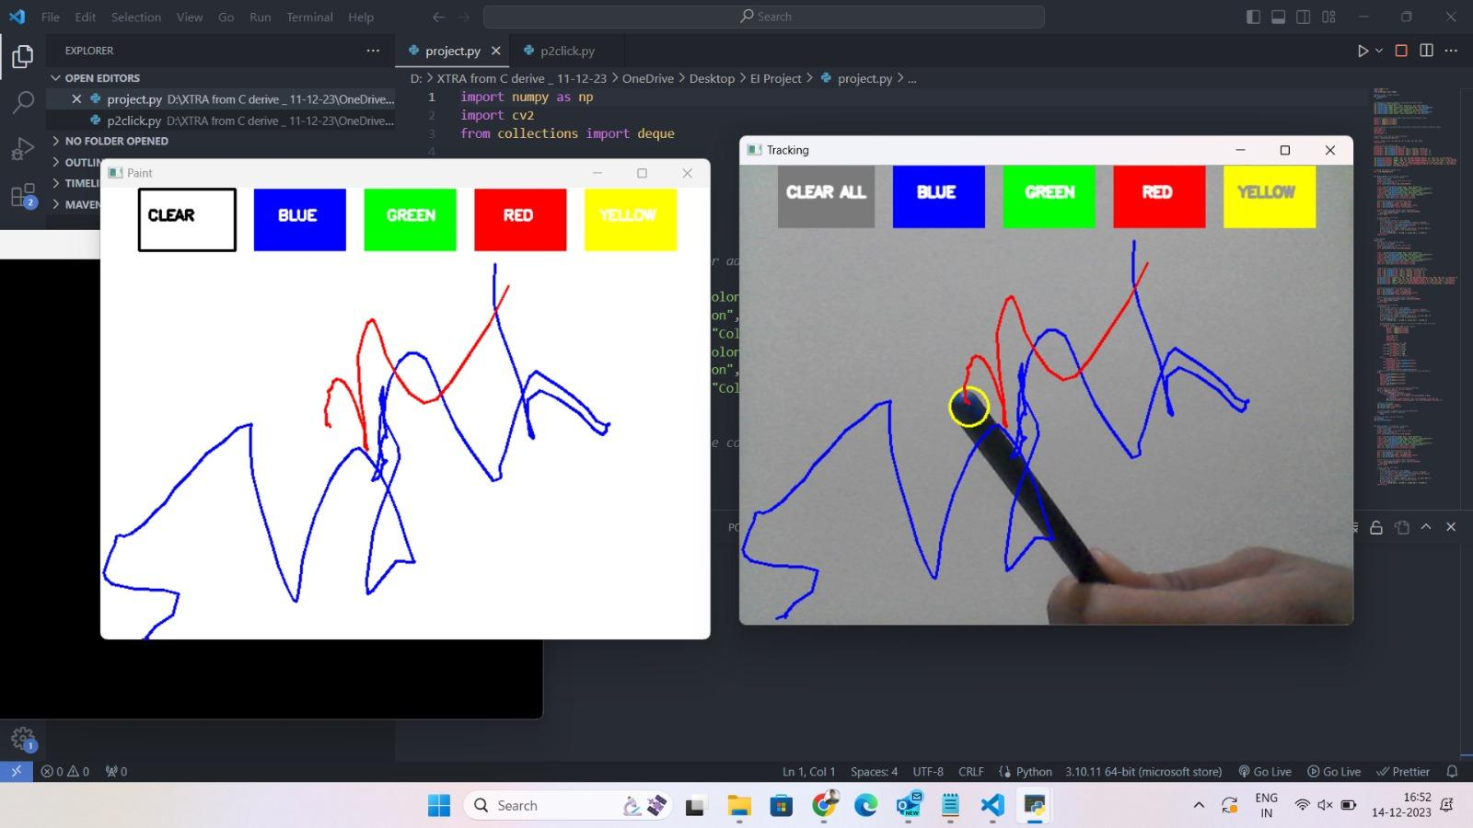

Fig 5. Four colors available to write along with CLEAR button functionality