
AI-Governed Enterprise
Knowledge Assistant

AI Ideathon 2026
Submission Document

Submitted by: Meet Patel.
Submission Date: March 31, 2026
Live Demo: https://aiideathon.vercel.app
Source Code: https://github.com/meetpstewart/AI_Ideathon
Backend API: https://ai-knowledge-backend-655994006172.us-central1.run.app

Table of Contents
1. Problem Statement 3
2. Solution Overview 3
3. Architecture Design 5
4. Working Demonstration 8
5. Competitive Differentiation - Why Not Just Use Microsoft 365 Copilot? 9

Live Deployment Summary
Component | URL / Location
Web Application | https://aiideathon.vercel.app
Backend API | https://ai-knowledge-backend-655994006172.us-central1.run.app
Slack Bot | /ask command — AI_Documentation_Assistant workspace
Source Code | https://github.com/meetpstewart/AI_Ideathon
Frontend Hosting | Vercel (auto-deploys on push to main)
Backend Hosting | Google Cloud Run (us-central1)

1. Problem Statement

Enterprise documentation at Stewart is spread across hundreds of PDF and Word files — difficult to search, dependent on subject matter experts, and inaccessible to most employees. When teams attempt to use general-purpose AI tools (like ChatGPT) to answer internal questions, they face two critical risks:
- Hallucination — the AI answers from its training data, not from Stewart's actual documents, producing plausible but potentially wrong information
- No traceability — there is no way to verify or audit where an AI answer came from, violating enterprise governance and compliance standards

The core problem: How do we give employees fast, accurate answers from internal documentation — without hallucination risk and with full traceability?

2. Solution Overview

The AI-Governed Enterprise Knowledge Assistant is a RAG-based (Retrieval-Augmented Generation) AI system that answers employee questions strictly from approved Stewart documentation — with every answer cited, traceable, and confidence-rated.
How It Works
Instead of asking an AI to guess from its training data, the system first searches approved documents for the most relevant passages, then hands those passages to the AI and instructs it: "Answer using only this." The AI responds with the answer and a citation pointing back to the exact document it used.

Comparison — Our System vs Generic AI
Feature | Generic AI (ChatGPT, etc.) | Our System
Source of answers | AI training data (internet) | Approved Stewart documents only
Hallucination risk | High | Eliminated by design
Traceability | None | Every answer cited to source document
Confidence rating | None | FULL / PARTIAL / NO SUPPORT
Enterprise governance | None | Built-in — no data leaves GCP
Conversation memory | Session-based | Multi-turn with context
Access channels | Web only | Web UI + Slack bot

Key Features Delivered
- Cited answers — every response includes numbered citations [1] linked to source documents
- Confidence scoring — answers rated FULL SUPPORT, PARTIAL SUPPORT, or NO SUPPORT
- Multi-turn conversation — follow-up questions maintain full context (last 3 turns)
- Suggested follow-ups — AI proactively suggests 3 related questions after each answer
- Thumbs up / down feedback — per-answer helpfulness rating
- Session analytics — real-time dashboard: confidence breakdown, satisfaction rate, top referenced documents
- Slack bot integration — /ask slash command works in any Slack channel
- Stewart-branded UI — full enterprise design with official branding, colours, and logo

3. Architecture Design

Technology Stack
Layer | Technology | Purpose
Frontend | React 19 + Vite, hosted on Vercel | Web UI — chat, analytics, branding
Backend | Python FastAPI on Google Cloud Run | REST API, RAG orchestration
AI Search | Google Discovery Engine (Vertex AI) | Semantic document search + retrieval
AI Model | Gemini 2.5 Flash (Vertex AI) | Answer synthesis + follow-up generation
Embeddings | text-embedding-004 (Vertex AI) | Document vectorisation (offline)
Storage | Google Cloud Storage | Approved documents + embeddings
Messaging | Slack API (slash commands) | Bot integration for /ask

Google Cloud Services Used
GCP Service | Role in the System
Vertex AI — Gemini 2.5 Flash | Generates grounded answers from retrieved document context
Vertex AI — Discovery Engine | Indexes documents and performs semantic search at query time
Vertex AI — text-embedding-004 | Converts document chunks to vectors for semantic indexing
Cloud Run | Hosts FastAPI backend as a serverless, auto-scaling container
Cloud Storage (GCS) | Stores approved documents and generated embeddings
Cloud Build | Builds Docker container images on every deployment
Artifact Registry | Stores built container images for Cloud Run
Cloud IAM | Controls service-to-service authentication and permissions

RAG Pipeline — How Answers Are Generated
User Question
|
v
Discovery Engine searches indexed documents
|
v
Top 3 most relevant document passages retrieved
|
v
Numbered context block built:
[1] Source: Cloud Infrastructure — "The Quarter Rack has 1440 GB RAM..."
[2] Source: App Service Guide — "..."
|
v
Gemini prompt: "Answer ONLY using the numbered sources. Use citation [1]."
|
v
Gemini generates answer + 3 follow-up questions
|
v
Citations validated, confidence calculated, response returned

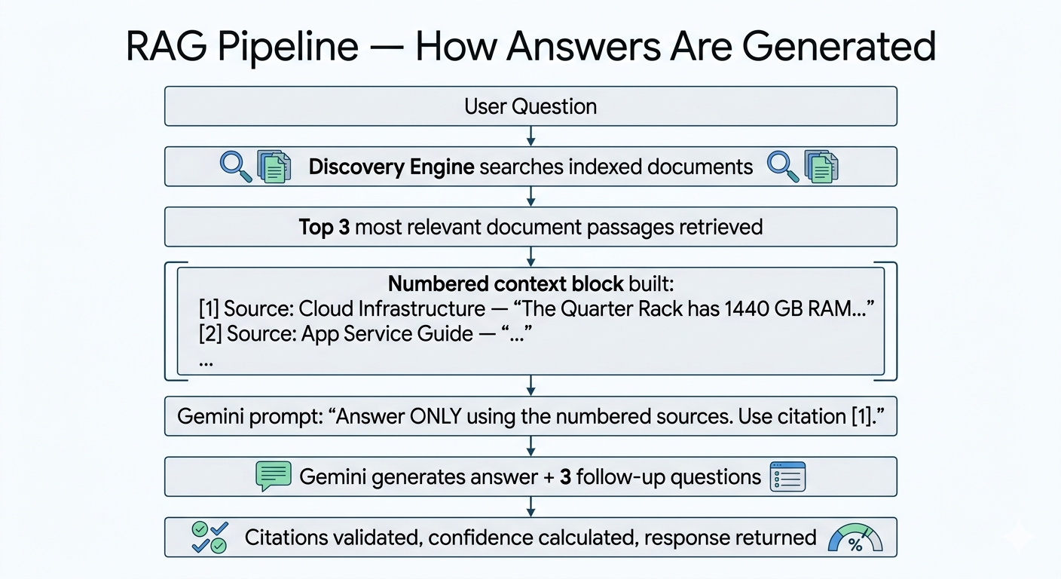

Document Ingestion Pipeline (Offline)
Approved PDFs / DOCX files
-> Text extraction (python-docx, pypdf)
-> Token-aware chunking (700 tokens, 100-token overlap via tiktoken)
-> Embedding generation (text-embedding-004 via Vertex AI)
-> Stored in GCS -> Indexed by Discovery Engine

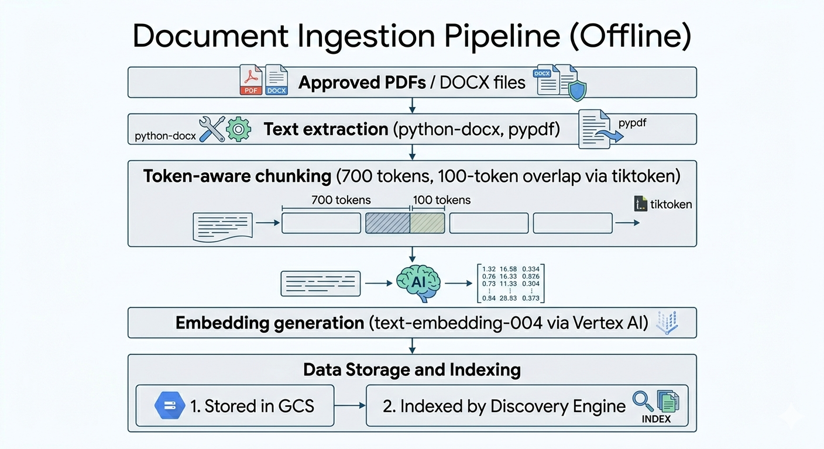
Confidence Scoring Logic
Confidence Level | Condition | Meaning
FULL SUPPORT | 2 or more documents cited | Answer corroborated by multiple independent sources
PARTIAL SUPPORT | Exactly 1 document cited | Answer sourced from a single document
NO SUPPORT | No documents cited | Could not be grounded — fallback message shown

4. Working Demonstration

Live URLs
 | URL
Web Application | https://aiideathon.vercel.app
Backend Health | https://ai-knowledge-backend-655994006172.us-central1.run.app
Slack | /ask in AI_Documentation_Assistant workspace

Demo
Step 1 — Open the web app
Navigate to https://aiideathon.vercel.app on any browser or mobile device.
Step 2 — Ask a question
Click a starter chip or type: "What are the RMI ports for distributed installation?"
Observe: Answer with [1] citation superscripts
Observe: FULL / PARTIAL SUPPORT confidence badge
Observe: Expandable source document card
Observe: 3 follow-up question chips
Step 3 — Click a follow-up chip
Click one of the suggested follow-up questions.
Observe: Answer references the previous turn (multi-turn memory active)
Step 4 — Rate the answer
Click the thumbs up or thumbs down button on any response.
Step 5 — View Analytics tab
Click Analytics in the left sidebar.
Observe: Questions asked, answers generated, satisfaction rate, confidence breakdown, top documents
Step 6 — Slack demo
In the Slack workspace, type in any channel:
/ask What is the total RAM capacity for Exadata System Configuration?
Observe: Instant acknowledgment < 1 second
Observe: Full answer posted with confidence emoji, sources, follow-up suggestions

Governance Demo
- Ask a question NOT covered in the documents → System says "The information is not available in the approved documentation" — it does not hallucinate
- Show the NO SUPPORT confidence badge when triggered
- Show source cards — every claim traceable to an exact document with title and link
- Show Analytics tab — confidence breakdown proves governance is measurable

5. Competitive Differentiation - Why Not Just Use Microsoft 365 Copilot?

A common question when evaluating this project: "Doesn't Microsoft 365 Copilot already do this?"
The short answer: Copilot solves a similar problem space, but in a fundamentally different — and less governed — way.
Feature Comparison
Feature | M365 Copilot | Our System
Cost | ~$30/user/month ($360/user/year) | GCP pay-per-use (cents per query)
Document scope | Searches ALL files user can access | Only explicitly approved documents
Citation level | General "based on your files" | Numbered [1] citations per sentence
Confidence scoring | None | FULL / PARTIAL / NO SUPPORT
Governance control | Microsoft controls the stack | 100% isolated in Stewart's GCP project
Approval workflow | No document gating | Only approved docs can be cited
Custom branding | Microsoft UI only | Full Stewart brand identity
Session analytics | None | Confidence breakdown + satisfaction rate
Follow-up suggestions | Basic | Context-aware, topic-specific chips
Vendor dependency | Deep Microsoft lock-in | Portable — any GCP service swappable
M365 license required | Yes — E3/E5 + Copilot add-on | No — open web + Slack
Data residency | Microsoft processes your data | Data never leaves your GCP project

The Core Governance Difference
Microsoft 365 Copilot searches everything a user has permission to access — SharePoint, OneDrive, emails, Teams chats. There is no document approval layer. A user asking about cloud infrastructure might get an answer pulled from an outdated email thread, an unapproved draft, or an irrelevant HR document.
Our system inverts this: only documents that have been explicitly approved, ingested, and indexed can ever appear in an answer. This is a fundamentally different trust model — one that aligns with enterprise compliance, legal defensibility, and audit requirements.
The Citation Difference
Copilot tells you an answer came "from your SharePoint files."
Our system tells you: "The Quarter Rack has 1440 GB RAM [1] — sourced from Cloud Infrastructure Guide, page 4." Every factual claim is numbered, every number links to a specific document card with title, URI, and the exact passage used. That is citation-level accountability that Copilot does not offer.
The Cost Difference
Scenario | M365 Copilot | Our System
100 users, 1 year | ~$36,000 | ~$50–200 (GCP usage only)
Requires M365 E3/E5 license | Yes (~$36/user/month extra) | No
Per-query cost model | Flat subscription | Pay only for what you use

Summary
This project demonstrates a production-deployed, enterprise-grade AI system built entirely on Google Cloud Platform during the AI Ideathon 2026. It directly addresses a real business problem at Stewart — knowledge accessibility and AI governance — using industry-standard patterns (RAG, grounding, citation tracking) deployed on GCP-native infrastructure.
The system is live, accessible from any device, and fully functional at https://aiideathon.vercel.app and via the Slack bot — not a prototype or mockup.
────────────────────────────────────────────────────────────────────────────────
AI Ideathon 2026 · Stewart Title Guaranty Company · © 2026 All Rights Reserved

