Practical 21

Task: -
- Deploy the application to the local IIS server and SQL server by publishing the application locally.
- Understand IIS logs and Application Pools.
- Use and understand the workings of the hosted (deployed) application by interacting with the UI.

Note: -
- For deploying purposes, the Practical 20 code base is used.
- While publishing the project “Folder” option is selected as target and then that folder is used by IIS.

Steps: -
- Download and install the Hosting Bundle from official page, select the latest long term supported dotnet version and then search on page for “Hosting Bundle” and then download and install it.
- Enable IIS windows feature in your computer and enable below options.
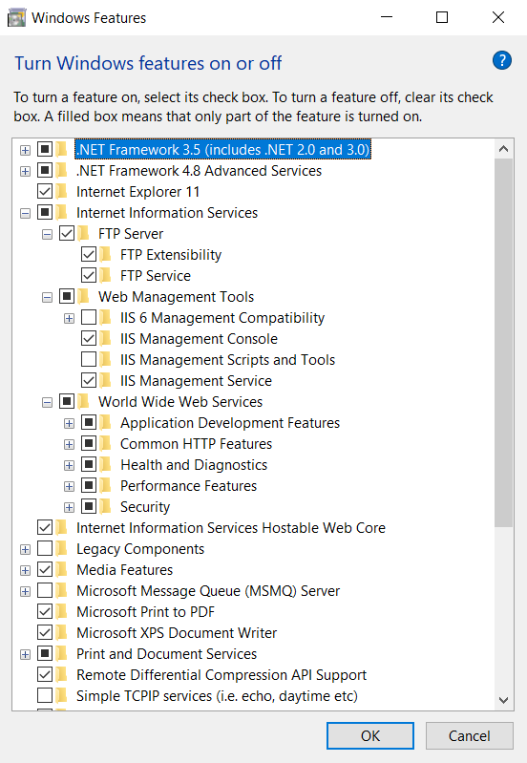
- Now open your project in Visual Studio and right-click on main project that can be deployed and click on “Publish”.
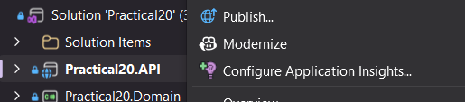

- Now select Folder as publish Target option.
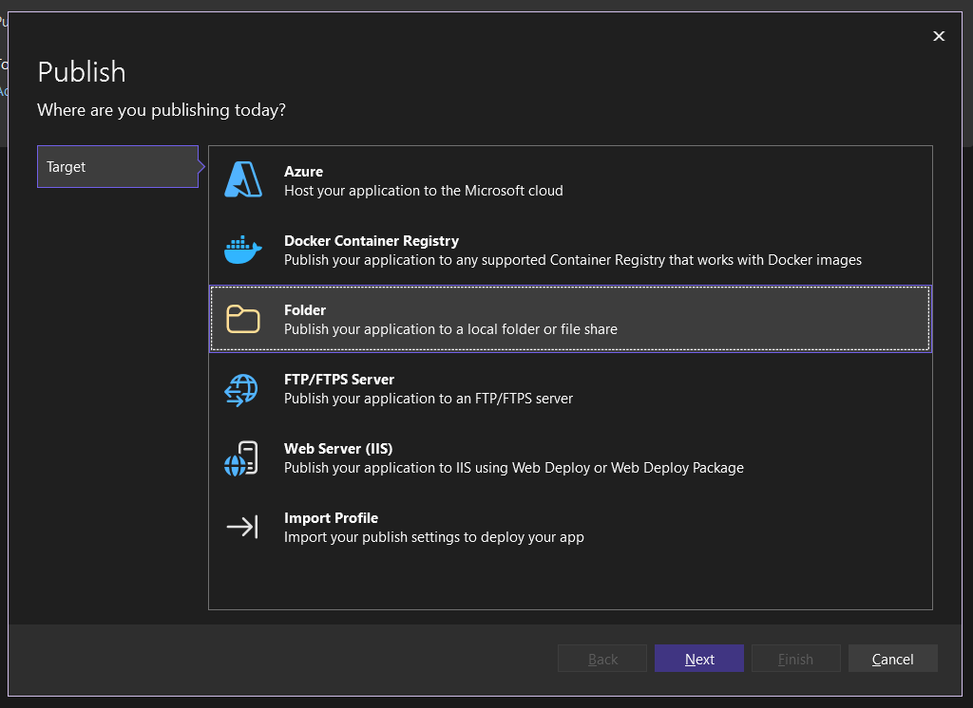

- Then select the location where you want to place the folder for deployment. And then click on Finish and at last click on Finish.
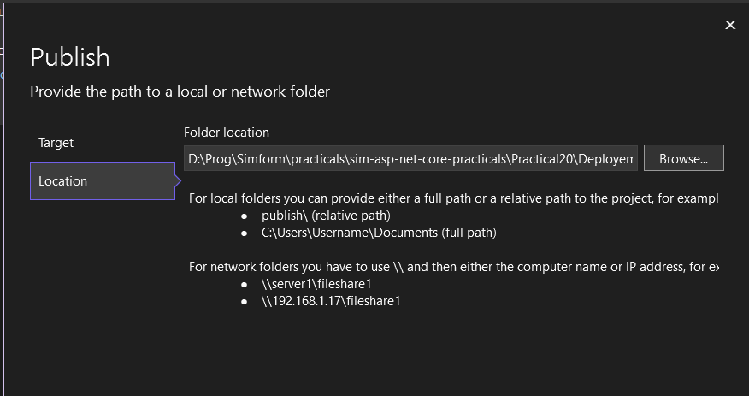

- Now for that folder give permission to access the folder to IIS_IUSRS from going to Properties > Security tab > Advanced > Add > Select Principle > Type IIS_IUSRS in object name > click on Check Names > click on OK
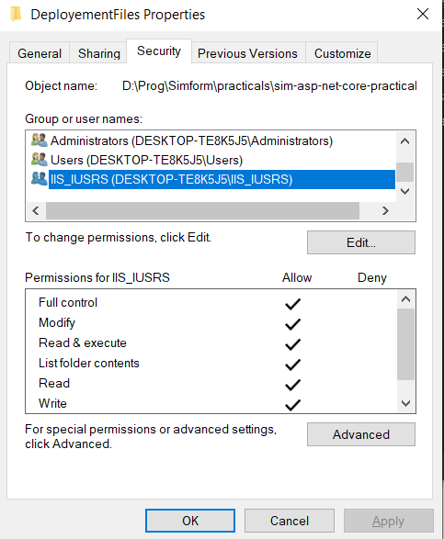

- Open IIS Manager and right-click on Sites add select Add Website.

- Then Give Name, select our published folder as physical path and select an un-used port for the website.
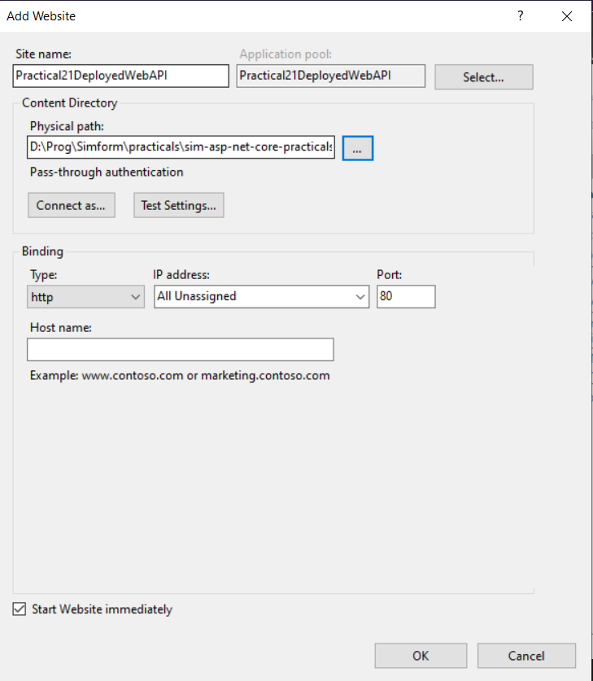

- In Application Pool, Right click your Project and go to its advanced setting then switch “.NET CLR Version” to “No Managed Code” as .Net 5+ apps not run directly on IIS.

- Now select your new website created from left pane and then open Configuration Editor from center pane.
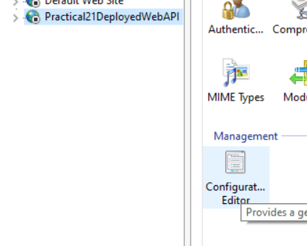
- Click on three dots at the end of environmentVariables and there you can provide your environment variables and then restart the website from IIS Manager right side pane.

- Use SQL Server database for deploying and not localdb as it is user only database provided by SSMS otherwise there will be error while connecting to database from IIS hosted website.

- Now at last you can browse your website from your host and port.
