**Bandit - Over The Wire**

Level - 0:

Login Command - ssh bandit0@bandit.labs.overthewire.org -p 2220

Password - bandit0

Next level Password -



Level - 1:

Login Command - ssh bandit1@bandit.labs.overthewire.org -p 2220

Password - NH2SXQwcBdpmTEzi3bvBHMM9H66vVXjL

Next level Password -



Level - 2:

Login Command - ssh bandit2@bandit.labs.overthewire.org -p 2220

Password - rRGizSaX8Mk1RTb1CNQoXTcYZWU6lgzi

Next level Password -

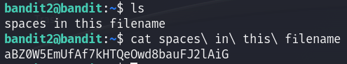

Level - 3:

Login Command - ssh bandit3@bandit.labs.overthewire.org -p 2220

Password - aBZ0W5EmUfAf7kHTQeOwd8bauFJ2lAiG

Next level Password -

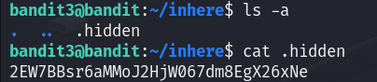

Level - 4:

Login Command - ssh bandit4@bandit.labs.overthewire.org -p 2220

Password - 2EW7BBsr6aMMoJ2HjW067dm8EgX26xNe

Next level Password -



Level - 5:

Login Command - ssh bandit5@bandit.labs.overthewire.org -p 2220

Password - lrIWWI6bB37kxfiCQZqUdOIYfr6eEeqR

Next level Password -



Level - 6:

Login Command - ssh bandit6@bandit.labs.overthewire.org -p 2220

Password - P4L4vucdmLnm8I7Vl7jG1ApGSfjYKqJU

Next level Password -



Level - 7:

Login Command - ssh bandit7@bandit.labs.overthewire.org -p 2220

Password - z7WtoNQU2XfjmMtWA8u5rN4vzqu4v99S

Next level Password -

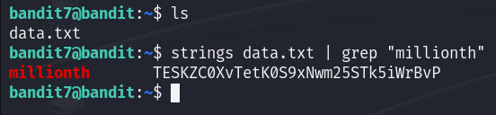

Level - 8:

Login Command - ssh bandit8@bandit.labs.overthewire.org -p 2220

Password - TESKZC0XvTetK0S9xNwm25STk5iWrBvP

Next level Password -



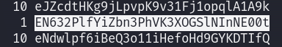

Level - 9:

Login Command - ssh bandit9@bandit.labs.overthewire.org -p 2220

Password - EN632PlfYiZbn3PhVK3XOGSlNInNE00t

Next level Password -

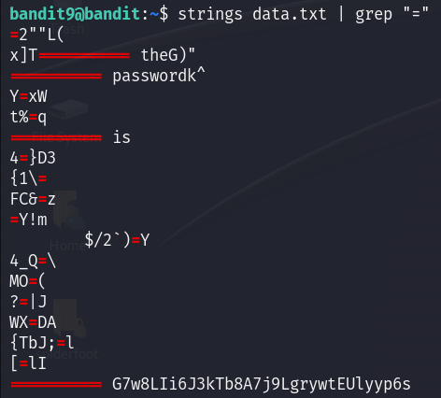

Level - 10:

Login Command - ssh bandit10@bandit.labs.overthewire.org -p 2220

Password - G7w8LIi6J3kTb8A7j9LgrywtEUlyyp6s

Next level Password -

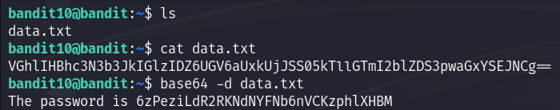

Level - 11:

Login Command - ssh bandit11@bandit.labs.overthewire.org -p 2220

Password - 6zPeziLdR2RKNdNYFNb6nVCKzphlXHBM

Next level Password -

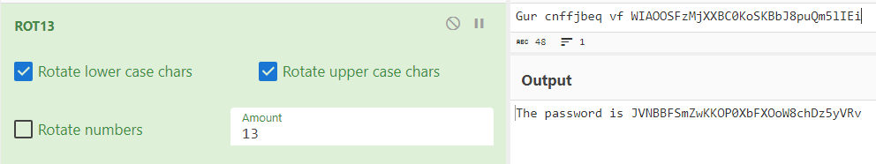

Level - 12:

Login Command - ssh bandit12@bandit.labs.overthewire.org -p 2220

Password - JVNBBFSmZwKKOP0XbFXOoW8chDz5yVRv

Next level Password -

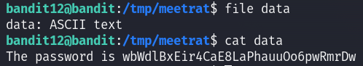

Level - 13:

Login Command - ssh bandit13@bandit.labs.overthewire.org -p 2220

Password - wbWdlBxEir4CaE8LaPhauuOo6pwRmrDw

Next level Password -



Level - 14:

Login Command - ssh bandit14@bandit.labs.overthewire.org -p 2220

Password - fGrHPx402xGC7U7rXKDaxiWFTOiF0ENq

Next level Password -

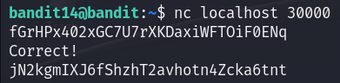

Level - 15:

Login Command - ssh bandit15@bandit.labs.overthewire.org -p 2220

Password - jN2kgmIXJ6fShzhT2avhotn4Zcka6tnt

Next level Password -

