MY FILLED FORM

BUSINESS ADDRESS
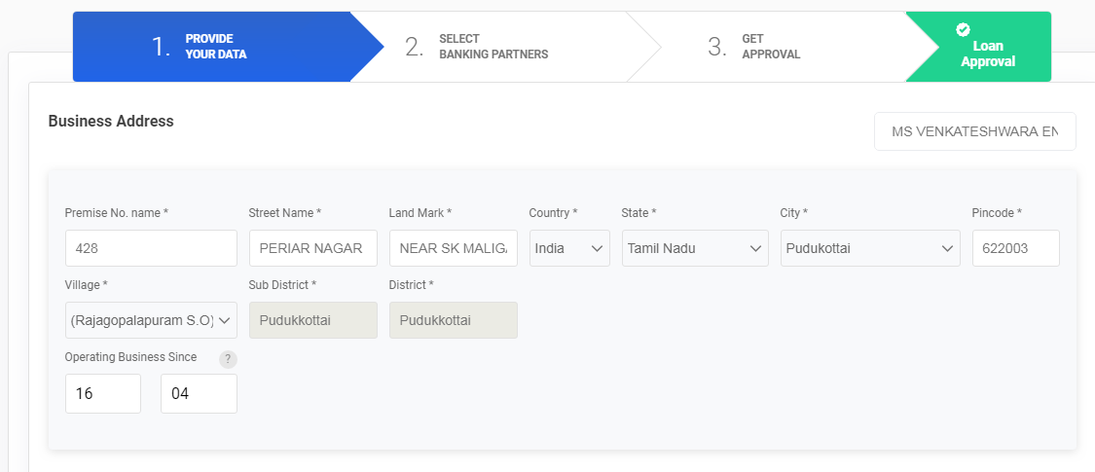
PROPRIETOR DETAILS
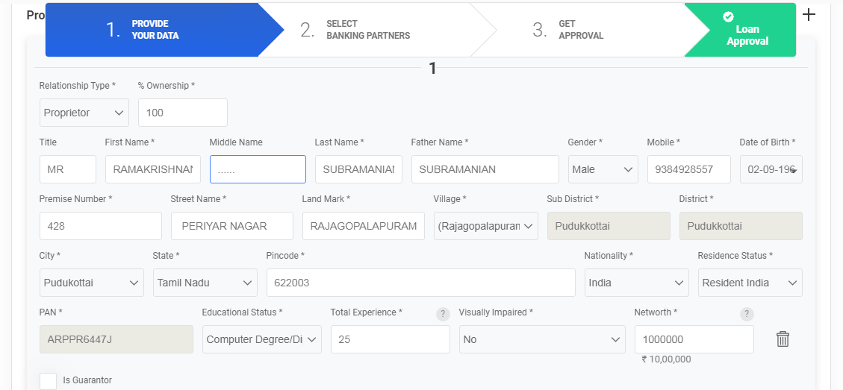
PROMOTER DETAILS
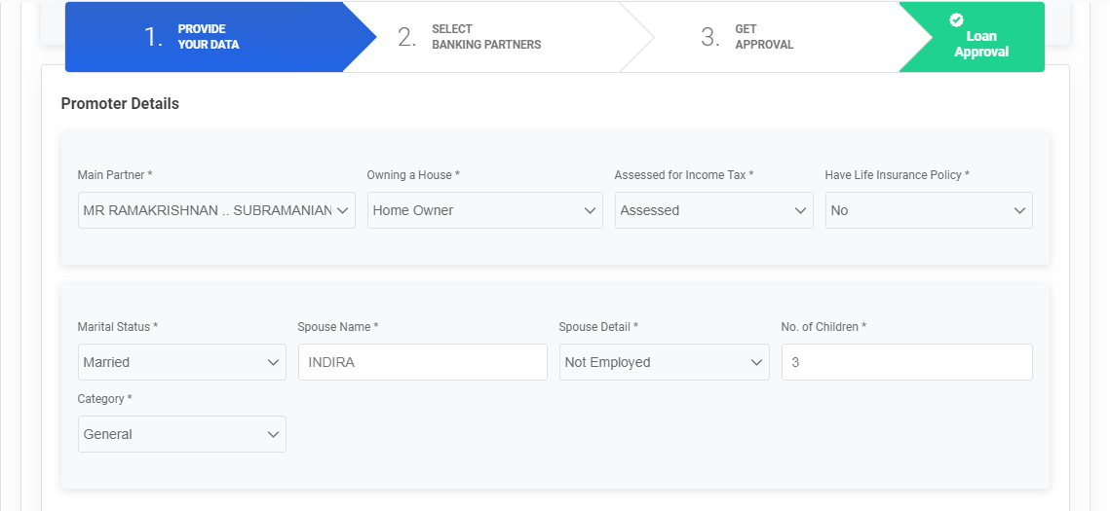

ERROR
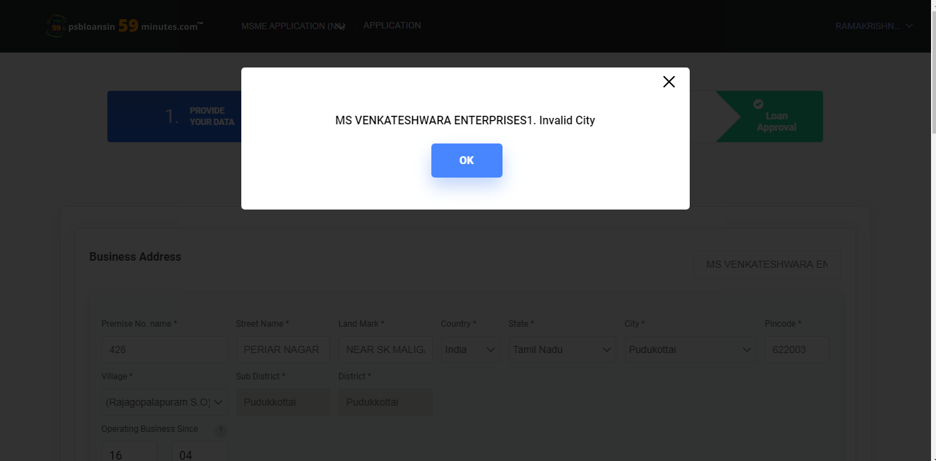

WHY
DETAILS FOR THE CORRECT PICODE AND CITY
