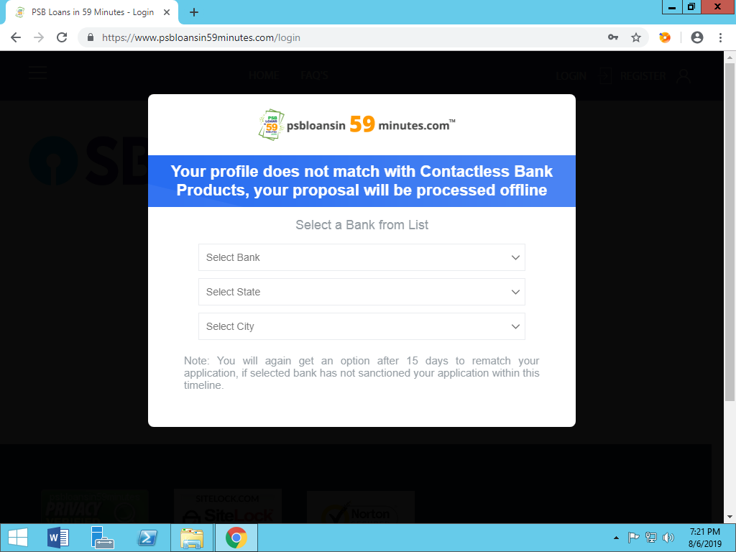

SUPPORT@PSPLOANSIN59MINUTES.COM