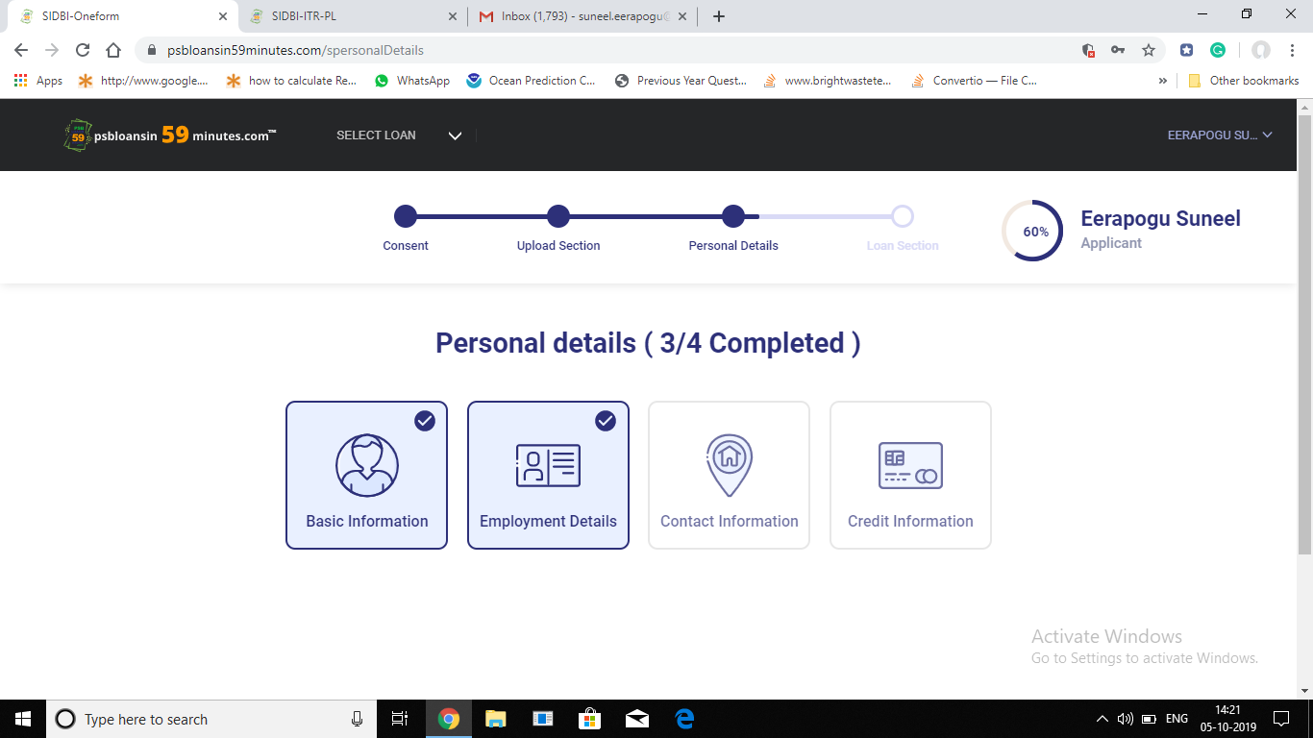

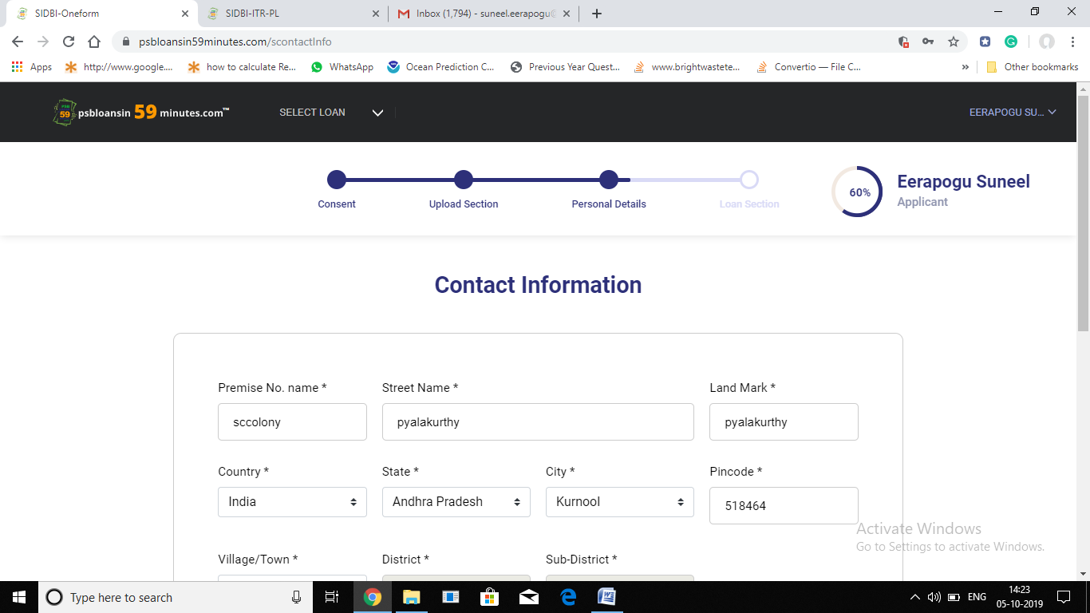

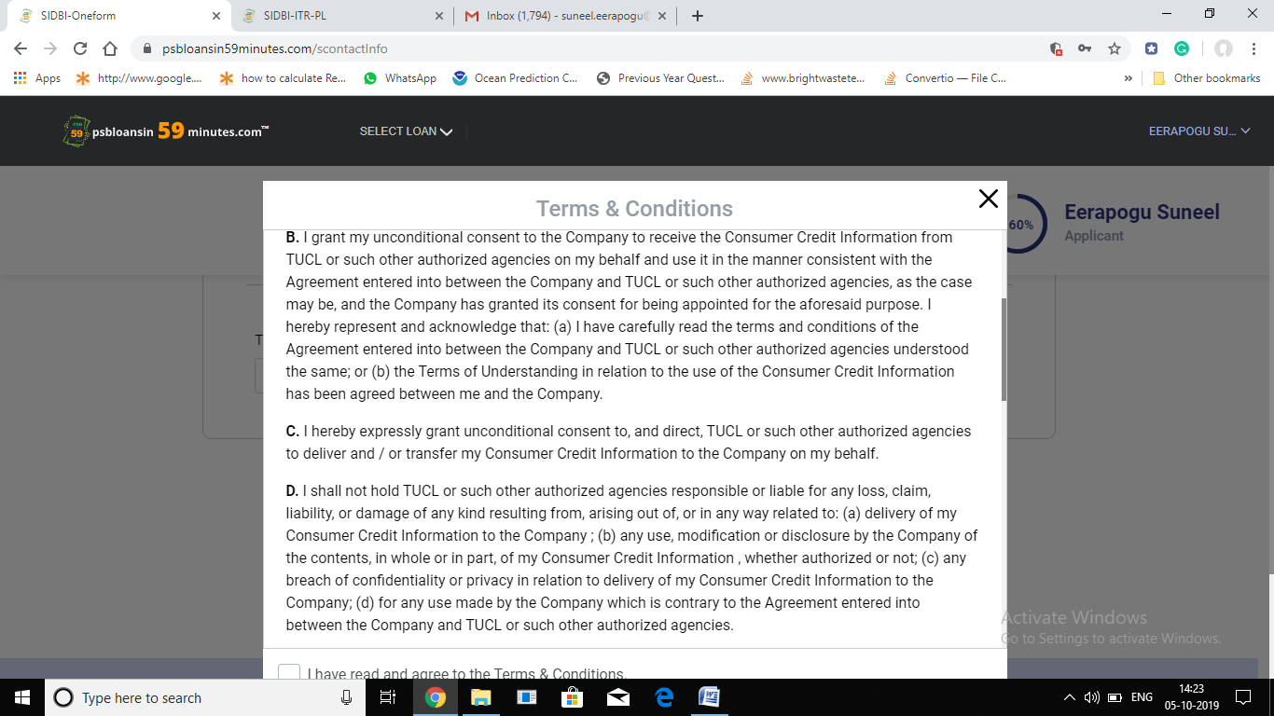

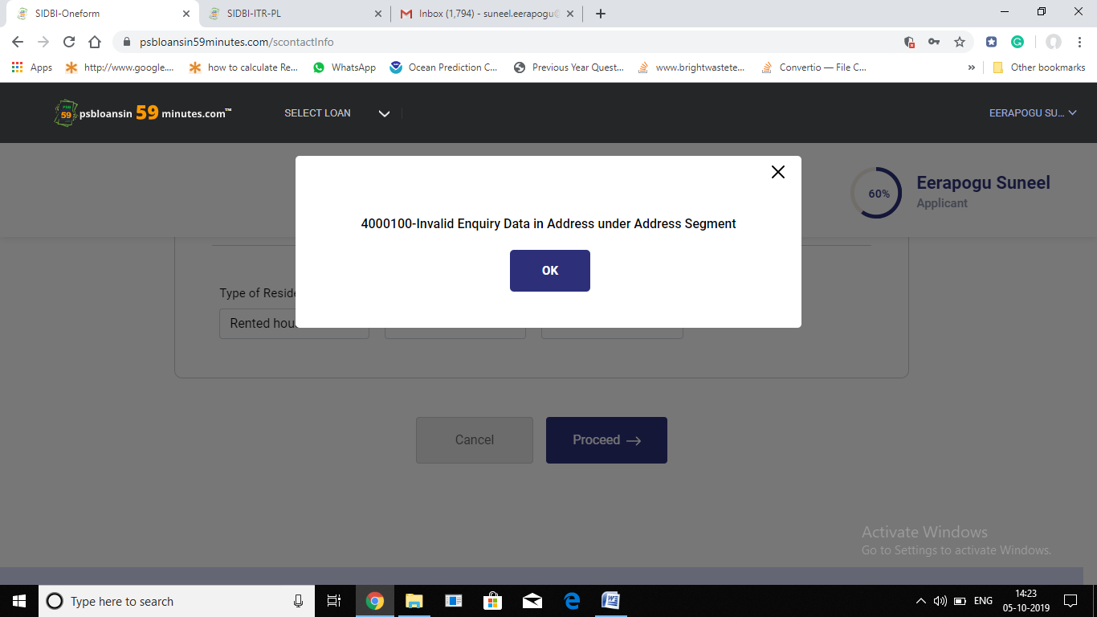

Sir what can i do sir ...... till 1month same massage will come sir ..how can i salove sir..pls rectifier my problem other wise not solve pls remove my application ...i will apply fresh ok sir