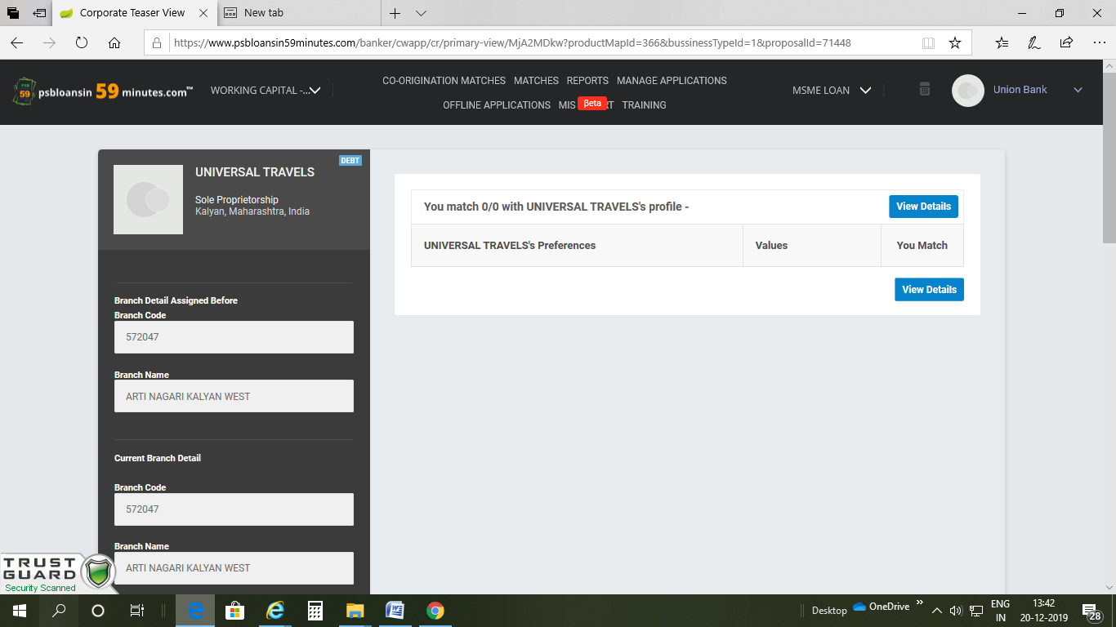

No Accept,Approve,Reject tab available