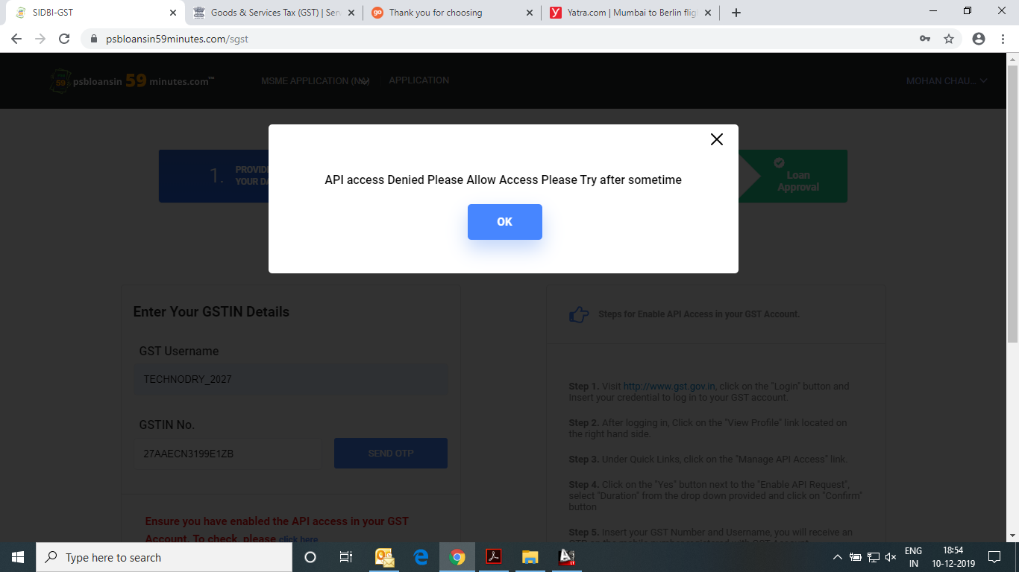

Mobile no. 9665036923

Email I.D. – [mohan@technodrysystems.com](mailto:mohan@technodrysystems.com)

G.S.T. no. – 27AAECN3199E1ZB