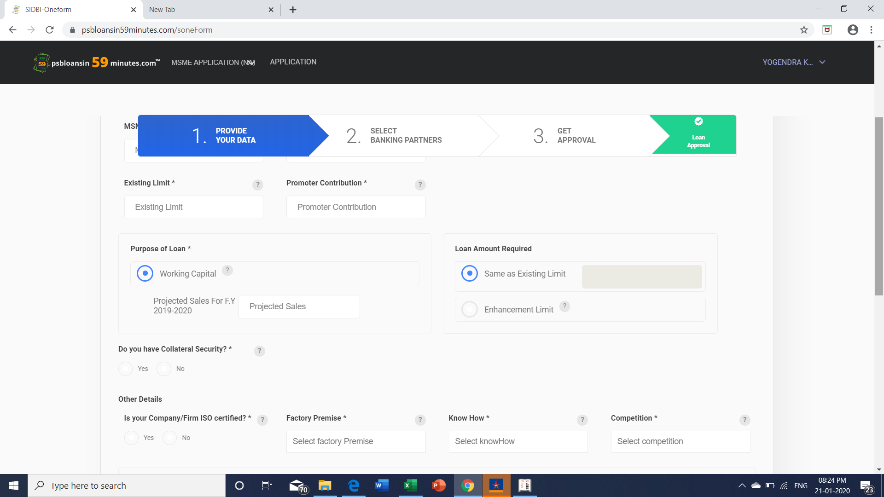

Same as exsisting limit option is greyed out without any amount. The filed is not enterable.

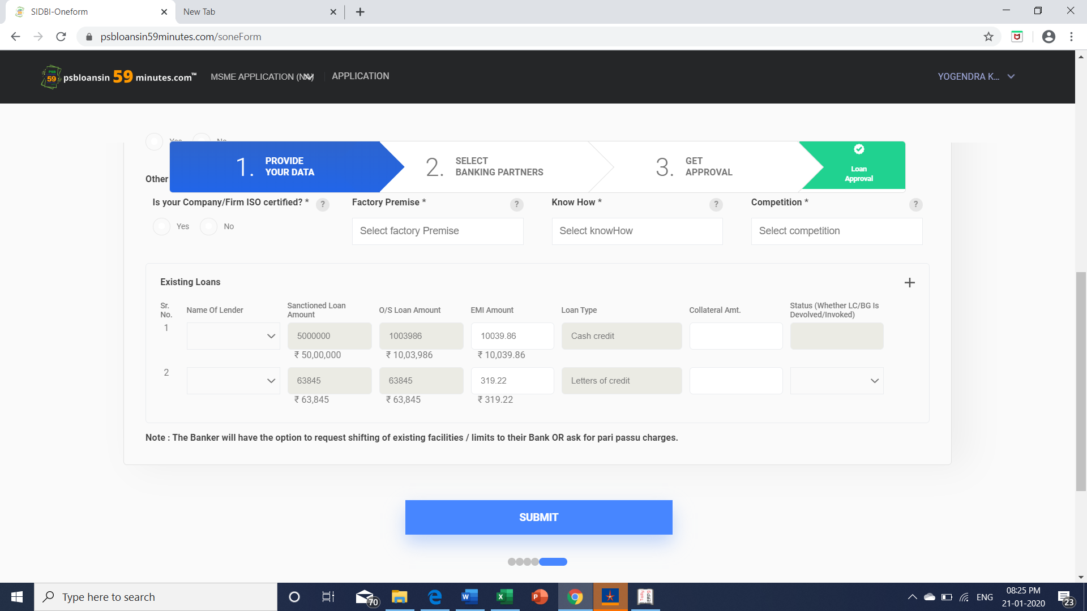

In LC Sanctioned amount is Rs. 75,00,000 but the data shows only Rs. 63,845

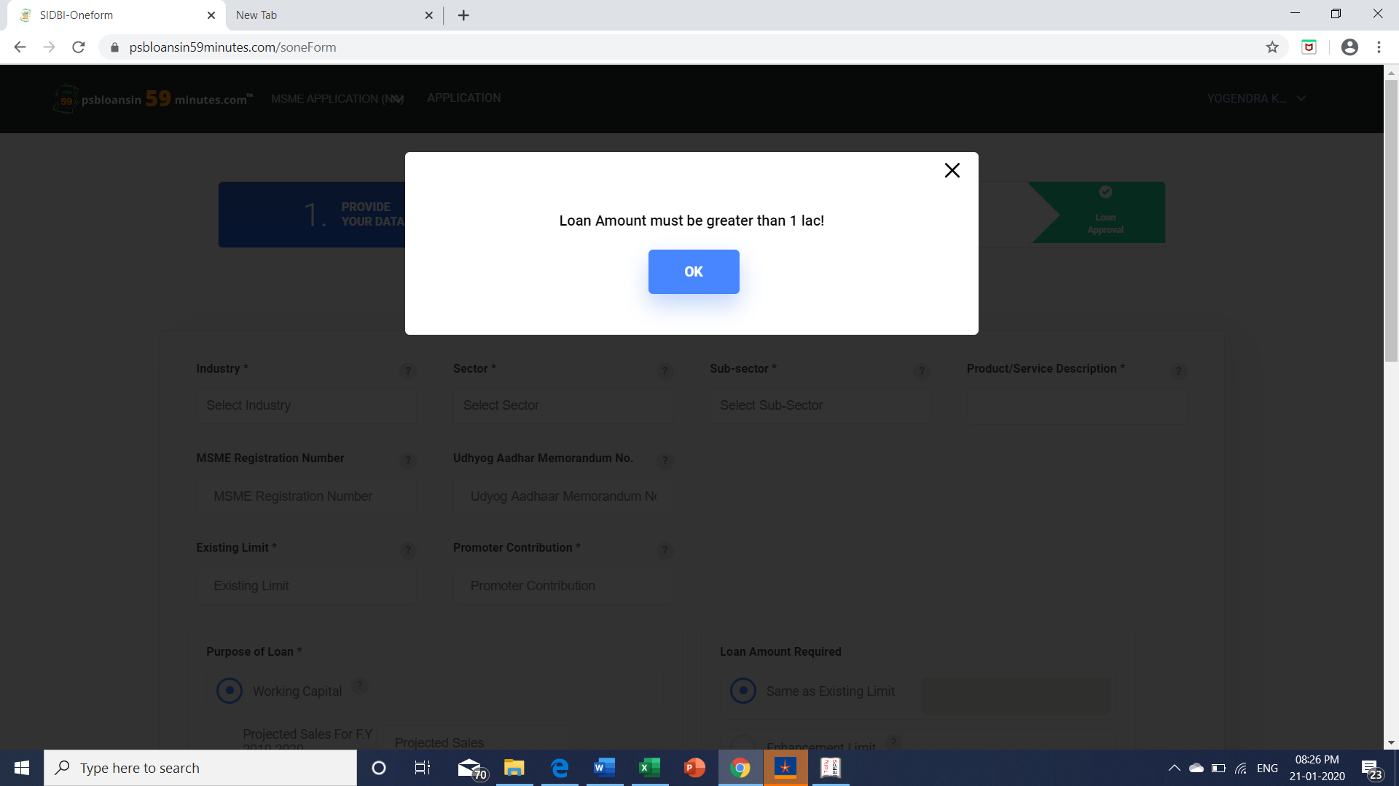

After entering the required details it shows the above mentioned message.