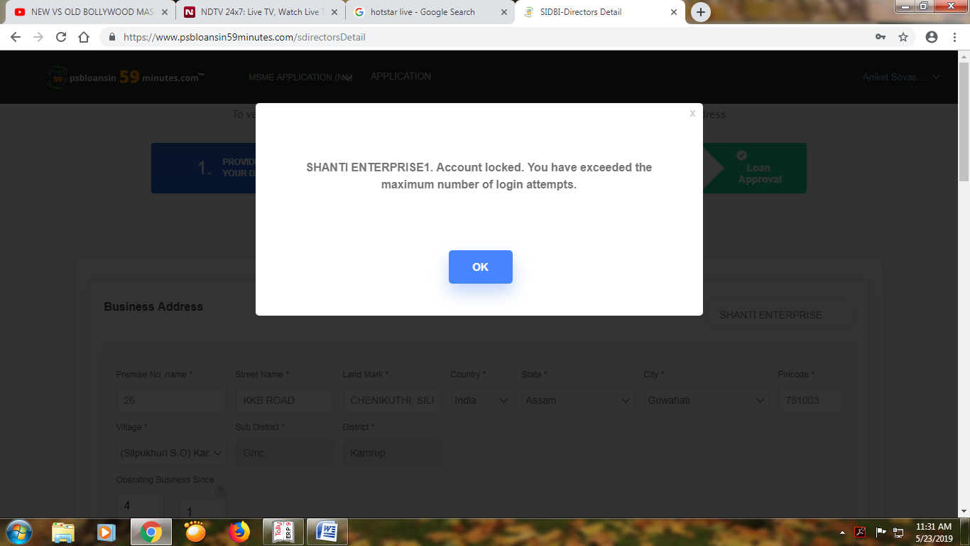

<https://www.psbloansin59minutes.com/sdirectorsDetail>

it’s the url of PNB.

While submission the screenshot appears.