NIFTY 50 CORRECTION-RISK
PREDICTION
Machine Learning Project Report

Project outcome, methodology, model comparison and interpretation

B.Tech – Production Engineering | NIT Tiruchirappalli
Historical dataset: 8 December 2010 – 31 December 2020

1. Executive Summary
This project investigates whether market indicators and historical NIFTY 50 price behaviour can help identify periods associated with an upcoming market correction. The study compares Logistic Regression and Random Forest classifiers and benchmarks them against a simple India VIX threshold rule.
On the supplied target labels and the chronological test set, Logistic Regression produced the strongest overall result: 90.2% precision, 87.4% recall, an F1-score of 0.888 and average precision (PR-AUC) of 0.947. It identified 166 of the 190 positive test labels, missed 24, and generated 18 false alarms. Random Forest generated slightly fewer false alarms but missed more positive labels. The VIX-only rule had high recall but generated many false alarms.
The result should be interpreted as a model-development experiment, not as proof that the system can reliably forecast real-world market corrections. The input file contains known calendar/date irregularities, suspicious price movements and target-label inconsistencies; the supplied labels were retained as requested.

2. Problem Statement
Market corrections can develop over time and may be accompanied by changes in volatility, valuation and currency movements. The project examines whether a machine learning model can use historical market information to classify whether the supplied dataset indicates a correction within the next 20 observations.

Project Objective
- Build a binary classification model for the supplied correction_within_20d target.
- Use only current and historical market information as predictors.
- Compare a linear baseline (Logistic Regression) with a non-linear model (Random Forest).
- Compare both models with a simple India VIX threshold benchmark.
- Evaluate performance using precision, recall, F1-score, PR-AUC, ROC-AUC and confusion matrices.

3. Dataset Description
Item | Description
Source file | final 2(1).csv (project dataset supplied for analysis)
Raw observations | 2,495 rows
Date coverage | 8 December 2010 to 31 December 2020
Target | correction_within_20d (binary label)
Rows with missing target | 20 removed before model evaluation
Labeled observations | 2,475 (1,172 class 0; 1,303 class 1)
Market variables | NIFTY 50 OHLC and P/E; India VIX; USD/INR values

The target column was treated as provided. Therefore, a positive label means that the dataset marks that observation as having a correction within 20 days; it is not an independent verification that a market correction actually occurred.

4. Methodology

4.1 Feature Engineering
Predictors were reconstructed from raw market columns rather than using pre-existing helper columns that could encode the target or future price information. The feature set included:
- NIFTY 50 open, high, low and close values, and P/E ratio.
- India VIX closing value and available current-day VIX information.
- USD/INR closing value and reference rate.
- NIFTY returns over 1, 5, 20 and 60 observations.
- Rolling NIFTY volatility over a 20-observation window.
- Historical VIX and USD/INR return/volatility features.
The model assumes prediction is made after the current day's market close, because current-day OHLC and closing indicators are included. A pre-market or intraday prediction system would need these features shifted or replaced with information available at that time.

4.2 Data Preparation and Leakage Controls
- Rows with missing target values were excluded from supervised model fitting and evaluation.
- Data was ordered chronologically; observations were not randomly shuffled.
- The nominal split was 70% training, 15% validation and 15% final testing, with 20-observation purge gaps around split boundaries.
- Median imputation was fitted on training data only and then applied to validation and test data.
- Logistic Regression used standardization fitted within the training pipeline.
- Class weights were used to account for the class distribution.
- Decision thresholds were selected using validation data only; the final test partition was kept separate.

4.3 Models
Model | Purpose / configuration
Logistic Regression | Interpretable linear baseline; median imputation, standard scaling and class weighting.
Random Forest | Non-linear ensemble; 500 trees, minimum leaf size 5, square-root feature sampling and balanced class weighting.
India VIX threshold | Simple benchmark; a single VIX cutoff selected using validation performance.

5. Experimental Results
The following results are from the saved project evaluation output. The untouched test partition contains 372 observations, including 190 positive labels.
Metric | Logistic Regression | Random Forest | India VIX rule
Validation-selected threshold | 0.607 | 0.554 | 12.238
Precision | 90.2% | 90.0% | 49.0%
Recall | 87.4% | 75.8% | 92.1%
F1-score | 0.888 | 0.823 | 0.640
Accuracy | 88.7% | 83.3% | 47.0%
Balanced accuracy | 88.7% | 83.5% | 46.1%
PR-AUC / Average precision | 0.947 | 0.867 | 0.492
ROC-AUC | 0.950 | 0.906 | 0.461
False alarms | 18 | 16 | 182
Missed positive labels | 24 | 46 | 15

5.1 Confusion Matrices
Rows represent actual labels; columns represent model predictions.
Model | True negatives | False alarms | Missed positives | True positives
Logistic Regression | 164 | 18 | 24 | 166
Random Forest | 166 | 16 | 46 | 144
India VIX rule | 0 | 182 | 15 | 175

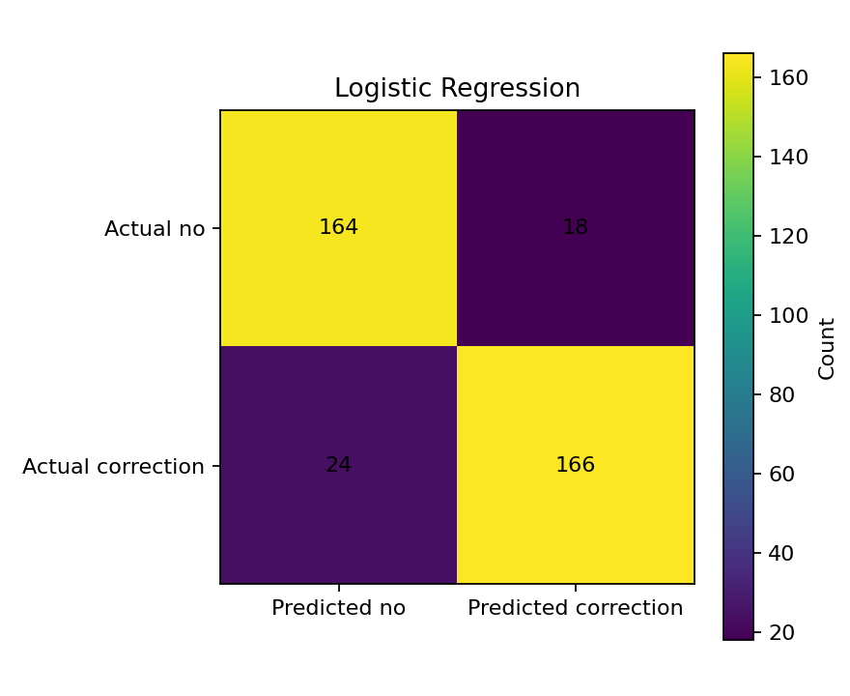
Figure 1. Logistic Regression confusion matrix
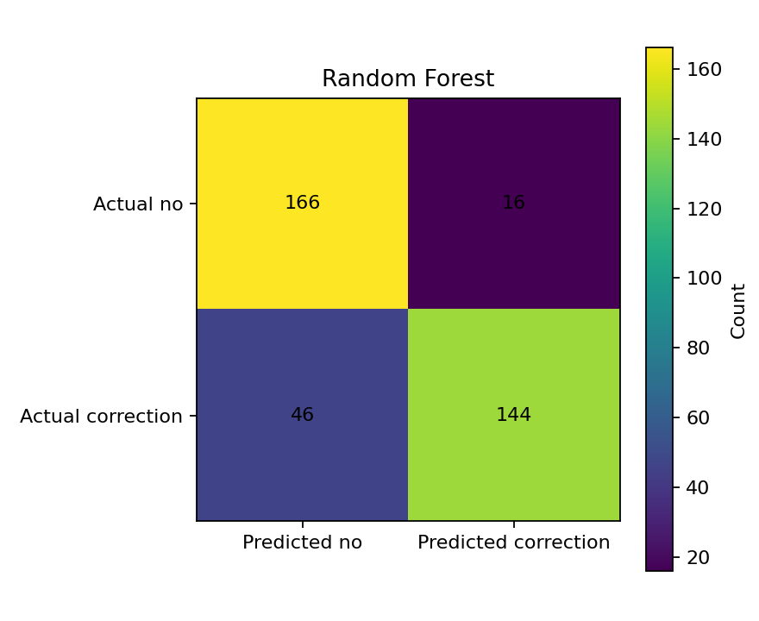
Figure 2. Random Forest confusion matrix
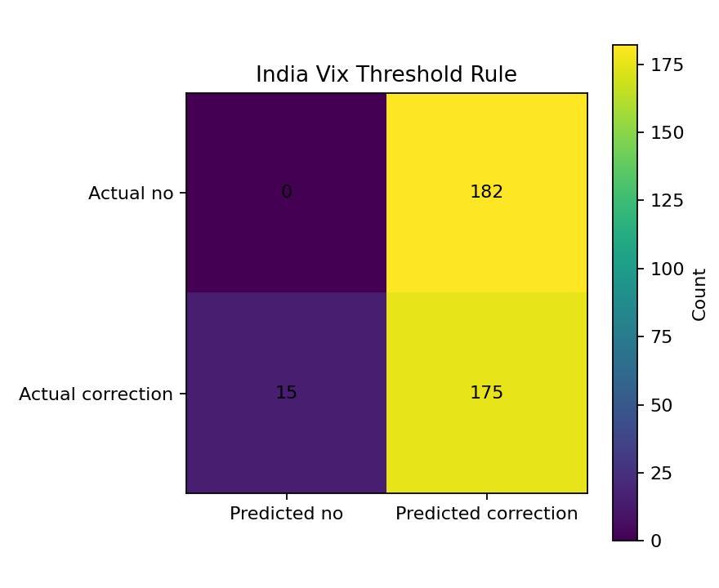
Figure 3. India VIX threshold-rule confusion matrix
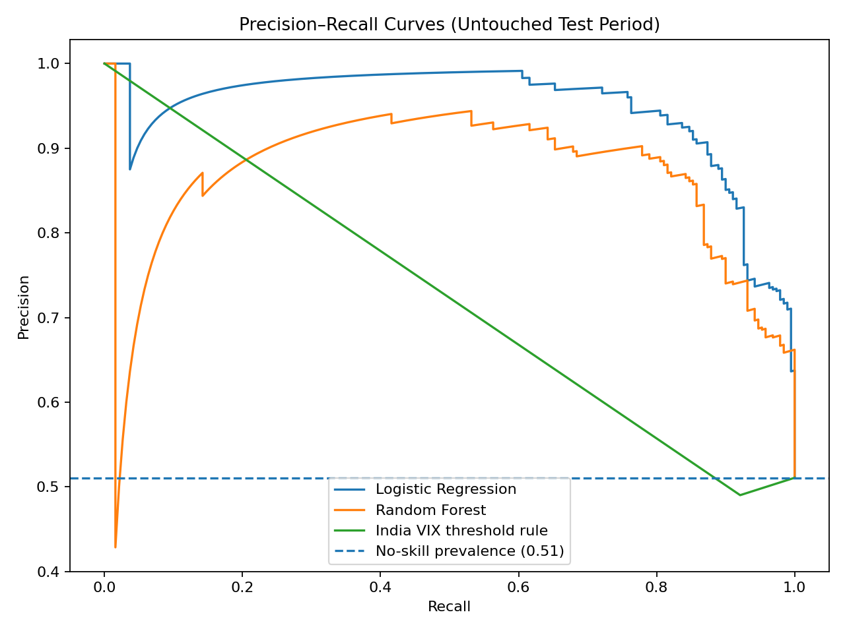
Figure 4. Precision–recall curve comparison

6. Interpretation of Results

6.1 Logistic Regression
Logistic Regression performed best overall on the supplied labels. Its precision of 90.2% means that approximately nine out of ten positive predictions were correct relative to the dataset labels. Its recall of 87.4% means it identified 166 of the 190 positive test labels. It missed 24 positive labels and raised 18 false alarms.

6.2 Random Forest
Random Forest achieved 90.0% precision and generated 16 false alarms, two fewer than Logistic Regression. However, its recall was lower at 75.8%, and it missed 46 positive labels. Its F1 score and PR-AUC were also lower, so it was not the strongest overall model in this experiment.

6.3 India VIX Threshold Benchmark
The VIX-only rule achieved 92.1% recall but only 49.0% precision. It missed 15 positive labels but raised 182 false alarms, and its balanced accuracy was 46.1%. This indicates that a single VIX cutoff, at the selected operating point, was not sufficiently selective.

7. Feature-Importance Findings
The saved Random Forest feature-importance output ranked NIFTY price-level variables and short/medium-term return and volatility features among the leading predictors. The leading features were:
Feature | Importance
nifty50_close | 0.1641
nifty50_low | 0.1335
nifty50_high | 0.1179
nifty50_open | 0.1020
nifty_return_5d_recalc | 0.0732
nifty50_pe | 0.0704
nifty_volatility_20d_recalc | 0.0685
usd_inr_reference_rate | 0.0532
india_vix_close | 0.0527
nifty_return_60d_recalc | 0.0493

Feature importance indicates how the fitted Random Forest used the available predictors; it does not establish causation. Correlated price variables can share or distort importance.

8. Key Project Outcomes
- A complete binary-classification workflow was developed using chronological training, validation and testing.
- Logistic Regression was the best-performing model overall on the supplied test labels.
- Random Forest produced marginally fewer false alarms but missed substantially more positive labels.
- The single-threshold India VIX benchmark was too prone to false alarms to serve as a balanced warning system.
- The experiment demonstrates how market indicators can be combined in a supervised learning workflow, while highlighting the importance of label quality and time-aware validation.

9. Limitations and Risks
- The dataset contains known date/calendar anomalies and suspicious market movements.
- The supplied correction labels show inconsistencies against at least one independently tested interpretation of a 20-observation correction rule.
- The project deliberately retained the supplied labels and did not repair the underlying anomalies; reported metrics therefore measure agreement with those labels.
- The 20-observation purge reduces overlap across split boundaries but cannot correct inaccurate labels or irregular dates.
- The final test period ends in 2020. The results do not establish performance in later market regimes.
- This is a historical classification exercise, not a trading strategy or investment recommendation. Transaction costs, execution, risk limits and live-data validation were not evaluated.

10. Conclusion and Future Scope
Within this experiment, Logistic Regression provided the best balance between precision and recall and achieved the highest F1-score and PR-AUC. The findings suggest that combining multiple market variables can be more useful than relying on a single volatility threshold. However, the data and target-label limitations are substantial; the model should not be described as a dependable live market-correction predictor.
Recommended next steps:
- Rebuild the target using a clearly documented market-correction definition and independently verify positive events.
- Clean the trading calendar, remove duplicate or invalid dates, and investigate extreme price changes against authoritative sources.
- Recalculate all rolling features on the full chronological series before filtering rows with missing targets.
- Test on later years (2021 onward) and use walk-forward validation across multiple market regimes.
- Calibrate probabilities and compare operating thresholds based on the relative cost of missed corrections versus false alarms.
- Add additional indicators only when their timestamps and availability are known, and document the prediction time precisely.

Appendix: Metric Definitions
Metric | Meaning
Precision | Of all observations predicted as correction, the proportion that had a positive supplied label.
Recall | Of all positive supplied labels, the proportion identified by the model.
F1-score | Harmonic mean of precision and recall.
PR-AUC / Average precision | Summary of the precision–recall trade-off across probability thresholds.
ROC-AUC | Ability to rank positive labels above negative labels across thresholds.
False alarm (FP) | A no-correction label predicted as correction.
Missed correction (FN) | A positive correction label predicted as no correction.

