Feedback REST API

CRUD operations

**Create operation**

Initial Database

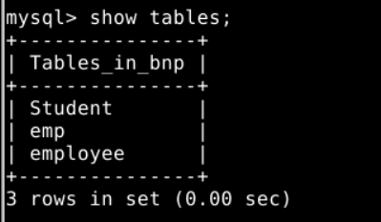

Using postman to access REST API

Using **post** request

Request

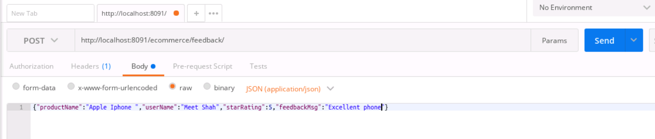

Response

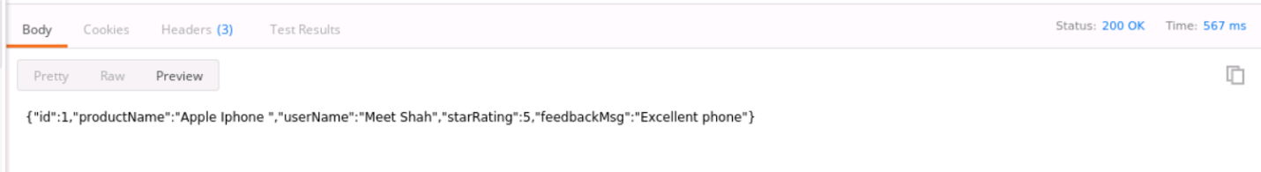

Database after using adding feedback through REST API

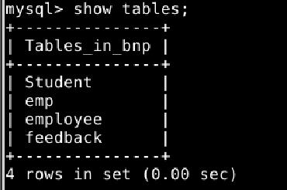

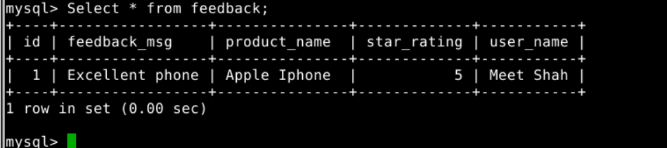

**Read Operation**

Using **get** request

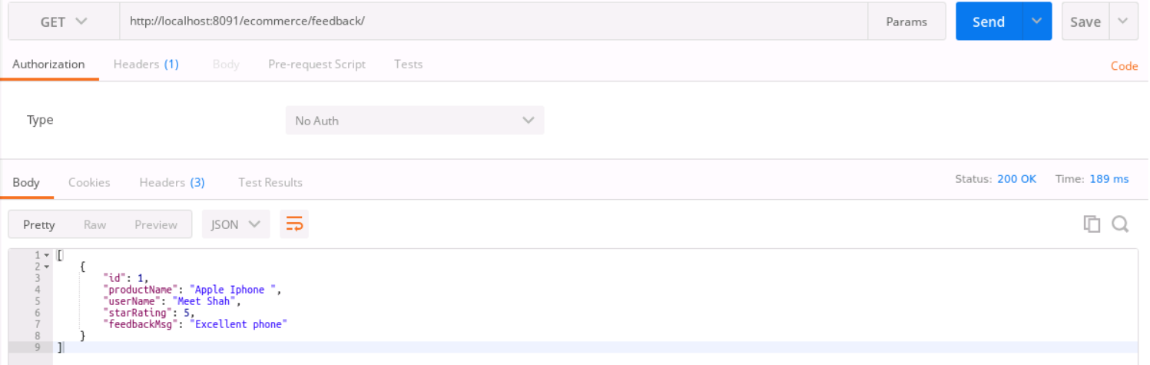

**Update Operation**

Using **put** request and specifying id of the feedback to be updated

Request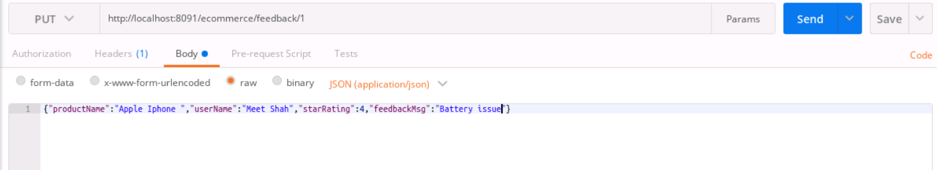

Response

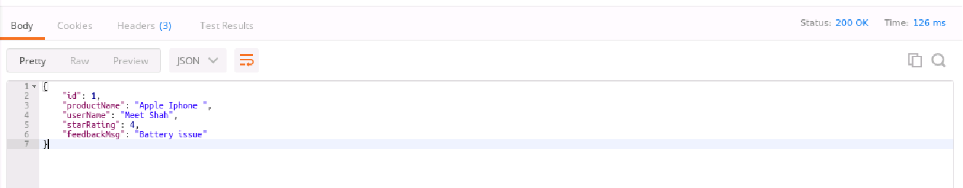

Viewing Database to ensure update operation is performed

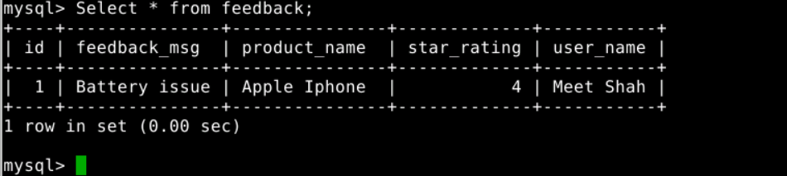

Delete operation

Using **delete** request and specifying the id of the feedback to be deleted

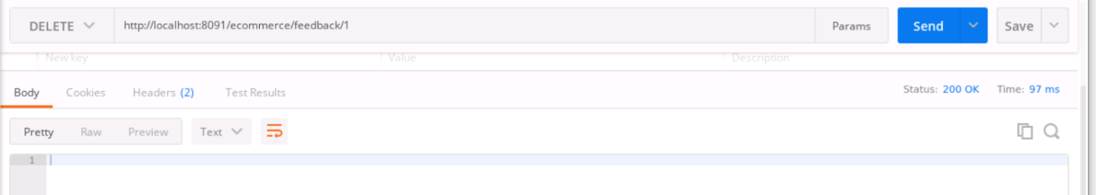

Checking database

