**Screenshots for LockedMe prototype developed by Meet Shah**

**Github link :** [**https://github.com/meetshah133/JavaProjects**](https://github.com/meetshah133/JavaProjects)

**App interface**

Main Menu

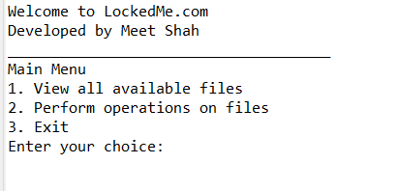

Entering choice 1 to view available files in ascending order

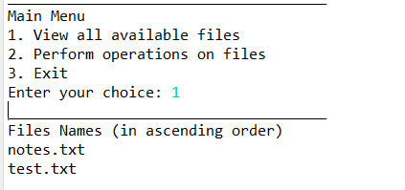

Selecting choice 2 to perform various operations on file

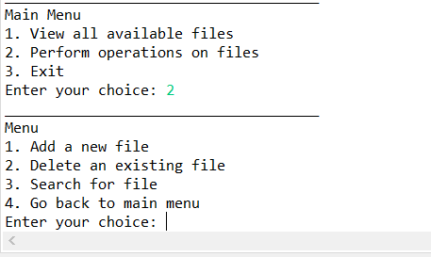

1. Adding a new file

Case 1: File already exist

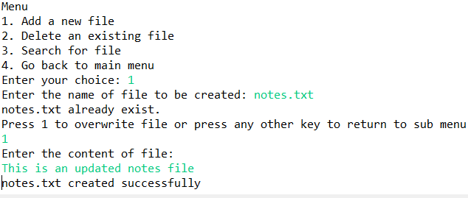

Case 2: When the file is newly created

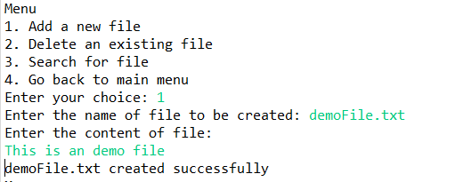

1. Deleting an existing file

Case 1 : When the file to be deleted does not exist

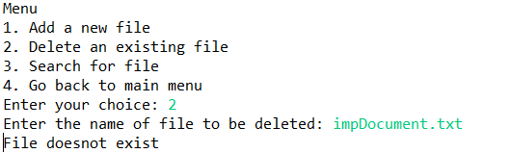

Case 2: When an existing file is deleted

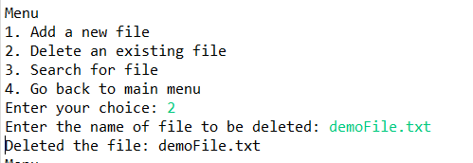

1. Searching for a file

Case 1 : When file is available

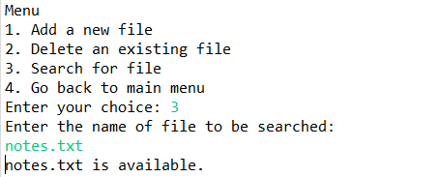

Case 2 : When file is not available

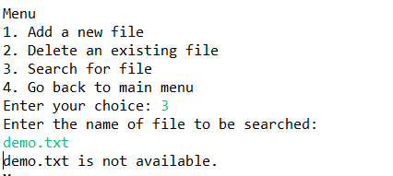

Selecting choice 4 to go back to main menu

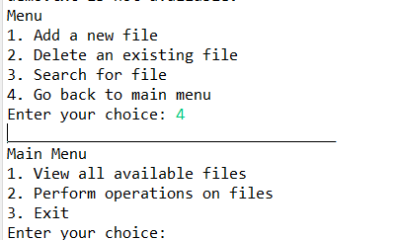

Closing the application by selecting choice 3

