**Online Test Application**

**Developed by : Meet Shah**

**Github link :** <https://github.com/meetshah133/Quiz-App>

Homepage (index.html)

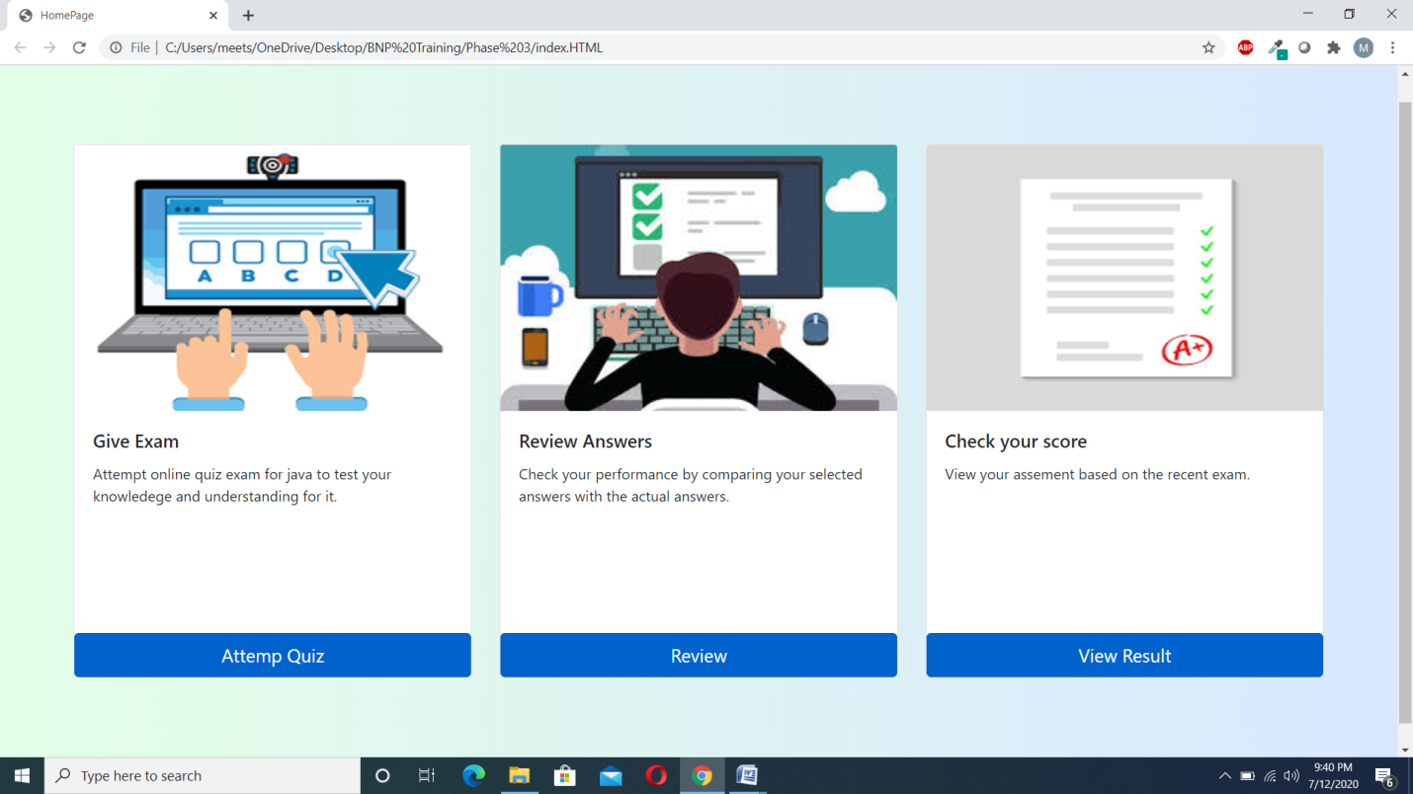

Quiz page (quiz.html)

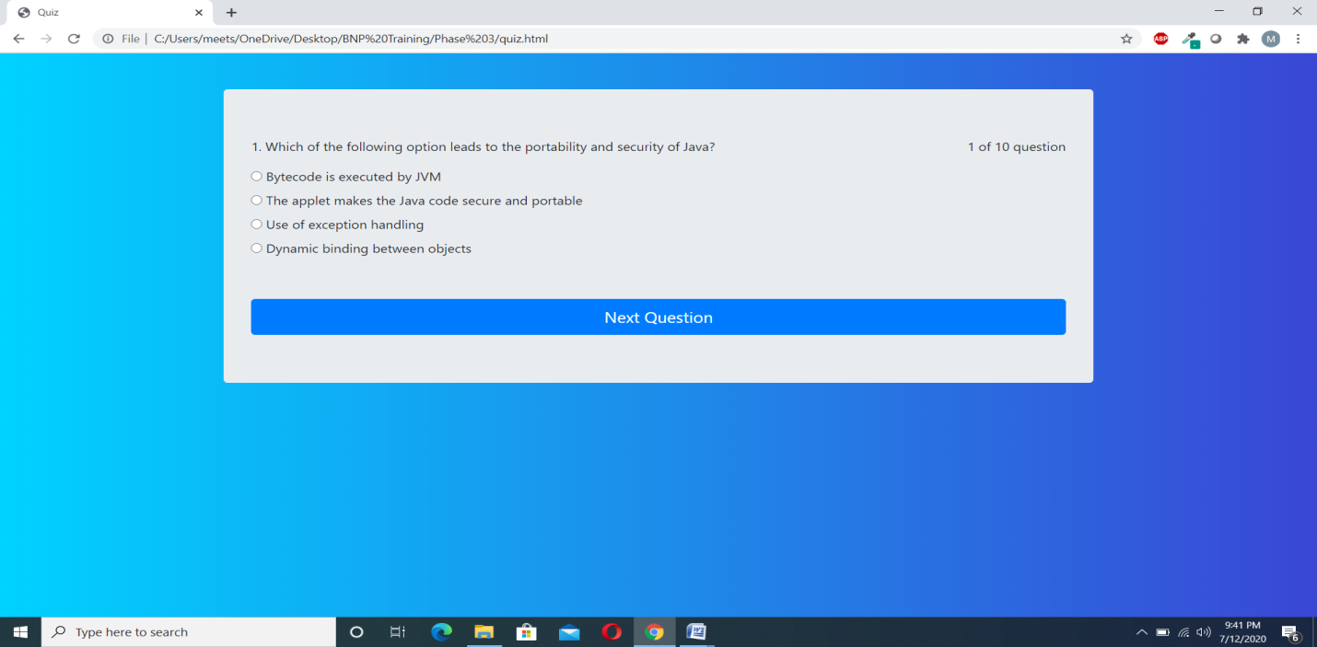

Quiz page (When user clicks on next question without selecting any option)

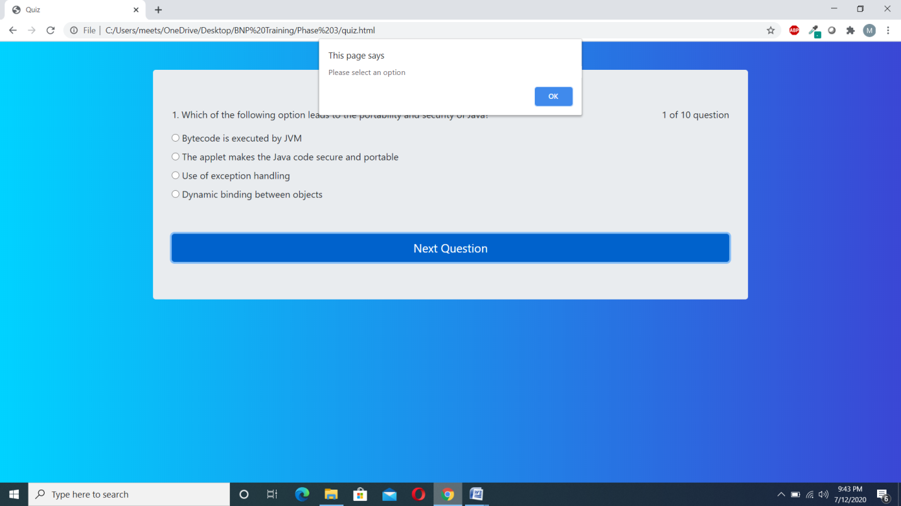

Quiz page (When user select’s submit exam option)

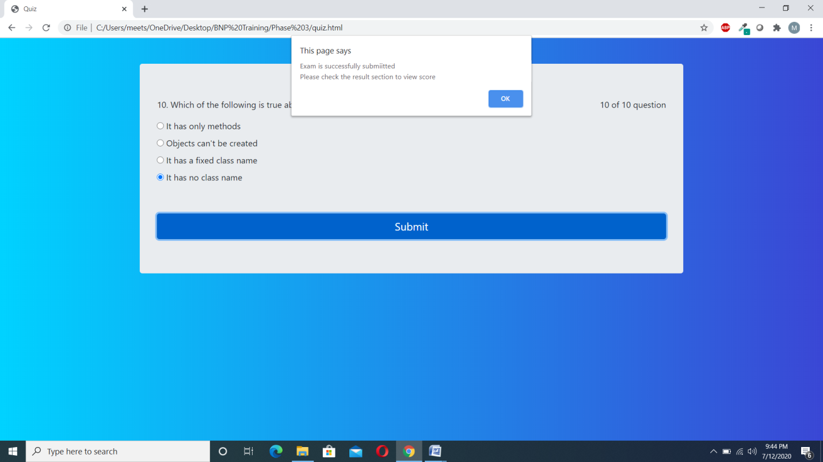

Review Page

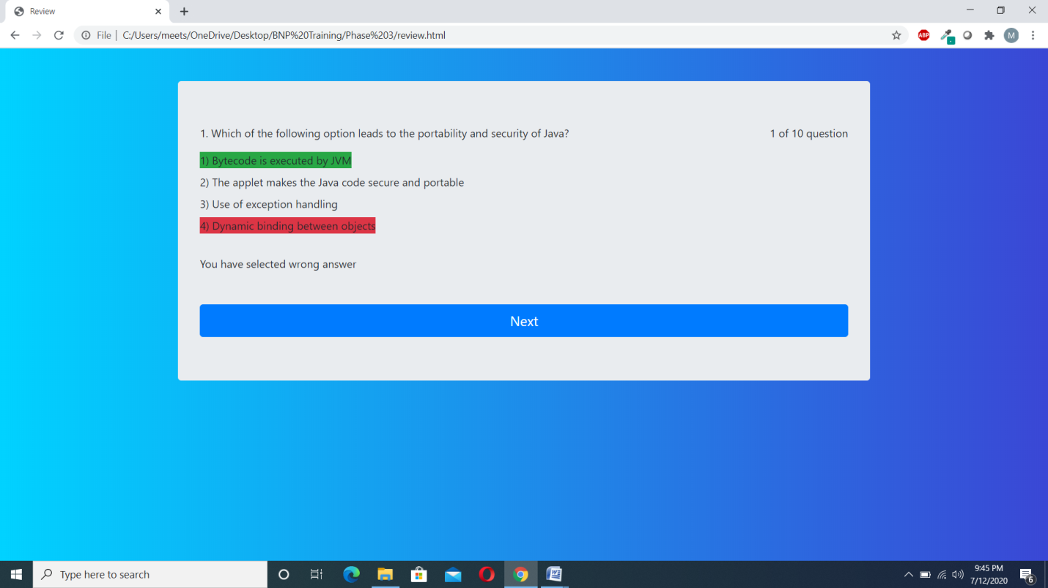

Review Page

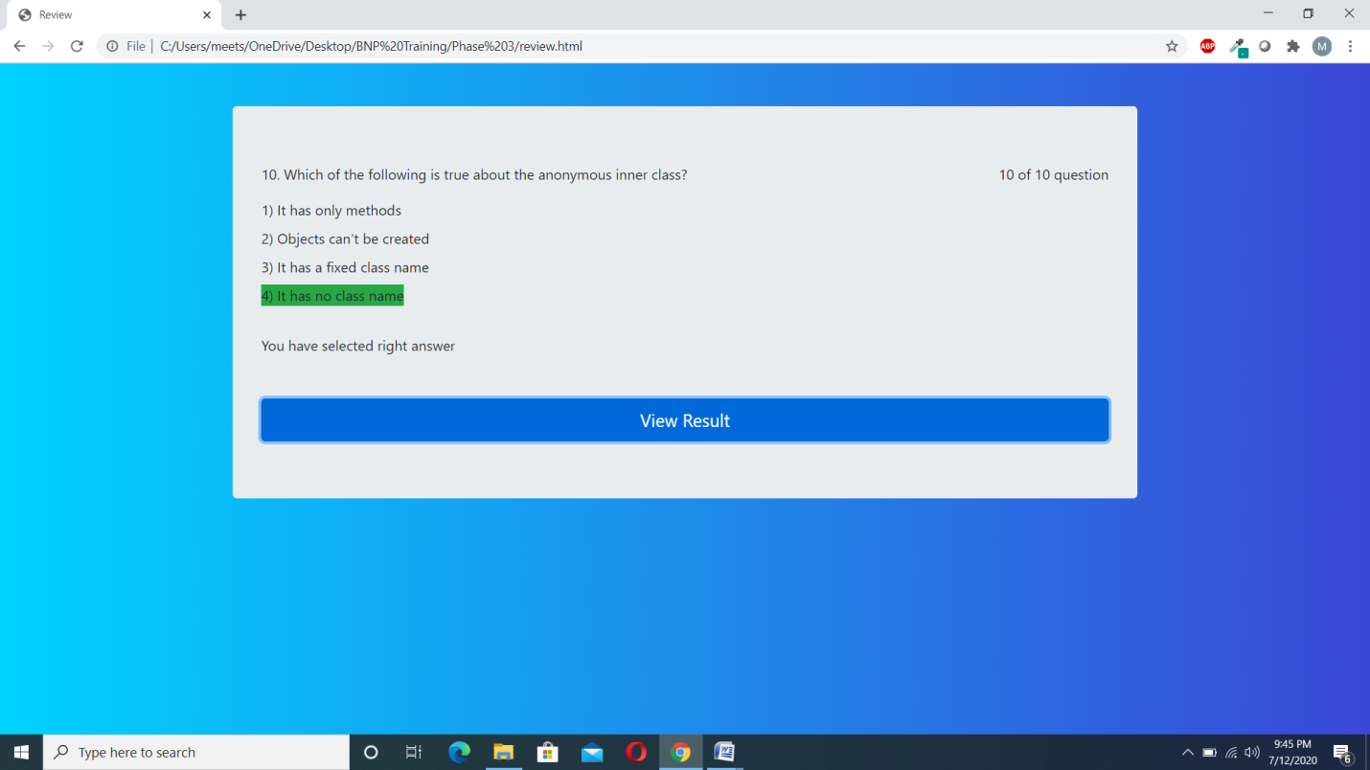

Result page (When user has successfully cleared the exam)

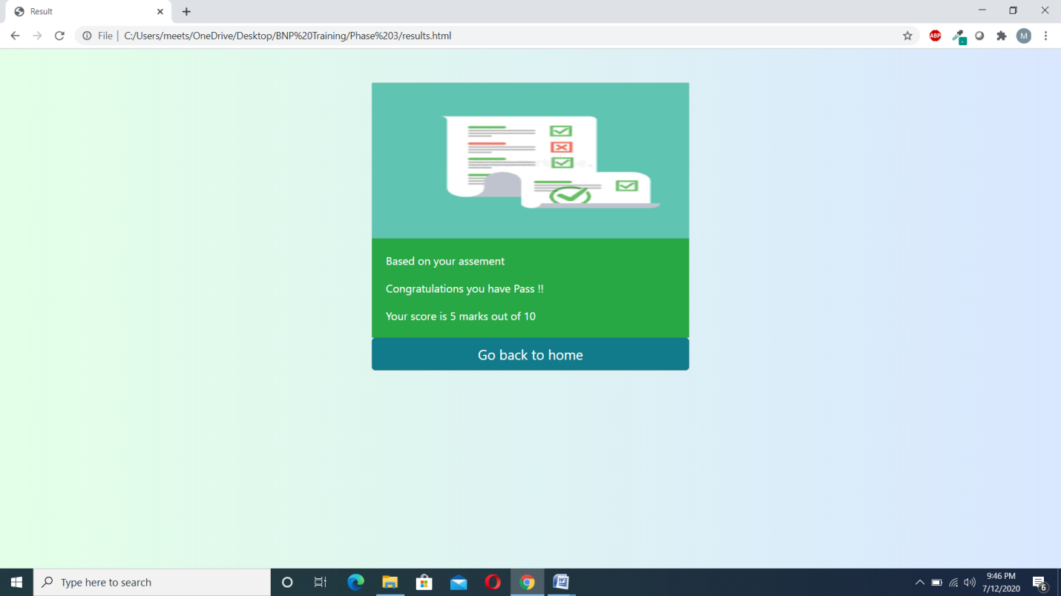

Result page (When user has failed in the exam)

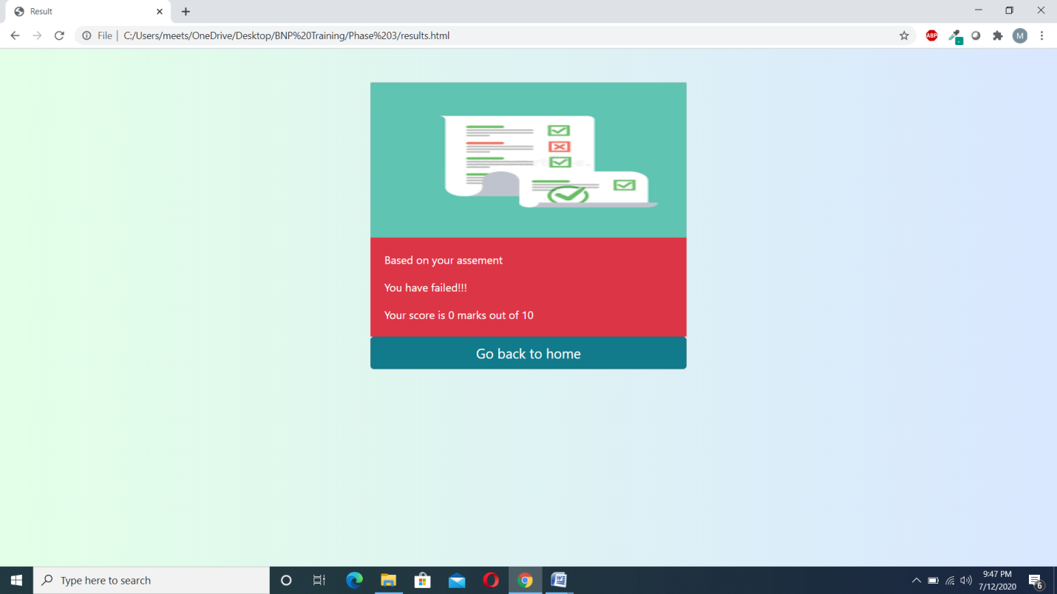

When the users clicks on view result page before attempting exam

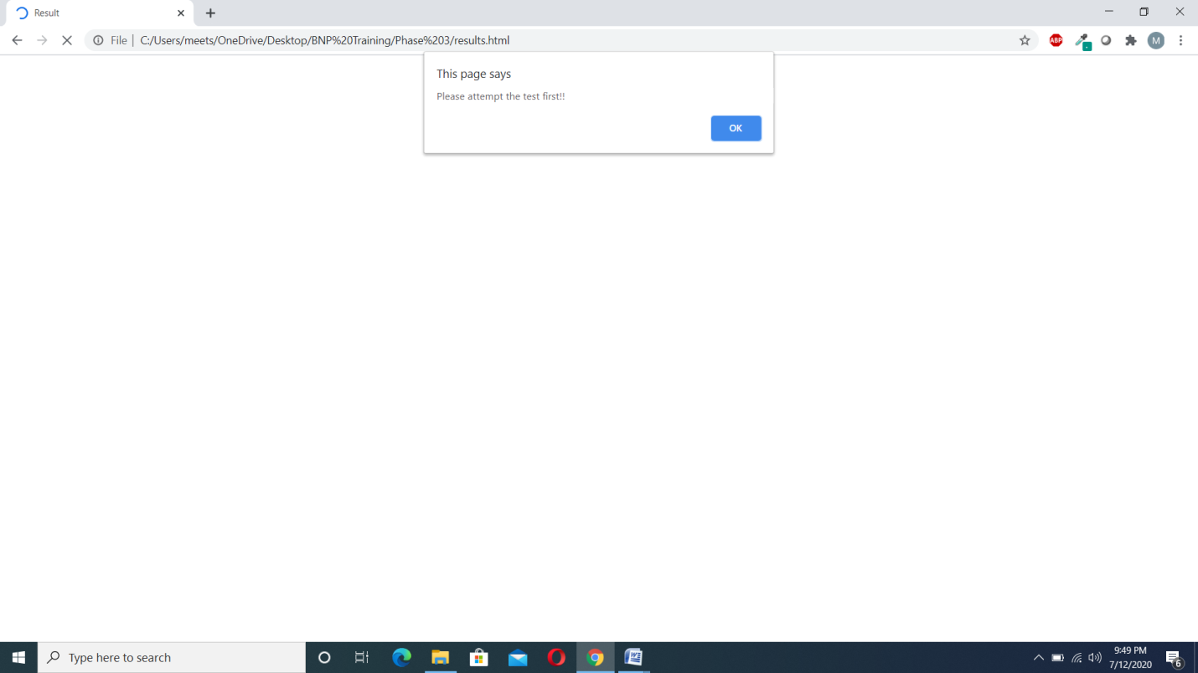

When the user clicks on review questions page before attempting exam

