LAB720 Ignite-Day Lab: Operating Caldova Retail Ops with Azure SRE Agent

Core duration: 25 minutes of guided activities.

Welcome to Caldova operations
In this lab you act as the on-call engineer for Caldova Retail Co., a storefront and operations app running on Azure App Service. You will connect a real Azure SRE Agent to the live environment, explore what it discovers on its own, make a small configuration change through it, and then use it to debug a real production-style failure end to end.
You will work with a dedicated user account and GitHub account on your lab VM. An Azure SRE Agent named caldova-sreagent has already been created for you and is connected to the resource group that hosts the lab's Web App, caldova-webapp.

What you will accomplish
- Start importing the lab's GitHub repository in the background, then confirm it is ready before the debugging activity.
- Interact with the agent's onboarding thread, then review how its permissions are scoped across a subscription and a resource group.
- Run a live discovery prompt against caldova-webapp and review what the agent finds unprompted.
- Approve a real, reversible configuration change proposed by the agent.
- Reproduce a live product-search failure, then use the agent to investigate and fix it — all without a code deployment.
- Create a scheduled task that runs a recurring, read-only cost audit and delivers a branded report automatically.
- Build a live, reusable report that turns raw telemetry into a traffic-and-health dashboard.

Clone the repo
Caldova Retail Ops's source code, including the ASP.NET Core backend and the static storefront frontend, lives in a GitHub repository. You'll start the import now and let it run in the background while you continue the lab — the SRE Agent reads directly from this repo during the Debug task to connect a configuration problem back to the exact line of code that is affected.
Repository: puneetg1983/caldova-ignite-authoring: caldova-ignite-authoring Web App
- On your lab VM, sign in to GitHub using the lab GitHub account provided to you (not a personal account).
- Go to https://github.com/new/import, or select the + menu in the top-right corner of any GitHub page and choose Import repository.
- In Your old repository's clone URL, paste https://github.com/puneetg1983/caldova-ignite-authoring.git
- Under Owner, select the lab GitHub account.
- In Repository Name, enter caldova-ignite-authoring (or keep the suggested name).
- Set the repository visibility to Private, then select Begin import.
- After selecting Begin import, leave the import-status page open in a browser tab and continue to Interact with the onboarding thread without waiting. Check the import status again before Debug it with the agent; GitHub shows a completion status and also sends a confirmation email. The background import duration varies.
Note: You won't need to browse the code yet — start the import and continue to the next section without waiting. You'll come back to this exact repo in the Debug task, where the SRE Agent will read from it directly.

Interact with the onboarding thread
- Open the Azure SRE Agent for your lab. If the onboarding thread opens automatically, go to step 6.
- Otherwise, in the left navigation pane, under Favorites, select Team onboarding. If the thread opens, go to step 6.
- If Team onboarding is not listed, select Search Threads in the left navigation pane.
- In the search box, enter get to know.
- Select the result titled "Hey <your lab user>, let's get to know each other!". The greeting uses your lab account name.
- Read the onboarding conversation and environment summary. Review any saved knowledge files, missing connections, and suggested next steps.
- Reply to the onboarding questions as the on-call engineer for Caldova Retail Co.
- Ask a follow-up question if needed. Keep the interaction read-only; do not request resource changes or enter personal or confidential information.
- If the agent is still processing, continue to Basic configuration exploring. Return later to review its response.
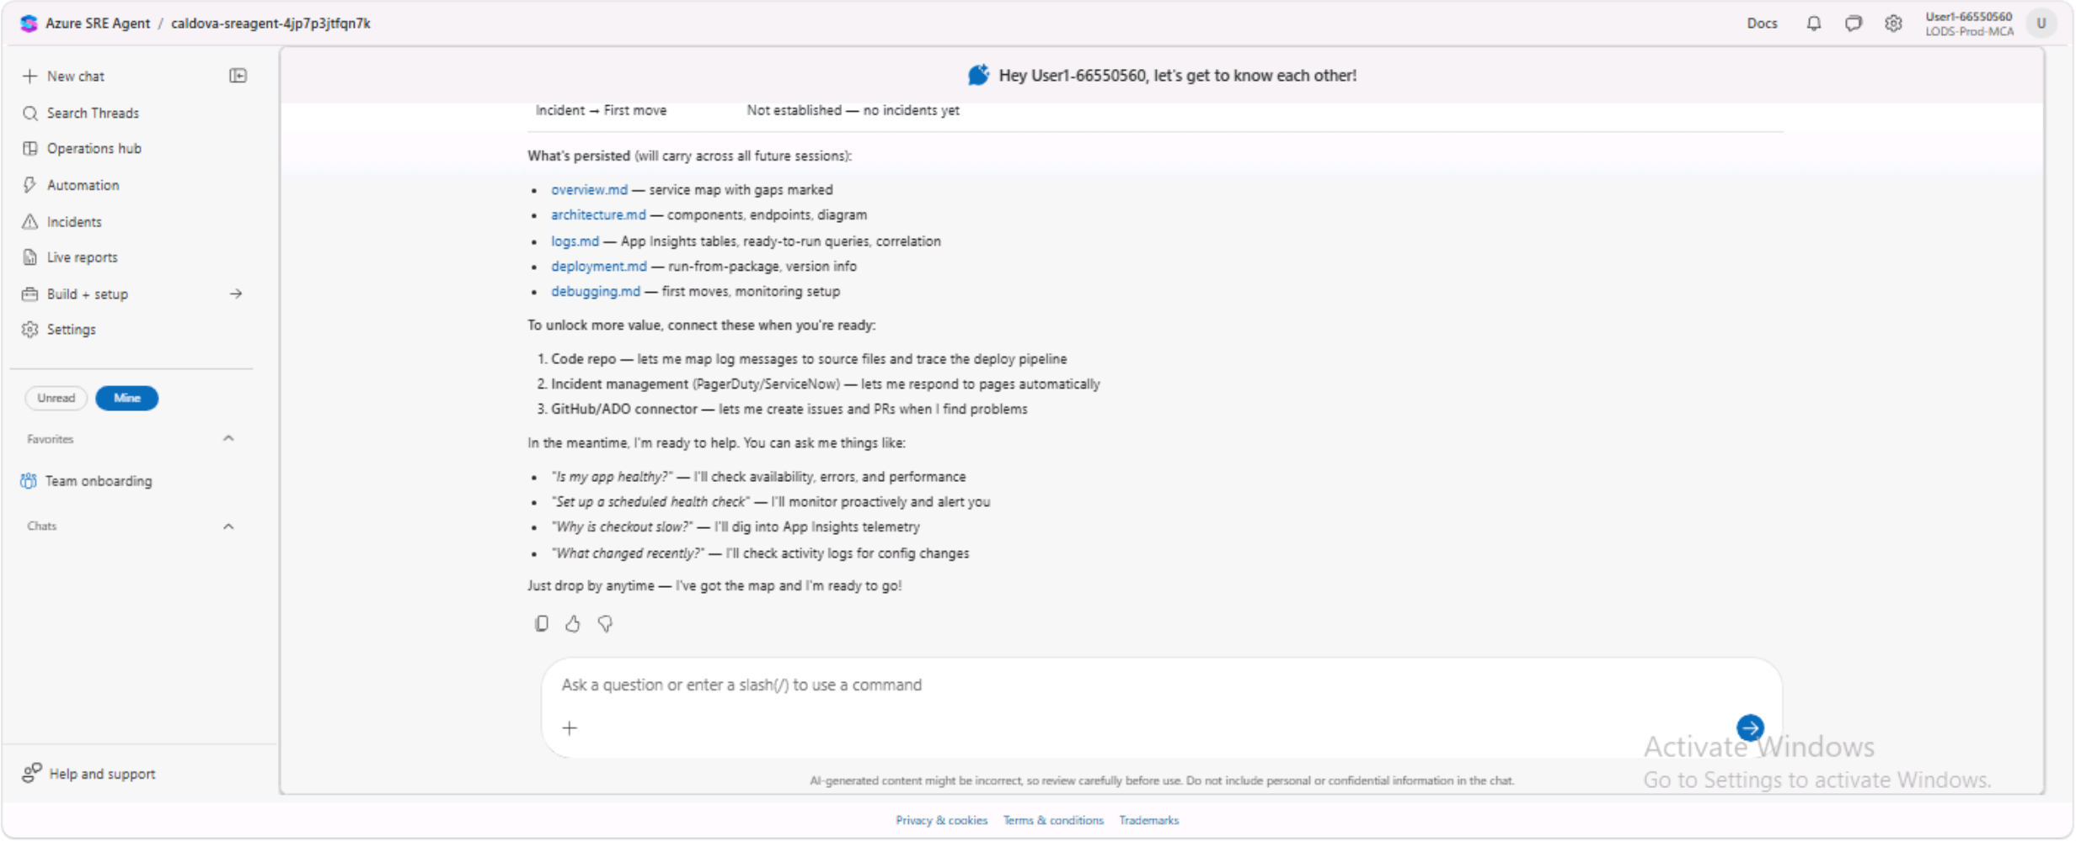
The onboarding thread in the lab VM, with the navigation and chat controls visible.

Basic configuration exploring
caldova-sreagent is already connected to the Caldova GitHub repository. Your job in this task is to review — not change — how its Azure access is scoped, then confirm it discovered the environment correctly.
- Open the Azure SRE Agent named caldova-sreagent.
- In the agent's Build + setup (or Settings) view, open Azure resources.
- Confirm the subscription is added in Reader mode — this lets the agent's managed identity read resource state and run diagnostic Azure CLI commands across the subscription, but not change anything.
- Confirm the resource group that hosts caldova-webapp is added in Privileged mode — this is what allows the agent to actually change resources inside that resource group later in this lab (like the health check setting you'll approve shortly).
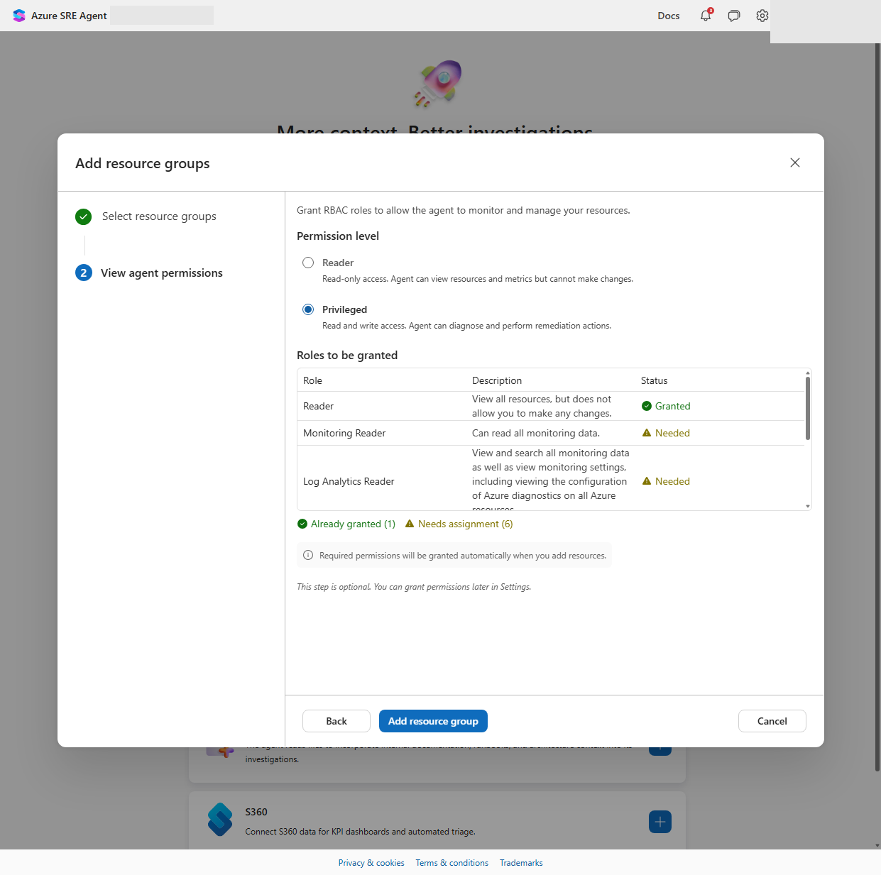
Choosing a Privileged permission level when adding a resource group to the agent.
Note: The first time the agent runs a command against a resource, it may show “Authorization required” and ask you to select Grant permissions — even though you already added the subscription/resource group above. This is a one-time, per-session consent step (the agent temporarily borrows your own credentials to complete that first call). Click Grant permissions if you see it; you normally won't see it again this session.
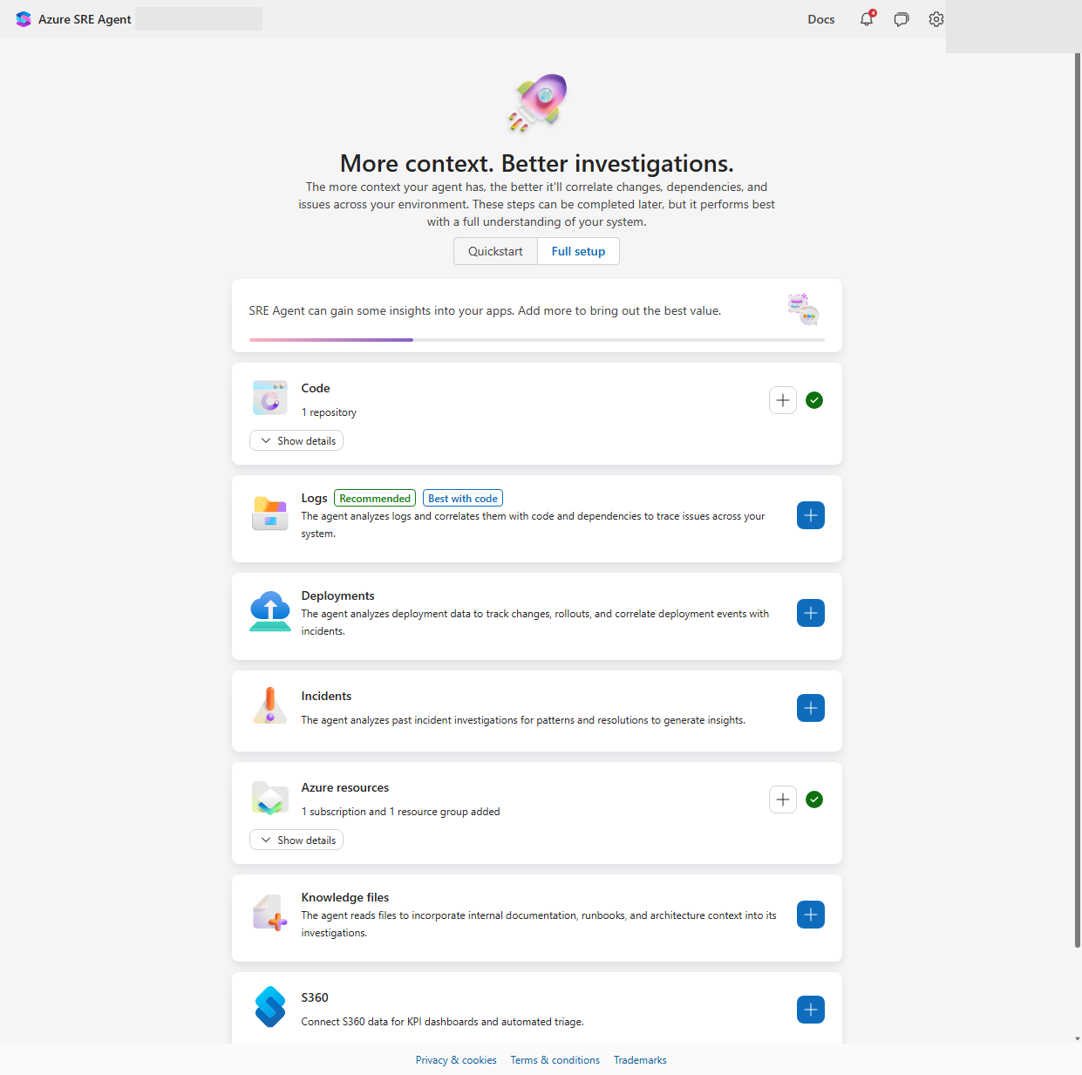
Agent setup summary — Code and Azure resources both connected.

First chat thread
Start a new chat with the agent and ask it to introduce itself to the environment with a single, open-ended discovery prompt:
Discover all Azure resources in the resource group where the caldova-webapp Web App is deployed. For the Web App, list its current health status, running configuration, app settings, and any monitoring/alerting already set up.

The agent will run a series of read-only Azure CLI commands and read the GitHub repo. While it works, skim back up to the setup view to see the commands streaming in.
When it finishes, the response will include the Web App's health and configuration, and a list of monitoring gaps — for example, that no Health Check path is configured even though the app already exposes a /api/health endpoint. You'll close that exact gap in the next task.
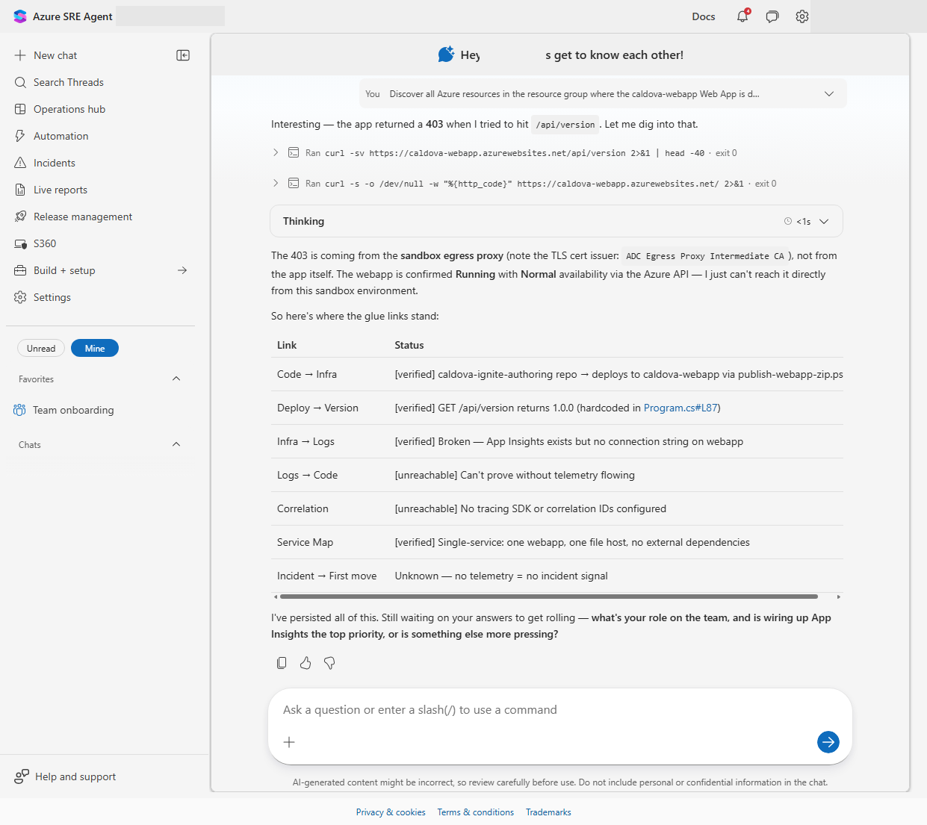
The agent's discovery response: health, configuration, app settings, and identified gaps.

Update Web App Configuration
Use the gap the agent just surfaced as your next prompt — this is a small, safe, fully reversible change:
caldova-webapp doesn't have a health check path configured even though the app exposes a /api/health endpoint. Configure the Health check path app setting to /api/health so App Service can detect and route around unhealthy instances. Go ahead and make the change.

The agent will show you its reasoning as Current state / Proposed change / Rollback, then present the exact Azure CLI command it intends to run behind an Approve action button. This approval gate is how the agent keeps a human in the loop for any change with real impact.
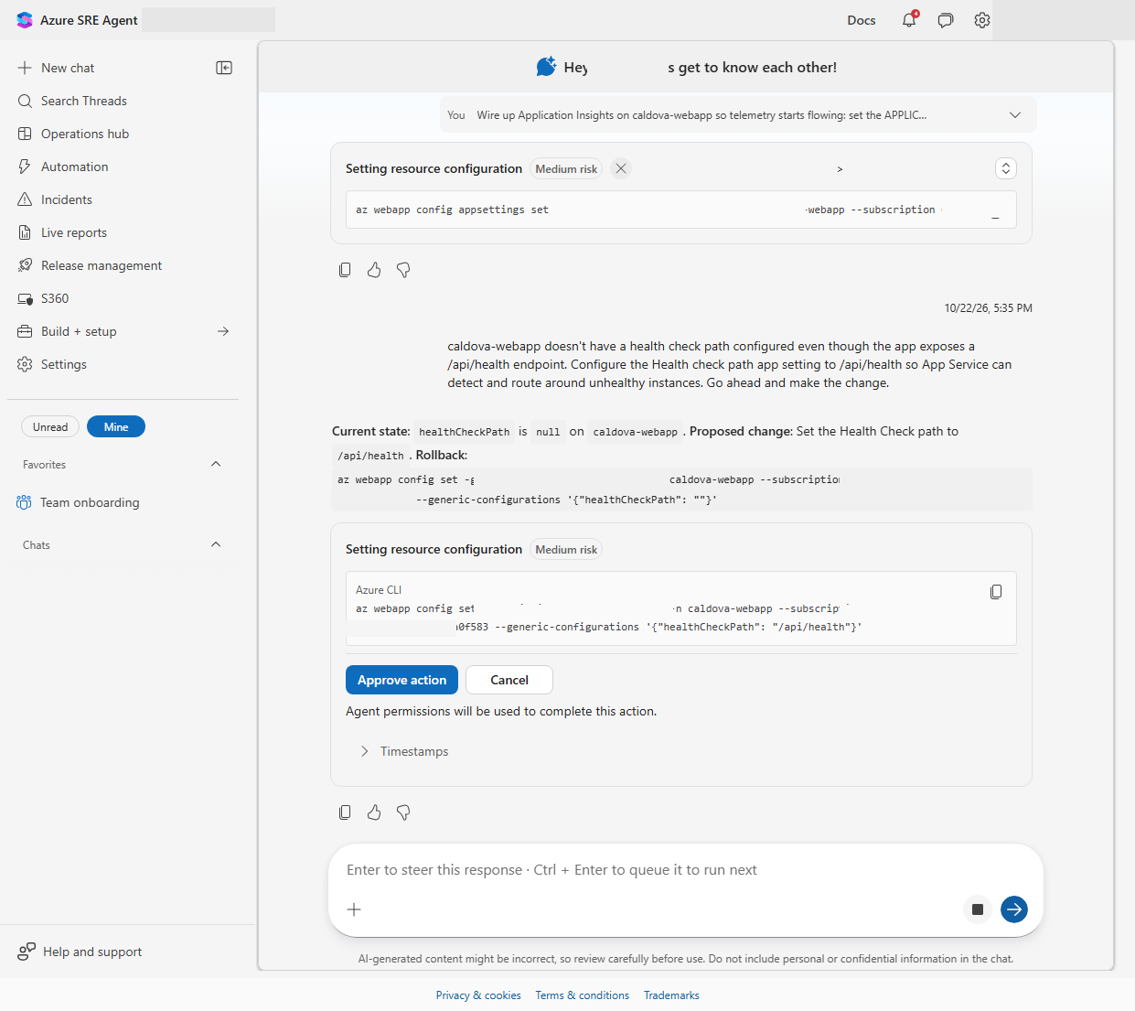
Approval prompt for the Health check path configuration change, with the exact CLI command and rollback shown.
- Review the proposed command.
- Select Approve action.
- Confirm the agent reports the change completed.

Debug a scenario

See the problem
Before asking the agent for help, experience the problem the way a customer would.
- Browse to the caldova web app in your browser.
- Select Catalog in the navigation. Confirm the paginated product catalog loads normally — browsing is not affected.
- In the Search by product name box, search for a product (for example, jacket) and select Search.
- Confirm the search fails with 500 - Search failed, while the catalog table below it continues to display normally.
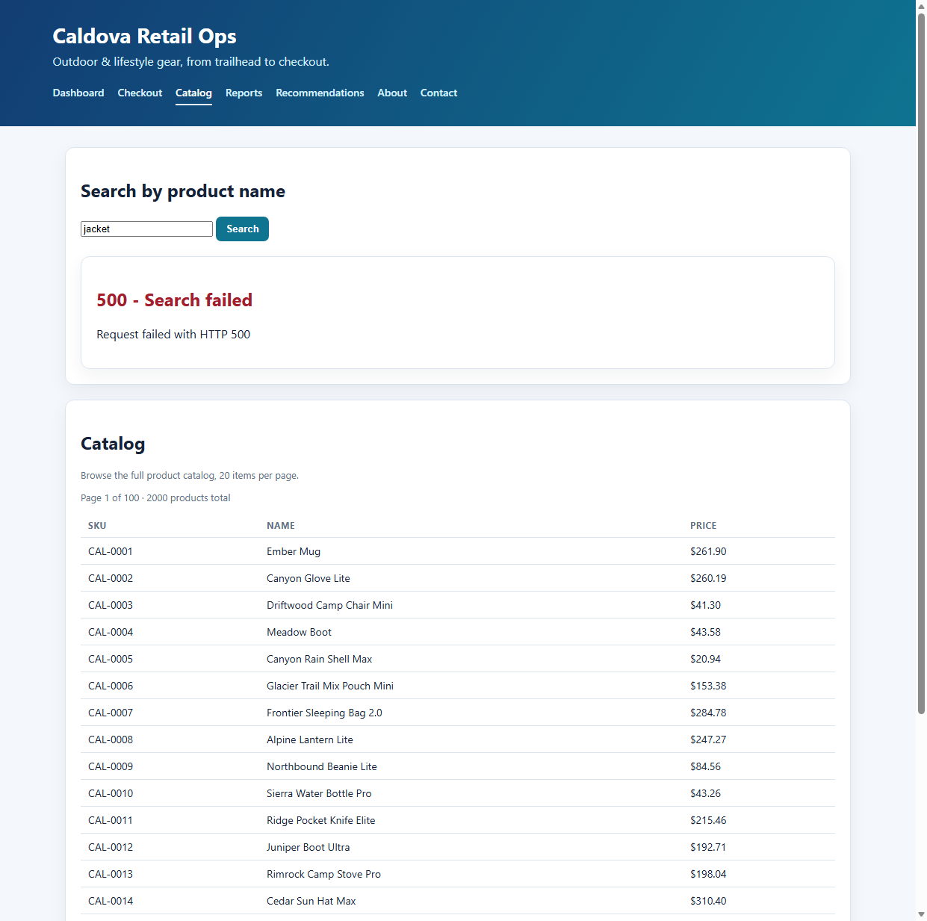
The live failure: product search returns HTTP 500 while catalog browsing keeps working.
Note: This is a real, live failure in the lab environment — not a staged screenshot. It's caused by an App Service configuration setting, not by a code bug, which is exactly the kind of issue an SRE Agent is well suited to find quickly.

Debug it with the agent
First, return to the repository's import-status tab and confirm the import completed. Open the imported repository and confirm its files are visible. If it is still importing, finish reviewing the preceding activities and check again; do not start this investigation until the repository is ready. Then start a new chat thread and describe the symptom the way an on-call engineer would hear it reported — don't give away the cause:
Users are reporting that searching the product catalog on caldova-webapp fails with an error. Browsing the catalog works fine, but searching by product name returns HTTP 500. Investigate the root cause.

The agent will correlate the failing requests, the Web App's app settings, and the relevant source code from the GitHub repo you imported earlier. When it completes, review how its response:
- Distinguishes the customer-visible symptom (search fails) from the technical cause.
- Cites the specific app setting responsible — Catalog__AsOfDate — and explains why it only affects search and not browsing.
- Proposes fix options ranked from quickest to most durable, including both a configuration mitigation and a defensive code fix.
The agent's first instinct is often to resolve the misconfiguration by deleting the app setting outright. In production, it's usually safer to correct a value than to remove it — so redirect the agent toward the more precise fix:
Instead of deleting the Catalog__AsOfDate app setting, please update its value to today's correct date so it no longer points at a future, unbuilt catalog wave. Go ahead and make that change.

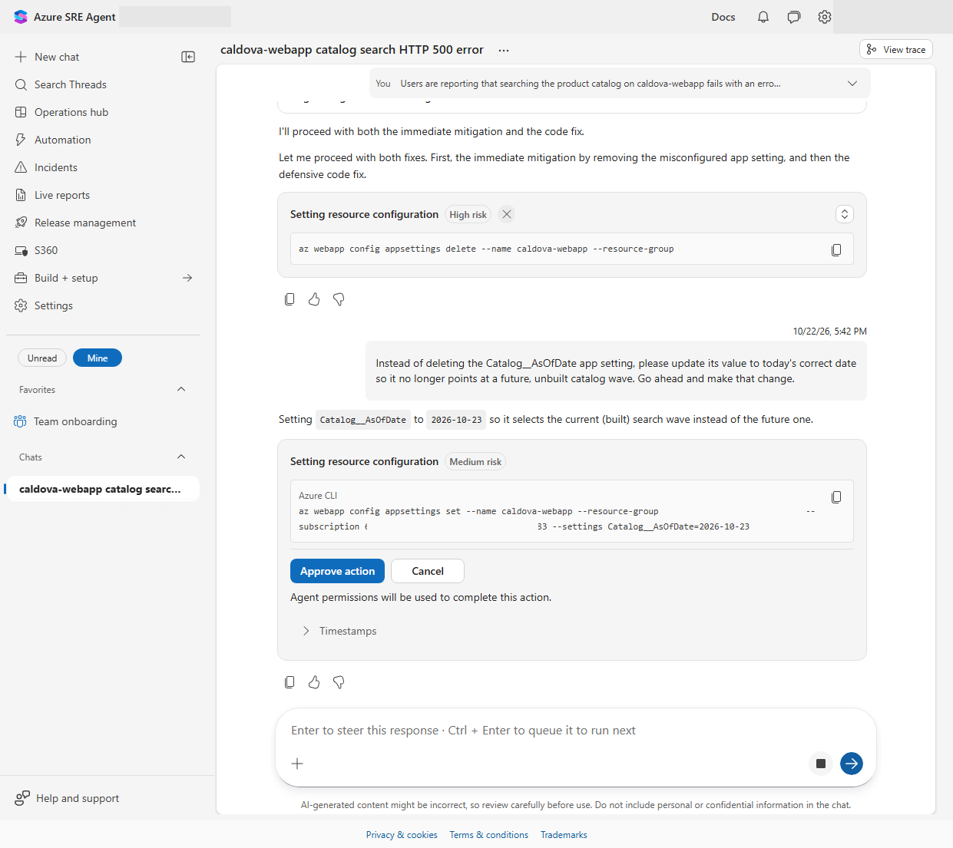
The corrected fix: updating Catalog__AsOfDate to today's date instead of deleting the setting.
- Review the updated proposed command — it should now set Catalog__AsOfDate to the current date, not delete it.
- Select Approve action.
- Browse back to the caldova web app, repeat the same product search, and confirm it now returns results instead of an error.
Note: This mirrors a real SRE Agent debugging pattern: read-only investigation across code, config, and telemetry; a ranked set of fix options; a human approval gate; and a verification step after the fix is applied.

Scheduled tasks
Not every operational task needs a human to kick it off. A scheduled task lets you give caldova-sreagent a prompt once, then have it run automatically on a recurring cadence — the same way a weekly report or a nightly health check runs on-call today, minus the on-call engineer.
In this task you'll create a weekly Cloud Cost Audit: the agent works out which resources it manages, compares spend week over week, flags idle or oversized resources, rates its findings by cost impact, and delivers a Caldova-branded PowerPoint deck — all read-only, with no changes made to any resource.

Create the scheduled task
- In caldova-sreagent, select Automation in the left-hand navigation.
- Select New task.
- Name the task, for example Weekly Cloud Cost Audit (Caldova deck).
- Paste the prompt below into the task's instructions.
- Set Frequency to Weekly, choose a day and time, then select Create task.

Run a weekly, read-only Cloud Cost Audit for the Azure resources this agent manages — work out the subscription and resource group yourself, don’t assume names. Use billed cost data where available; if it isn’t, estimate from inventory and say so. Compare this week with last week, find the top cost drivers and any idle, oversized, or orphaned resources, and rate each finding SEV1–SEV3 by cost impact with a recommendation and a rough monthly saving. Post a short posture summary in the thread plus a downloadable PowerPoint deck. Change nothing, don’t use agent memory, and state your data source and limitations. Style the deck 16:9 and Caldova-branded: navy #1F3A5F header bar with a CALDOVA wordmark, teal #00A39A accents, red/amber/slate severity colors, one idea per slide, charts preferred over tables over text, with a consistent header and footer on every slide.

The task now appears in the Automation grid with its schedule. Rather than waiting a week to see it run, validate it immediately:
- Select the task's row.
- Select Run now.
- Open the run to watch it work in real time.

Watch the agent work through a clear plan — discover, collect, analyze, generate, post — running real, read-only Azure CLI commands you can see streaming into the thread. When billed-cost data isn't available in the lab subscription, it falls back to a pricing-based estimate automatically, exactly as instructed.
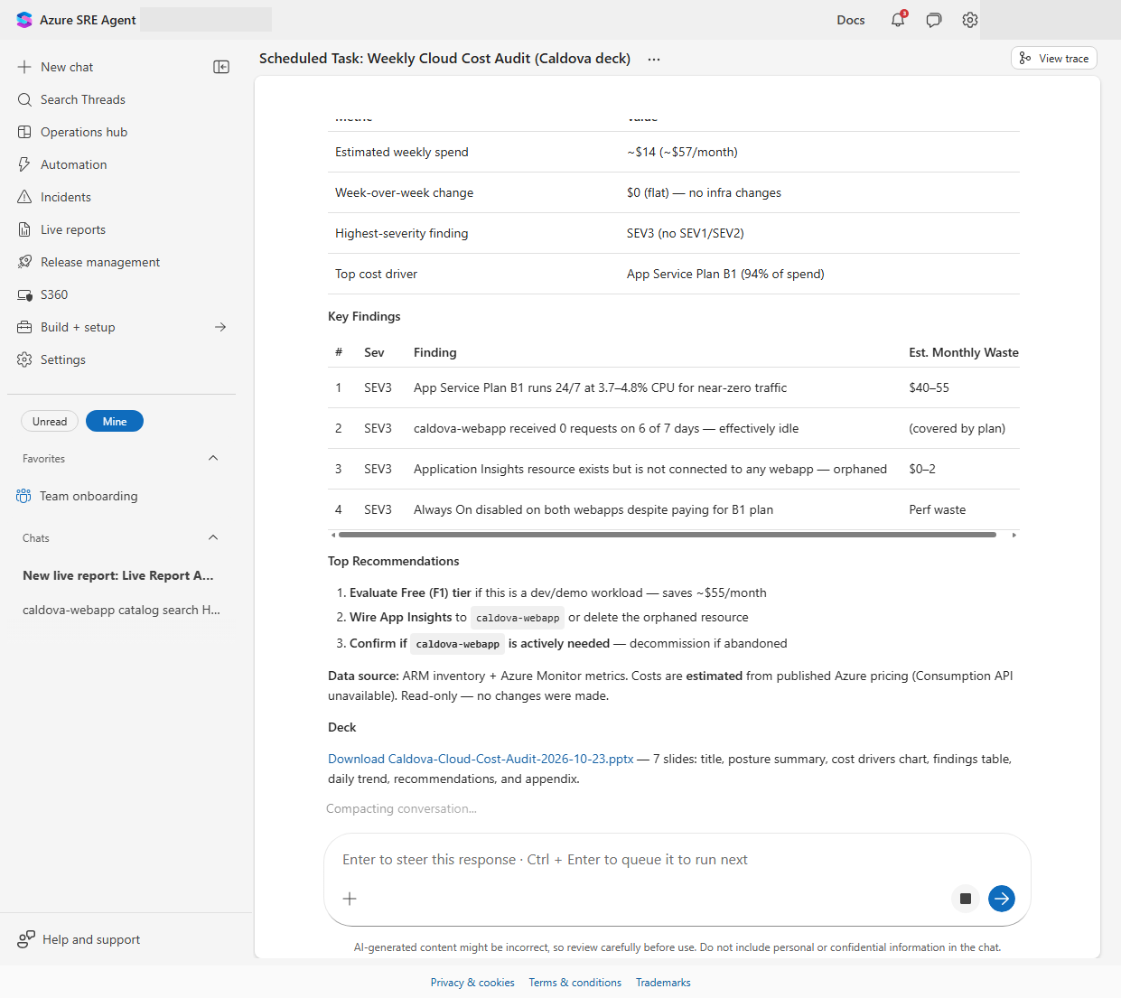
A completed Weekly Cloud Cost Audit run: posture summary, SEV-rated findings, recommendations, and a downloadable, Caldova-branded PowerPoint deck.
Note: The generated deck follows the full Caldova brand spec end to end — navy header bar with the CALDOVA wordmark, teal accents, severity-colored finding cells, and a data-source and limitations slide — without any manual formatting.

Live reports
A live report is different from a normal chat answer: it's a small, self-contained dashboard that re-runs its queries against live data every time someone opens it, rather than showing a one-time snapshot. It's a good fit for anything you'd otherwise have to rebuild in chat over and over — like a traffic-and-health dashboard for caldova-webapp.

Confirm a telemetry connector is available
Live reports can only query data sources the agent is actually connected to. Before building one, confirm caldova-sreagent has a telemetry connector configured:
- Select Build + setup in the left nav, then open Extensions > Connectors.
- Confirm an Application Insights (or Log Analytics Workspace) connector shows a status of Connected.
- If none exists, select Connectors, choose Application Insights, point it at caldova-webapp's Application Insights resource, and complete the wizard (Set up connector, then Review + add).
Note: Having a connector on the agent isn't the same as caldova-webapp actually emitting telemetry — that also requires its own Application Insights app setting. If the dashboard you build next comes back empty, that wiring is the first thing to check.

Build the dashboard
Open Live reports in the left nav, select New report, and describe exactly what you want instead of picking a generic preset:
Build a live report called “caldova-webapp Traffic & Health” using the Application Insights connector for caldova-webapp. Include: (1) an overall health summary tile (request count, failure rate, average response time, 24h); (2) a traffic trend chart; (3) a top 10 most-requested URLs table; (4) a top failing URLs table with status codes; (5) a country/region breakdown chart. Refresh the data each time the report is opened.
The agent inspects its available connectors, authors a self-contained HTML dashboard, then asks for one-time approval to save it, since the report calls a connector tool every time it's opened.
- Review the permission prompt — it names the exact tool and confirms it only queries diagnostic and activity logs for this one Azure resource.
- Select Allow once.
- Confirm the dashboard renders: health tiles, a traffic trend chart, Top Requested URLs, Top Failing URLs, and a Requests by Country/Region breakdown.
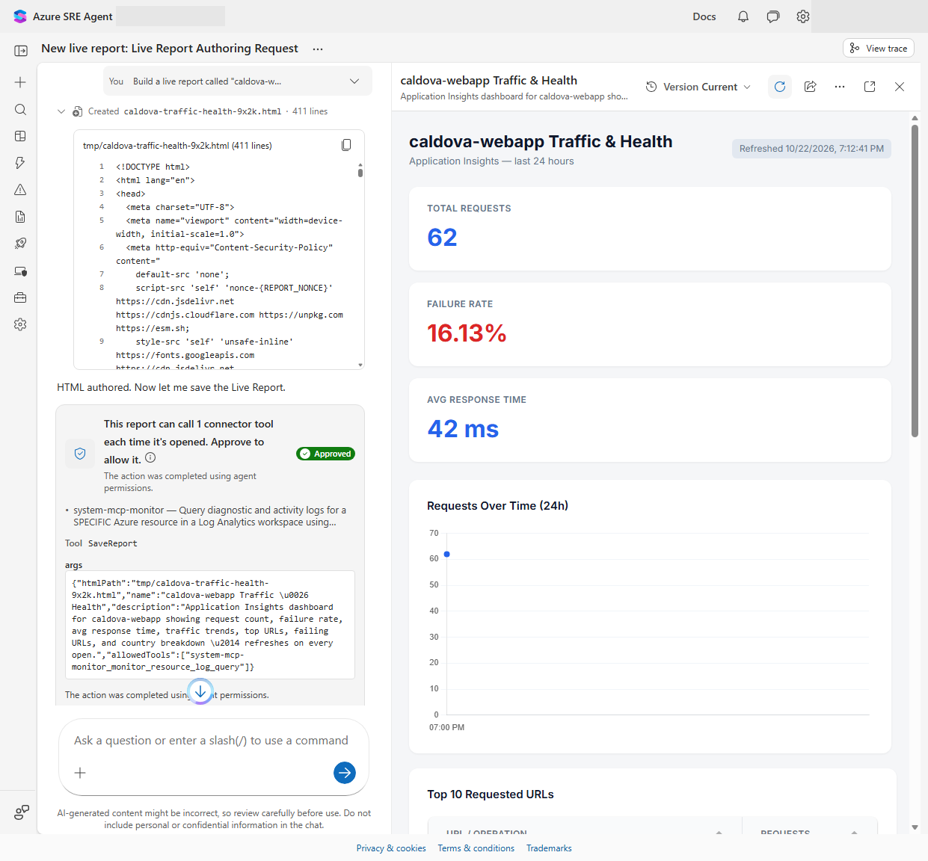
The live report's health summary tiles and traffic trend chart.
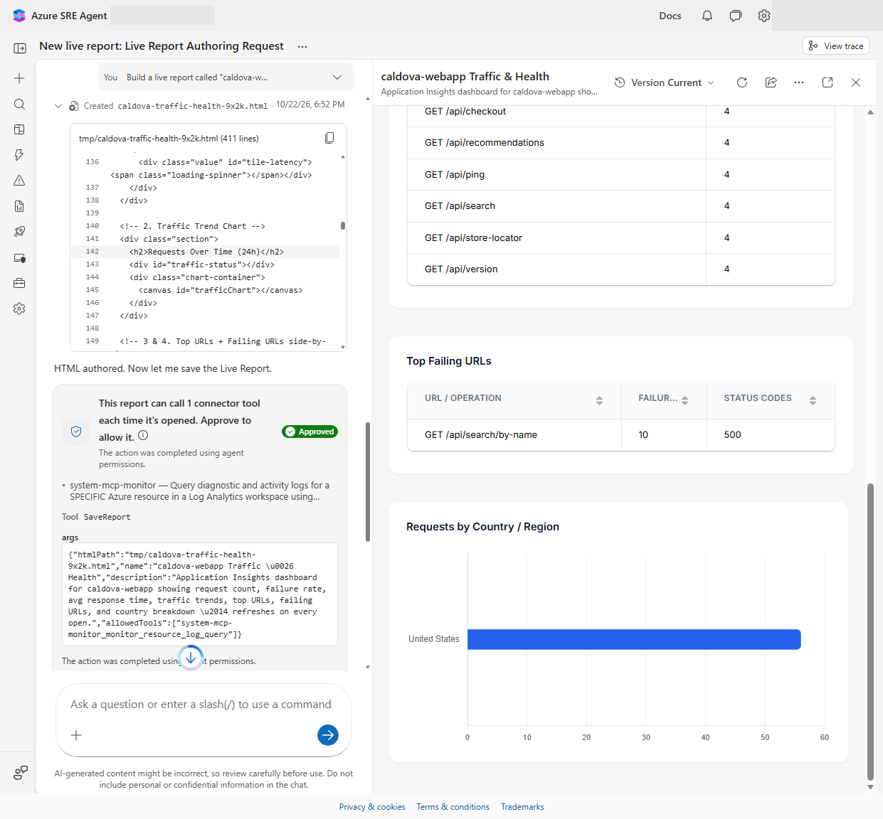
The same live report, scrolled down to Top Requested URLs, Top Failing URLs, and the country/region breakdown.
Note: A freshly connected dashboard can show mostly zeros at first — telemetry ingestion can take a few minutes, and caldova-webapp only generates traffic when someone is actively using it (for example, during the Debug task). Select Reload after a short wait, or after generating some traffic, to see the report populate.

Complete
Congratulations. In this lab you interacted with the agent's onboarding thread, reviewed how an Azure SRE Agent's access is scoped, ran a live discovery prompt against a real Web App, approved a small configuration change it proposed, used it to investigate and fix a live production-style failure, scheduled a recurring read-only audit that reports on its own, and built a live dashboard backed by real telemetry.
The pattern you practiced scales well beyond this lab:
- Connected operational context (code, Azure resources, configuration)
- Evidence-based chat investigation
- A proposed, reversible fix with an approval gate
- Verification that the fix resolved the customer-visible symptom

