**Design and Implementation of Computerised Stadium Seat Booking Management System**

**Meet Shelediya**

**Renish Jagani**

**Rishit Samariya**

**Rishabh Patel**

**Ujash Thakkar**

**Ananya Khandelwal**

**Nishant Doshi (Prof.)**

Pandit Deendayal Energy University, India

**Abstract.** The aim of this research work was to create a reliable and easy to use online ticket booking system for use by fans, customers and the management. The main objectives of the project were to: (a) Create a system that makes it easier for customers to buy the tickets they want online. (B) Developing a more modern and efficient system for providing access to land by matches. Day, which will reduce costs as per the game. (c) Providing a better system for the distribution of remote game tickets. Unfortunately, the current ticket management system leads to improper inclusion of financial payment details, as well as timely reporting and insecurity of records. This research project aims equally to compile all ticketing activities and to make management decision-making reports. To achieve this goal, a Comprehensive Research and Investigation System was conducted and data was collected and analysed in the current process using text drawings and data flow data. The concept of report generation has been computerized and therefore, there is no longer a delay in making reports to the field manager. Mistakes made by hand the fundraisers are completely excluded. I would like to recommend that each department should be provided with a set of computers and a central computer to facilitate communication and access to the software database, and provide adequate reporting and workload for each department in line with technological trends in the 21st Century. Continuous software development should be made as improvements arise from technology.

**Keywords: -** Stadium-ticket, mobile booking, Management System

# 1 Introduction

The stadium serves as the center point for major events, especially sporting events such as cricket. It’s one thing to build a stadium and it’s quite another to run one. Ticket sales and management are an essential part of stadium operations. The system is also deemed crucial because its failure will result in substantial financial loss for the stadium's management business, as well as, for the viewers.

The seat booking system must be built using well-established software engineering principles that ensure a high level of reliability. The primary goal of this study is to develop a dependable and simple-to-use database system that will make buying tickets easier. A more reliable and modern entry system to the stadium, which will minimize costs on a match-by-match basis and provide a more equitable system for ticket distribution while monitoring seating space.

Through the implementation of a stadium ticket booking system, we will try to find solutions to the challenges that seat booking management faces. This research would transform the conventional system for managing tickets to an automated system in order to reduce problems for stadium staff.

Our system will facilitate precise statistics for each match, including the number of spectators in each match, Temperature of respective attendees, the revenues generated from the sales of tickets as well as other amenities such as jerseys and food.

### 1.1 Our Contributions

In this paper, we have shown the unique features of stadium Seat booking management system and done the comparative analysis using features of this paper with other papers.

* Seat Location: The System has inbuilt tracking system function where using GPS sensor to determine seat location.
* Seating Arrangement: Harmonic Search algorithm and graph colouring algorithm used to allocate seats for each person.
* Fixtures and Venue: The system has a feature of providing details of the upcoming matches which will identify the detailed information about fixtures and venue of the match.
* Jersey and Food: The system has a features for controlling and managing orders, to store records and its helps manager to control each part of section orders.
* Audience Verification: Whenever person entered the stadium security guard check the ticket how he can know ticket is authentic or not so in every ticket they are some kind of Unique QR codes are included in tickets.
* Weather: The database allows the authority to keep an eye on the weather pattern to arrange the next matches accordingly.
* Audience Temperature: This system provides feature which measures and stores the temperature of the audience while entering the stadium.

### 1.2 Paper organization

Section 2 gives the Literature Survey of other research papers. In section 3, we give the proposed database system such as framework and models like relational model and entity relational model. In section 4, we have given the comparative analysis using features of our paper with other research papers. Finally, in section 5, we conclude and give the future scope of this work. References are at the end.

# 2 Literature Survey

# Following points refers to the previously implemented systems:

* The three authors Mohammad awni ahmad Mahmoud, Saleem Issa Al Zoubi, Zeyad Alfawaer proposed a Versatile Ticketing System for Amman worldwide Stadium Prototype helps people in general by acquiring a simpler method to reserve their spot by giving them the important data of the tagging and permit them to make booking for watching the football match. From the testing and assessment led, the model satisfies the prerequisites required the portable client. In any case, upgrades must be made for the model to be more client well-disposed by adding a few pictures and shadings to the model which needs an illustrations originator.
* The fundamental exploration question of the paper-The added value of smart stadiums: A case study at Johan Cruijff Arena by Van Heck was: which smart devices can be recognized in arenas and how can the utilization of these smart instruments be streamlined. In view of the consequences of the investigation of the Johan Cruijff Field, nine distinctive keen apparatuses can be distinguished. These outcomes exhibit the capability of these advancements for the smart arena idea and the handiness of researching advances inside arenas.
* The author Hushang Jawazal present the execution of "On-line Football Tickets Reservation Framework". This framework is a work to build up a product that can be gotten to through the web association by means of advanced mobile phone or Computer. Our venture makes the ticket reservation straightforward and simple.
* The authors Amanze B.C, Ononiwu C.C, Nwoke B.C, and Amaefule I.A had proposed a System that Computer can be utilized to handle information identified with STADIUM The board. With this product, the administration of the arena can undoubtedly get accomplish the accompanying; Total Attendance in a Match, Accounting Information, Staff Records, Maintaining security framework. Filling/access framework, updating/keeping up framework for fans and staff (identification, update and addition activity), Records yields as delicate duplicates and hard duplicates concerning accomplishing these framework above, the paper limits focus down to the clients.
* The authors Gerd Nufer, Jan Fischer proposed a system in their paper that cost is the best benefit driver and better valuing choices can drive incomes and benefits up with no speculation forthright. Mispricing has an extremely negative impact on the clubs' primary concerns. This paper has featured the way that German Bundesliga clubs are unfit to benefit from ticket deals because of wasteful evaluating. Particularly, the group's force to be reckoned with Bayern Munich offers strikingly low ticket costs, given the abundance interest for all its Bundesliga games. The Bavarian club is run as a business and seemingly quite possibly the best groups in European football. Oddly enough, the club does, in any case, not benefit from ticket deals, leaving great cash on the table.
* In view of authors E S Soegoto, I F Siddiq the aftereffects of the exploration, at that point it tends to be presumed that with the data arrangement of online ticket booking tickets for Persib Bandung matches. It is normal that purchasers can undoubtedly arrange tickets. The ticket booking interaction will be more proficient, in light of the fact that the purchaser can just purchase two tickets utilizing one ID number.

# 3 Proposed System

### 3.1 Framework

The stadium seat booking system is a huge task in itself that needs to be managed and recorded in order to maintain a flawless and efficient management of audience coming to watch the sport. The database allows the management team to analyse the data and make the necessary arrangements accordingly. It helps to study the pattern of a particular stadium’s seat bookings and the revenue generating over the years.

The database can provide many details of a particular stadium including average seat bookings of a particular sport, which sport matches had maximum tickets sold and generated maximum revenue, average revenue generated by a particular stadium etc.

### 3.2 Relational Model

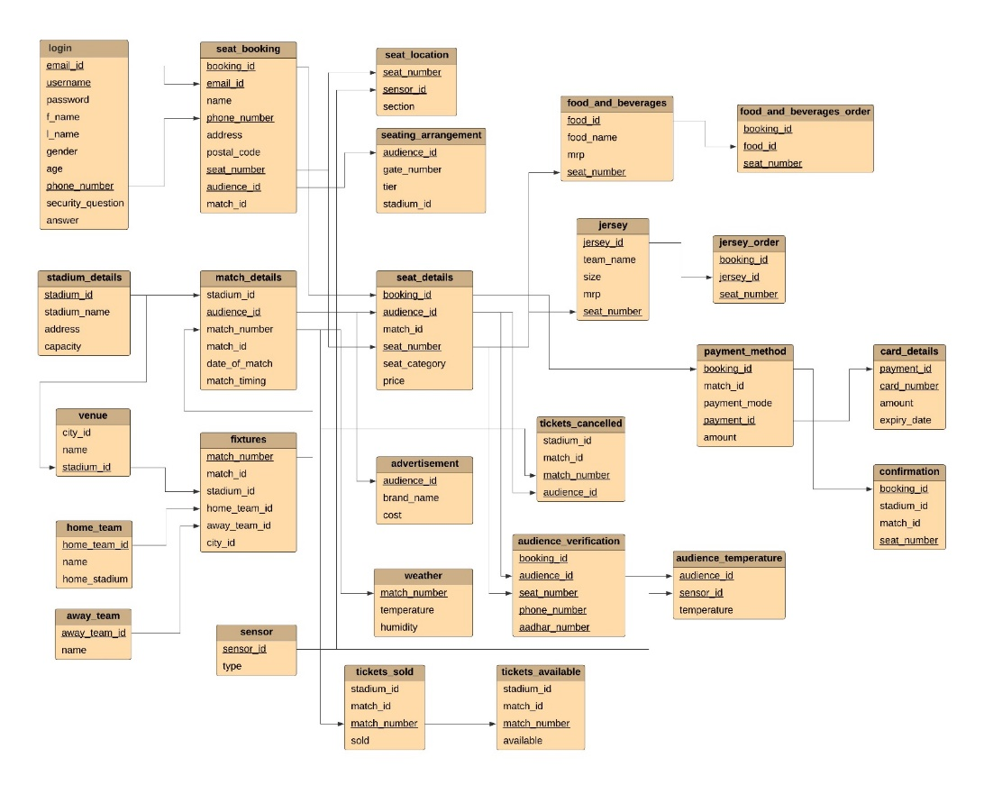

## 3.3 Entity Relational Model

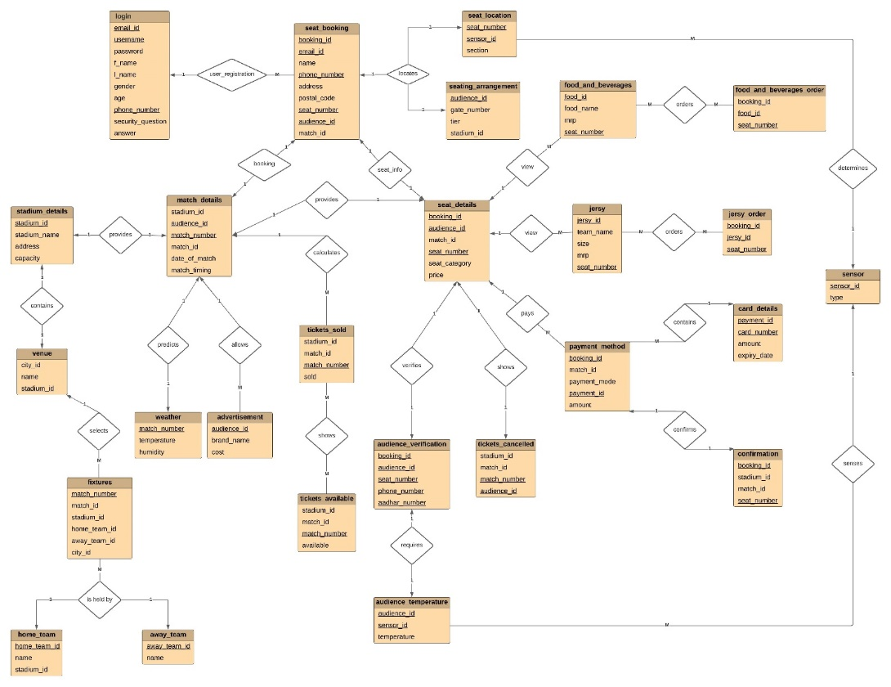

**4 Experimental Analysis**

**Feature 1 (seat Location) -** The System has inbuilt tracking system function where using GPS sensor to determine seat location.

**Feature 2 (seat_arrangement**) - Harmonic Search algorithm and graph colouring algorithm used to allocate seats for each person.

**Feature 3 (fixtures, venue) -** The system has feature of providing details of the upcoming matches which will identity the detailed information about fixture and venue of the match.

**Feature 4 (food and beverage, jersy) -** The system has a feature for controlling and managing orders, to store records and its helps manager to control each part of section orders.

**Feature 5 (audience_verification) -** Whenever person entered the stadium security guard check the ticket how he can know ticket is authentic or not in every ticket they are some kind of Unique QR codes are included in tickets.

**Feature 6 (weather) -** The database allows the authority to keep an eye on the weather pattern to arrange the next matches accordingly.

|  |  |  |  |  |  |  |
| --- | --- | --- | --- | --- | --- | --- |
|  | Feature 1 | Feature 2 | Feature 3 | Feature 4 | Feature 5 | Feature 6 |
| [Development of online ticket system at a football club] | No | Yes | No | No | No | No |
| [On-Line Football Tickets Reservation System] | Yes | No | No | No | No | No |
| [Mobile E-Ticketing Reservation System For Amman International Stadium In Jordan] | No | Yes | No | No | No | No |
| [Ticket Pricing in European Football – Analysis and Implications] | No | No | Yes | No | No | No |
| [Stadium Management Information System. A Case study Of Dan Anyiam Stadium Owerri Nigeria] | No | No | No | No | No | No |
| [Our Approach] | Yes | Yes | Yes | Yes | Yes | Yes |

|  |  |
| --- | --- |
| **Legends** | **Meaning** |
| Feature 1 | The System has inbuilt global positioning framework work where utilizing GPS sensor to decide seat area. |
| Feature 2 | Consonant Search calculation and chart shading calculation used to distribute situates for every individual. |
| Feature 3 | The framework has highlight of giving subtleties of the forthcoming matches which will character the definite data about apparatus and scene of the match. |
| Feature 4 | The framework has a highlights for controlling and overseeing orders, to store records and its assists supervisor with controlling each piece of segment orders. |
| Feature 5 | At whatever point person entered the arena safety officer check the ticket how he can realize ticket is valid or not in each ticket they are some sort of Unique QR codes are remembered for tickets. |
| Feature 6 | The data set permits the power to watch out for the climate example to mastermind the following matches appropriately. |

# 5 Conclusion and Future Work

Overall, we believe we have achieved our primary goals and objectives. We believe that a consistent approach was taken to the system's design and implementation. Through in-depth study of the vast activities of database management and computerization covered in this research paper, the seat booking interface and data management system that we have achieved is robust, user friendly, easy to use, and efficient. We will continue to research future systems based on this, as well as investigate some of the newer innovations that might be useful for the stadium ticket booking system.

# References

1. Abraham S., Henry F.K, & Surdarshan S. (2006). Database System Concepts: (5th ed.). McGraw Hill Companies Inc, New York.
2. Loudon, K.C. & Loudon, J.P (2001). Business Information Systems: A Problem Solving Approach USA, The Dryden Press.
3. Kim, L. and M.J. Albers, 2001. Web design issues when searching for information in a small screen display. Proceedings of the 19th Annual International Conference on Computer Documentation, Oct. 21-24, Sante Fe, New Mexico, USA., pp: 193-200.
4. Choi, S.Y., D.O. Stahl and A.B. Whinston, 1997. The Economics of Electronic Commerce. Macmillan Publisher, India.
5. Laudon, K.C. and J.P. Laudon, 2000. Management Information Systems. Prentice Hall, PTR Upper Saddle River, NJ, USA.
6. Vaishnavi, V. and B. Kuechler, 2004. Design research in information system. <http://www.isworld.org/Researchdesign/drisISworld.htm>
7. Melander, B. A. (2016). Smart Stadiums: An Illustration of How the Internet of Things Is Revolutionizing the World. Ariz. St. U. Sports & Ent. LJ, 6, 349.
8. Giorgio, P., Deweese, C., Reicheld, A., & Ebb, S. (2018). The stadium experience. Keeping sports fans engaged—and loyal. Retrieved from https://www2.deloitte.com/content/dam/Deloitte/us/Documents/technologymedia-telecommunications/us-tmt-stadium-experience-keeping-sports-fansengaged-loyal.pdf
9. Giulianotti, R. (2002). Supporters, followers, fans, and flaneurs: A taxonomy of spectator identities in football. Journal of sport and social issues, 26(1), 25-46. doi:https://doi.org/10.1177/0193723502261003
10. Giorgio, P., & Campbell, P. (2016). The stadium as a platform: A new model for integrating venue technology into sports business. Retrieved from https://www2.deloitte.com/us/en/pages/consumer-business/articles/integratingvenue-technology-sports-business.html
11. Wiedmann, K.P., Hennigs, N. and Siebels, A. (2009), “Value-based segmentation of luxury consumption behavior”, Psychology and Marketing, Vol. 26 No. 7, pp. 625-651.
12. Yang, W. and Mattila, A.S. (2016), “Why do we buy luxury experiences? Measuring value perceptions of luxury hospitality services”, International Journal of Contemporary Hospitality Management, Vol. 28 No. 9, pp. 1848-1867.
13. Sanford K and Scott F 2014 What are SEC football tickets worth? Evidence from secondary market transactions Southern Economic Journal 81 1 p 23-55
14. Prakoso L P, Aditya B R, and Tridalestari F A 2017 E-cash Untuk Pembayaran E-ticketing Pertandingan Klub Sepak Bola Persib Bandung Berbasis Web Dan Sms Gateway (studi Kasus Pt Persib Bandung Bermartabat). eProceedings of Applied Science, 3(3), pp 11-17.
15. Howard D R and Crompton J L 2004 Tactics used by sports organizations in the United States to increase ticket sales Managing Leisure 9 2 p 87-95.
16. Biscaia R, Correia A,Yoshida M, Rosado A and Marôco J 2013 The role of service quality and ticket pricing on satisfaction and behavioural intention within professional football International Journal of Sports Marketing and Sponsorship 14 4 p 42-66.
17. Barzdins, J. & Caplinskas, A., 2001. Databases and information systems. Dordrecht, The Netherlands: Kluwer Academic Publishers.
18. Ismail, N. A. & Hussin H. (26-27 March 2013). E-CRM features in the context of airlines e-ticket purchasing: A conceptual framework. Paper presented at Information and Communication Technology for the Muslim World (ICT4M), pp. 1-5, doi: 10.1109/ICT4M.2013.6518907.
19. Ani, C.O(2003). Programming with Microsoft Basic: Immaculate Publications limited, Enugu.
20. French, C.S. (2006). Computer Science, Book: Power publisher London.