***ABSTRACT***

* Shrink IT! is an application which helps you quickly reduce your picture size or resolution. Optimize your images with a perfect balance in quality and file size.
* Shrink IT! is also a super easy to use application to crop and rotate your photos.
* Shrink IT! uses smart lossy compression techniques to reduce the file size of your photos. By selectively decreasing the number of colors in the image, fewer bytes are required to store the data.
* Shrink IT! utilizes Application Programming Interface(API) and Dependencies to perform its task.
* Shrink IT! rotates the photo by 90° either clockwise and then crop the photo



***1.INTRODUCTION***

Overview

Shrink IT! is an application which helps you quickly reduce your picture size or resolution. Optimize your images with a perfect balance in quality and file size

Motivation

* Every Government Or Private form filling site has an Maximum size limit.
* For example, if your email account allows you to send messages up to 5 megabytes (MB) and you include just two pictures in the attachment (today’s pictures taken by a phone or tablet camera are about 5 or 8 MB), you will probably exceed the maximum message size. In this case, this image resize app is very helpful, because it helps to avoid exceeding the maximum message size limits associated with most email accounts. Compress pictures before composing the e-mail and then attach much smaller photos.

Objective

People can use Shrink IT! to compress and save images.

They just have to take/select pictures and click Shrink IT!

It is easy to use and efficient.

Scope of Work

Better Interface

More Compression

Better Quality Retention.

***2.SYSTEM REQUIREMENTS***

FOR DEVELOPER:

Hardware Requirements:

* RAM- >=8GB
* PROCESSOR: Intel Core i5 10th or 11th Generation or later
* GPU: Intel R Graphics 610

Software Requirements:

* Android Studio or Android Application development environment
* Language: JAVA or KOTLIN and XML(Extensive Markup Language)

FOR USER:

Hardware Requirements:

* Camera
* Android Version>10
* RAM: >=2GB

Software Requirements:

* Permissions: Access Camera, Media, File and Folder
* Android Operating System

***3.DESIGN / IMPLEMENTATION***

TECHNOLOGY USED

Frontend- XML (Extensive Markup Language)

Backend-Java

Integrated Development Environment-Android Studio

DESIGN

1. Welcome Screen

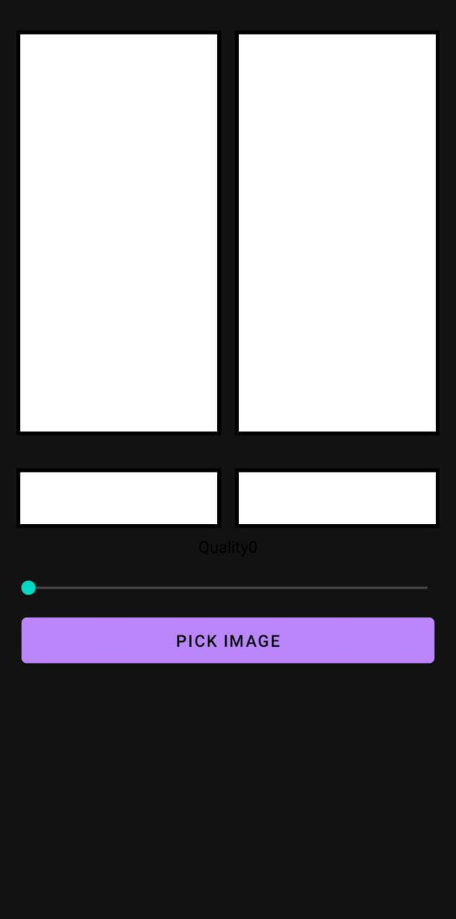

Fig.1

1. On clicking “Pick Image” Selection Screen Appears.

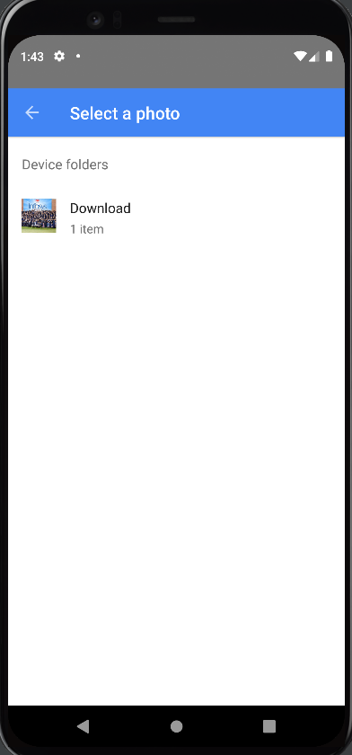

Fig.2

Here, the user is can select any image from gallery or folders.

1. User selects a photo

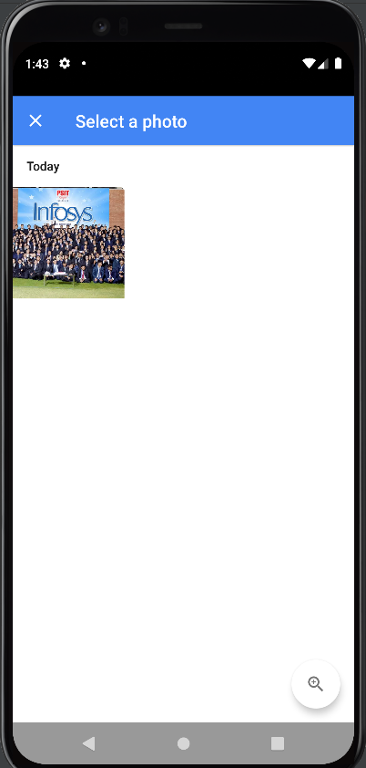

Fig.3

1. The user selects the various size ratios and quality level.

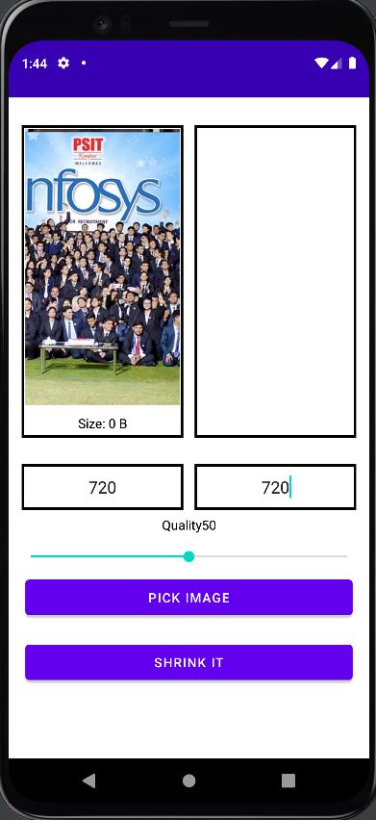

Fig.4

1. Press SHRINK IT! Button



The Compressed image is saved in your gallery, without the loss of quality and in just a simple click.

The total of 4 steps made a big problem look so easy.

***4. TESTING, RESULT AND ANALYSIS***

Testing is necessary for the development of a project.

Testing involves collecting data, giving that data to the project and observing the results.

On the basis of test results, further improvement and addition of details are done.

1.The app was tested for structure.

The display of the layouts on the screen was the way it was expected.

The functionality of the buttons and toasts were tested.

Now, the functionality of the app for the whole was tested.

Any crashing were debugged by checking log files and tracing back to errors for correction.

2.The app was tested for logic.

The app was run on multiple devices and checked

for proper working still.

Each stage of the app was checked for all functions present in it.

***5.FUTURE ENHANCEMENT***

* Image Enhancing
* Background Removal
* Image Type Conversion

1. ***CONCLUSION***

When the size of your photo matters, you often have to give up its quality. But with SHRINK IT! you don’t have to make this compromise! You can resize your pictures and images without changing their quality.

Shrink IT! is an application specialized to reduce image size at the slightest tap

Whether you need to resize your image for a social media profile or optimize images for your website or online store, ShrinkIT! App will help you to do it the most effective way.