Measurement of RTT (Round Trip Time) between any pair of active servers with error correction

Sri Harsha Chennavajjala
University Of Missouri, Kansas City
sc9v9@mail.umkc.edu
Teja Garidepally
University Of Missouri, Kansas City
tgww4@mail.umkc.edu

Raj Kiran Reddy Munnangi
University Of Missouri, Kansas City
rmyb9@mail.umkc.edu

Vinay Kumar Matoori
University Of Missouri, Kansas City
vm8b8@mail.umkc.edu

Uday Chowdary Malineni
University Of Missouri, Kansas City
um5m2@mail.umkc.edu
Aishwarya Rao Venkata
University Of Missouri, Kansas City
avrpn2@mail.umkc.edu

Pallavi Ramineni Swetha Karroti
University Of Missouri, Kansas City University Of Missouri, Kansas City
pr3md@mail.umkc.edu sckqn8@mail.umkc.edu

FALL 2015, October 30, 2015

Abstract— The main aim of the project is to calculate the RTT(Round trip time) between any two nodes by collecting data and correcting error there by obtaining exact distance between the servers. Automated geolocation of IP addresses has important applications to targeted delivery of local news, advertising and other content over the Internet. Previous measurement-based approaches to geolocation employ active probing to measure delays among a set of landmark nodes with known locations. The location of a target IP address can be approximated by that of the nearest landmark, as determined by the delay measurements.

Introduction
The project mainly deals with calculating the RTT(Round trip time) between any two nodes by collecting data and correcting error there by obtaining exact distance between the servers.
Round Trip Time: In telecommunications, the round-trip delay time (RTD) or round-trip time (RTT) is the length of time it takes for a signal to be sent plus the length of time it takes for an acknowledgment of that signal to be received. This time delay therefore consists of the propagation times between the two points of a signal.
Basically RTT value depends on various factors including:
- The speed with which intermediate nodes and remote server function.
- The number of other requests handled by intermediate nodes and remote server.
- The number of nodes between source and destination.
- The physical distance between the source and destination.
- The data transfer rate of source internet’s connection.
- The presence of interference in the circuit.
- The amount of traffic on LAN to which the end user is connected.
- The nature of the transmission medium.
Other than above factors RTT depends mainly on two parameters.
Scheduling delay: It refers to a difference between a desired time of arrival or departure and the actual time.
Network delay: Network delay is an important design and performance characteristic of a computer network or telecommunications network. The delay of a network specifies how long it takes for a bit of data to travel across the network from one node or endpoint to another. It is typically measured in multiples or fractions of seconds. Delay may differ slightly, depending on the location of the specific pair of communicating nodes.

Existing System
Geolocation of IP addresses has important applications to targeted delivery of local news, advertising and other content over the Internet. One approach to IP geolocation is to maintain a large distributed database containing mappings of IP addresses to geographical locations. Many sites rely on more or less accurate databases to determine the location of a customer for various reasons:
• Determining regional distribution of the clients, local news delivery, targeted advertising, restriction of content delivery based on regional policies, etc.;
• Prevention/reduction of Internet frauds such as credit card fraud, identity theft, spam and phishing;
• Application to intrusion detection.
Research is going on now to automate the geolocation of IP addresses. Padmanabhan and Subramanian have investigated three techniques:
GeoTrack: Inferring the geographic location of an Internet host based on the DNS name of the host or another nearby node.
GeoCluster: clustering the IP address space into likely collocated clusters.
GeoPing: Pinging the host, with geolocation of the IP address performed by correlating ping delays.
The latter approach employs active probes to measure delays among a set of landmark nodes with known locations. Such delay measurements can be performed by a distributed network of servers. Such a network of servers can be self-calibrating and potentially able to detect when a target IP address has changed its geographical coordinates significantly.
However, inferring geographical location from Internet delay measurements may result in large errors due to the nonlinear relationship between geographical distance and “Internet” distance as determined from delay measurements. Given delay measurements among a set of landmark nodes with known locations, the location of a target IP address can be approximated by that of the nearest landmark. To improve geolocation accuracy, a variation of this approach uses multilateration with geographic distance constraints to obtain a continuous location space rather than the discrete set of landmark locations. Gueye improved upon GeoPing using an idea borrowed from sensor networks. Their Constraint-Based Geolocation (CBG) algorithm uses a multilateration algorithm to determine the probable location of the targets. Katz-Bassett proposed Topology Based Geolocation (TBG), which finds hosts along Internet paths using the traceroute utility and geolocates hosts simultaneously using CBG. All of these methods are based on deterministic algorithms, which can have unacceptable geolocation errors of more than 1000 km.
PROBLEM DESCRIPTION

The existing techniques are not up to the mark because of their way of approach will not always have the accurate and updated database. So we are using RTT phenomena to estimate the distance of nodes.

DETAIL DESCRIPTION OF OUR APPROACH

In this project are developing a RTT measurement system which measures the RTT between any pair of server through exchange of files with error correction.
The resources that we have used are
- Ubuntu Linux
- SCP/SSH
- MySQL
- gcc compiler
- PlanetLab
- Matlab
- R Language
Steps for data collection:

- PlanetLab is a global research network that supports the development of new network services.
- Since the beginning of 2003, more than 1,000 researchers at top academic institutions and industrial research labs have used PlanetLab to develop new technologies for distributed storage, network mapping, peer-to-peer systems, distributed hash tables, and query processing.
- After creating account in planet lab , a slice has been allocated to us
- Selected 89 nodes which are geographically diversified and added to our slice.
- Generated private key and public key using ssh keygen, and uploaded the generated public key in to planetlab for authentication.
- Created 5 different sized files with names file32B, file1KB, file256KB, file512KB, file1MB in our local machine and transferred these files to all nodes using scp command.
- Installed gcc compiler in all machines to run our programs for communication between nodes.
- Our program starts each and every node as both client and server from our local machine.
- Every node acts a client and fetches 5 files from all other servers.
- Every node acts a server and sends files to all the requested clients.
- Time taken by every node to download files will be recorded in logs.
- All the generated logs will be loaded in to database downloaddetails_bkp.

Here the collected data will be analyzed in next section
Data representation
We have plotted different kinds of graphs using the collected data.
- CDF of delay vs distance.
- Distribution of measurements for 4 nodes in our planetlab set.
- Q-Q plot for 4 planetlab nodes.

CDF of delay vs distance

- CDF of delay vs distance for 32B file
X-axis: distance
Y-axis: CDF of different delay ranges

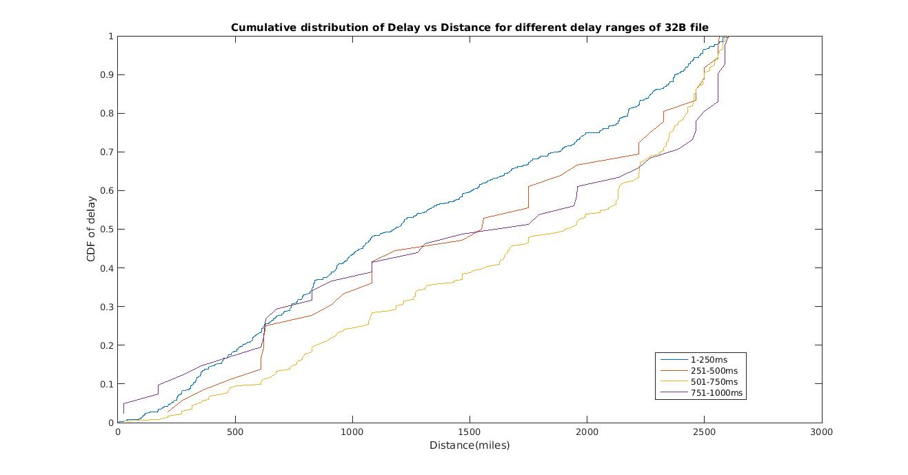

2. CDF of delay vs distance for 1KB file
X-axis: distance
Y-axis: CDF of different delay ranges

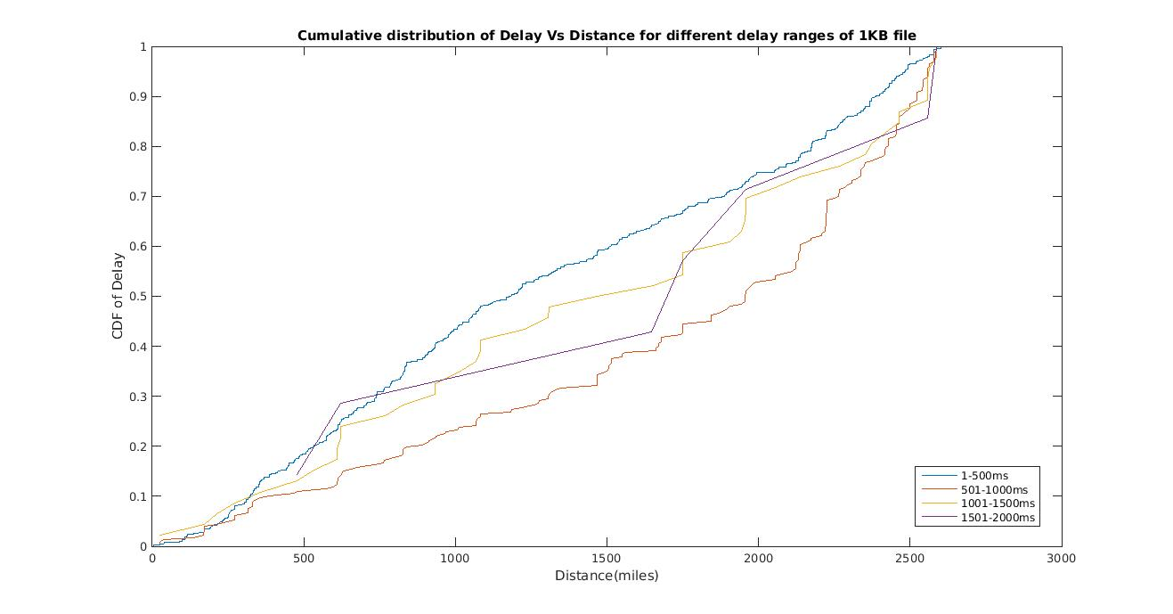

3. CDF of delay vs distance for 256KB file
X-axis: distance
Y-axis: CDF of different delay ranges

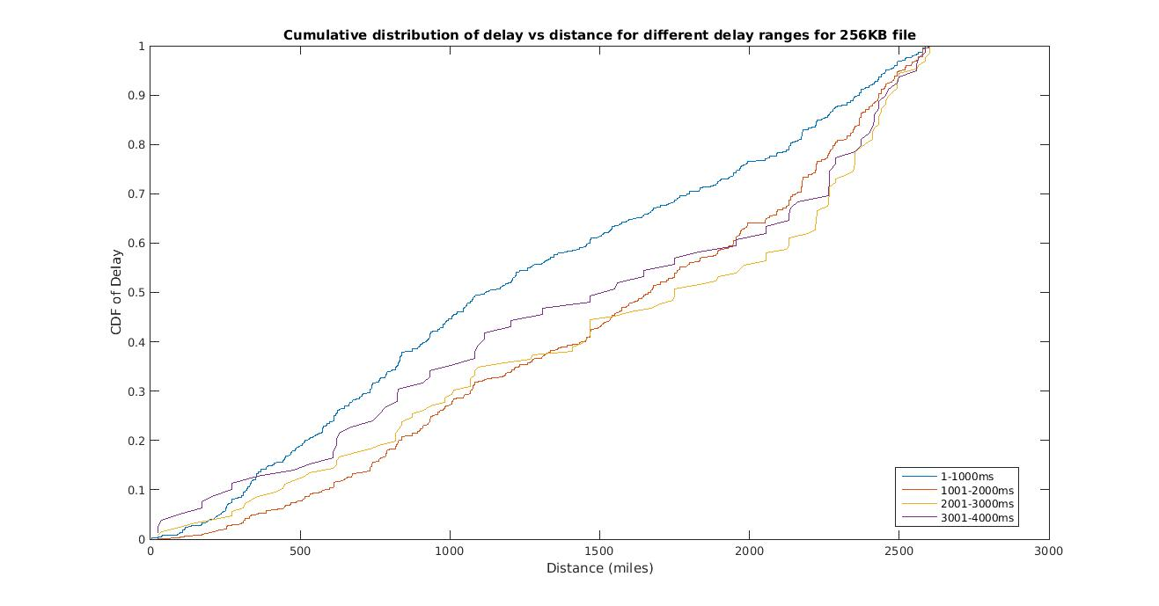

4. CDF of delay vs distance for 512KB file
X-axis: distance
Y-axis: CDF of different delay ranges

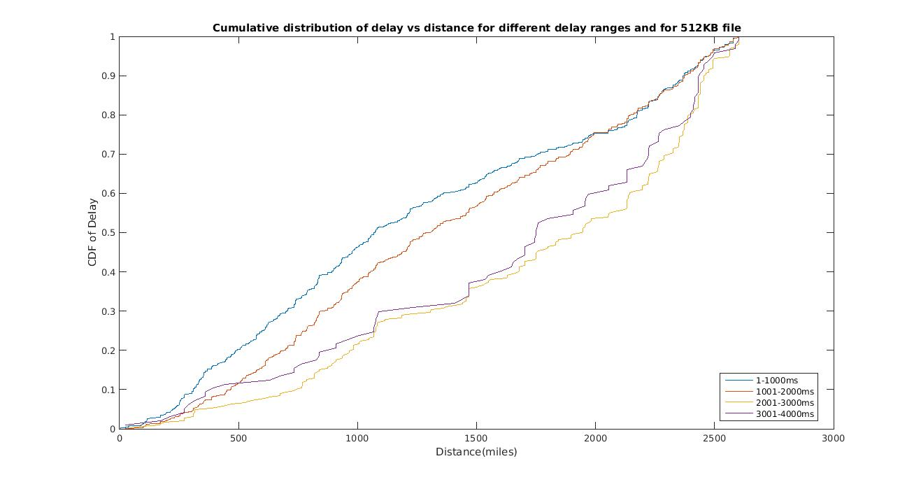

5. CDF of delay vs distance for 1MB file
X-axis: distance
Y-axis: CDF of different delay ranges

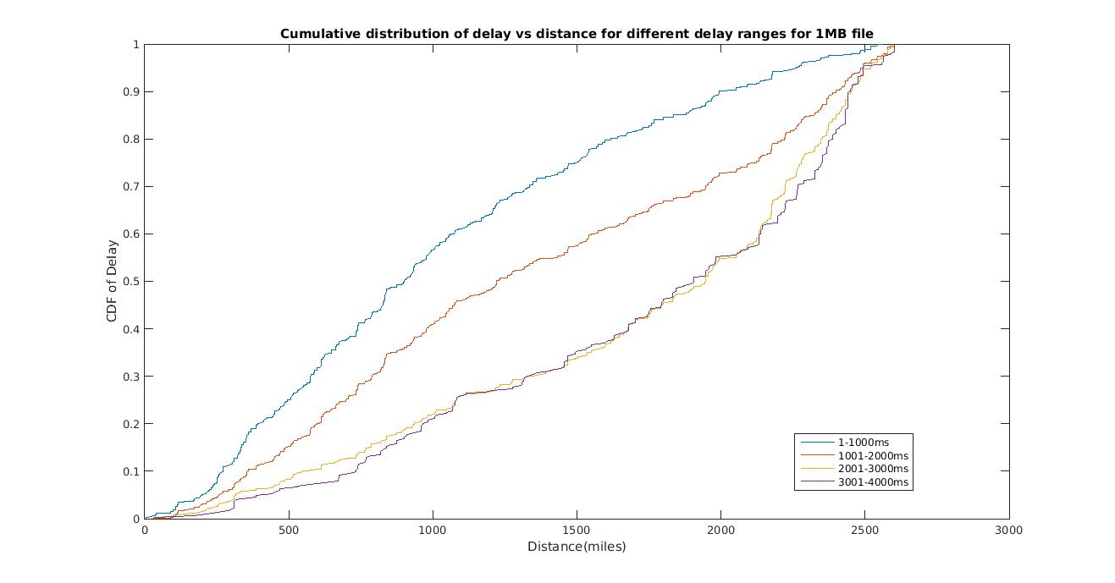

Distribution of measurements

- ebb.colgate.edu and 32B file:

X-axis: z scores for standard normal distribution
Y-axis: φ (z)

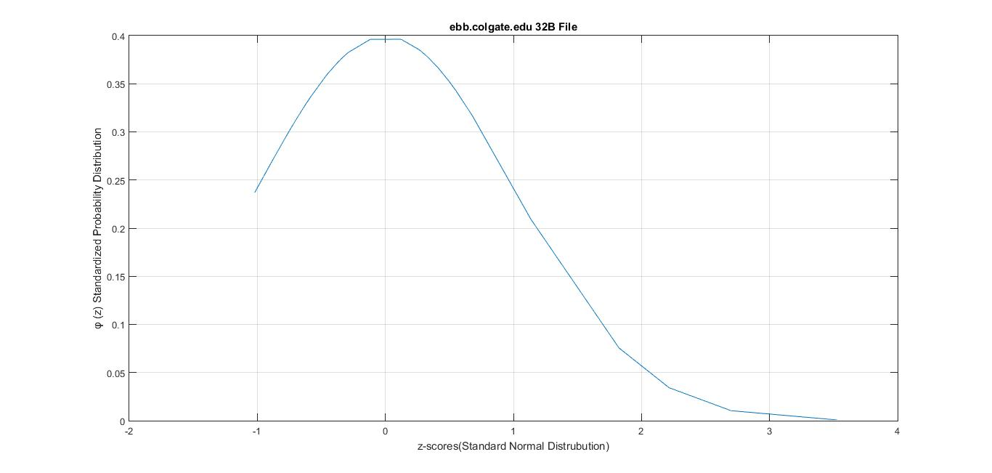
- ebb.colgate.edu and 1KB file:

X-axis: z scores for standard normal distribution
Y-axis: φ (z)

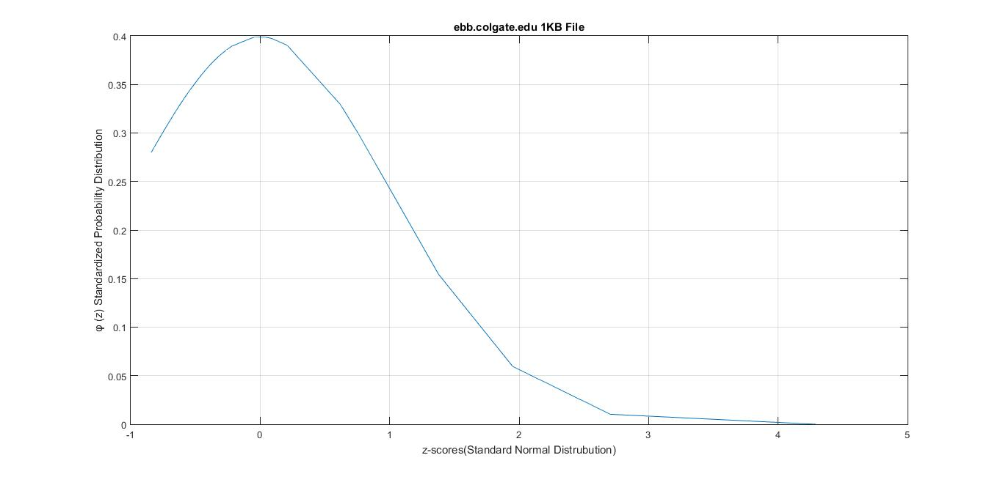

- ebb.colgate.edu and 256KB file:

X-axis: z scores for standard normal distribution
Y-axis: φ (z)

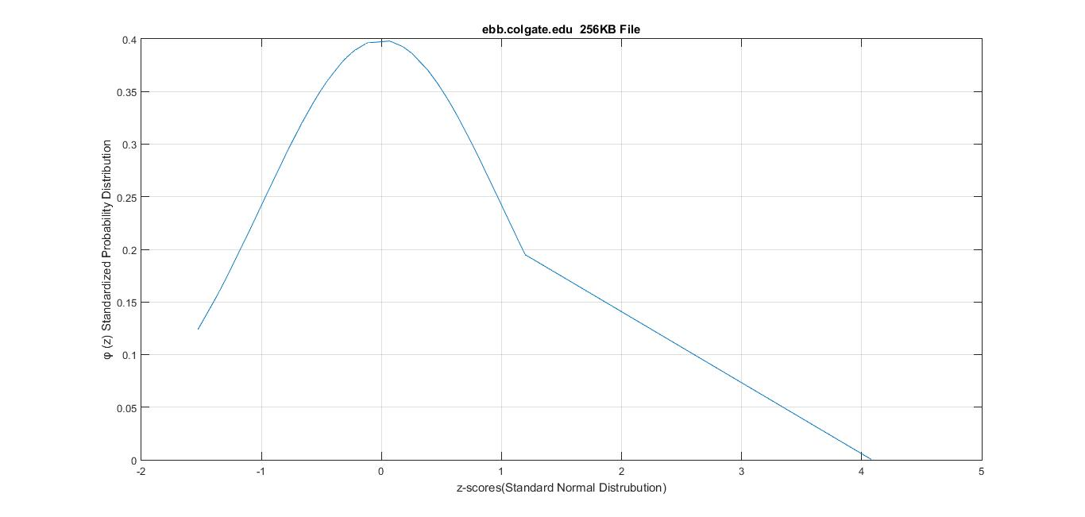

4. ebb.colgate.edu and 512KB file:

X-axis: z scores for standard normal distribution
Y-axis: φ (z)

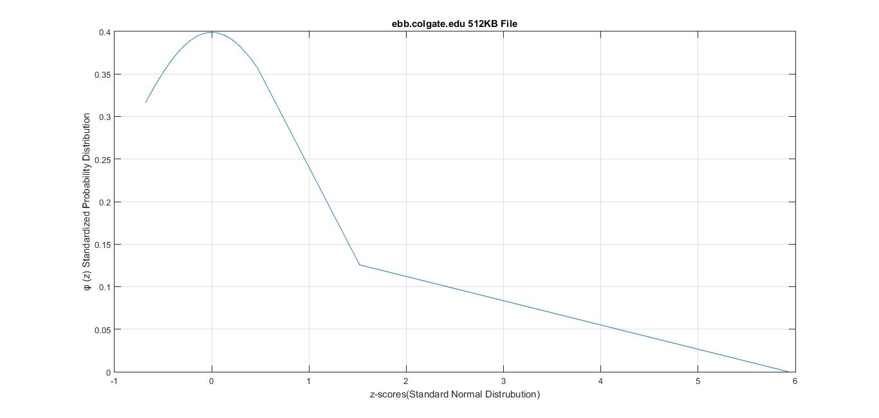

5. ebb.colgate.edu and 1MB file:

X-axis: z scores for standard normal distribution
Y-axis: φ (z)
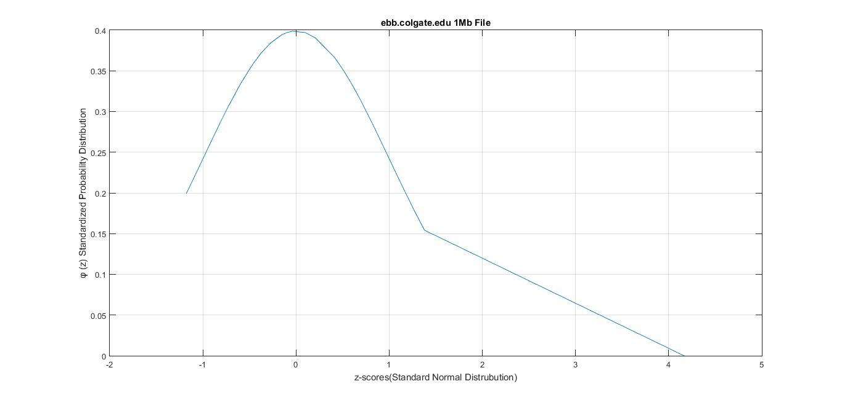

6. planetlab2.unr.edu and 32B file:

X-axis: z scores for standard normal distribution
Y-axis: φ (z)
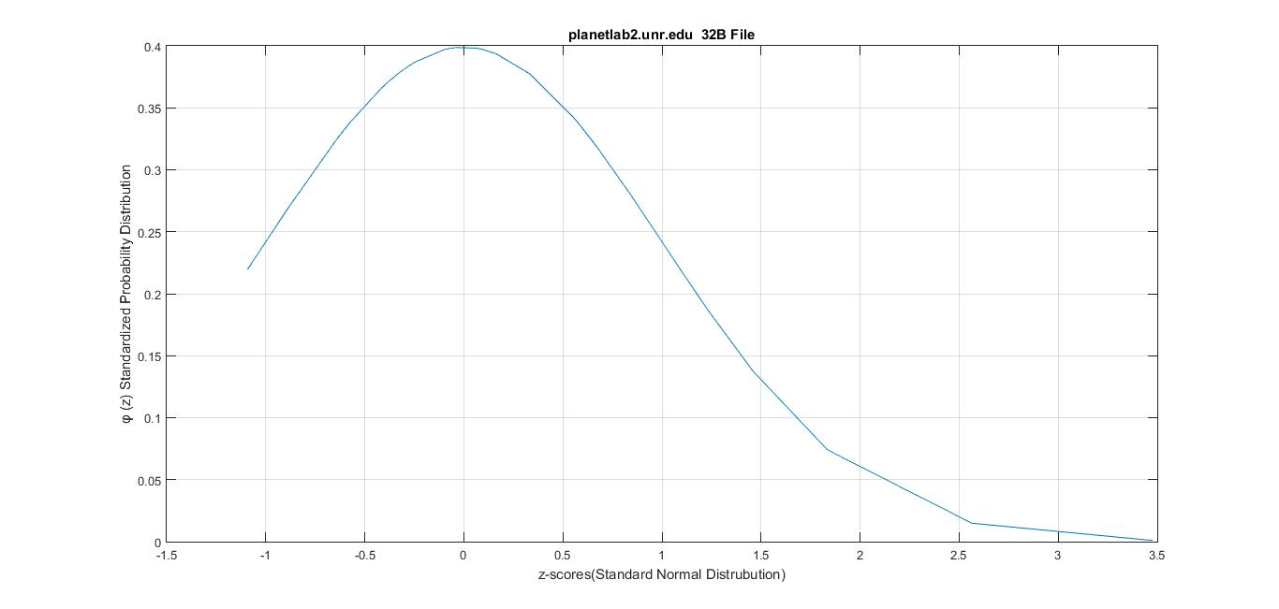
7. planetlab2.unr.edu and 1KB file:

X-axis: z scores for standard normal distribution
Y-axis: φ (z)
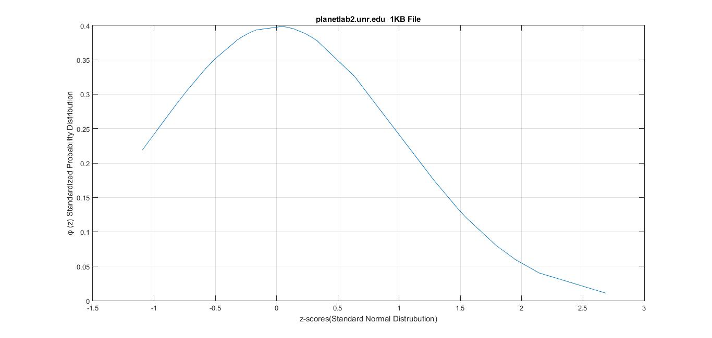

8. planetlab2.unr.edu and 256KB file:

X-axis: z scores for standard normal distribution
Y-axis: φ (z)
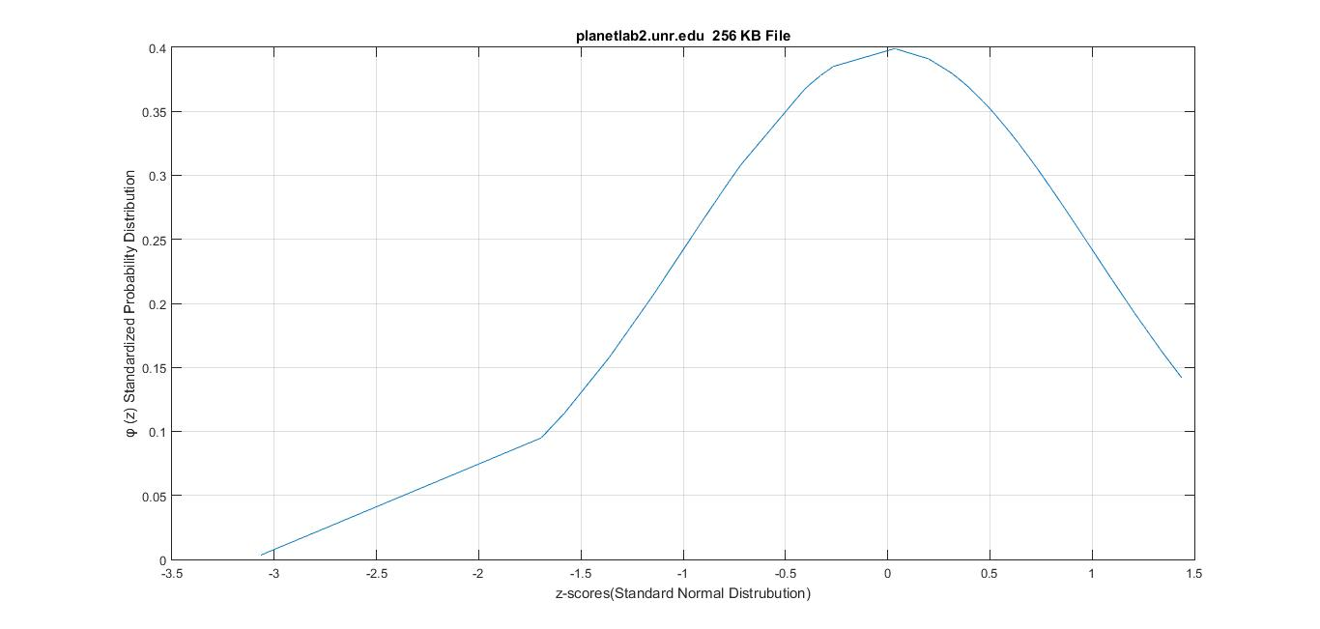
9. planetlab2.unr.edu and 512KB file:

X-axis: z scores for standard normal distribution
Y-axis: φ (z)
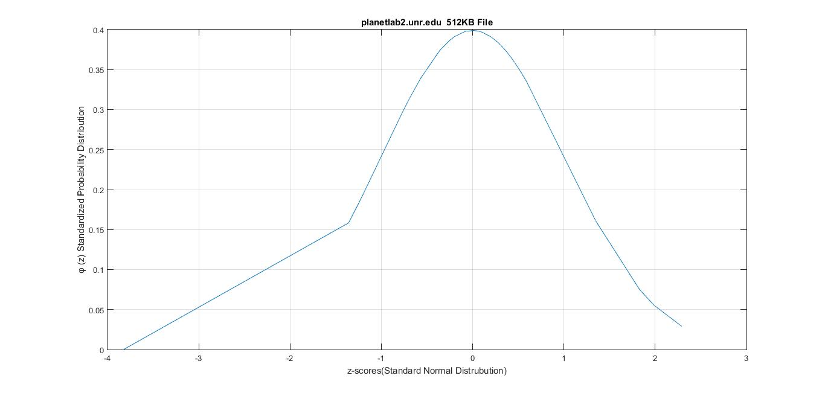

10. planetlab2.unr.edu and 1MB file:

X-axis: z scores for standard normal distribution
Y-axis: φ (z)
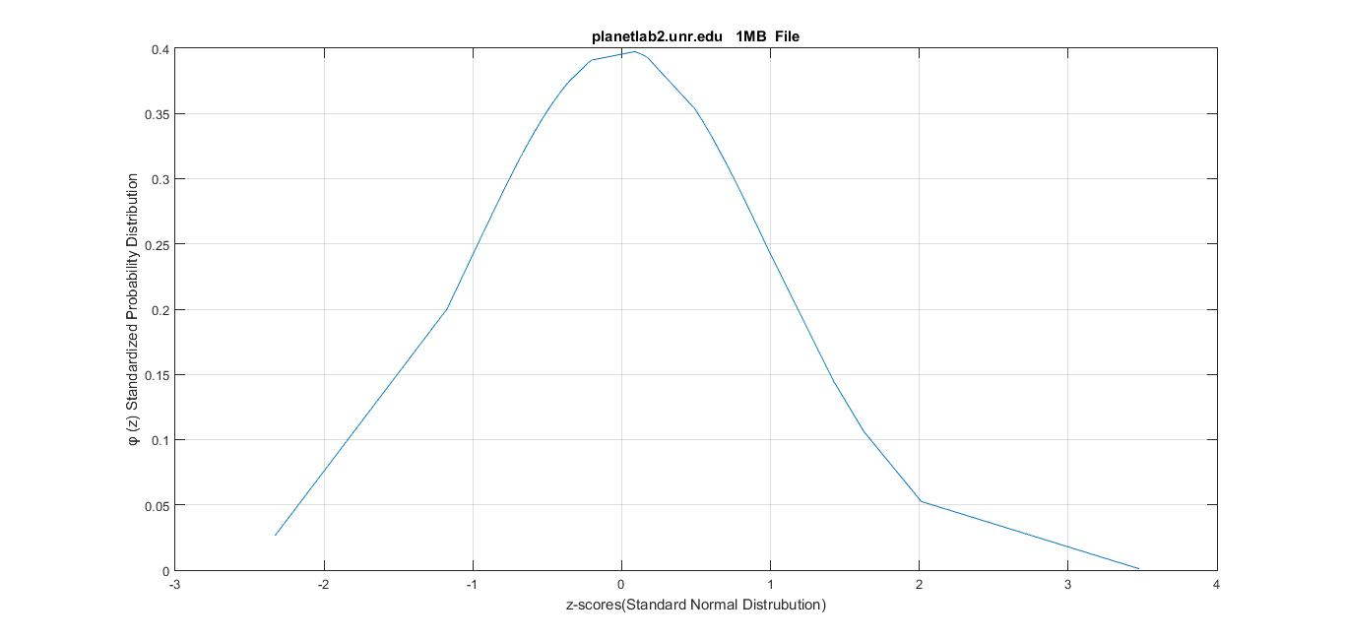
11. planetlab2.eecs.umich.edu and 32B file:

X-axis: z scores for standard normal distribution
Y-axis: φ (z)
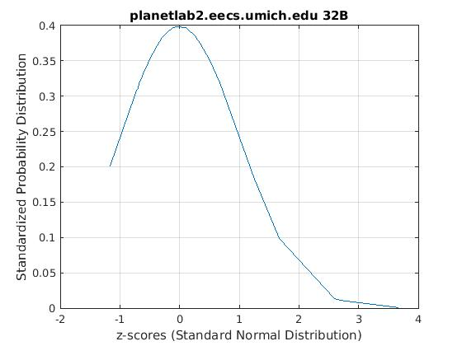

12. planetlab2.eecs.umich.edu and 1KB file:

X-axis: z scores for standard normal distribution
Y-axis: φ (z)
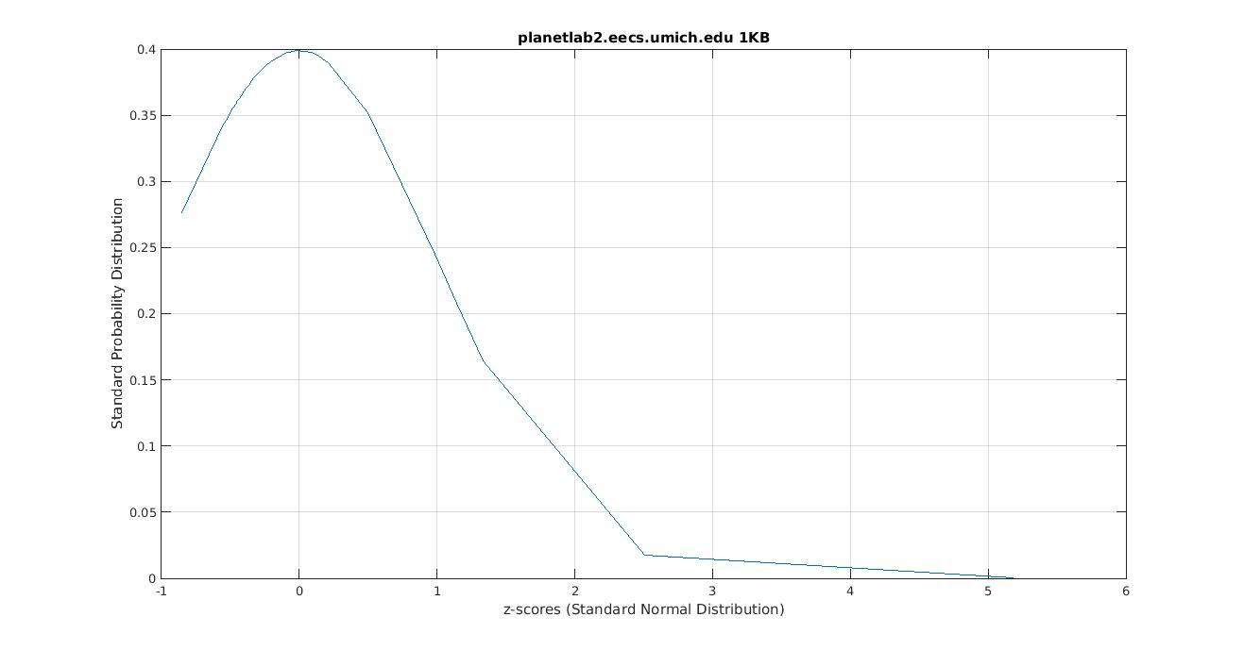
13. planetlab2.eecs.umich.edu and 256KB file:

X-axis: z scores for standard normal distribution
Y-axis: φ (z)
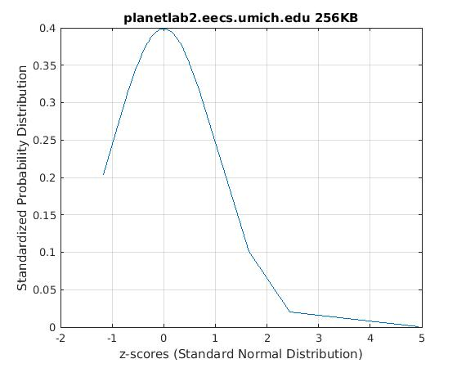
13. planetlab2.eecs.umich.edu and 512KB file:

X-axis: z scores for standard normal distribution
Y-axis: φ (z)

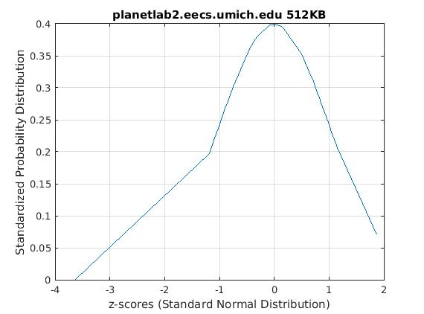

15. planetlab2.eecs.umich.edu and 1MB file:

X-axis: z scores for standard normal distribution
Y-axis: φ (z)
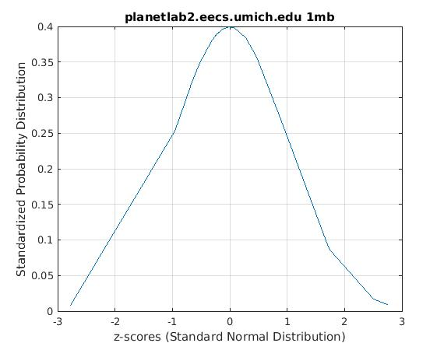

16. planetlab3.cs.uoregon.edu and 32B file:

X-axis: z scores for standard normal distribution
Y-axis: φ (z)
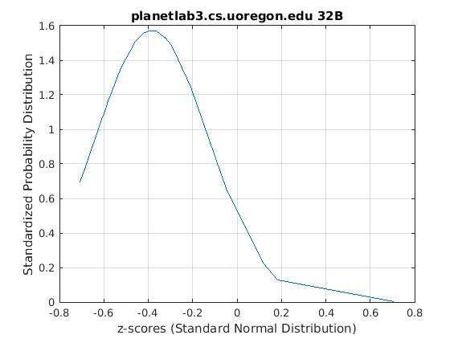
17. planetlab3.cs.uoregon.edu and 1KB file:

X-axis: z scores for standard normal distribution
Y-axis: φ (z)
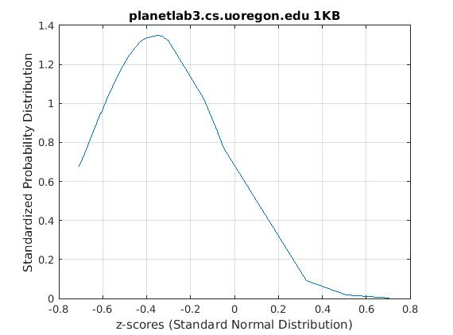
18. planetlab3.cs.uoregon.edu and 256KB file:

X-axis: z scores for standard normal distribution
Y-axis: φ (z)
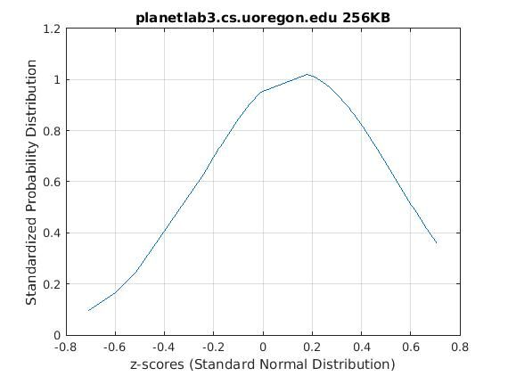
19. planetlab3.cs.uoregon.edu and 512KB file:

X-axis: z scores for standard normal distribution
Y-axis: φ (z)
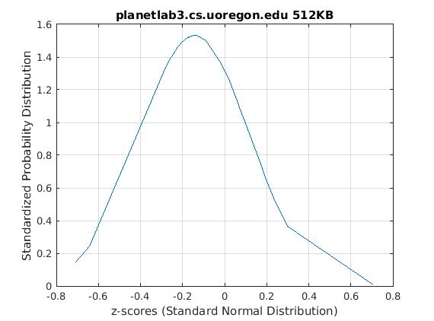
20. planetlab3.cs.uoregon.edu and 1MB file:

X-axis: z scores for standard normal distribution
Y-axis: φ (z)

Q-Q plot

Q-Q plot for nodes ebb.colgate.edu, planetlab2.unr.edu, planetlab3.cs.uoregon.edu, planetlab3.eecs.umich.edu

X-axis: Standard Normal expected quantities
Y-axis: Standard Normal observed quantities

- Q-Q plot for 32B file

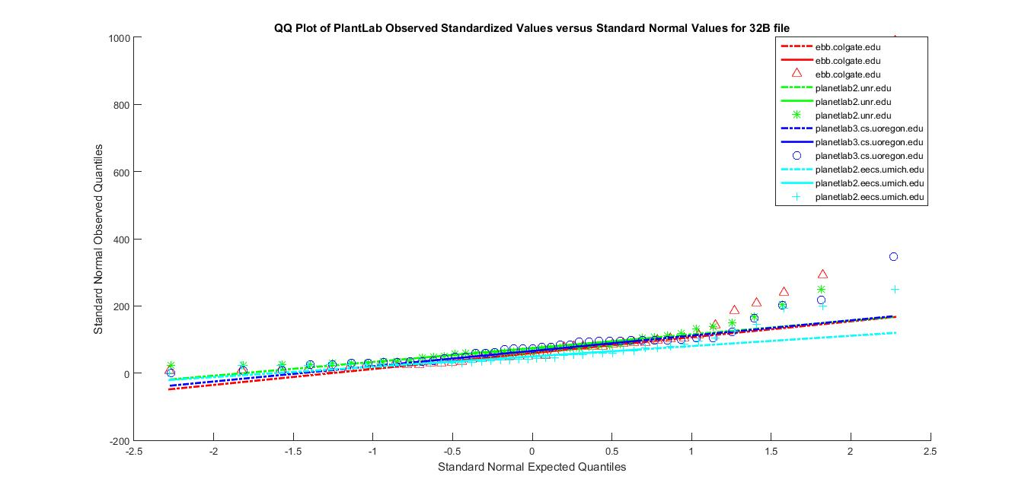

- Q-Q plot for 1KB file

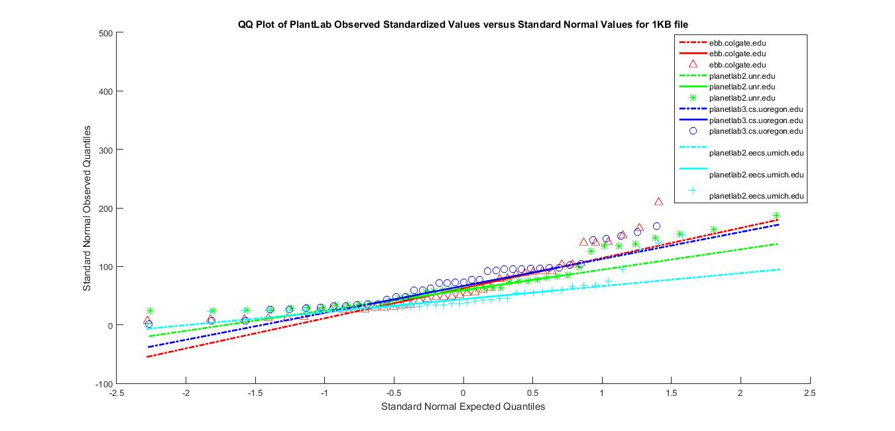
- Q-Q plot for 256KB file

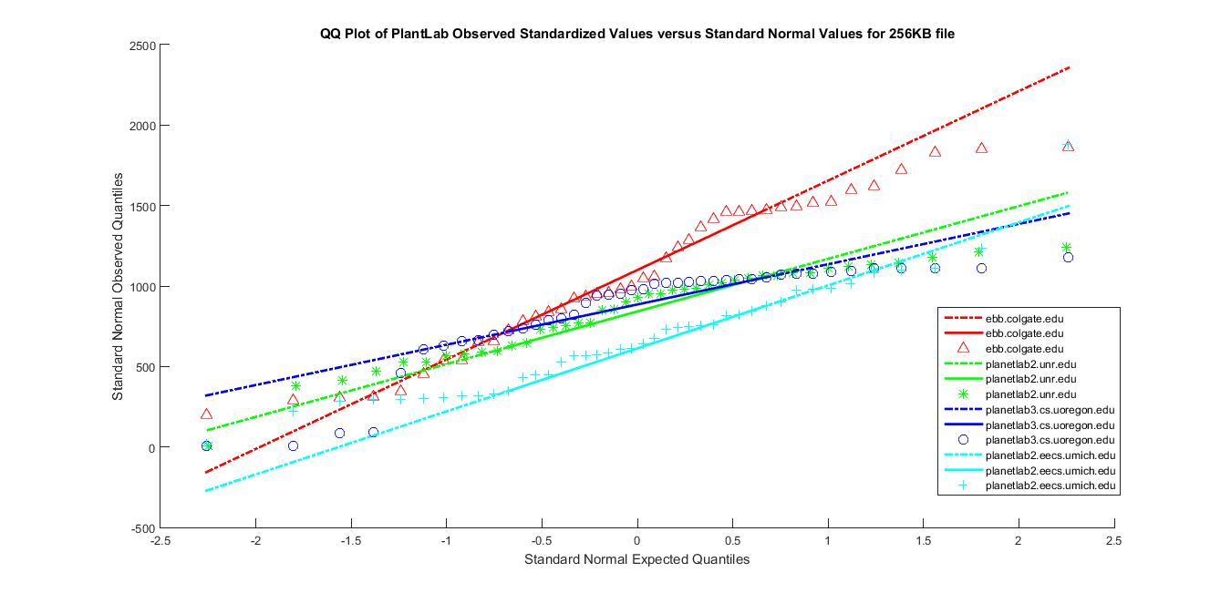

- Q-Q plot for 512KB file

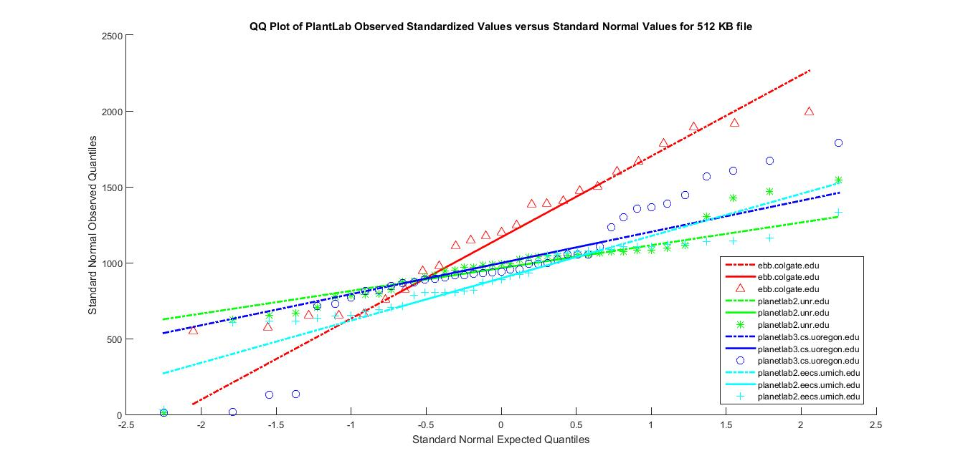

- Q-Q plot for 1MB file

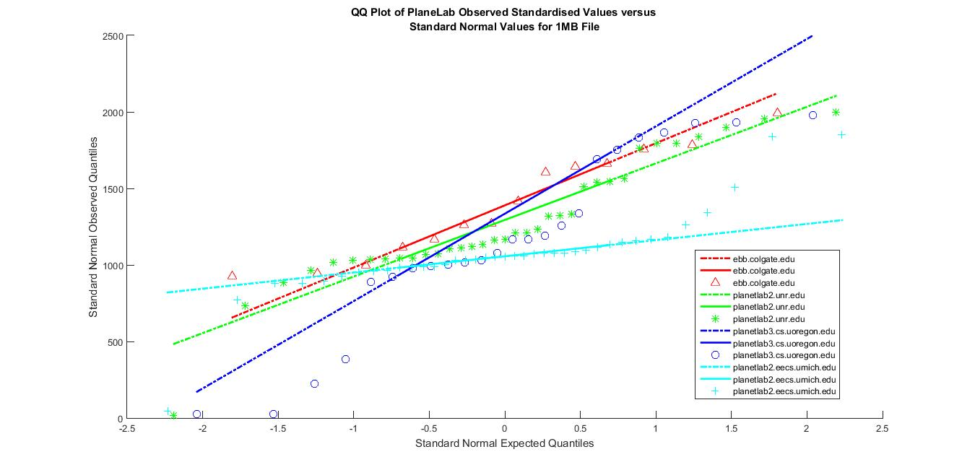

References
- Venkata N.Padmanabhan, Lakshminaryanan, Determining the Geographic Location of Internet, Microsoft research report November 2000.
- Inja Youn,Brian L.Mark,Dana Richards, Statistical Geolocation of Internet Hosts. Dept. of Computer Science George Mason Unversity Fairfax, Virginia 22030 USA Email: richards@cs.gmu.edu
- https://en.wikipedia.org/wiki/Round-trip_delay_time
- http://searchnetworking.techtarget.com/definition/round-trip-time
- https://tools.ietf.org/html/rfc1323
- Phillipa Sessini and Anirban Mahanti, Observations on Round-Trip Times of TCP Connections, Phillipa Sessini and Anirban
- Jay Aikat, Jasleen Kaur, F. Donelson Smith, Kevin Variability in TCP Round-trip Times, Department of Computer Science University of North Carolina at Chapel Hill Chapel Hill, NC 27599-3175
- http://www.statemethods.net/graphs/line.html
- http://www.statemethods.net/input/contents.html
[10] http://www.statemethods.net/blog/?p=779

