COMP-SCI 5551 Advanced Software Engineering

Assignment 7 Solution

Sri Harsha Chennavajjala (7),

[Sc9v9@mail.umkc.edu](mailto:Sc9v9@mail.umkc.edu)

I’ve extended the tutorial 6 application to implement the basic CRUD operations of REST. Below are the screenshots of the application.

**Welcome page:**

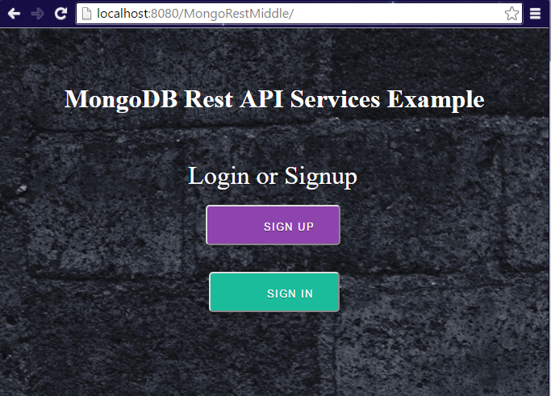

The user will select either login or signup options.

**Sign Up Page:** User will be presented with a basic form for INSERTing the details into MongoDB.

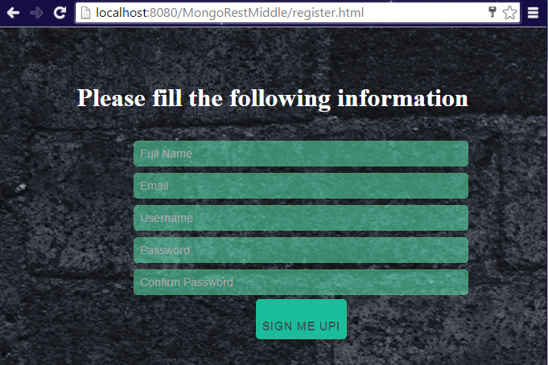

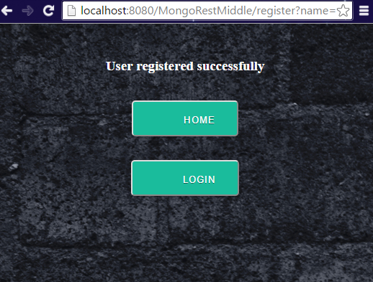

**Login page: READ Operation**

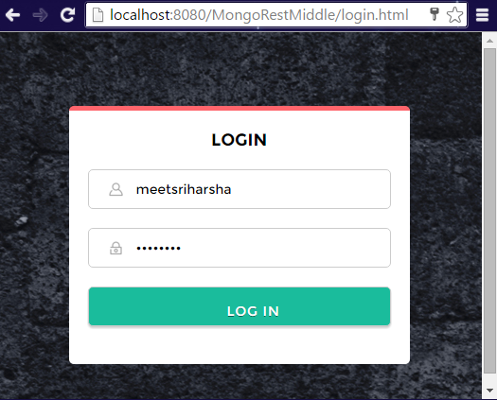

**Start Page: UPDATE and DELETE operations**

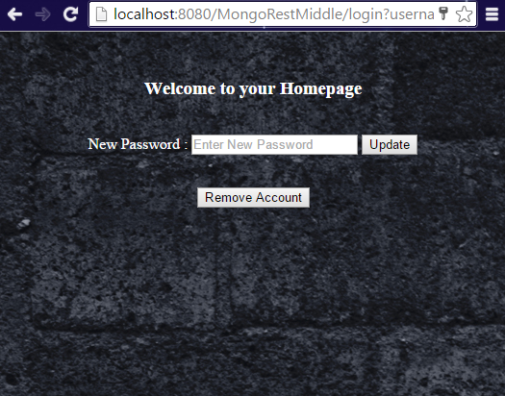

User can update his password using UPDATE service or he can delete his account using DELETE service.

