Specification and Description Language (SDL)

Group 7

Sri Harsha Chennavajjala,

Teja Garidepally,

Karthik Reddy Vundela

Raj Kiran Reddy Munnangi

# Definition

Specification and Description Language (SDL) is a standardized language used for the description system architecture, behavior of system components. SDL is based on experience within the telecommunications industry in describing systems as communicating state machines. It is developed and maintained by ITU-T as ITU Recommendation Z.100. The latest version of the standard was published in 2011. The language is intended for the specification of complex, event-driven, real-time and interactive applications involving many concurrent activities that communicate using discrete signals.

Due to its suitability for real-time, stimulus-response systems, SDL has been used extensively within the telecommunications industry by both standards makers and manufacturers. SDL has also been used as a real-time design language outside the communications industry.

# Overview

Started as an informal drawing technique SDL has evolved to a full-blown visual and precise language, equally applicable to specification tasks and design activities. SDL is intuitive and helps in visualizing relationships, thanks to its simple conceptual basis (communicating extended finite state machines), and its graphical representation. The graphical abstractions that originally led to its popularity when used informally are semantically well-defined and tools exist to allow complete code generation directly from SDL descriptions.

More and more systems are multi-process and distributed, and they execute in a heterogeneous environment. It is increasingly accepted within a steadily growing range of industrial segments that the best way to meet the needs of these systems is through formal methods.

The Specification and Description Language provides both a graphical Graphic Representation (SDL/GR) as well as a textual Phrase Representation (SDL/PR), which are both equivalent representations of the same underlying semantics. Models are usually shown in the graphical SDL/GR form, and SDL/PR is mainly used for exchanging models between tools. A system is specified as a set of interconnected abstract machines which are extensions of finite state machines (FSM).

# Benefits of SDL

SDL is able to describe the structure, behavior, and data of real-time and distributed communicating systems with a mathematical rigor that eliminates ambiguities and guarantees system integrity.

SDL has a graphical syntax that is extremely intuitive. Even non-constructors quickly obtain an overview of a system’s structure and behavior. The most important characteristic of SDL is its formality. The semantics behind each symbol and concept are precisely defined SDL satisfies the following demands:

* A well-defined set of concepts
* Unambiguous, clear, precise and concise specifications
* A thorough and accurate basis for analyzing specifications
* A basis for determining whether or not an implementation conforms to the specification
* A basis for determining the consistency of specifications
* Computer support for generating applications without the need for the traditional coding phase

# History

The development of SDL started in 1972. A 15-member study group within Comité Consultatif International Téléphonique et Télégraphique (CCITT) representing several countries and large telecom companies like Bellcore, Ericsson, and Motorola began research on a standard specification language for the telecommunications industry. The first version of the language was issued in 1976, followed by new versions in 1980, 1984, 1988, 1992 and 1996. The latest version of the standard was published in 2011. Today SDL is a complete language in all senses.

# SDL and Other Languages

SDL is well suited to be the core of full-scale projects because of its abilities to interface with other languages like Object Modeling Technique (OMT), Abstract System Notation (ASN.1) etc.,

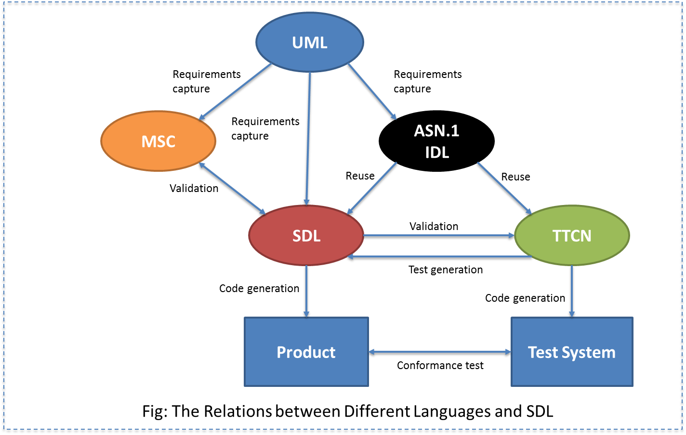

The procedure from requirements analysis to product implementation and testing would involve the following steps:

* Collect the initial requirements in a text document.
* Study system analysis results in a number of OMT/UML object models and MSC use-cases depicting typical scenarios. The resultant classes are implemented in SDL as SDL block diagrams and SDL/ASN.1/IDL data-type definitions
* Complete the SDL diagrams and ASN.1 or IDL specifications to a level where they can be simulated and checked for consistency with the system requirements analysis.
* Use verification and validation to determine whether required properties are correctly and completely implemented. The verification procedure also detects general errors like deadlocks, signal races, loss of signals, etc. When SDL design has proved consistent with the requirements, a code for the application can be generated.
* Make a test suite in TTCN. Tests can be generated from the SDL specification. In some cases, such tests are already available.
* Generate code to create an executable test suite that can be run in a test system.
* Run the executable tests and test the application in the target environment.

# SDL Characteristics

Typical SDL application areas are high- and low-level telecom systems, aerospace systems, and distributed or highly complex mission-critical systems.

SDL has a set of specialized characteristics that distinguishes it from other technologies for example, SDL is standard, formal, graphical and symbol-based, object-oriented, highly testable, portable, scalable and open.

# Theoretical Model

The basic theoretical model of an SDL system consists of a set of extended finite state machines that run in parallel. These machines are independent of each other and communicate with discrete signals. An SDL system consists of the following components:

* Structure - system, block, process, and procedure hierarchy
* Communication - signals with optional signal parameters and channels
* Behavior - processes
* Data - abstract data types (ADT)
* Inheritance - describing relations and specialization