CSEE 5110 Network Architecture I

Assignment 2 solution

Sri Harsha Chennavajjala (16210893)

[SC9V9@mail.umkc.edu](mailto:SC9V9@mail.umkc.edu)

1. In CSMA/CD, after the fifth collision, what is the probability that a node choose K=10? The result K=10 corresponds to a delay of how many seconds on a 10 Mbps Ethernet?

CSMA/CD uses binary exponential back off for choosing the time interval for retransmission of packets when there is a collision.

In this given problem, there were already five collisions. Therefore the probability of choosing K=10 is 1/32. This is because the interval for K is {0, 1, 2… 31}.

NIC waits K*512 bits time before it starts the retransmission. In the given problem, the delay for 10Mbps Ethernet can be calculated as below:

$$Delay =\frac{K*512 bits}{10Mbps}$$

$$=\frac{10*512}{10*1000000}$$

$$=\frac{512}{1000000}$$

$$Delay = 512 microsecond$$

1. Consider three LANs interconnected by two routers, as shown in the diagram below.

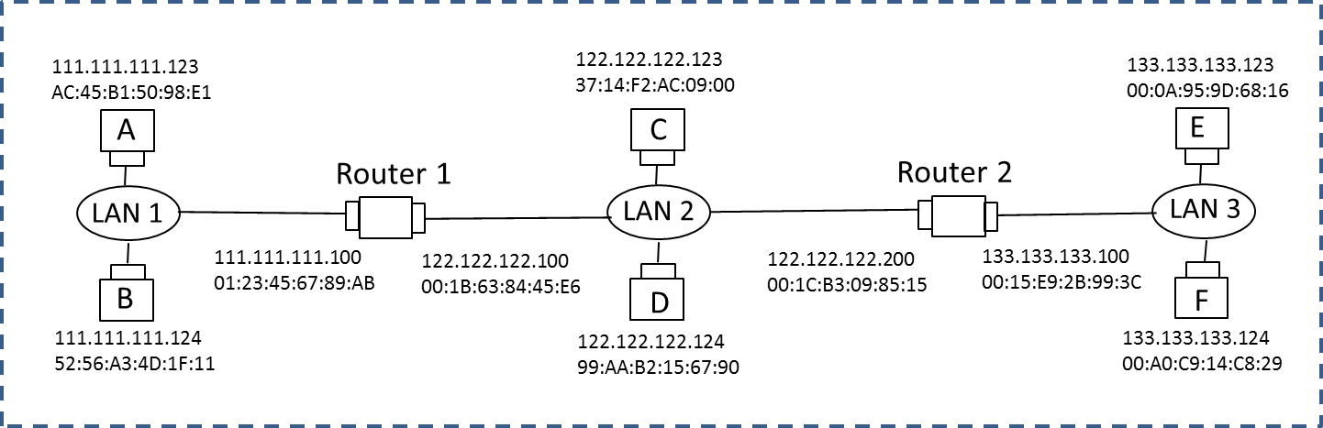

* 1. Assign IP addresses to all the interfaces. For subnet 1 use address of the form 111.111.111.xxx; for subnet 2 use address of the form 122.222.222.xxx; and for subnet 3 use addresses of the form 133.133.133.xxx.

Here, all the subnets are using 24 bit network prefixes. So, I’ve assigned IP addresses so that interfaces on the same subnetwork have the same network-part of their IP address. I’ve assigned the IP addresses for each subnet as shown in the above figure.

* 1. (randomly) Assign MAC addresses to all the adapters.

Each network interface device will have a unique MAC address. I’ve assigned the MAC addresses as shown in the above figure.

* 1. Consider sending and IP datagram from Host A to Host F. Suppose all of the ARP tables are up to date. Enumerate all the steps as done for the single-router example.

The packet will follow the below mentioned route to reach the destination.

1. Forwarding table in host A determines that the datagram should be routed to interface 111.111.111.100.
2. Host A uses ARP table to determine the MAC address for 111.111.111.100, namely 01:23:45:67:89:AB.
3. The adapter in host A creates an Ethernet packet with MAC destination address 01:23:45:67:89:AB.
4. Router 1 receives the packet and extracts the datagram. The forwarding table in this router indicates that the datagram is to be routed to 122.122.122.200.
5. The Router 1 then uses the ARP to obtain the associated Ethernet address, namely 00:1C:B3:09:85:15.
6. The adapter in Router 1 creates an Ethernet packet with Ethernet destination address 00:1C:B3:09:85:15.
7. The Router 2 receives the packet and extracts the datagram. The forwarding table in Router 2 indicates that the datagram is to be routed to 133.133.133.124.
8. The Router 2 uses the ARP to obtain the associated Ethernet address, namely 00:A0:C9:14:C8:29.
9. The adapter in Router 2 creates an Ethernet packet with Ethernet destination address 00:A0:C9:14:C8:29 and forwards the packet.
10. The host F receives the packet.
    1. Repeat (c), now assuming that the ARP table in the sending host is empty (and the other tables are up to date).

In this case, ARP in A must now determine the MAC address of its gateway - Router 1 with IP address 111.111.111.100. So,

1. Host A sends out an ARP query packet within a broadcast Ethernet frame.
2. Router 1 receives the query packet and sends ARP response packet which contains the Ethernet address of Router 1 to Host A.
3. Now, as host A knows the MAC address of Router 1, it stores the corresponding information in its ARP table. As all the other interfaces have updated ARP tables, the same steps of (c) will continue.
4. Host A uses ARP table to determine the MAC address for 111.111.111.100, namely 01:23:45:67:89:AB.
5. The adapter in host A creates an Ethernet packet with MAC destination address 01:23:45:67:89:AB.
6. Router 1 receives the packet and extracts the datagram. The forwarding table in this router indicates that the datagram is to be routed to 122.122.122.200.
7. The Router 1 then uses the ARP to obtain the associated Ethernet address, namely 00:1C:B3:09:85:15.
8. The adapter in Router 1 creates an Ethernet packet with Ethernet destination address 00:1C:B3:09:85:15.
9. The Router 2 receives the packet and extracts the datagram. The forwarding table in Router 2 indicates that the datagram is to be routed to 133.133.133.124.
10. The Router 2 uses the ARP to obtain the associated Ethernet address, namely 00:A0:C9:14:C8:29.
11. The adapter in Router 2 creates an Ethernet packet with Ethernet destination address 00:A0:C9:14:C8:29 and forwards the packet.
12. The host F receives the packet.

3. Suppose a CSMA/CD network is running 100 Mbps over a 1-km cable with no repeaters. The signal speed in the cable is 200,000km/sec.

(a) Compute the following:

a. End-to-end propagation delay

**Given information:**

$$CSMA/CD Network speed = 100 Mbps$$

$$Cable length (d)= 1 km$$

$$Signal speed in the cable (s)= 200,000 km/sec$$

End to End propagation delay can be calculated using:

$$Delay =\frac{2d}{s}$$

$$=\frac{2*1}{200,000}$$

$$= 10 microseconds$$

b. Worst-case (i.e., the longest) collision detection time.

The worst case collision detection time will be 10 microseconds

c. Minimum frame size. (Hint: the frame size should be big enough to be transmitted during the full worst case collision detection time)

Minimum frame size can be calculated by:

$$L = \left(10 µ sec\right)*\left(100 Mbps\right)$$

$$=1000 bits$$

1. Suppose we increase the bandwidth from 100 Mbps to 1 Gbps, how does it affect the above three values?

If we increase bandwidth from 10 Mbps to 1 Gbps, then there will be no change in End-to-End propagation delay and in worst case collision detection time as these are not dependent on link speed.

But, the minimum frame size will change if we change the bandwidth as it is dependent on link speed.

New minimum frame size can be calculated as follows:

$$L = \left(10 µ sec\right) *\left(1 Gbps\right)$$

$$= 10000 bits$$

**Laboratory Homework**

***Laboratory Homework Part 1: using ipconfig(Windows) or ifconfig (Unix/Linux)* ipconfig** is a command line tool used to control the network connections on Windows machines. The Linux/Unix equivalent of ipconfig is ifconfig. For more detail, refer http://www.ss64.com/nt/ipconfig.html.

Answer to the following questions after trying various options.

1. What are the Physical and IP addresses of the host?

* ipconfig /all

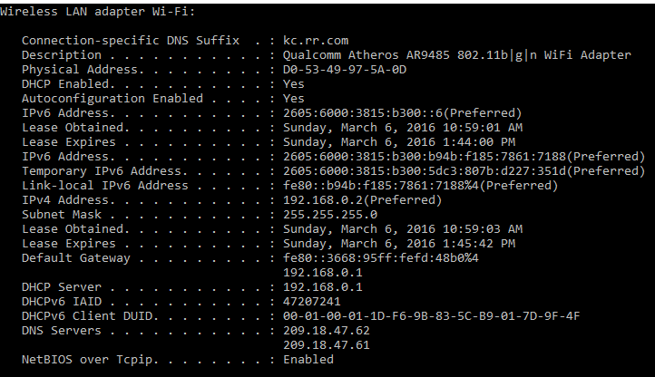

IPv6 Address: 2605:6000:3815:b300:b94b:f185:7861:7188

IPv4 Address: 192.168.0.2

Physical Address: D0-53-49-97-5A-0D

Subnet Mask: 255.255.255.0

1. How many bits are for the subnet mask? What is the subnet (not subnet mask) of the host?

255.255.255.0 in binary form can be represent as:

11111111.11111111.11111111.00000000

Therefore, there are 24 bits for the subnet mask 255.255.255.0.

Subnetting is the process of designating some high-order bits from the host part and grouping them with the network mask to form the subnet mask.

In this case, all the hosts in the subnet will have the IP addresses in the form 192.168.0.xxx.

Subnet ID of this network is: 192.168.0.0

***Laboratory Homework Part 2: arp***

1. Try ‘arp’ command in order to
2. show the current ARP table of an interface of your host

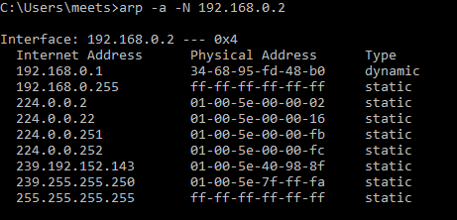

1. delete all current entries of the ARP table of an interface of your host

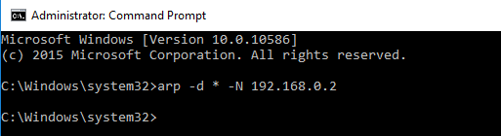

1. show the ARP table again after a web browsing

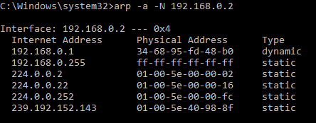

1. show the ARP table again after a few minutes of no network activity

