Network Architecture I

Project Report

Part I. GENI/Socket programming Warm‐up

Sri Harsha Chennavajjala(16210893)

Teja Garidepally(16183523)

Raj Kiran Reddy Munnangi(16210167)

**Introduction:**

In this project, we have developed a simple TCP client and server programs using GENI for simple message exchanges and simple file transfers.

**Project participation:**

**Initial setup:**

**Sri Harsha Chennavajjala, Teja Garidepally and Raj Kiran reddy Munnangi**

* Geni account creation
* Slice creation
* Resource allocation.

**Part I**

**Sri Harsha Chennavajjala, Teja Garidepally and Raj Kiran reddy Munnangi**

* Client and server java code
* Initial lookup for part 2.

**Requirements:**

* Geni account and a slice to add resources where we can work on.
* SSH Keypairs for logging in to nodes and running scripts.
* Java scripts for communication between client and server.

**Steps involved:**

**Step 1:**

After logging in to GENI Portal, we have downloaded the SSH keypairs for authentication purposes.

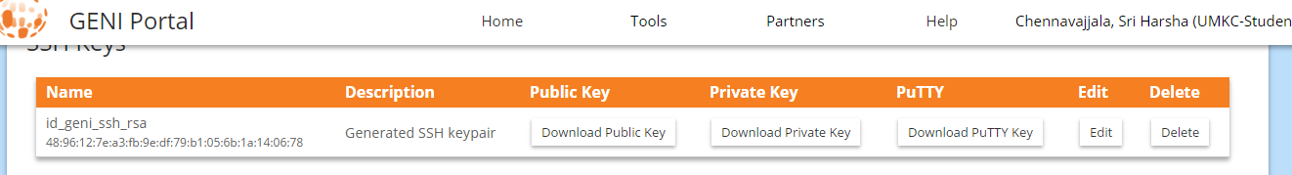

**Step 2:**

Created a slice “HTP” and added two resources i,'e two VM’s and named them as client and server, established connection between the two resources.

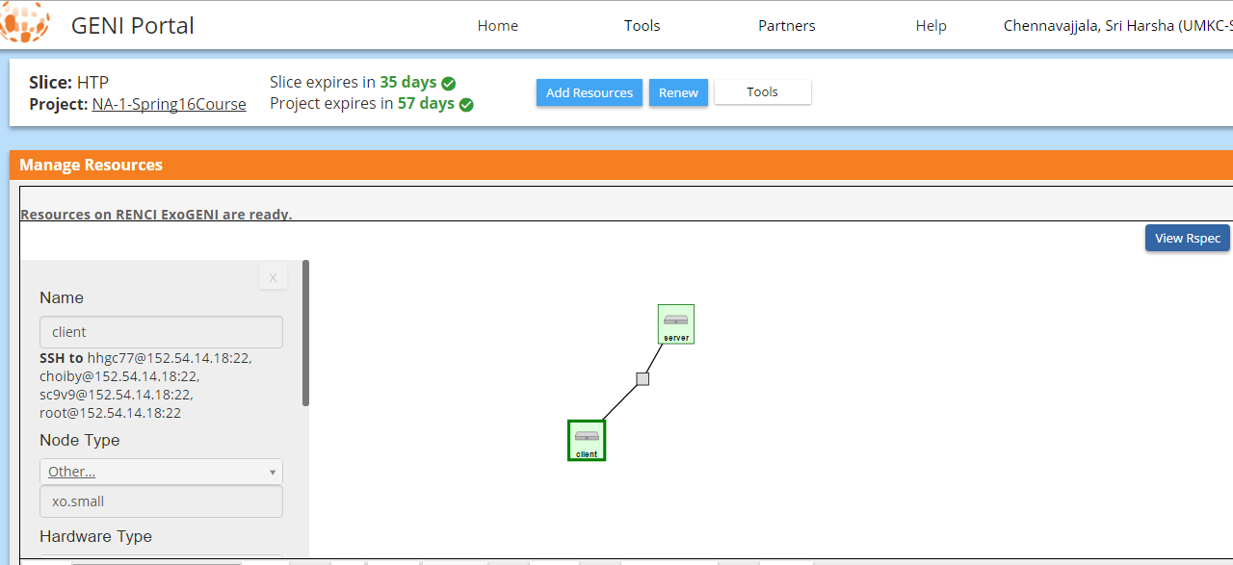

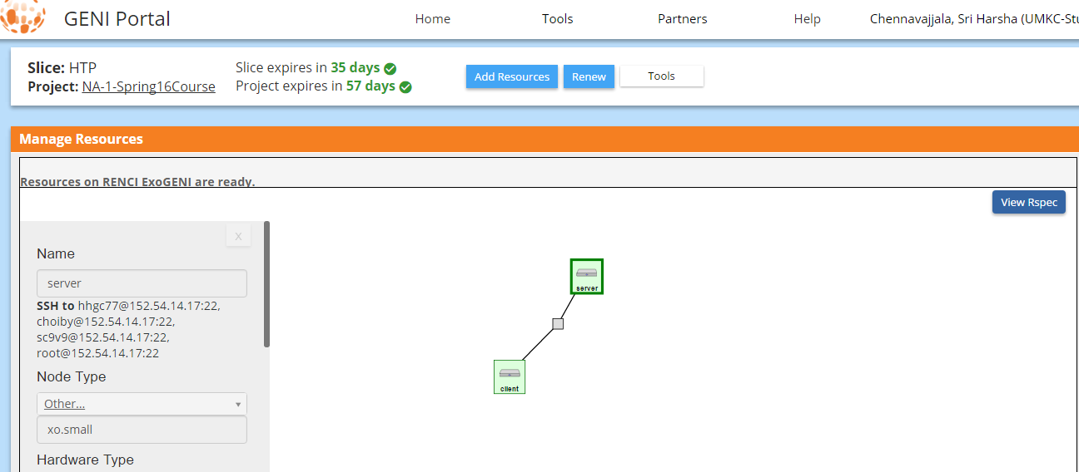

**Step 3:**

Logged in to our client and server nodes using SSH command to the client IP address and server IP address.

Screenshots showing client and server login:

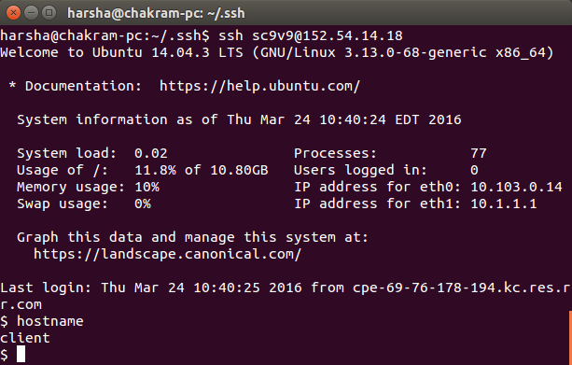

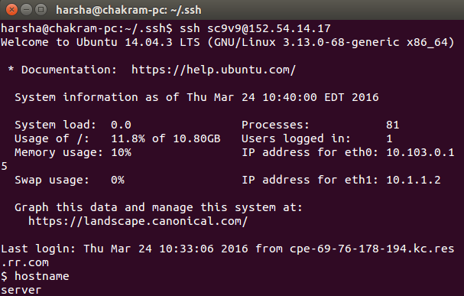

**Step 4:**

Part 1 contains two tasks, communication through simple messages and file exchanges.

For task 1 communication through simple messages we developed two java files ChatClient.java and ChatServer.java.

The mechanism in ChatClient.java and ChatServer.java is as follows:

* Running ChatServer.java starts server and waits for the client to connect to it.
* After connection establishment client can send message to server and server can send message to client.
* Server or client needs to send “bye from server” or “bye from client” message to terminate the connection.

Below are screenshots of simple chat between client and server:

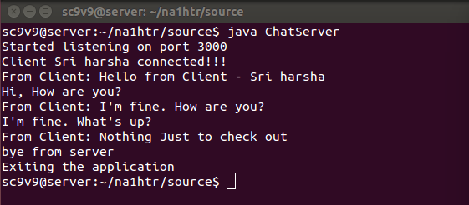

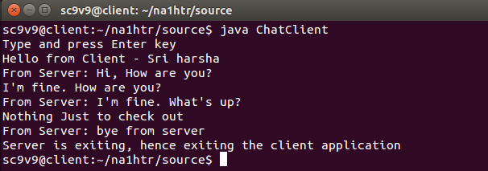

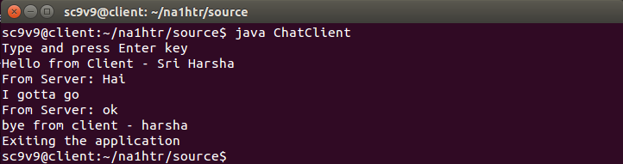

For task 2 we have developed two scripts FileClient and FileServer, running FileClient sends a text file to server and server first displays the contents of received file and saves the file in local system.

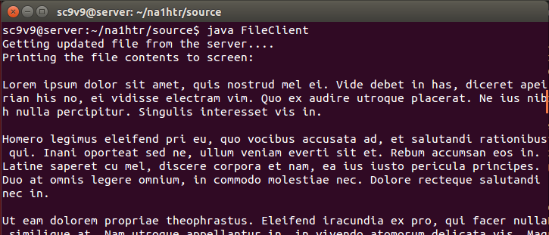

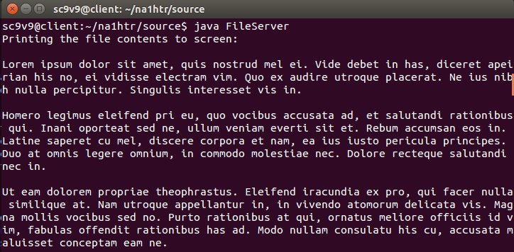

Server appends the one more line to received file and sends the updated file back to client. Client now displays the file on screen after receiving the full updated file.

