**Twitter Big Data Analytics Using Spark**

**CS5540 Project Report**

**Project Members:**

**Sri Harsha Chennavajjala (SC9V9)**

**Teja Garidepally (TGWW4)**

**Raj Kiran Reddy Munnangi (RMYB9)**

# Introduction

## Big Data:

Big data is the buzzing word in the present software industry. Huge amounts of data is being generated daily from various sources. Companies are trying to perform analytics on big data and get some valuable output which gives an edge over there competitors. In order to achieve this we need to program map reduce jobs in Hadoop ecosystem. It is very difficult to develop the code and reuse it for different business cases. On the other hand, People are very much comfortable to query data using SQL like queries.

## Apache Spark:

## Apache Spark is an open source cluster computing framework originally developed in the AMPLab at University of California, Berkeley but was later donated to the Apache Software Foundation where it remains today. Spark provides multi-stage in-memory primitives provides performance up to 100 times faster for certain applications.

Spark SQL is a component on top of Spark Core that introduces a new data abstraction called DataFrames, which provides support for structured and semi-structured data. Spark SQL provides a domain-specific language to manipulate DataFrames in Scala, Java, or Python. It also provides SQL language support, with command-line interfaces and ODBC/JDBC server.

# Objective:

The goal of our project is to collect tweets using the keyword “#android” from the twitter and to analyze the collected data using Spark. We Selected “android” as our keyword because, the resulting tweets will be more and will be from throughout the world.

## Environment Setup:

**Environment**: IBM Bluemix

**Database:** IBM dashDB

**Frame Work**: Apache Spark

**Visualization**: *matplotlib* from MatLab

**Programming Languages**: Python, Scala, Spark SQL

**Data Source**: Twitter Data on keyword “#android”

**Volume of Data**: 0.32 Million Tweets

**Data Format**: JSON

# Introduction to IBM Bluemix:

IBM Bluemix is a cloud platform as a service (PaaS) developed by IBM. It supports several programming languages and services as well as integrated DevOps to build, run, deploy and manage applications on the cloud. Bluemix is based on Cloud Foundry open technology and runs on SoftLayer infrastructure. Bluemix supports several programming languages including Java, Node.js, Go, PHP, Python, Ruby Sinatra, Ruby on Rails and can be extended to support other languages such as Scala through the use of buildpacks.

Bluemix provides the following features:

• A range of services that enable you to build and extend web and mobile apps fast.

• Processing power for you to deliver application changes continuously.

• Fit-for-purpose programming models and services.

• Manageability of services and apps.

• Optimized and elastic workloads.

• Continuous availability.

**The services we used in Bluemix are…**

## IBM Cloudant:

IBM Cloudant is a fully managed JSON document DBaaS that’s optimized for data availability, durability, and mobility…perfect for fast-growing mobile & web apps. What makes Cloudant unique is its advanced indexing and ability to push data to the network edge, across multiple data centers and devices, for faster access and greater fault tolerance. It allows users to access data anytime, anywhere.

## dashDB:

dashDB offers massive scalability and performance through its MPP architecture, and is compatible with a wide range of business intelligence toolsets and analytics. dashDB's integrated, in-database analytics let you quickly realize more value from your data.

## Node-RED:

Node-RED provides a browser-based UI for creating flows of events and deploying them to its light-weight runtime. With built in node.js, it can be run at the edge of the network or in the cloud. The node package manager (npm) ecosystem can be used to easily extend the palette of nodes available, enabling connections to new devices and services.

# System Architecture:

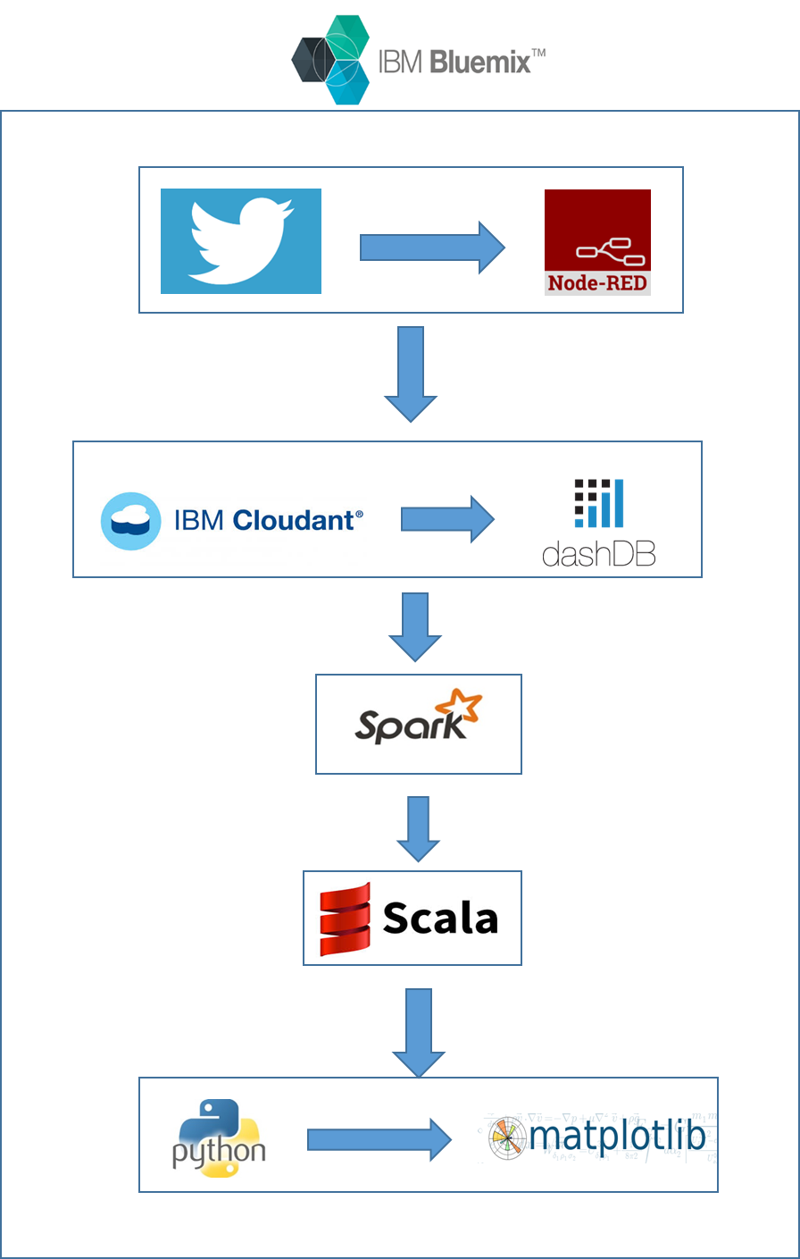

Each module of the above architecture diagram will be explained in the next section.

## Approach:

The main idea of the project is to collect tweets using a keyword “#android” from a twitter streaming API and to analyze the data using Apache Spark.

# Implementation of Proposed Approach:

We used IBM Bluemix as our environment to perform the analytical queries on Twitter data.

**Implementation steps:**

## Stage 1:

* First we have created an account in IBM Bluemix.

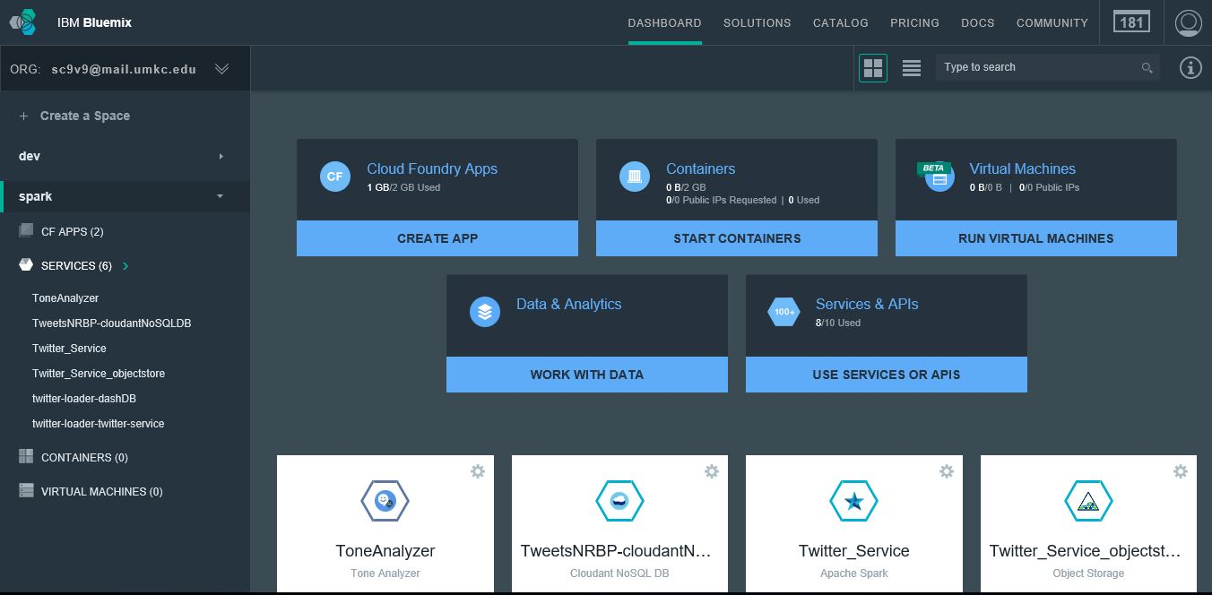

**User Dashboard Screen in Bluemix**

* Next, we developed an application **TweetsNRBP** using Node.js language for collecting tweets based on the given keyword.
* This application collects tweets data with the keyword “#android”.

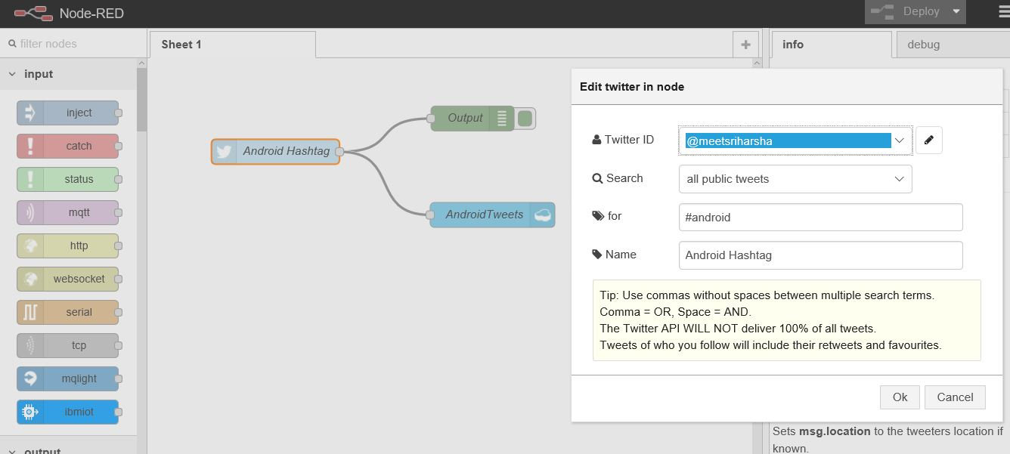

**Node-RED interface for application workflow design**

* The collected tweets are pushed in to IBM Cloudant data storage.

## Stage 2:

* The collected data in IBM Cloudant is stored in JSON format.

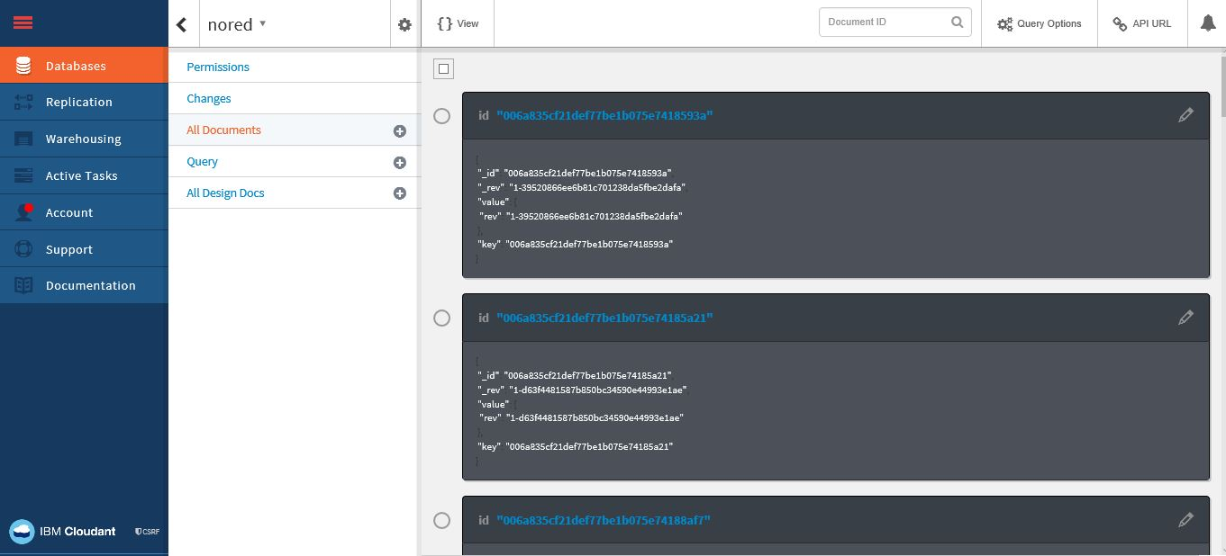

**Snapshot of Cloudant database**

* The data in IBM Cloudant will be parsed and stored in a table format in dashDB.
* In dashDB, data is stored in table DASH019411.nored.

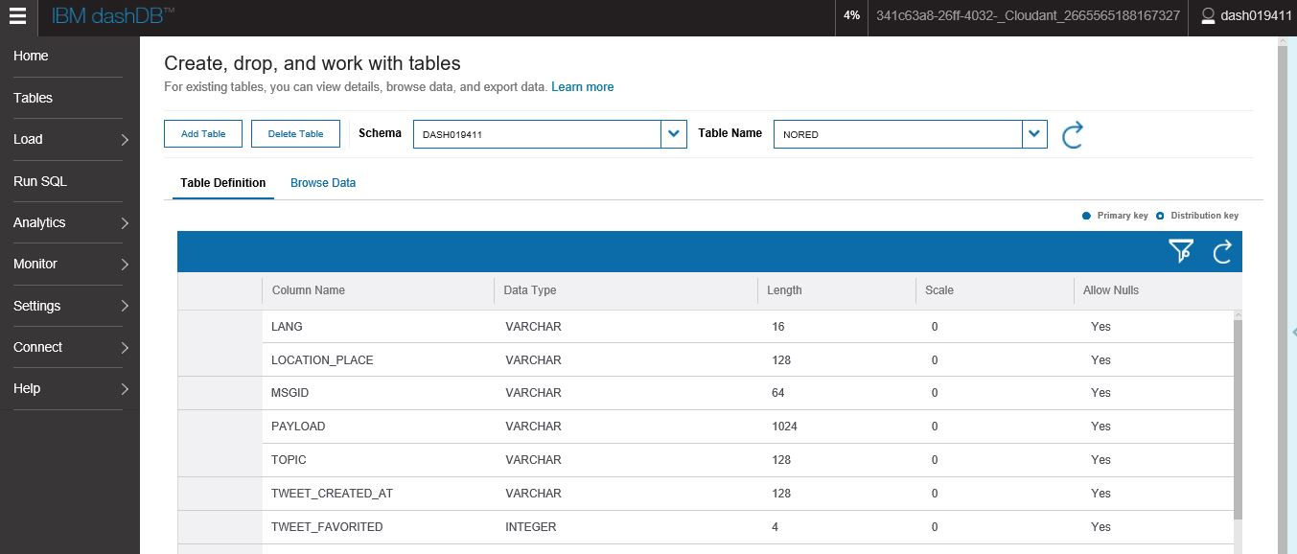

**Snapshot of IBM dashDB table for storing tweets data**

## Stage 3:

* In IBM Analytics for Apache Spark we have created two notebooks in scala and python.
* Scala notebook is used to analyze the data using Spark SQL queries.

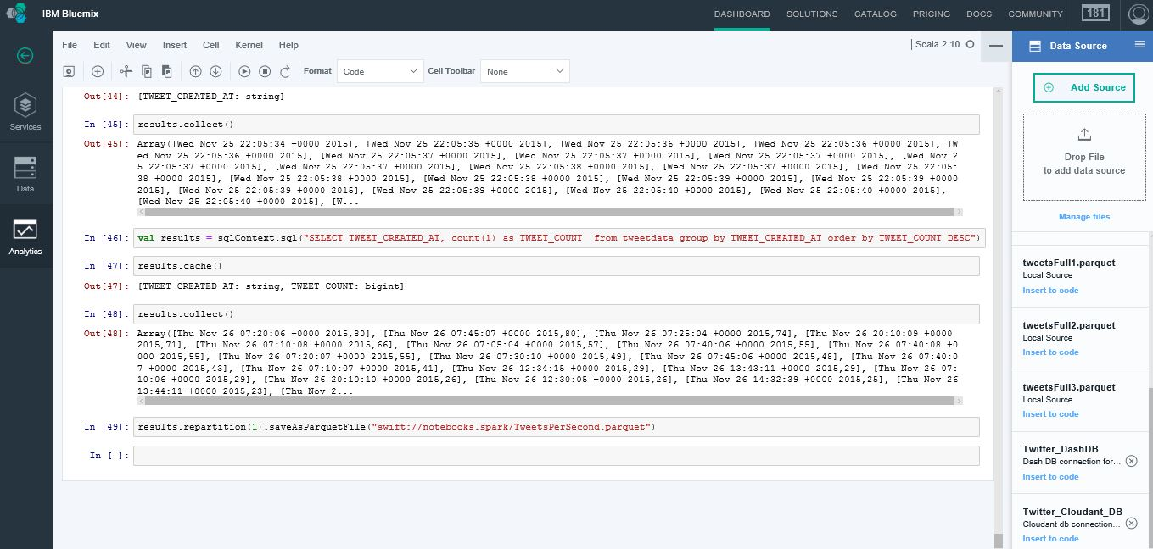

**Scala notebook interface**

* The results of analytical queries are stored in an object storage named **Twitter_objectstore** in form of parquet files.

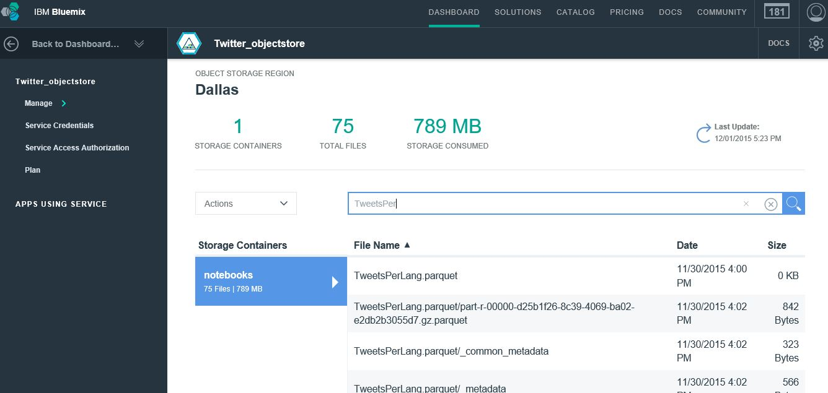

**Object Storage view with files and storage statistics**

* In Python notebook, results of analytical queries are visualized.

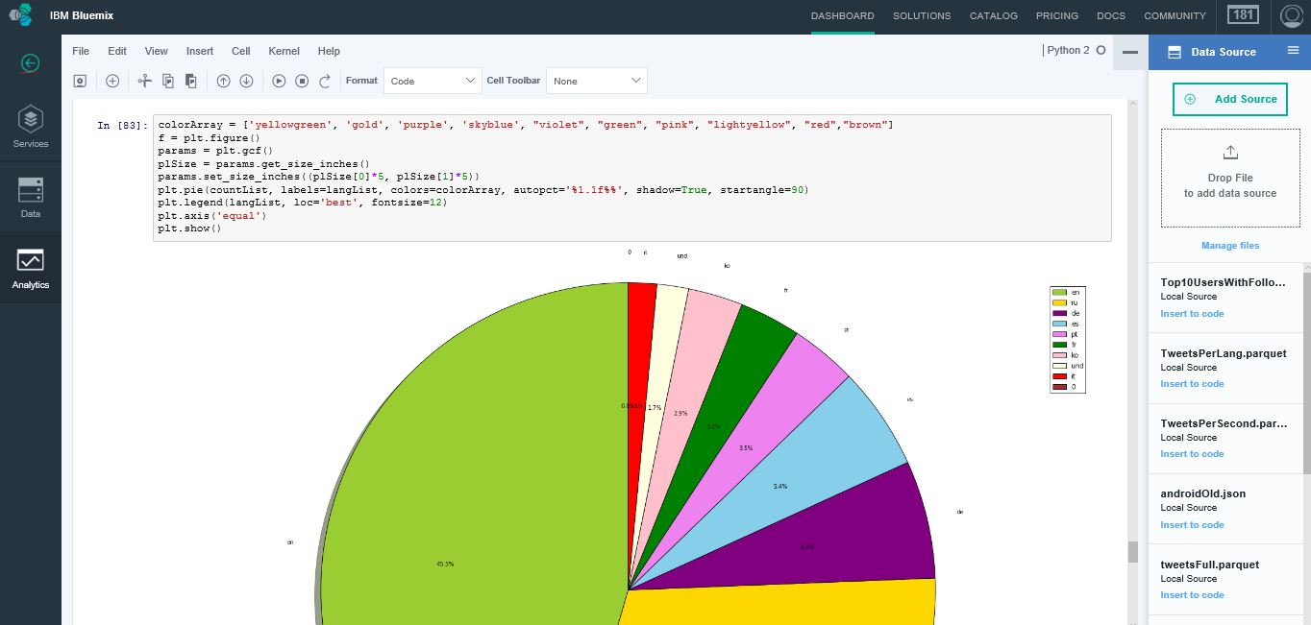

**Python notebook interface**

# Analytic Queries and Visualization:

## Query 1:

**SELECT** TWEET_USER_SCREEN_NAME**,** **MAX(**TWEET_USER_STATUSES_COUNT**)** **AS** TWEET_USER_STATUSES_COUNT **FROM** tweetdata **group** **by** TWEET_USER_SCREEN_NAME **order** **by** TWEET_USER_STATUSES_COUNT **DESC** **LIMIT** 20

**Description: To find top active users in dataset**

**Visualization: Bar Graph**

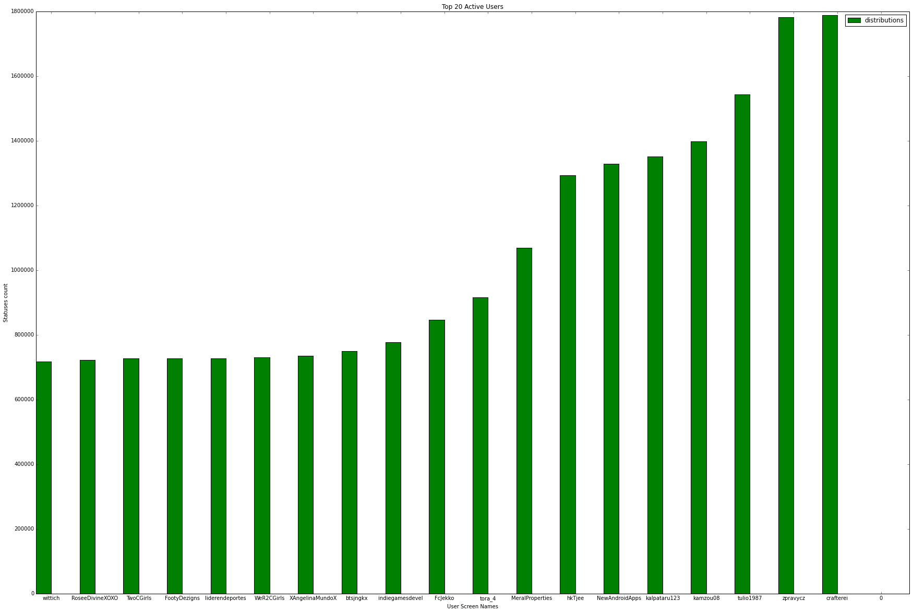

**X-axis: User Screen names**

**Y-axis: Statuses count**

## Query 2:

**SELECT** TWEET_USER_SCREEN_NAME**,** **MAX(**TWEET_USER_FOLLOWERS_COUNT**)** **AS** TWEET_USER_FOLLOWERS_COUNT **FROM** tweetdata **group** **by** TWEET_USER_SCREEN_NAME **order** **by** TWEET_USER_FOLLOWERS_COUNT **DESC** **LIMIT** 10

**Description: To find Top Users with highest Followers Count**

**Visualization: Bar Graph**

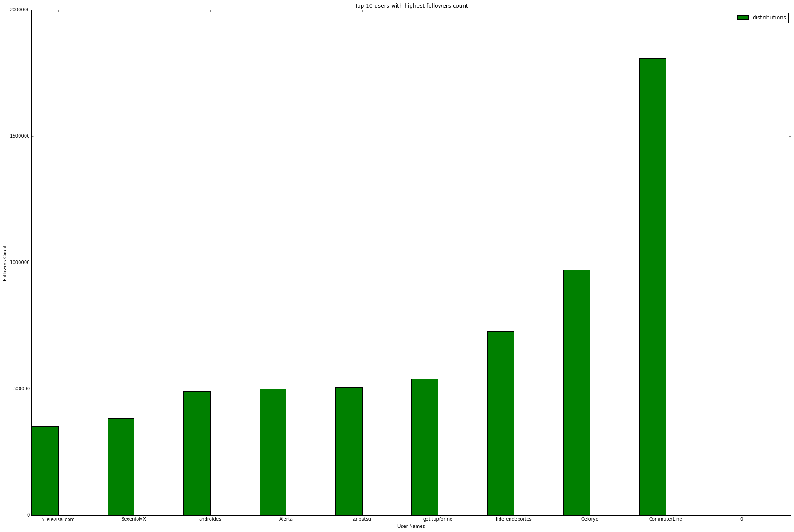

**X-axis: User Name**

**Y-axis: Follower count**

## Query 3:

**SELECT** TWEET_PLACE_COUNTRY_CODE**,** **COUNT(**1**)** **AS** TWEETS_PER_COUNTRY **FROM** tweetdata **group** **by** TWEET_PLACE_COUNTRY_CODE **order** **by** TWEETS_PER_COUNTRY **DESC** **LIMIT** 10

**Description: To find tweets per country**

**Visualization: Bar Graph**

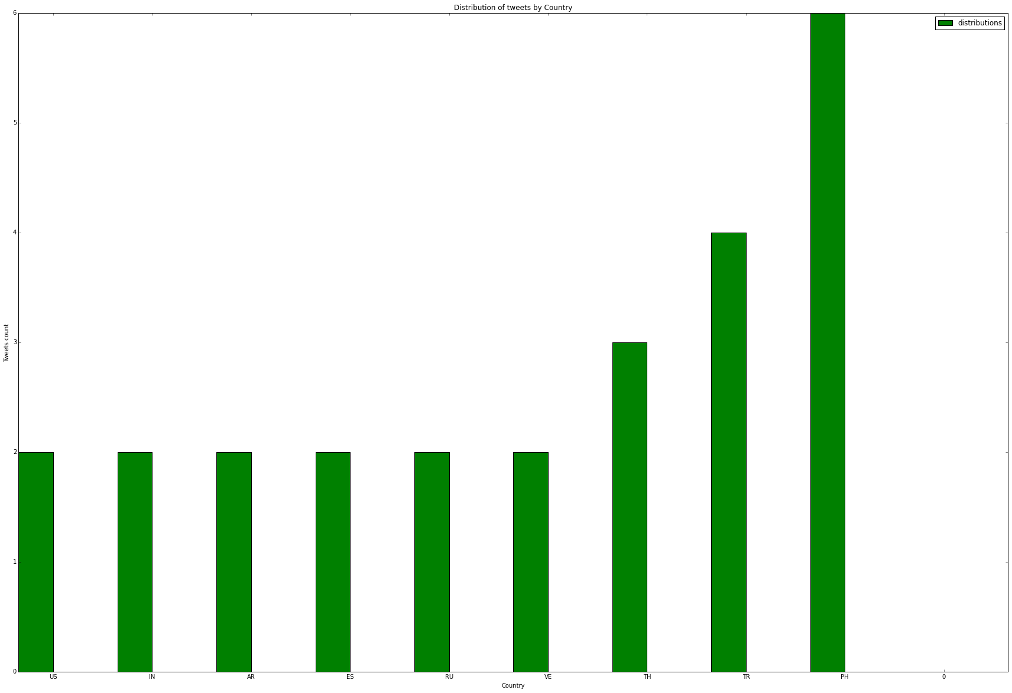

**X-axis:Country**

**Y- axis:Tweets count**

## Query 4:

**SELECT** TWEET_LANG**,** **count(**1**)** **as** totTweets **from** tweetdata **group** **by** TWEET_LANG **order** **by** totTweets

**Description: To find number of tweets per language**

**Visualization: Pie Chart**

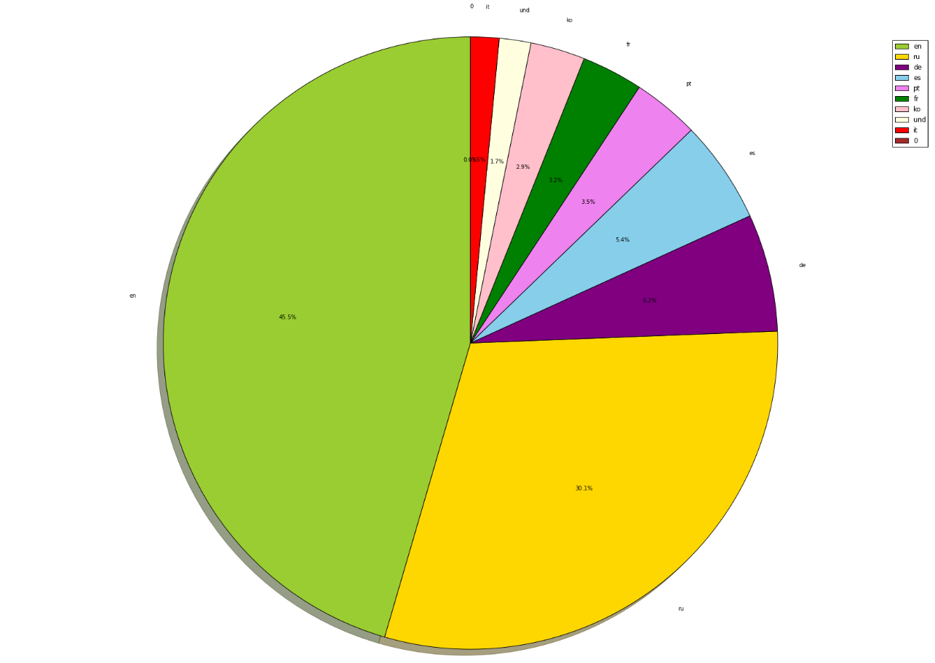

## Query 5:

**SELECT** t1**.**YR **as** YR**,** **count(**1**)** **as** CNT **FROM** **(select** **DISTINCT** TWEET_USER_ID**,** **substring(**TWEET_USER_CREATED_AT**,**26**)** **AS** YR **FROM** tweetdata **where** TWEET_USER_CREATED_AT **IS** **NOT** **NULL)** t1 **group** **by** YR **order** **by** YR

**Description: To find user accounts created per year**

**Visualization: Bar graph**

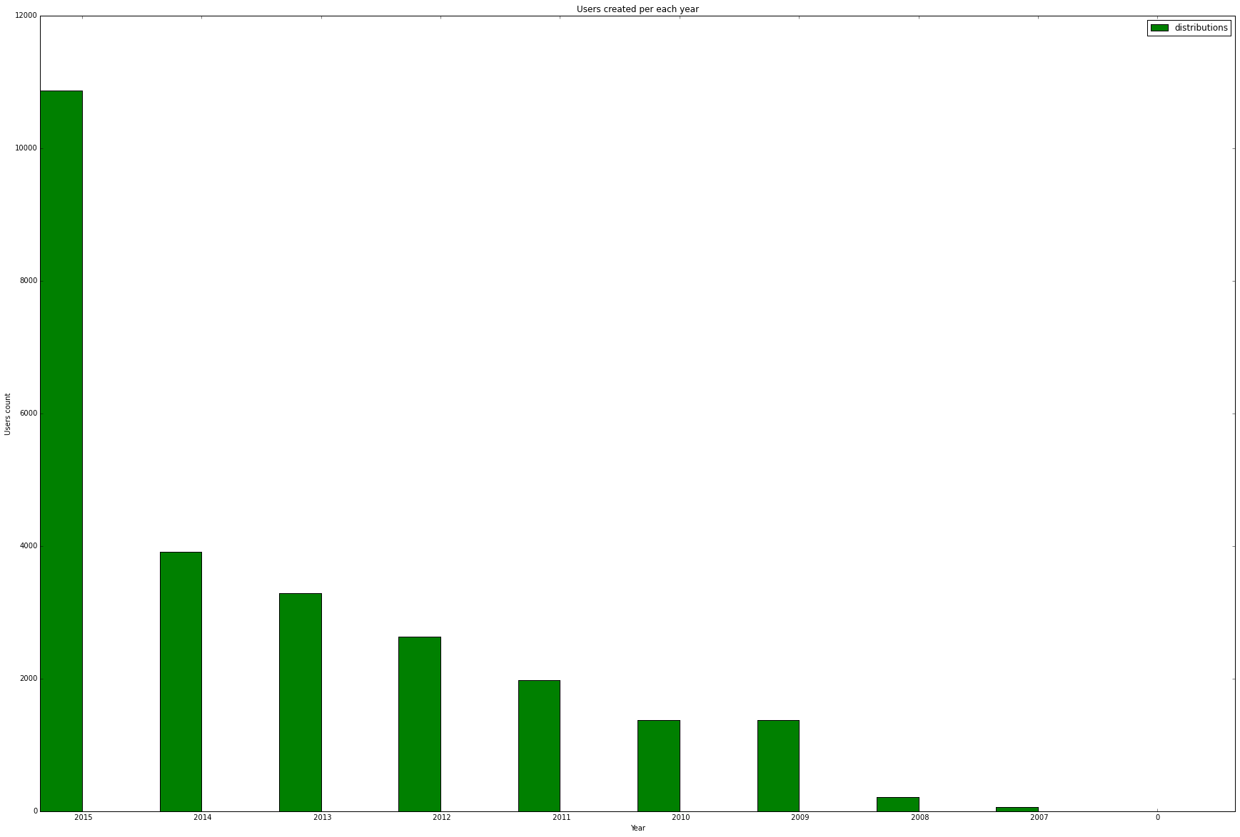

**X-axis: Year**

**Y-axis: Users Count**

## Query 6:

val tweetCreatedDt **=** tweets**.**filter**(**_**.**nonEmpty**).map(**x **=>** **(**extractTweetDate**(**x**),** 1**))** val tweetCreatedDtCnt **=** tweetCreatedDt**.**reduceByKey**((**a**,** b**)** **=>** a **+** b**)** tweetCreatedDtCnt**.**repartition**(**1**).**saveAsTextFile**(**"D:/UMKC/Docs/Subjects/PBDM/PB_Project/TweetsPerTime"**)**

**Description: To find users per year**

**Visualization: Bar Graph**

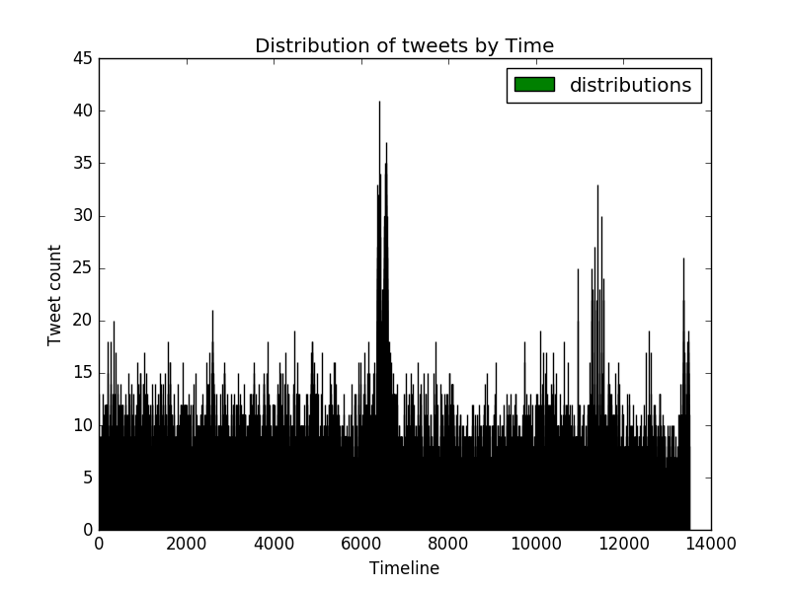

**X-axis: Timeline in seconds**

**Y-axis: Tweet count**