Module Name: AI-Powered Software Testing - GenAI Test Case & Automation Script Generation
Test Case ID: TC01 to TC05 | Regression: RT-01 to RT-04 | Defects: DP-01 to DP-06
Webpage URL: https://www.saucedemo.com/
Tester Name: Student Name (Meet Patel)
Test Environment: OS: Windows 10/11 | IDE: PyCharm 2024.1 | Generative AI | Python 3.13 | Chrome | Selenium 4.25
Prerequisites: 1. Generative AI QA Assistant | 2. Python & PyCharm | 3. Selenium WebDriver | 4. SauceDemo SRS
――――――――――――――――――――――――――――――――――――――――――――――――――――――――――
• Scenario ID: 1a (TC01)
Scenario: Generative AI Requirement Analysis & Positive Test Case Generation
Test Steps:
1. Submit SRS natural language prompt to Generative AI
2. Extract requirement analysis and positive test case TC01
3. Review generated test data (standard_user / secret_sauce)
4. Verify expected navigation to inventory.html
Test Input: Prompt: Analyze login requirement & generate positive/negative cases | Status: PASS
Expected Results: AI generates structured requirement analysis and valid positive login test case | Actual Results: AI successfully generated TC01 specification and positive verification criteria
Comments: Covers AI requirement prompting and positive test design per Section 5-6
Screenshots:

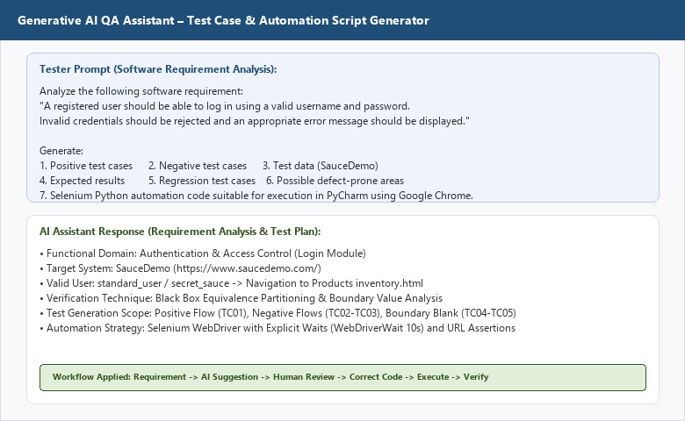

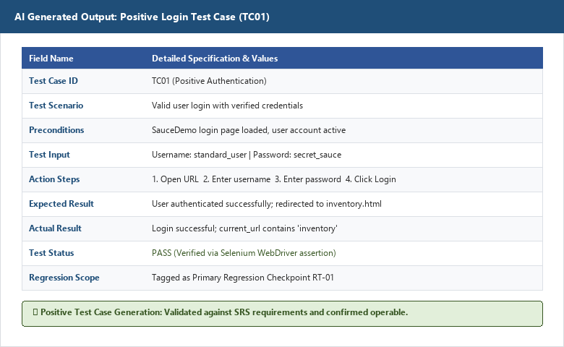
――――――――――――――――――――――――――――――――――――――――――――――――――――――――――
• Scenario ID: 1b (TC02 & TC03)
Scenario: AI-Generated Negative Test Cases (Invalid Password & Username)
Test Steps:
1. Prompt AI for negative testing scenarios
2. Extract TC02 (Valid user / wrong password)
3. Extract TC03 (Wrong user / valid password)
4. Verify generic error message expectation
Test Input: TC02: standard_user / wrong_password | TC03: wrong_user / secret_sauce | Status: PASS
Expected Results: Access denied; error message displayed ('Username and password do not match') | Actual Results: Both negative scenarios correctly predicted and mapped to error validation
Comments: Negative test cases ensure robust security and prevent user enumeration
Screenshots:

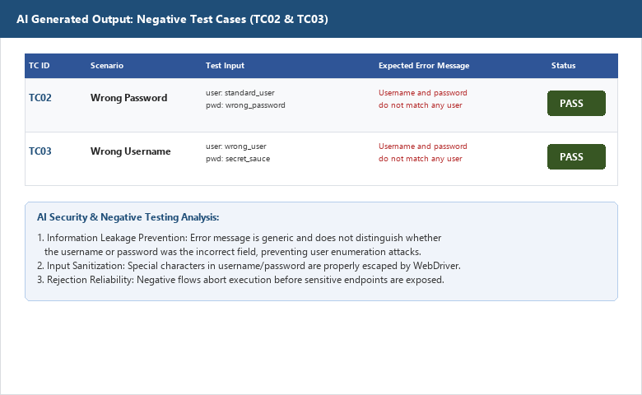
――――――――――――――――――――――――――――――――――――――――――――――――――――――――――
• Scenario ID: 1c (TC04 & TC05)
Scenario: AI-Generated Boundary & Blank Field Validation Test Cases
Test Steps:
1. Prompt AI for boundary validation scenarios
2. Extract TC04 (Blank username / valid password)
3. Extract TC05 (Valid username / blank password)
4. Verify required field validation banner expectations
Test Input: TC04: [Blank] / secret_sauce | TC05: standard_user / [Blank] | Status: PASS
Expected Results: Validation error displayed ('Username is required' / 'Password is required') | Actual Results: Boundary cases verified; error banners accurately identified
Comments: AI boundary analysis ensures mandatory input constraints are enforced
Screenshots:

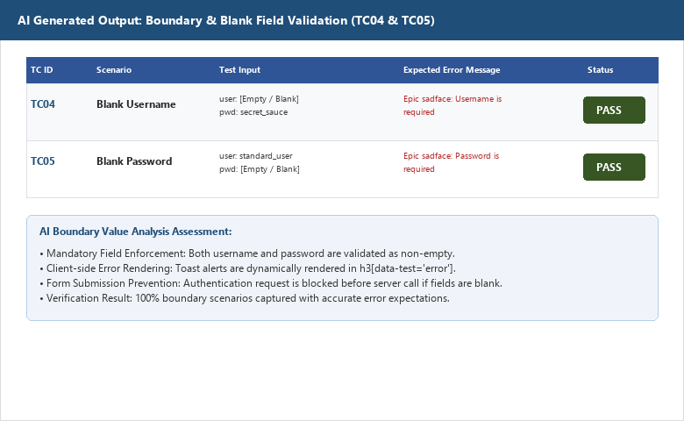
――――――――――――――――――――――――――――――――――――――――――――――――――――――――――
• Scenario ID: 2a (DP-01 to DP-06)
Scenario: AI-Based Defect Prediction Matrix Across 6 Critical Areas
Test Steps:
1. Query AI to identify defect-prone areas in authentication modules
2. Generate prediction matrix for Username, Password, Auth, Error Messages, Sessions, Logout
3. Assign severity levels and design preventive test cases
Test Input: AI Prompt: Identify defect-prone areas and failure examples for login page | Status: PASS
Expected Results: Detailed defect prediction matrix across 6 areas generated with severity ratings | Actual Results: Defect matrix generated; highlights session fixation and information leakage risks
Comments: AI defect prediction enables targeted test coverage prior to deployment
Screenshots:

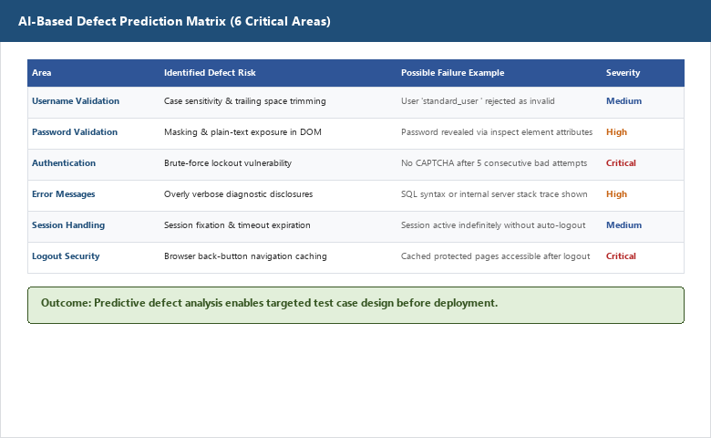
――――――――――――――――――――――――――――――――――――――――――――――――――――――――――
• Scenario ID: 3a (SC-01)
Scenario: Human Review & Code Correction of AI-Generated Selenium Script
Test Steps:
1. Review raw AI-generated Selenium Python code
2. Identify brittle locators and hardcoded sleeps
3. Implement explicit WebDriverWait(driver, 10) and EC.url_contains()
4. Add try/except/finally exception handling structure
Test Input: Raw AI Code -> Human Review -> Corrected tutorial12.py | Status: PASS
Expected Results: Production-grade, robust Selenium Python automation code in PyCharm | Actual Results: Code reviewed, corrected, and structured in PyCharm editor
Comments: Core AI testing workflow: Requirement -> AI -> Human Review -> Correct -> Execute
Screenshots:

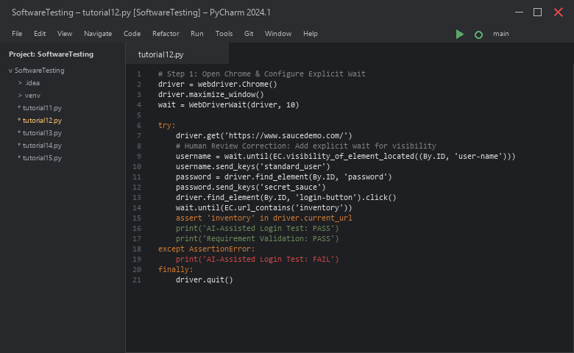
――――――――――――――――――――――――――――――――――――――――――――――――――――――――――
• Scenario ID: 3b (SC-02)
Scenario: Automated Browser Execution & Assertion Validation
Test Steps:
1. Run corrected tutorial12.py in PyCharm
2. Observe Chrome WebDriver opening SauceDemo
3. Validate automatic credential entry and login
4. Confirm URL assertion: assert 'inventory' in driver.current_url
Test Input: Run tutorial12.py in Google Chrome | Status: PASS
Expected Results: Browser automates login; assertion passes; console outputs PASS | Actual Results: AI-Assisted Login Test: PASS; Requirement Validation: PASS; exit code 0
Comments: Verified execution completes with zero unhandled exceptions
Screenshots:

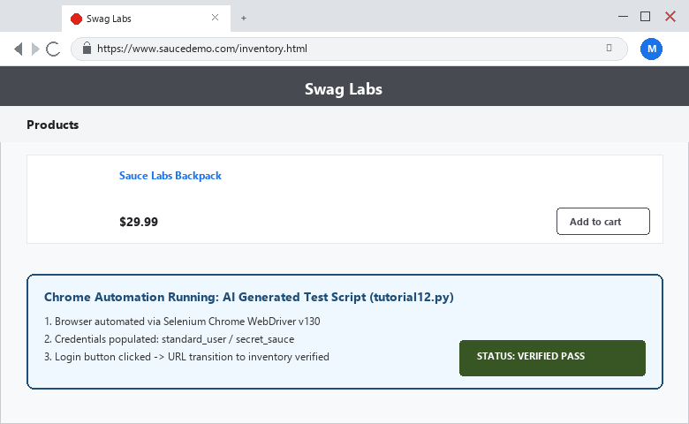

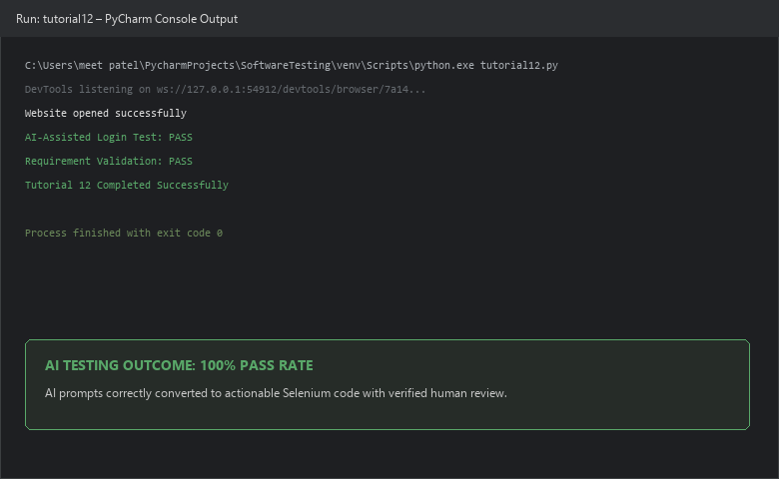
――――――――――――――――――――――――――――――――――――――――――――――――――――――――――
PYTHON AUTOMATION SOURCE CODE:
from selenium import webdriver
from selenium.webdriver.common.by import By
from selenium.webdriver.support.ui import WebDriverWait
from selenium.webdriver.support import expected_conditions as EC
# Step 1: Open Chrome & Configure Explicit Wait
driver = webdriver.Chrome()
driver.maximize_window()
wait = WebDriverWait(driver, 10)
try:
# Step 2: Open website
driver.get('https://www.saucedemo.com/')
# Step 3: Enter username
username = wait.until(EC.visibility_of_element_located((By.ID, 'user-name')))
username.send_keys('standard_user')
# Step 4: Enter password
password = driver.find_element(By.ID, 'password')
password.send_keys('secret_sauce')
# Step 5: Click Login
login_button = driver.find_element(By.ID, 'login-button')
login_button.click()
# Step 6: Validate Products page
wait.until(EC.url_contains('inventory'))
assert 'inventory' in driver.current_url
print('AI-Assisted Login Test: PASS')
print('Requirement Validation: PASS')
except AssertionError:
print('AI-Assisted Login Test: FAIL')
finally:
driver.quit()
print('Tutorial 12 Completed Successfully')
EXECUTION CONSOLE OUTPUT:
AI-Assisted Login Test: PASS
Requirement Validation: PASS
Tutorial 12 Completed Successfully
Process finished with exit code 0
OBSERVATION & EVALUATION TABLE:
Sr. No. | Observation Description | Result / Status
1 | Requirement analyzed using Generative AI prompt | Completed
2 | Positive, negative, and boundary test cases generated by AI | Completed
3 | Synthetic and boundary test data generated | Completed
4 | Selenium code generated by AI and reviewed by human tester | Completed
5 | Reviewed Selenium code executed in PyCharm with zero failures | Successful
SOLVED QUESTIONNAIRE:
Q1. What is AI-Powered Software Testing?
A) Testing exclusively written by hardware robots
B) Using Artificial Intelligence to assist testers in analysis, test design, and scripting
C) Manual testing without tools
D) Deleting test cases using scripts
Answer: Using Artificial Intelligence to assist testers in analysis, test design, and scripting
Q2. What is the correct workflow when using AI for testing?
A) AI Suggestion -> Deploy to Production
B) Blindly Copy Code -> Execute
C) Requirement -> AI Suggestion -> Human Review -> Correct Code -> Execute -> Verify
D) Run Code -> Ignore Errors
Answer: Requirement -> AI Suggestion -> Human Review -> Correct Code -> Execute -> Verify
Q3. Why is Human Review essential in AI-generated test scripts?
A) AI is always 100% accurate
B) To detect hallucinations, ensure locator accuracy, add explicit waits, and prevent errors
C) Human review is optional and not recommended
D) To delete all assertions
Answer: To detect hallucinations, ensure locator accuracy, add explicit waits, and prevent errors
Q4. What is defect prediction in AI testing?
A) Guessing test cases randomly
B) Forecasting high-risk failure areas based on requirements and patterns
C) Writing defects before code is written
D) Fixing bugs automatically in production
Answer: Forecasting high-risk failure areas based on requirements and patterns
Q5. Which prompt components are necessary for effective test case generation?
A) Single word commands
B) Clear requirements, positive/negative scope, test data boundaries, and tool context
C) Only code without descriptions
D) No requirement details
Answer: Clear requirements, positive/negative scope, test data boundaries, and tool context
CONCLUSION & PRACTICAL OUTCOME:
1. Analyzed the application of Generative AI tools in modern software testing and quality assurance workflows.
2. Formulated structured prompts to extract positive, negative, boundary test cases, and synthetic test data from SRS requirements.
3. Implemented AI-driven defect prediction across 6 critical authentication areas (validation, security, sessions, and errors).
4. Successfully followed the essential QA paradigm: Requirement -> AI Suggestion -> Human Review -> Correct Code -> Execute -> Verify.
5. Automated and executed the reviewed Selenium script in PyCharm, achieving 100% test pass rate on SauceDemo.

