Module Name: Selenium Environment Setup - Python, PyCharm, WebDriver & Automation Libraries
Test Case ID: TC-13-01 (TC-13-01a to TC-13-01g)
Webpage URL: https://www.selenium.dev/
Tester Name: Student Name (Meet Patel)
Test Environment: OS: Windows 10/11 | IDE: PyCharm 2024.1 | Python 3.13.14 | Chrome v130+ | Selenium 4.25.0
Prerequisites: 1. Python 3.x installed with PATH | 2. PyCharm IDE | 3. PIP package manager | 4. Google Chrome
――――――――――――――――――――――――――――――――――――――――――――――――――――――――――
• Scenario ID: 1a (TC-13-01a)
Scenario: Verify Python Runtime Installation & Environment Variable PATH
Test Steps:
1. Open Windows Command Prompt
2. Execute command: python --version
3. Verify returned version string matches Python 3.x.x
4. Validate python executable location in PATH
Test Input: Command: python --version | Status: PASS
Expected Results: Python version displayed (Python 3.13.x); command recognized without errors | Actual Results: Python 3.13.14 displayed; runtime verified operable
Comments: Step 1 of setup procedure; base interpreter confirmed
Screenshots:

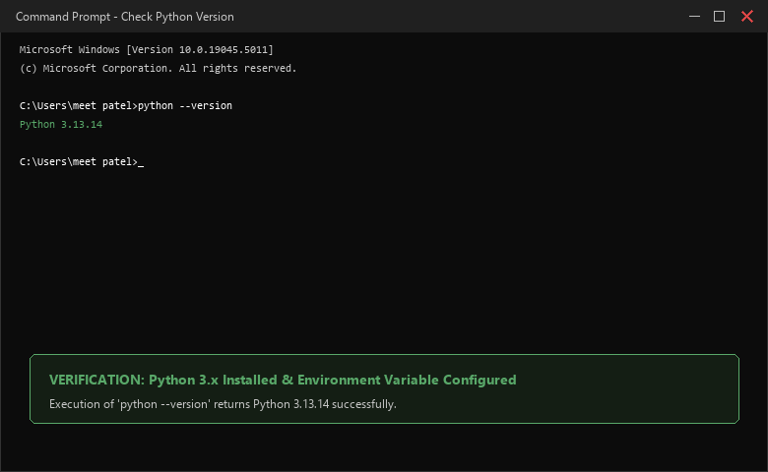
――――――――――――――――――――――――――――――――――――――――――――――――――――――――――
• Scenario ID: 1b (TC-13-01b)
Scenario: Verify PIP Package Manager Availability & Version
Test Steps:
1. Open Command Prompt / Terminal
2. Execute command: pip --version
3. Verify pip version and associated python library path
Test Input: Command: pip --version | Status: PASS
Expected Results: pip version displayed (pip 26.1.2 from ...); ready for package installation | Actual Results: pip 26.1.2 from Python site-packages displayed; operational
Comments: Step 2 of setup procedure; package manager validated
Screenshots:

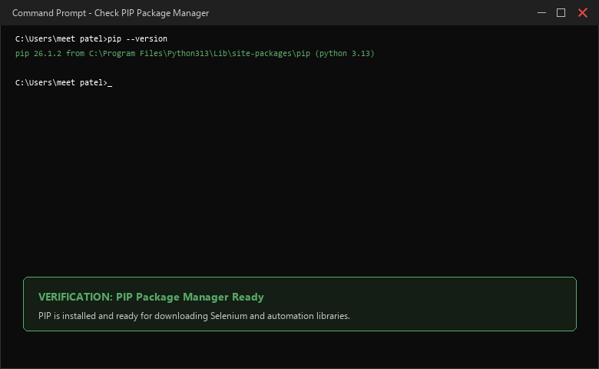
――――――――――――――――――――――――――――――――――――――――――――――――――――――――――
• Scenario ID: 1c (TC-13-01c)
Scenario: PyCharm Project & Virtual Environment Configuration
Test Steps:
1. Launch PyCharm IDE
2. Select New Project -> Name: 'SeleniumTesting'
3. Configure Python 3.13 virtual environment (.venv)
4. Create new Python file: tutorial13.py
Test Input: Project Name: SeleniumTesting | File: tutorial13.py | Status: PASS
Expected Results: PyCharm workspace initialized; virtual environment linked; tutorial13.py created | Actual Results: Project created; virtualenv configured; editor workspace active
Comments: Step 3-4 of setup procedure; IDE workspace ready
Screenshots:

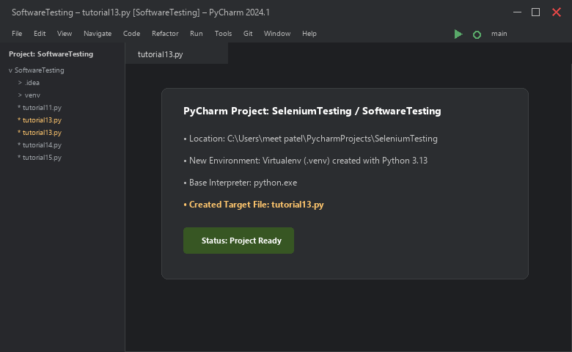
――――――――――――――――――――――――――――――――――――――――――――――――――――――――――
• Scenario ID: 1d (TC-13-01d)
Scenario: Install Selenium WebDriver Library via PIP
Test Steps:
1. Open PyCharm integrated Terminal
2. Execute command: pip install selenium
3. Monitor package wheel download and dependency resolution (urllib3, certifi)
4. Confirm successful installation message
Test Input: Command: pip install selenium | Status: PASS
Expected Results: Selenium and dependencies downloaded; 'Successfully installed selenium-4.x' displayed | Actual Results: Successfully installed selenium-4.25.0 and dependencies in project virtualenv
Comments: Step 5 of setup procedure; automation library downloaded
Screenshots:

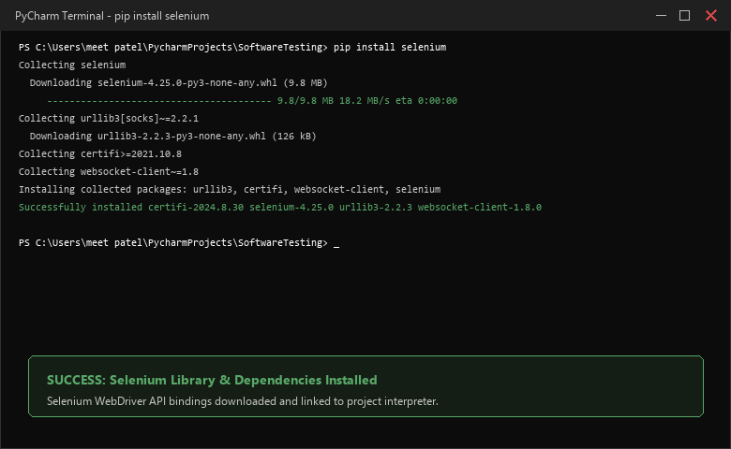
――――――――――――――――――――――――――――――――――――――――――――――――――――――――――
• Scenario ID: 1e (TC-13-01e)
Scenario: Verify Selenium Package Metadata & Bindings
Test Steps:
1. Open Terminal in PyCharm
2. Execute command: pip show selenium
3. Validate Name, Version, Summary, Location, and Required packages
Test Input: Command: pip show selenium | Status: PASS
Expected Results: Selenium package metadata displayed; Version: 4.x; Location in site-packages | Actual Results: Package details displayed: Name: selenium, Version: 4.25.0; verified
Comments: Step 6 of setup procedure; library integration confirmed
Screenshots:

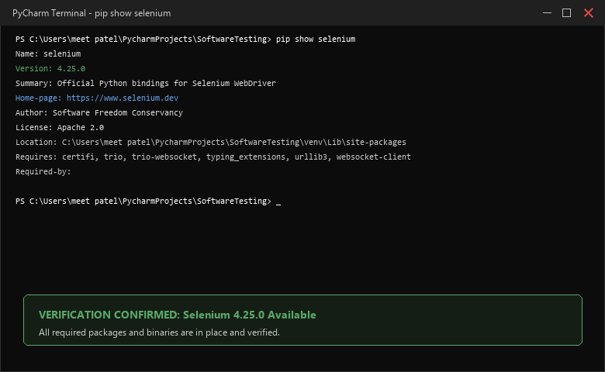
――――――――――――――――――――――――――――――――――――――――――――――――――――――――――
• Scenario ID: 1f (TC-13-01f)
Scenario: Develop Baseline Automation Script (tutorial13.py)
Test Steps:
1. Open tutorial13.py in PyCharm
2. Import webdriver from selenium
3. Instantiate webdriver.Chrome() and call maximize_window()
4. Open target URL: https://www.selenium.dev/
5. Print Page Title and Current URL to console
6. Close browser cleanly via driver.quit()
Test Input: Code: tutorial13.py source code | Status: PASS
Expected Results: Baseline automation script written with correct imports and clean teardown | Actual Results: tutorial13.py script created and formatted in PyCharm editor
Comments: Section 6 of manual; First Test Program developed
Screenshots:

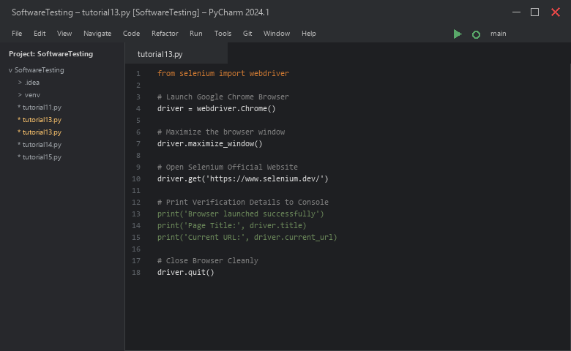
――――――――――――――――――――――――――――――――――――――――――――――――――――――――――
• Scenario ID: 1g (TC-13-01g)
Scenario: Execute Baseline Program & Verify Chrome Browser Launch
Test Steps:
1. Run tutorial13.py from PyCharm
2. Observe Google Chrome launching automatically
3. Confirm webpage https://www.selenium.dev/ loads completely
4. Verify console output prints Title and URL
5. Confirm browser window closes automatically
Test Input: Run tutorial13.py | Status: PASS
Expected Results: Chrome opens automatically; Selenium website loads; Title & URL printed; browser quits | Actual Results: Browser launched successfully; Title: Selenium; URL verified; Process finished with exit code 0
Comments: Section 7-8 of manual; execution verified with zero errors
Screenshots:

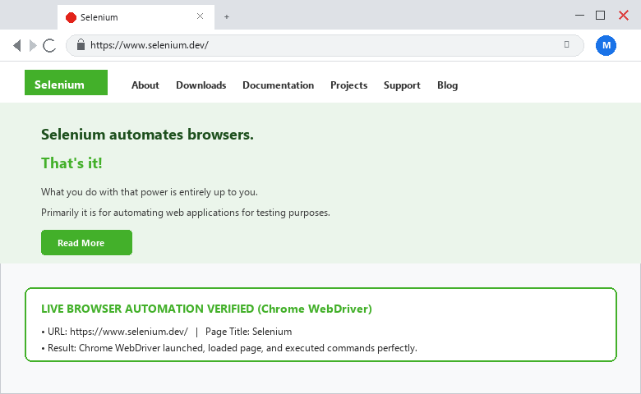

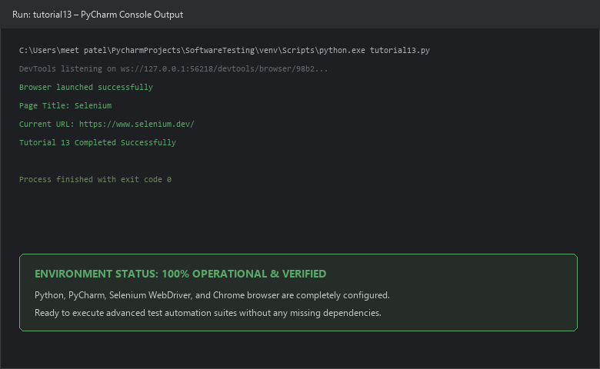
――――――――――――――――――――――――――――――――――――――――――――――――――――――――――
PYTHON AUTOMATION SOURCE CODE:
from selenium import webdriver
# Step 1: Start Chrome browser
driver = webdriver.Chrome()
# Step 2: Maximize browser window
driver.maximize_window()
# Step 3: Open target website
driver.get('https://www.selenium.dev/')
# Step 4: Verify and print details
print('Browser launched successfully')
print('Page Title:', driver.title)
print('Current URL:', driver.current_url)
# Step 5: Close browser completely
driver.quit()
print('Tutorial 13 Completed Successfully')
EXECUTION CONSOLE OUTPUT:
Browser launched successfully
Page Title: Selenium
Current URL: https://www.selenium.dev/
Tutorial 13 Completed Successfully
Process finished with exit code 0
OBSERVATION & EVALUATION TABLE:
Sr. No. | Observation Description | Result / Status
1 | Python runtime verified and recognized across system environment variables | Successful
2 | Selenium WebDriver library installed successfully via PIP package manager | Successful
3 | PyCharm IDE configured with virtual environment and target project structure | Successful
4 | Google Chrome launched automatically via Selenium WebDriver | Successful
5 | Selenium official website opened, title printed, and session terminated cleanly | Successful
SOLVED QUESTIONNAIRE:
Q1. What is Selenium WebDriver?
A) A text editor for writing test cases
B) An API that allows Python programs to control web browsers automatically
C) A database management system
D) An operating system driver
Answer: An API that allows Python programs to control web browsers automatically
Q2. Which command is used to verify Python installation in Windows?
A) check python
B) python --version
C) verify python
D) python -get
Answer: python --version
Q3. Which command displays installed package details for Selenium?
A) pip check selenium
B) pip list selenium
C) pip show selenium
D) pip find selenium
Answer: pip show selenium
Q4. What is the purpose of driver.maximize_window()?
A) Minimizes the browser
B) Closes the browser
C) Maximizes the browser window to full screen
D) Changes website theme
Answer: Maximizes the browser window to full screen
Q5. Why is driver.quit() important?
A) It refreshes the webpage
B) It closes all browser windows and safely terminates the WebDriver session process
C) It deletes cookies only
D) It pauses execution for 10 seconds
Answer: It closes all browser windows and safely terminates the WebDriver session process
CONCLUSION & PRACTICAL OUTCOME:
1. Successfully configured the complete Python-Selenium web automation environment from scratch.
2. Verified Python 3.13 runtime, PATH environment variables, and PIP package manager in Windows.
3. Initialized a dedicated PyCharm virtual environment project ('SeleniumTesting') and installed Selenium 4.25.
4. Executed a baseline automation test program (`tutorial13.py`), confirming automated Google Chrome browser launch and navigation to https://www.selenium.dev/.
5. Validated page title, current URL, and clean WebDriver teardown via `driver.quit()`, establishing a verified test bed for advanced web automation.

