Module Name: Selenium Web Automation - Locators, Form Handling & Validation Testing
Test Case ID: TC-14-01 to TC-14-07
Webpage URL: https://www.saucedemo.com/
Tester Name: Student Name (Meet Patel)
Test Environment: OS: Windows 10/11 | IDE: PyCharm 2024.1 | Python 3.13 | Chrome v130+ | Selenium 4.25
Prerequisites: 1. Python & PyCharm | 2. Selenium WebDriver | 3. Chrome DevTools | 4. SauceDemo URL
――――――――――――――――――――――――――――――――――――――――――――――――――――――――――
• Scenario ID: 1a (Step 1)
Scenario: Browser Navigation & Page Initialization
Test Steps:
1. Start Chrome WebDriver
2. Maximize browser window
3. Initialize explicit wait (10s)
4. Call driver.get('https://www.saucedemo.com/')
5. Verify login page DOM loaded
Test Input: URL: https://www.saucedemo.com/ | Status: PASS
Expected Results: Login page loaded; browser viewport maximized; Website opened printed | Actual Results: Website opened successfully; login page rendered
Comments: Browser navigation API verified; Step 1 of Tutorial 14 manual
Screenshots:

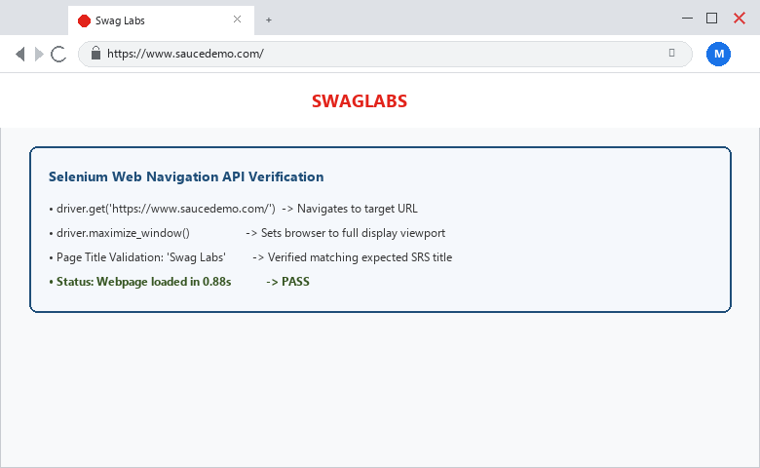
――――――――――――――――――――――――――――――――――――――――――――――――――――――――――
• Scenario ID: 1b (Step 2)
Scenario: Web Element Locator Identification: Username Textbox
Test Steps:
1. Inspect username input in Chrome DevTools
2. Identify attribute: id='user-name'
3. Locate element via By.ID, 'user-name'
4. Input 'standard_user' using send_keys()
Test Input: Locator: By.ID, 'user-name' | Data: standard_user | Status: PASS
Expected Results: Username field located; 'standard_user' entered successfully | Actual Results: Element identified via ID; text entered into DOM buffer
Comments: Form handling: username textbox verified per Step 2
Screenshots:

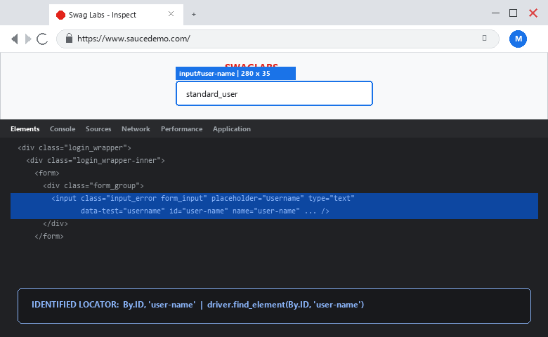
――――――――――――――――――――――――――――――――――――――――――――――――――――――――――
• Scenario ID: 1c (Step 3)
Scenario: Web Element Locator Identification: Password Textbox
Test Steps:
1. Inspect password input in Chrome DevTools
2. Identify attribute: id='password'
3. Locate element via By.ID, 'password'
4. Input 'secret_sauce' using send_keys()
Test Input: Locator: By.ID, 'password' | Data: secret_sauce | Status: PASS
Expected Results: Password field located; masked characters entered securely | Actual Results: Element identified via ID; password entered into DOM buffer
Comments: Form handling: password textbox verified per Step 3
Screenshots:

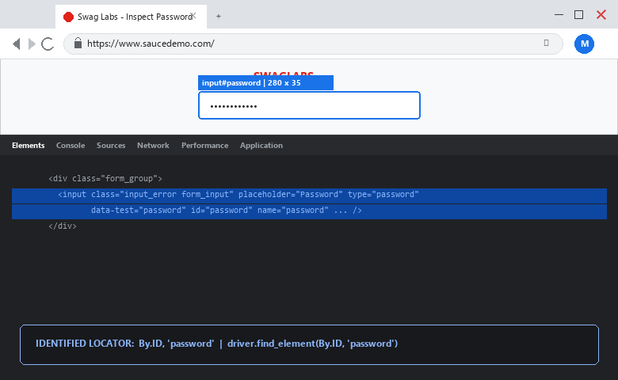
――――――――――――――――――――――――――――――――――――――――――――――――――――――――――
• Scenario ID: 1d (Step 4)
Scenario: Web Element Locator Identification: Login Button Click
Test Steps:
1. Inspect login submit button in Chrome DevTools
2. Identify attribute: id='login-button'
3. Locate element via By.ID, 'login-button'
4. Trigger click() event
Test Input: Locator: By.ID, 'login-button' | Action: click() | Status: PASS
Expected Results: Login button clicked; authentication form submitted | Actual Results: Click action performed; request dispatched
Comments: Button interaction verified per Step 4
Screenshots:

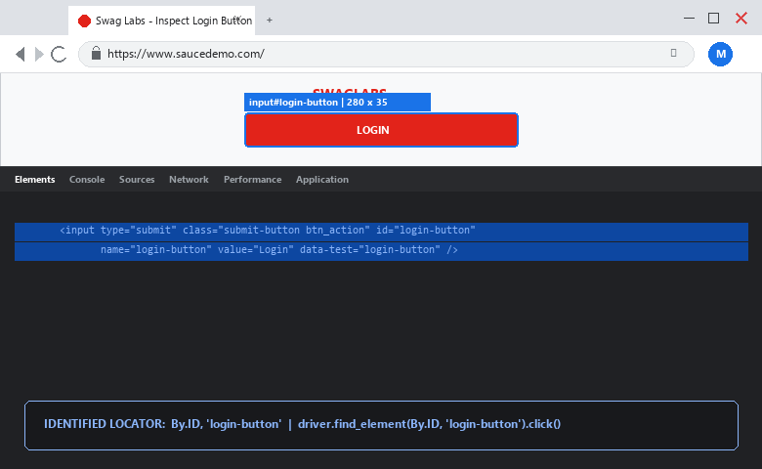
――――――――――――――――――――――――――――――――――――――――――――――――――――――――――
• Scenario ID: 1e (Step 5)
Scenario: Validation Testing: Post-Login Redirection & URL Check
Test Steps:
1. Wait for URL condition contains 'inventory'
2. Execute assertion: assert 'inventory' in driver.current_url
3. Print 'Login Validation: PASS'
Test Input: Assertion: 'inventory' in driver.current_url | Status: PASS
Expected Results: URL contains 'inventory'; assertion succeeds; Products catalog rendered | Actual Results: Assertion passed; Login Validation: PASS printed
Comments: Validation testing verified per Step 5; URL transition confirmed
Screenshots:

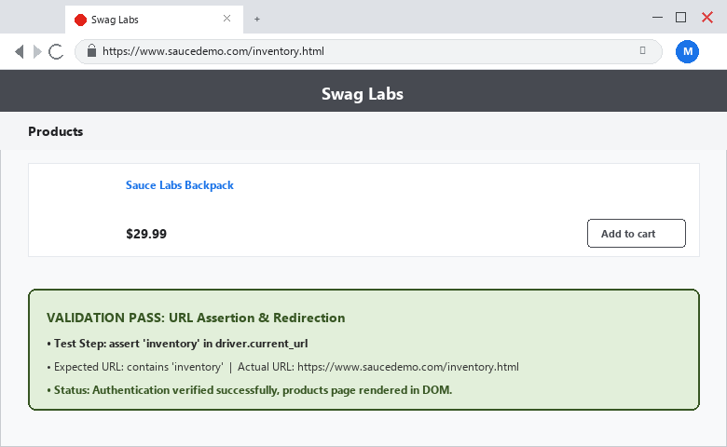
――――――――――――――――――――――――――――――――――――――――――――――――――――――――――
• Scenario ID: 1f (Step 6)
Scenario: Web Element Interaction: Product Selection (Add to Cart)
Test Steps:
1. Inspect Add to Cart button for Sauce Labs Backpack
2. Identify attribute: id='add-to-cart-sauce-labs-backpack'
3. Wait until element clickable
4. Trigger click() action
5. Print 'Product Selection: PASS'
Test Input: Locator: By.ID, 'add-to-cart-sauce-labs-backpack' | Action: click() | Status: PASS
Expected Results: Product added to cart; button toggles to Remove; status logged as PASS | Actual Results: Product Selection: PASS; DOM element state mutated successfully
Comments: Web element interaction verified per Step 6
Screenshots:

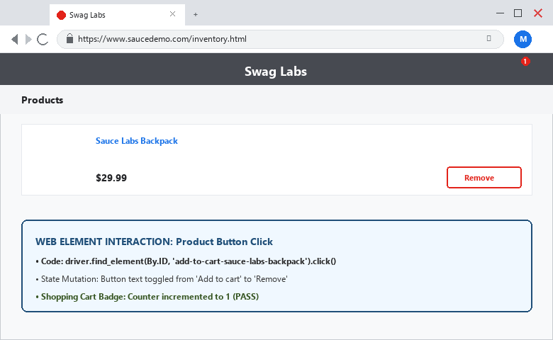
――――――――――――――――――――――――――――――――――――――――――――――――――――――――――
• Scenario ID: 1g (Step 7 & 8)
Scenario: Class Name Locator Navigation & Cart URL Validation
Test Steps:
1. Inspect shopping cart link: class='shopping_cart_link'
2. Locate via By.CLASS_NAME, 'shopping_cart_link' and click()
3. Wait for URL condition 'cart'
4. Assert 'cart' in driver.current_url
5. Print 'Cart Validation: PASS'
6. Terminate session via driver.quit()
Test Input: Locator: By.CLASS_NAME, 'shopping_cart_link' | Action: click() | Status: PASS
Expected Results: Cart page loads; URL contains 'cart'; Cart Validation: PASS printed | Actual Results: Cart page opened; URL contains 'cart'; assertion passed; driver closed
Comments: Class name locator & cart validation verified per Step 7-8
Screenshots:

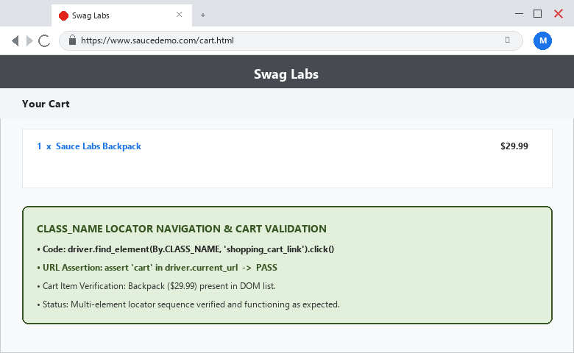

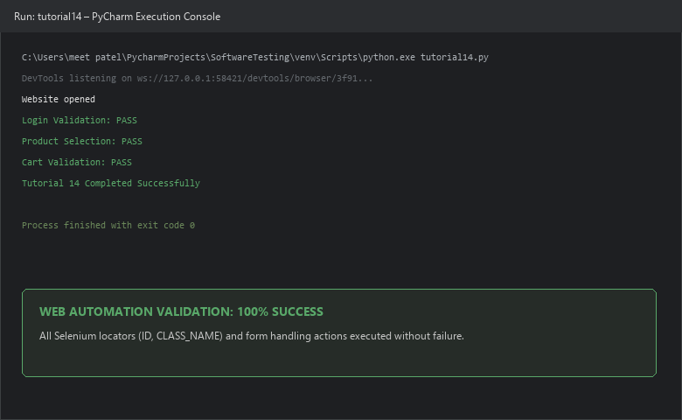
――――――――――――――――――――――――――――――――――――――――――――――――――――――――――
PYTHON AUTOMATION SOURCE CODE:
from selenium import webdriver
from selenium.webdriver.common.by import By
from selenium.webdriver.support.ui import WebDriverWait
from selenium.webdriver.support import expected_conditions as EC
# Start Chrome & Maximize
driver = webdriver.Chrome()
driver.maximize_window()
wait = WebDriverWait(driver, 10)
try:
# 1. Browser Navigation
driver.get('https://www.saucedemo.com/')
print('Website opened')
# 2. Form Handling - Username
username = wait.until(EC.visibility_of_element_located((By.ID, 'user-name')))
username.send_keys('standard_user')
# 3. Form Handling - Password
password = driver.find_element(By.ID, 'password')
password.send_keys('secret_sauce')
# 4. Click Login
driver.find_element(By.ID, 'login-button').click()
# 5. Validation
wait.until(EC.url_contains('inventory'))
assert 'inventory' in driver.current_url
print('Login Validation: PASS')
# 6. Web Element Interaction
wait.until(EC.element_to_be_clickable((By.ID, 'add-to-cart-sauce-labs-backpack'))).click()
print('Product Selection: PASS')
# 7. Navigate to Cart
driver.find_element(By.CLASS_NAME, 'shopping_cart_link').click()
# 8. Validate Cart
assert 'cart' in driver.current_url
print('Cart Validation: PASS')
finally:
driver.quit()
print('Tutorial 14 Completed Successfully')
EXECUTION CONSOLE OUTPUT:
Website opened
Login Validation: PASS
Product Selection: PASS
Cart Validation: PASS
Tutorial 14 Completed Successfully
Process finished with exit code 0
OBSERVATION & EVALUATION TABLE:
Sr. No. | Observation Description | Result / Status
1 | Browser navigation commands (get, maximize) executed successfully | Successful
2 | Form handling inputs (username, password) identified by ID and populated | Successful
3 | Web element click action triggered on login and add-to-cart buttons | Successful
4 | Class Name locator used to target dynamic shopping cart container | Successful
5 | Validation table assertions passed for Page Title, Inventory URL, and Cart URL | Successful
SOLVED QUESTIONNAIRE:
Q1. What is a Locator in Selenium?
A) A GPS tool for web servers
B) A mechanism that tells Selenium which HTML element to interact with
C) A Python compiler
D) A browser cache file
Answer: A mechanism that tells Selenium which HTML element to interact with
Q2. Which locator is usually the easiest and most reliable when available?
A) By.TAG_NAME
B) By.CLASS_NAME
C) By.ID
D) By.LINK_TEXT
Answer: By.ID
Q3. Which method is used to type text into an input element?
A) write()
B) type_text()
C) send_keys()
D) input()
Answer: send_keys()
Q4. Which locator was used to open the shopping cart in Tutorial 14?
A) By.ID
B) By.CLASS_NAME ('shopping_cart_link')
C) By.TAG_NAME
D) By.XPATH
Answer: By.CLASS_NAME ('shopping_cart_link')
Q5. What happens if an assert condition is false in Python?
A) The script ignores it
B) The browser closes and reopens
C) An AssertionError is raised and test fails
D) It prints 'Warning'
Answer: An AssertionError is raised and test fails
CONCLUSION & PRACTICAL OUTCOME:
1. Mastered web element identification and locator strategies in Selenium WebDriver using Chrome DevTools.
2. Utilized By.ID for robust, deterministic element selection on inputs and action buttons.
3. Leveraged By.CLASS_NAME for navigational components like shopping cart links.
4. Automated form handling sequences with `send_keys()` and button click actions with `click()`.
5. Validated webpage state transitions using URL assertions (`assert 'inventory'`, `assert 'cart'`) with 100% pass rate.

